Godalming College Physics Department
Charles’ Law
While conducting this experiment, you will be assessed for CPAC3: Working Safely.
Your lab report will be assessed for CPAC4: Correctly tabulating sufficient data and CPAC5: Percentage uncertainties and referencing standard values.
Apparatus
This method uses a straightforward piece of apparatus where a capillary tube containing a small volume of air is sealed by a small bead of mercury. The mercury is contained entirely within the tube, and presents no safety risk providing the tube is not broken. For accurate results, the whole enclosed air column needs to be submerged within a tall beaker of water, which is then heated. Do NOT heat the water bath above 80 ºC, or the material of the backing plate will soften.
What are the main safety precautions you need to take with this experiment? Write these below and discuss with your teacher before starting.

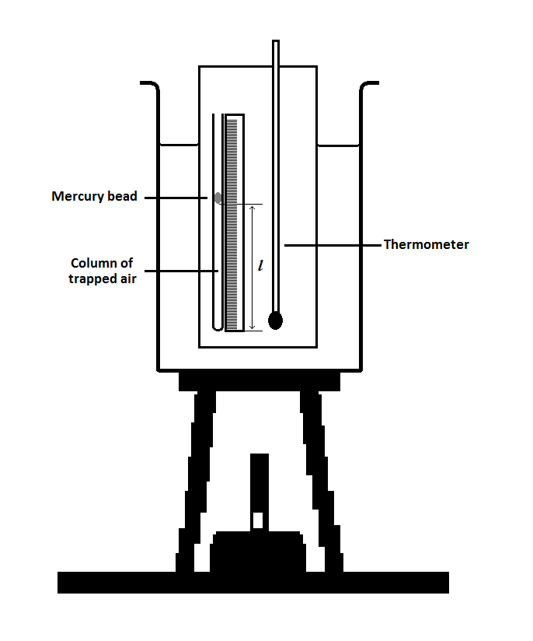
Theory
For a fixed mass of gas: V α T at constant Pressure.
Where: T is the kelvin temperature,
In this apparatus we assume that the bore of the capillary is uniform, so we can say that the length of the trapped air column is proportional to its volume.
Method
Start with an ice water mixture surrounding the apparatus, but with the top of the tube open to the air as shown. When this has reached equilibrium, record the length of the air column in mm and the corresponding celsius temperature from the thermometer. Now heat the beaker gently and once the ice has melted, record a series of values for temperatures up to 80 ºC.

Results and Analysis

You should now be able to plot a graph of the length of the trapped air column against celsius temperature.

You need to extrapolate the graph back to find the intercept on the x axis, however you should not do this graphically. The following diagram shows what the graph would look like if not plotted with a false origin.

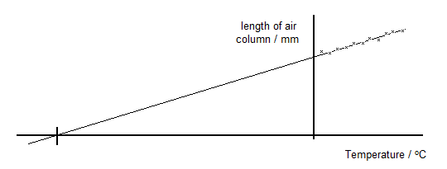
Can you explain why you would not expect a very good result if you plotted the graph with these axes?

Use a false origin and a larger scale to only include the values you have measured, however you should ensure that your temperature axis starts at 0 ºC.

From your graph measure the gradient, m and the intercept on the y axis, c.

You should then be able to use the equation ‘y = mx + c’ to calculate the value of x when y = 0.

What significance can you attach to this temperature? Look up the accepted value and compare it with your result. Remember to reference your research appropriately.

Work out the percentage difference between your result and the accepted values. Also work out the percentage uncertainties for typical values from a middle row of your table and find the combined uncertainty.

Given the nature of the graphical analysis, your uncertainties may not fully account for the difference. Also the apparatus relies on the volume of the trapped air being proportional to the length of the column - you should consider what effect the tapering at the end of the capillary tube may have on the result.

