Godalming College Physics Department

Magnetic flux linkage with search coil and CRO
Your lab report will be assessed for CPAC4: Correctly tabulating sufficient data and CPAC5: Referencing and researching the magnetic field due to a Helmholtz coil arrangement.
Theory

A search coil is a small coil of many turns, N of fine wire used to sample a magnetic field. When the axis of the coil is at an angle θ to the field, the magnetic flux linkage, NΦ, is given by:
NΦ = BAN cos θ
where B is the flux density of the field and A is the area of the search coil.

In an alternating field, an emf of peak value, ε is induced in the search coil where:
ε = BAN(2πf) cos θ
where B is the peak magnetic flux density and f is the frequency of the a.c. producing the field.

Apparatus required

The magnetic field is produced by a double coil arrangement known as a Helmholtz coil. The diagram shows a cross-section through the coils – a picture is included to help with the set-up.

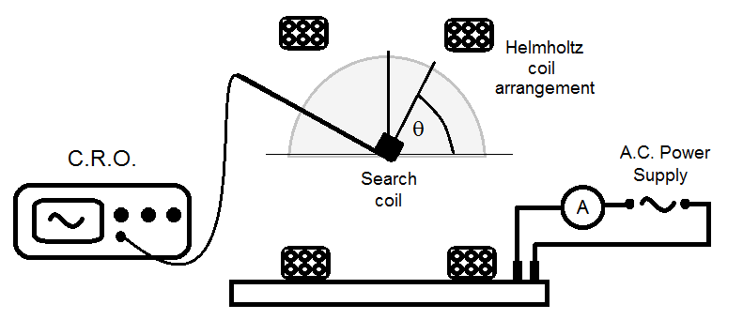 | 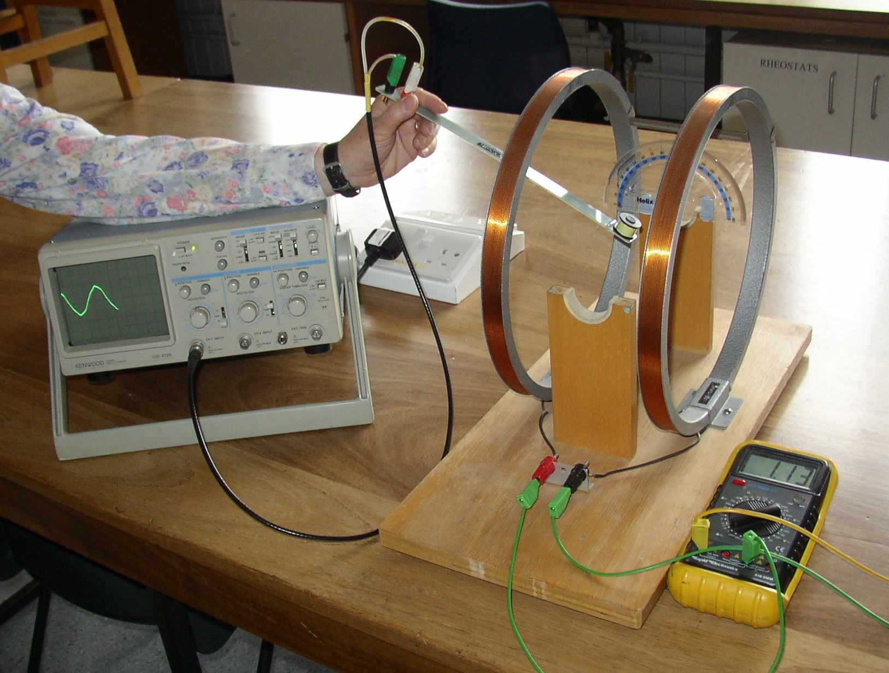

Method

Set up the apparatus as shown and adjust the power supply output to give an r.m.s. current of about 1 A. Record the current, as you will need this to calculate the peak value of B for the Helmholtz arrangement. It is not easy to clamp the search coil in position and the clamp and stand may upset the magnetic field, therefore you will need to hold the search coil at the centre of the field. One person should hold the coil (2 hands are recommended) and the other should read the C.R.O. Clearly there is a large degree of procedural uncertainty involved here, so several repeat measurements are advised with roles exchanged.

Take a series of readings of the peak-to-peak voltage on the oscilloscope for a variety of angles, θ. The angle θ should be judged from the large protractor fixed to the apparatus, being particularly careful to avoid parallax error. To measure the peak-to-peak voltage, you may find it easier to set the oscilloscope on X-Y mode. If you are using a ‘Kenwood’ oscilloscope make sure that the variable calibration control is set to the ‘Cal’ position. You may find that there is quite a bit of interference on the oscilloscope trace, which is another source of error to consider in your discussion.

When you have finished, measure as accurately as possible the diameter of the Helmholtz coils and also obtain an estimate for the mean diameter of the search coil. Also note the number of turns on each coil. All of these values will be needed for the later analysis.

Processing of results

Tabulate your results for your repeat readings of the peak-to-peak induced emf against angle and calculate a mean value for ε_{p-p} and the corresponding value of cos θ.

Plot a graph of ε_{p-p} against cos θ, draw a best fit straight line and measure the gradient. To preserve precision for the plotting, there is no point in halving the individual values, but once you have obtained a gradient value you should divide this by 2 so it corresponds to the peak value of the induced emf.

From the equation given in the theory and the values of A & N for the search coil, calculate a value for the peak value of B at the centre of the Helmholtz arrangement.

Research and Discussion

Research the behaviour of the Helmholtz coil and find out an expression for the magnetic flux density at the centre. Make sure you document and reference your findings in your report as this will be assessed a part of the ‘research, reference and reporting’ criteria of the CPAC for the practical endorsement.

Use the r.m.s. current in the Helmholtz coil to calculate a peak current and then apply the formula for magnetic flux density to calculate the peak value of B at the centre. Remember this time to use the number of turns and the dimension for the Helmholtz coil.

How does this value compare with that calculated from the search coil measurements? Calculate a percentage difference and discuss whether the discrepancy is reasonable given the inherent uncertainty in the experimental measurements.

You should also comment on the shape of you graph of ε_{p-p} against cos θ, again discussing possible sources of uncertainty in the measurements.

Conclusion

For your conclusion, you should state the relationship between the emf induced in the search coil and its orientation, and the value of the peak magnetic flux density measured at the centre of the Helmholtz system.

