**How to add a menu to your Edublogs**

Before you start adding your work you’ll need to click *‘****Posts****’ ‘****Add New****’*, then title each one exactly as below, with the names of the units for the year:

UNIT 8: COMMISSION

UNIT 10: FILM FICTION

UNIT 20: SINGLE CAMERA PRODUCTION

UNIT 21: EDITING

UNIT 18: STORYBOARDING

**1.** Ensure the posts that need to go into your menu are **published** and not in draft mode

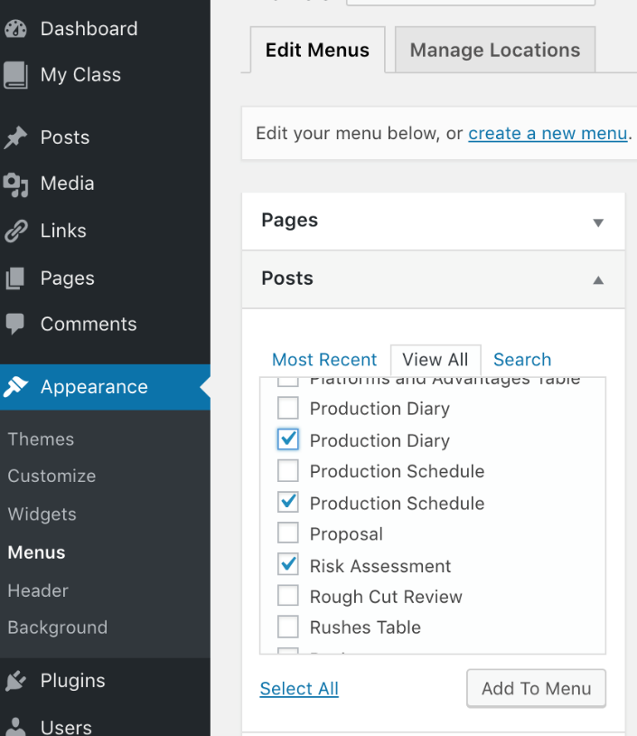

**2a**

**2.** Go to *‘****Dashboard****’*

‘***Appearance****’*

*‘****Menus****’*

**2b**

**2c**

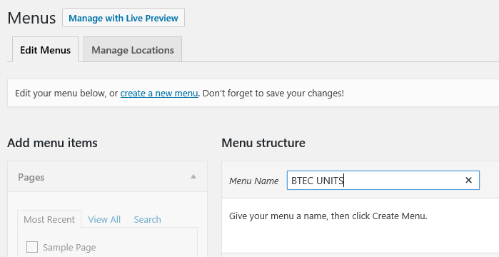**3.** At the top click on ‘***Edit Menus****’*

**3a**

**3b**

‘***Create a new menu****’*

**3c**

Call *‘****Menu Name****’* **BTEC UNITS**

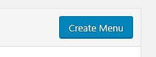 Then select *‘****Create Menu****’*

**3d**

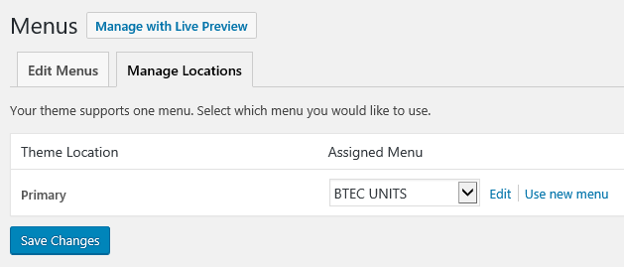**4.** Then click *‘****Manage Locations****’*

**4d**

**4a**

Check that the ‘***Primary Menu****’ is* ***BTEC UNITS***

The positioning of your menu is determined by the template you have chosen, the default location is normally fine. It should be clearly visible and at the top of your site.

**4c**

**4b**

Then click *‘****Save Changes****’*

You can select *‘****Manage with Live Preview***’ to check your menu.

**5.** Then once you have uploaded a piece of work you’ll need to assign it to the right menu so we can find it!



**5a**

**5b**

**5c**

**5e**

**5f**

Go back to ***Dashboard*** - ***Appearance*** - ***Menus***

Then click the little triangle to the right of *‘****Posts****’* and ‘***tick****’* the post/s you want to be included in your menu.   
  
Then select *‘****Add to Menu****’*

**5d**

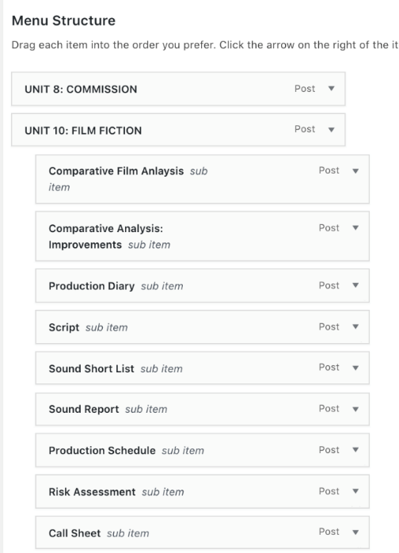

**6.** In the *‘****Menu Structure****’* section on the right, the posts you have selected will appear

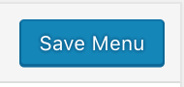

**Drag and drop** to put your menu in the correct order.   
Make a note of the **hierarchy** of the menu, so work belonging to the corresponding unit needs to be dragged and dropped **below** and to the **right**.  
Then select *‘****Save Menu****’*