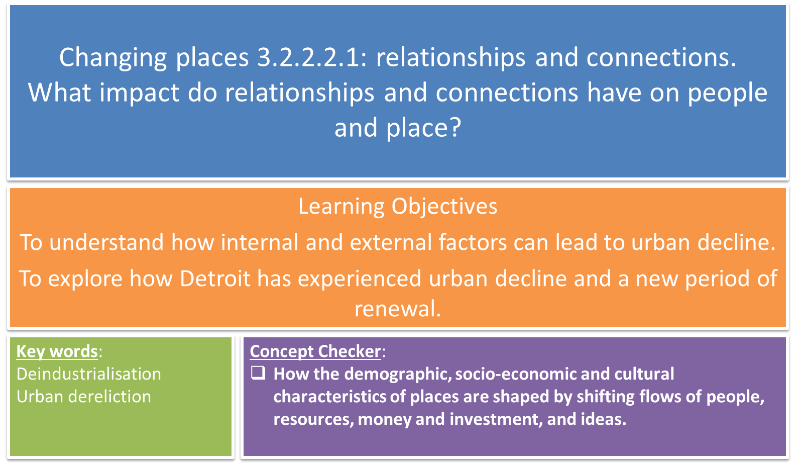

Key words identification:

De-industrialisation Dereliction Deprivation

|  |  |
| --- | --- |
|  | The state of having been abandoned and become dilapidated. |
|  | The damaging lack of material benefits considered to be basic necessities in a society. |
|  | The decline of regionally important manufacturing industries. The decline can be charted either in terms of workforce numbers or output and production measures. |

|  |
| --- |
| Residential properties become abandoned as area’s reputation declines |
| Schools and shops close |
| Less skilled workforce |
| Industrial buildings sit empty |
| People become resigned or depressed about the situation |
| Some people turn to crime to supplement income |
| Local shops and services get less income or customers |

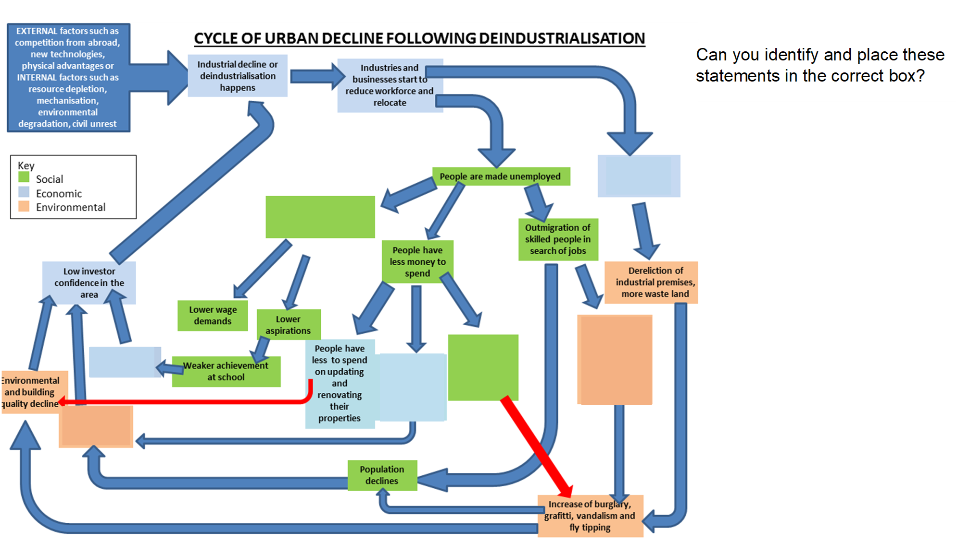

Case study: Detroit, Michigan

[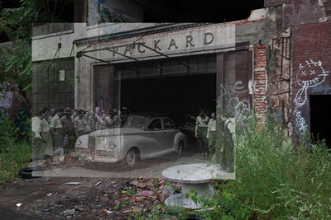](http://www.detroiturbex.com/content/ba/feat/index.html)[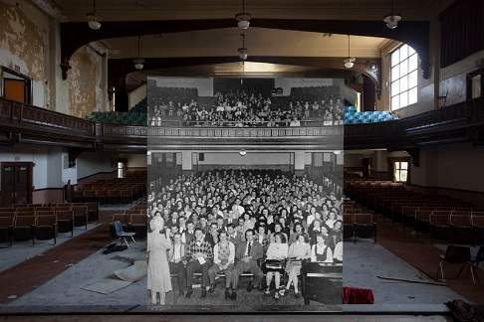](http://www.google.co.uk/url?sa=i&rct=j&q=&esrc=s&source=images&cd=&cad=rja&uact=8&ved=0ahUKEwjtj6anmYrQAhWFVxoKHSCzBAsQjRwIBw&url=http://photos.metrotimes.com/45-photo-montages-showing-detroit-then-and-now/&bvm=bv.137132246,d.ZGg&psig=AFQjCNEAZGM0_GjTvugQAigBMhHt6Awybw&ust=1478180412105975)Detroit became famous as America’s car-making capital. It was known as ‘Motor City’ and was the birth place of ‘Motown’ records.

This began to change in the 1970s and 80s as the automotive (car) industry endured competition from imported cars and from the growth of car manufacture further south where trade unions were weak or non-existent, making labour cheaper. Racial tensions and increasing drug related gang activity lead to increasingly divided neighbourhoods and what has been termed “white flight”.

Watch the news clips and make notes on the effects of the decline of Detroit in the space below:

Economy:

Communities:

Urban environment

**Read the article ‘Detroit: where did it all go wrong?’**

* Use 3 colours to produce a key and highlight social, economic and environmental impacts of deindustrialisation.
* Answer the questions beneath the article.

**Detroit: Where did it all go wrong?**

Detroit has filed for bankruptcy, unable to pay $18.5 billion in debts. How did the city of Motown and the car industry sink so low? It shouldn't have come to this. Detroit was once the pride of America; home of the car industry, and centre of the Motown music scene. In the 1950s 1.8 million people called the city, on the Canadian border, their home.

But it has all gone terribly wrong, with the city now unable to pay its $18.5 billion (£12bn) debt. On Thursday the city was forced to declare itself bankrupt – the largest municipal bankruptcy in history.

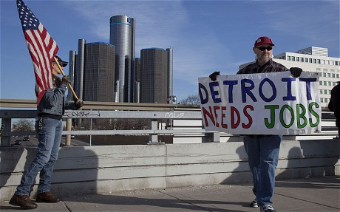Once a bustling beacon of industrial might, the city is now a poster child for urban decay, its landscape littered with abandoned skyscrapers, factories and homes.

Crime has soared and the murder rate is at a 40 year high; the council has literally been unable to keep the lights on, and 40 per cent of all street lights are out of order.

Now a third of Detroit's 700,000 residents live in poverty and about a fifth are unemployed. The population has fallen by 60 per cent since its 1950s peak, as those able to leave the city do so. As a result, the educated people able to contribute to the economy, run businesses and pay their taxes have moved out, leaving behind those reliant on the state.

Almost 80,000 homes are empty, and more than half of the owners of Detroit's 305,000 properties failed to pay their 2011 tax bills, exacerbating the city's financial crisis.

The exodus from the city stemmed from race riots in the 1960s – in particular the July 1967 riots, which killed 43, left 467 injured, and destroyed over 2,000 buildings when the army were sent in to quell the violence.

The collapse of the motoring industry played a part over the years, as car manufacturers went through round after round of mass layoffs as factories were automated or outsourced and Asian competitors siphoned away market share. President Barack Obama's decision to prop up the drowning General Motors in 2009 saved the main company, however, and GM has, since 2010, returned to being profitable.

But perhaps just as damaging as population flight and car manufacturing problems was the general mismanagement of the city's finances. Some 38 cents of every city dollar was going to debt repayment and obligations like pensions, and that was projected to hit 65 cents on the dollar by 2017.

A plan devised in June called for city-employed retirees to accept less than 10 per cent of what they were owed under pension plans. But earlier this week the city's two pension funds sued Detroit's state-appointed emergency manager in an attempt to stop the cuts in retirement pay.

Meanwhile, life in the city has got increasingly poor.

Only a third of ambulances are in working order, and police take an average of 58 minutes to arrive on crime scenes. Anyone who can leave has done so.

**Questions:**

1) Why did Detroit’s automotive industry go into such decline?

2) What effect has deindustrialisation had on the people of Detroit?

3) How was the economy affected?

*Are there specific groups that have been more badly affected? Explain.*

**Detroit – a new chapter?**

In recent years Detroit has begun to experience something of a resurgence and levels of investment and business occupancy rates in the downtown have soared. New, young and innovative residents have moved in, taking advantage of cheap rents and property prices, and have helped to move Detroit’s image towards something altogether cooler and desirable.

1) Read the Guardian article about the renewal of parts of the city. Identify 5 ways that the city is improving using evidence from the article:

2) Watch the clips on the renewal of Detroit and then answer these questions:

3) How do the new industries and developments differ from those of the past?

4) Are there certain groups who might be left out or ‘left behind’ by those helping to grow the new Detroit? Do you think inequality will improve or worsen?

<https://www.youtube.com/watch?v=sFJsXev3eU0> – urban farming in Detroit + regen

<https://www.youtube.com/watch?v=avwE1Va_48o> – Detroit bankruptcy and turnaround

<https://www.youtube.com/watch?v=TvZ3UngoS6Y> – Detroit regen – property boom

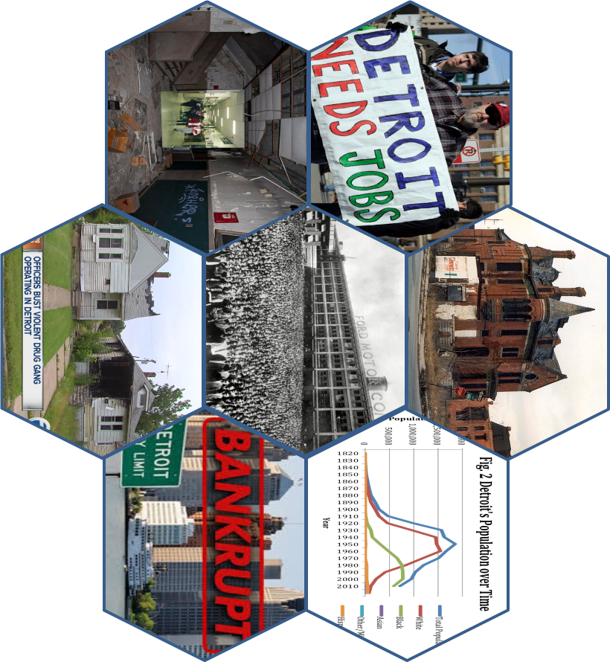

TASK:

Each hexagon relates to the one in the middle. Your task is to explain what each one shows and how it links to the middle hexagon. Level up by explaining how each hexagon links to the others it is connected to.

**HOMEWORK – read p110-113 of the Oxford book. Complete questions 1-6 on p113.**