**Human Rights**



**What this course will cover:**

* What is meant by the term ‘human rights’
* An overview of the history of human rights development and the impact of the American & French Revolutions
* The impact of the early twentieth century on human rights development and the adoption of the Universal Declaration of Human Rights
* The defenders of human rights and their effectiveness
* Human rights in the twenty-first century and the new challenges posed by terrorism and counter-terrorism, data collection and new technology

**What do we mean by the term ‘human rights’?**

In pairs or small groups you will be given one of the questions below to discuss.

* Begin by writing the question in the middle of a blank A4 piece of paper
* Add notes/comments around it. No prior knowledge is expected so think logically to add answers or add follow up questions.
* You will have **5 minutes** on your question before swapping it with another pair. Read their comments/answers and then add your own before swapping again
* Once you have looked at all 6 questions, you will need to feedback on the question you are left with – select the 3-4 most useful/interesting answers to feedback

1. **What are human rights?**
2. **How are human rights different from civil rights?**
3. **Should animals have the same rights as humans?**
4. **Where do human rights come from?**
5. **Who has human rights? Who does not have human rights?**
6. **Why are human rights important?**

**What are human rights?**

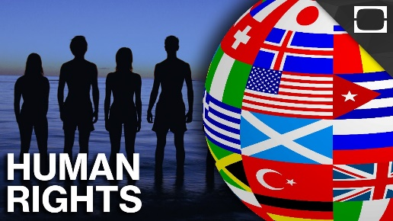Watch *‘The Story of Human Rights’* on YouTube. Use this to write down your definition of what human rights are below:

**Human rights are:**

**Should animals have the same rights as humans?**



Now watch Steven Wise’s TED talk: *‘Chimps have feelings and thoughts. They should have rights too’* and answer the following questions:

1. What is the ‘legal wall’ that Wise describes?
2. What is the difference between a ‘legal person’ and a ‘legal thing’?
3. Give some examples of human ‘legal things’ and non-human ‘legal persons’.
4. On what basis does Wise believe chimps should have rights?
5. Are there any ‘human rights’ which you think animals should not have?

**Human Rights Around the World**

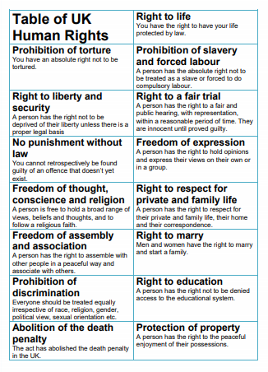

**Task:** Research the human rights record of the country you have been given (use the materials/links provided for you to do the research) and produce a similar factfile to the one on the previous page to share with the class.

* What were your expectations about your given country before you did the exercise?
* Do you feel that everyone in the UK enjoys all the human rights in Table 1?
* How are the countries you looked at similar / different to the UK on human rights?

**A Timeline of Human Rights History**

Research the events below and for each, write one sentence to explain its significance in the history of human rights:

**The Impact of the American and French Revolutions**

The modern concept of human rights can be traced back to the Enlightenment ideas and texts emerging in the late 18th century as part of two great revolutions – the American revolution and the French revolution – that challenged the ideas of absolute monarchy.

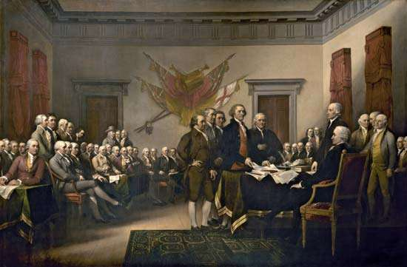In 1776 American colonists demanded freedom from the British Empire and declared their independence. In the eyes of American rebels, the revolution was fought against a tyrannical king and in the name of freedom and equality. The colonists fought a war with the British Empire until 1783, when the British government recognised American independence.

In 1789 the French revolution overthrew the Bourbon monarchy and established a French Republic, triggering the global decline of absolute monarchies. The two revolutions saw the emergence of two key texts in which we can see the emergence of modern ideas of human rights.

**Task:** Read the extracts from the two key texts below and answer the questions which follow:

The **U.S. Declaration of Independence (1776)** proclaimed:

*We hold these truths to be self-evident, that all men are created equal, that they are endowed by their Creator with certain unalienable Rights, that among these are life, liberty and the pursuit of happiness.- That to secure these rights, Governments are instituted among Men, deriving their just powers from the consent of the governed, That whenever any Form of Government becomes destructive of these ends, it is the Right of the People to alter or to abolish it, and to institute new Government, laying its foundation on such principles and organizing its powers in such form, as to them shall seem most likely to effect their Safety and Happiness.*

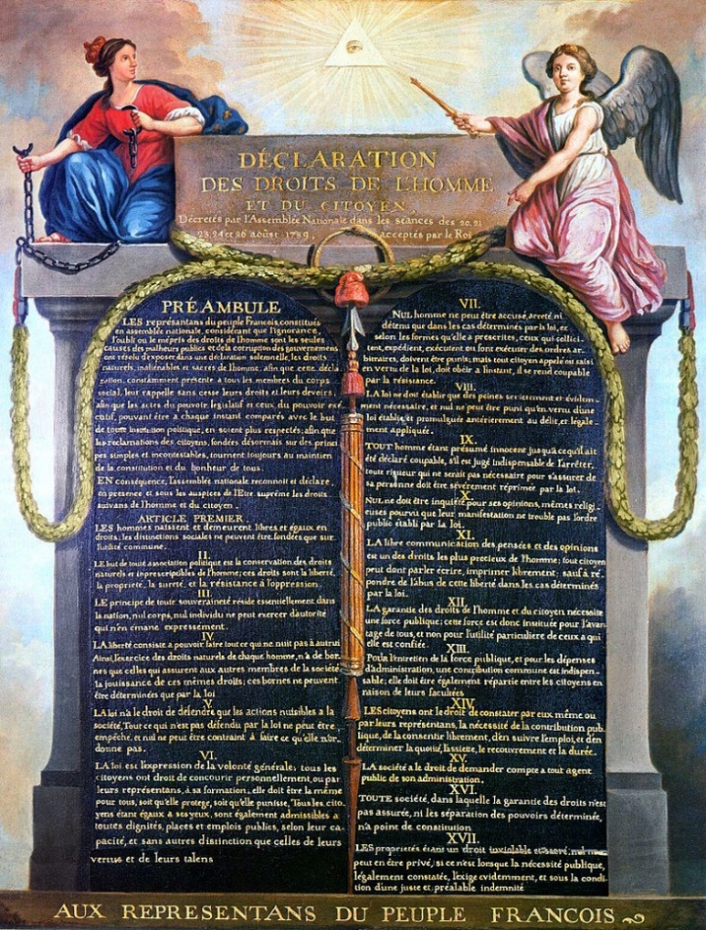The **Declaration of the Rights of Man and of the Citizen (1776)** was drafted by the Abbé Sieyès and the Marquis de Lafayette, in consultation with Thomas Jefferson (who was a draftsman of the U.S. Declaration of Independence) included the following articles:

***1.****Men are born and remain free and equal in rights. Social distinctions may be founded only upon the general good.*

***2.****The aim of all political association is the preservation of the natural and imprescriptible rights of man. These rights are liberty, property, security, and resistance to oppression…*

***6.****Law is the expression of the general will. Every citizen has a right to participate personally, or through his representative, in its foundation. It must be the same for all, whether it protects or punishes. All citizens, being equal in the eyes of the law, are equally eligible to all dignities and to all public positions and occupations, according to their abilities, and without distinction except that of their virtues and talents.*

***7.****No person shall be accused, arrested, or imprisoned except in the cases and according to the forms prescribed by law…*

***10.****No one shall be disquieted on account of his opinions, including his religious views, provided their manifestation does not disturb the public order established by law.*

***11.****The free communication of ideas and opinions is one of the most precious of the rights of man. Every citizen may, accordingly, speak, write, and print with freedom, but shall be responsible for such abuses of this freedom as shall be defined by law…*

***17.****Since property is an inviolable and sacred right, no one shall be deprived thereof except where public necessity, legally determined, shall clearly demand it, and then only on condition that the owner shall have been previously and equitably indemnified.*

1. What does ‘unalienable’ mean?
2. What is the significance of the American Declaration of Independence in terms of human rights?
3. 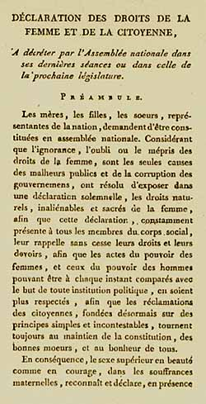What rights are specified in the Declaration of the Rights of Man and of the Citizen?
4. What limitations were there to the rights outlined in these two texts?

**The impact of war and genocide in the early twentieth century**

Why could state sovereignty be a barrier to human rights?

**A definition of State sovereignty:**

**Preface to The Lawful Rights of Mankind by Paul Sieghart**

*Down to the end of the second world war, it was a matter of universally accepted doctrine in international affairs that how a state treated its own citizens was a matter entirely for its own sovereign determination, and not the legitimate concern of anyone outside its own frontiers. Had a well-meaning delegation from abroad called on Chancellor Adolf Hitler in 1936 to complain about the notorious Nuremberg Laws, and the manner on which they were being applied to persecute German Jews, the Fuhrer would probably have dismissed such an initiate with the classic phrase of ‘an illegitimate interference in the internal affairs of the sovereign German state’, pointing out that these laws had been enacted in full accordance with the provisions of the German constitution, by an assembly constitutionally and legally competent to enact them, and that neither they nor their application were the concern of meddling foreigners. And in international law as it then stood, he would have been right – and so would party Secretary-General Joseph Stalin have been if a similar delegation had called upon him at around the same time to complain about the wholesale destruction of the kulaks* [wealthy peasant class] *in the Soviet Union.*

The first half of the twentieth century saw two world wars, both of which were accompanied by genocides resulting in the deaths of millions (the **Armenian genocide** of 1915 and the **Holocaust, 1941-45**). These events had a significant impact on human rights development.

**Woodrow Wilson and the League of Nations**

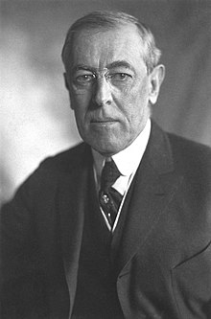In his 1918 address to Congress, U.S. President Woodrow Wilson spoke of his desire ‘to create a world dedicated to justice and fair dealing’. His ‘Fourteen Points’ programme included specific reference to rights to self-determination and statehood for nationalities seeking autonomy. The Fourteen Points formed the basis of the 1919 Versailles Peace Treaty which established the League of Nations (the forerunner to the U.N.) and the International Labour Organisation.

* The League of Nations attempted to legally recognize and protect minority rights through a series of treaties – the first multilateral effort to protect the rights of specific groups of people at international level, including the right to life and liberty for all inhabitants
* The International Labour Organisation endeavoured to protect workers’ rights (and is still in existence today as one of the U.N.’s specialized agencies)
* The League also set up commissions on slavery and adopted the 1926 Slavery Convention

WW1 also saw the extension of the franchise to women for the first time and to working class men.

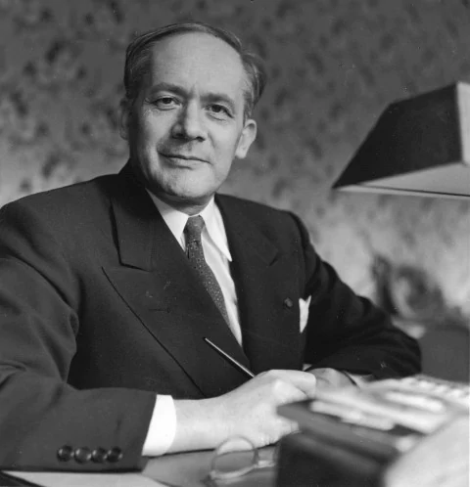**Raphael Lemkin and the Genocide Convention**

**Task:** Watch ‘Raphael Lemkin’s Fight Against the Crime with No Name’ on YouTube and answer the questions which follow

1. What happened for the first time on May 24 1915 and why was this not successful?
2. What event of WW1 horrified Lemkin, inspiring him to take up his life’s work?

1. What did Lemkin do in 1933 and why?
2. Where does the word ‘genocide’ come from?
3. What were the perpetrators of the Holocaust charged with at Nuremberg and what did Lemkin try to do?
4. What did Lemkin want the U.N. general assembly to do?
5. What was the significance of the Genocide Convention and the principle of state sovereignty?
6. Why did the USA take so long to ratify the Convention?
7. When was the Genocide Convention first used?

**Task:** Do some more research into the Nuremberg Trials and answer the questions below.

1. Who was on trial – and what for? Why was this significant?

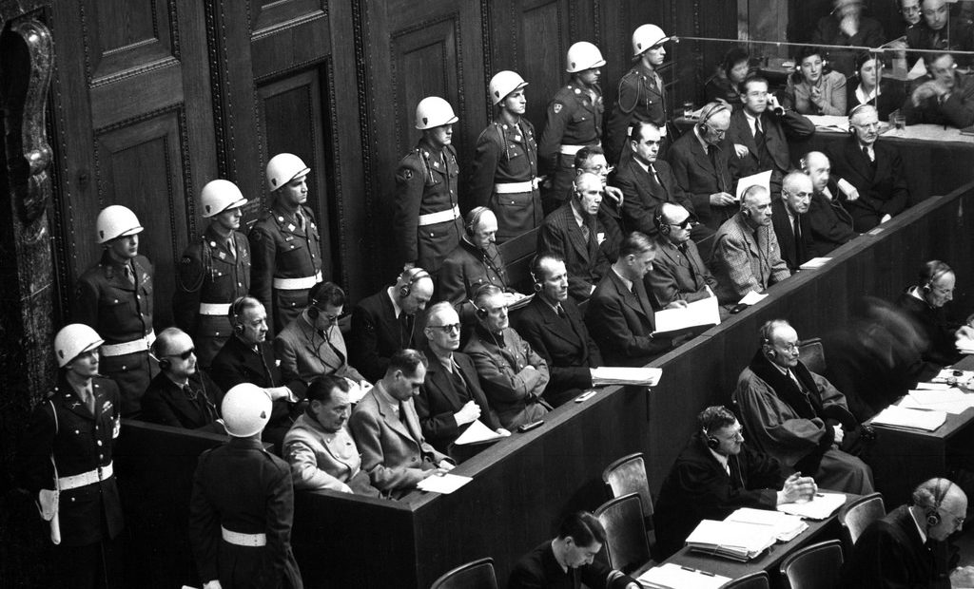

1. How have the trials been criticized?
2. Do you agree with the criticisms?

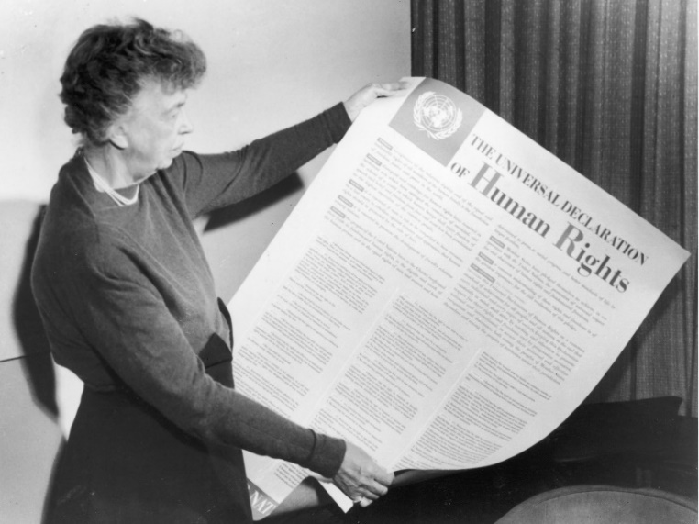

**Eleanor Roosevelt and the Universal Declaration of Human Rights**

In 1946 Eleanor Roosevelt, the former First Lady of the United States, was appointed as a delegate to the United Nations by President Harry Truman, who had succeeded to the White House after the death of Franklin Roosevelt in 1945. As head of the Human Rights Commission, she was instrumental in formulating the 1948 charter of liberties the Universal Declaration of Human Rights. The UDHR is the most translated document in the world, available in 500 languages, and laid the legal groundwork for the International Criminal Court, the tribunals that prosecuted war crimes in Rwanda and Yugoslavia, and the national constitutions of nearly 20 countries.

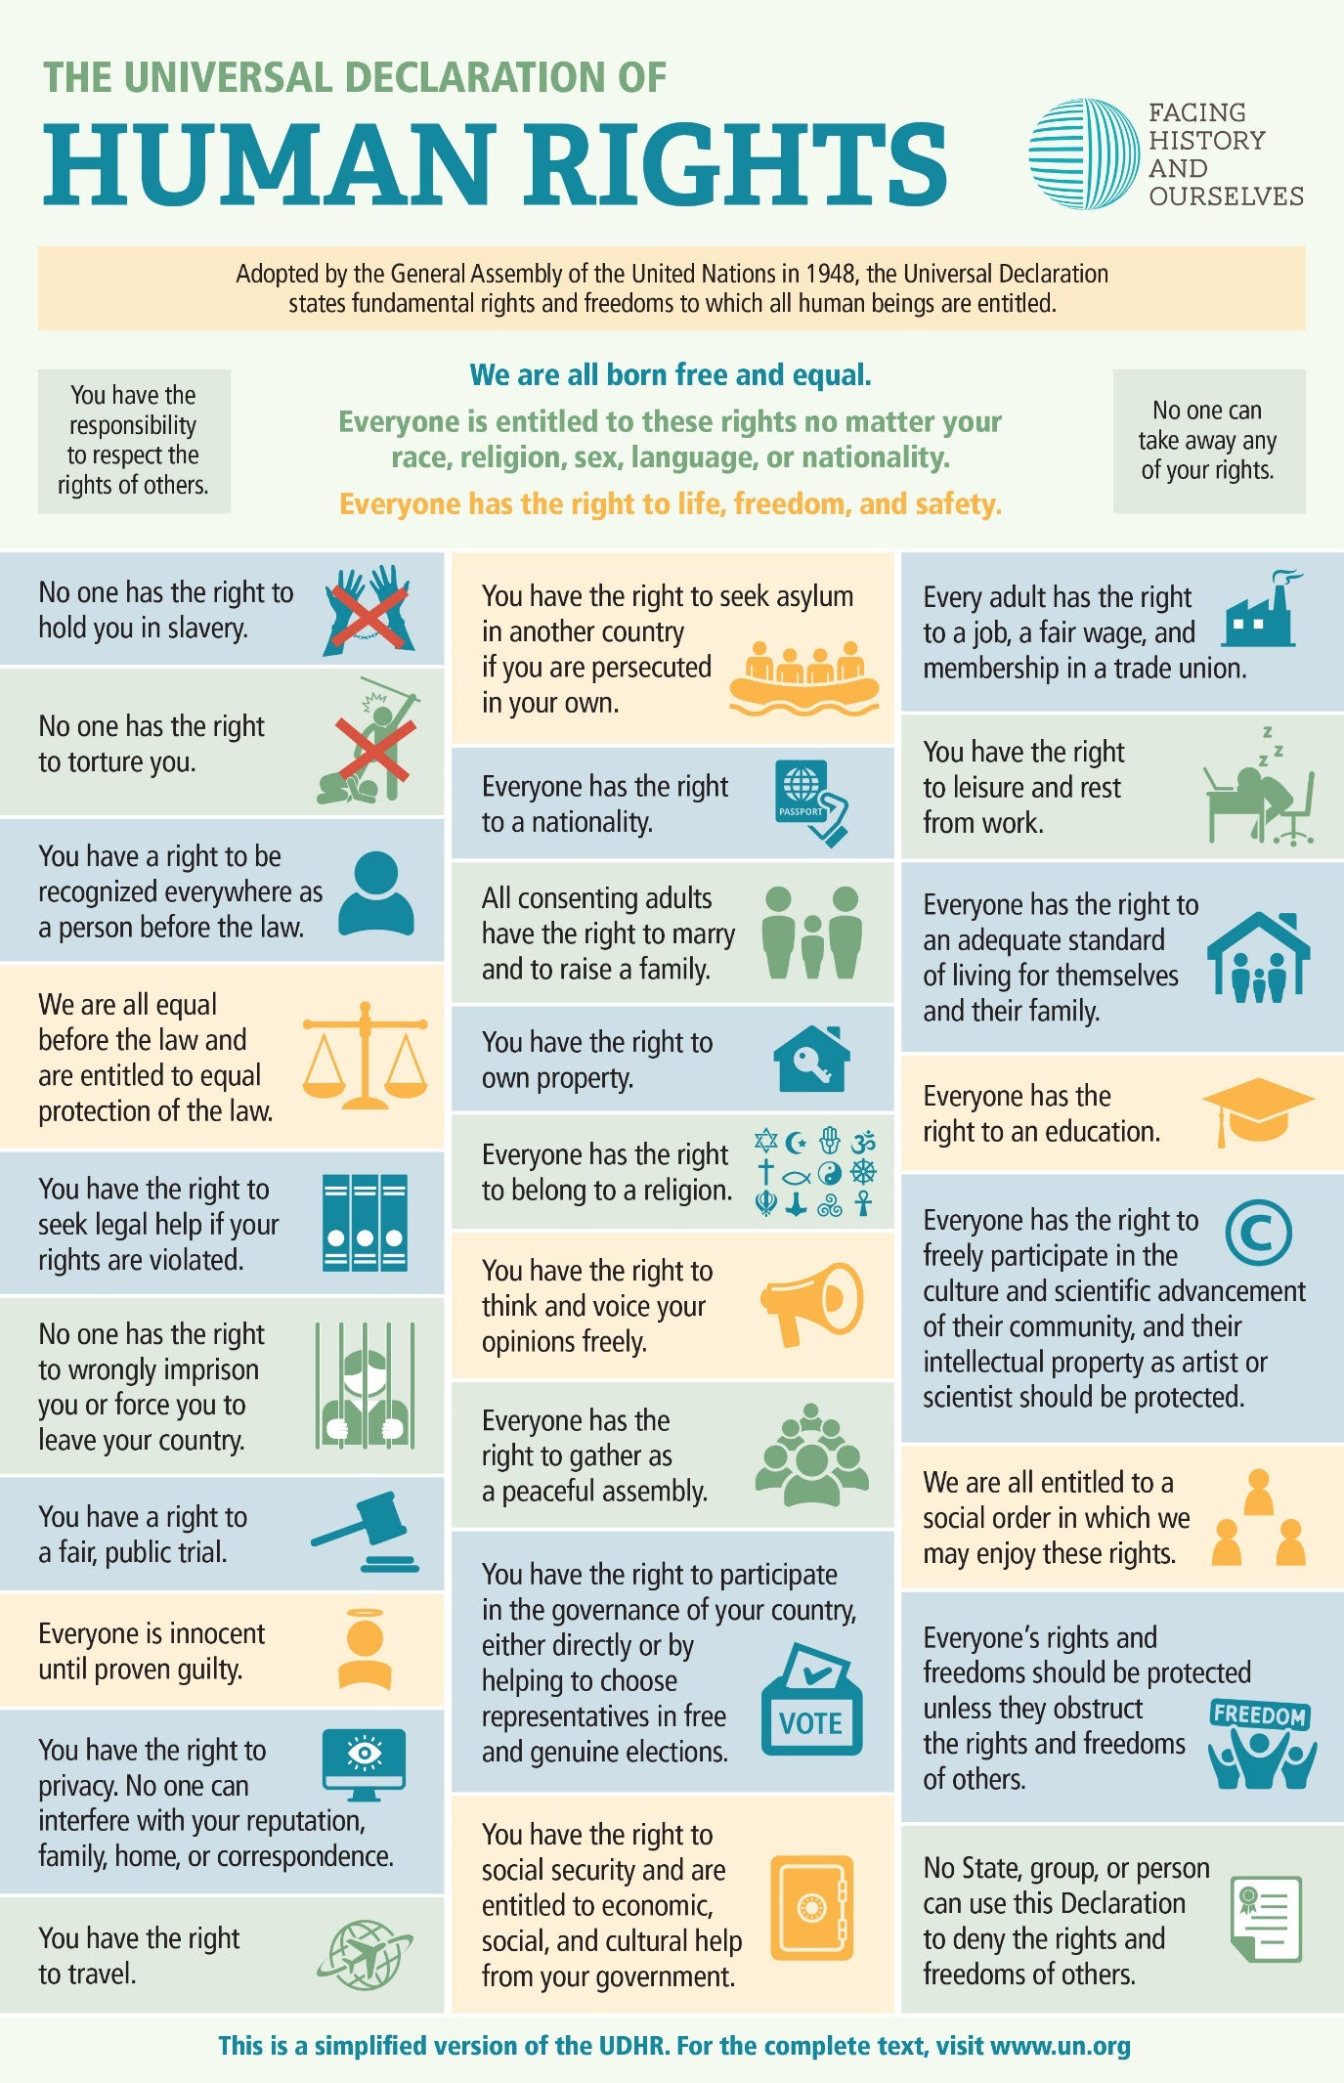

**Task:** Study the summary diagram of the UDHR (note this is a simplified version of the Declaration) and discuss the following questions in small groups:

1. What three UDHR rights do you think are the most important & why?
2. What UDHR right most surprises you?
3. What right do you think is missing from the UDHR that should be included in a universal human rights document?
4. Choose 3 of the rights on the UDHR. Do you think these rights are truly universal? Are they enjoyed by everyone? If not, can you think of any specific examples?
5. Why do you think some rights are only sometimes or never enjoyed by some people? What are the reasons for this? Does this suggest a problem with the rights included in the UDHR or does it suggest something else?
6. What responsibility do nations who signed the UDHR have to ensure that these rights are realised by every person in their country?
7. What responsibility do nations who signed the UDHR have to the people in other countries if any of these rights are violated?
8. What is the power or potential of a document like the UDHR? What are its limitations? Is there value in having an agreement whose goals may seem difficult or even impossible to achieve?

**Criticisms of the UDHR**

One of the main criticisms of the UDHR was that it was reflective of a Western view of what human rights are. Over the last 70 years, it has often drawn criticism by other parts of the world for not taking into consideration their own culture or stance on human rights. The two clearest examples of these are Islamic countries’ views on the importance of Sharia Law, as well as East Asian countries emphasising their own values:

1. A number of Islamic countries reject some of the rights in the Universal Declaration because they are contrary to sharia law – for instance, full equality for women or the right of Muslims to change their religion. In this view, ‘human rights’ are grounded in a false understanding of the nature of human dignity & rights, which derive solely from God.
2. 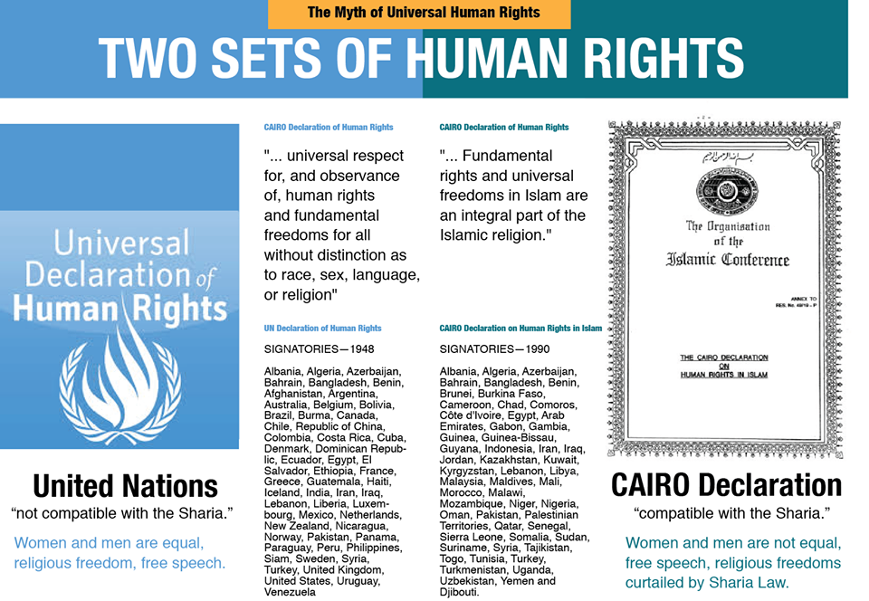Since the 1990s a number of authoritarian Asian states like China & Singapore claimed that some ‘human rights’ as set out in the Universal Declaration were inapplicable & reflected Western traditions. They claimed that the political systems & laws of Asian countries reflected their own traditions & so-called ‘*Asian Values’*, which emphasised collective rights & the need for stability & order over unfettered individual freedom, which led to dissent, which destabilised society. This has increased in recent years, as China increasingly portrays itself as an alternative to the Western, democracy-centered model of human rights.

**How effective are the defenders of Human Rights?**

**The UN**

The establishment of the United Nations in 1945 signalled the beginning of unprecedented international concern for the protection of human rights. It’s Charter, adopted in 1945, commits the organisation to encouraging respect for human rights.

**Task:** Visit the website of the UN’s Office of the High Commissioner for Human Rights ([www.ohchr.org](http://www.ohchr.org)) and see if you can find out the answers to these questions

1. Who is the current High Commissioner for Human Rights?
2. What is the OHCHR’s mission/aims?
3. How many human rights treaty bodies are there and can you give some examples?
4. Find out about some of the most recent issues the OHCHR has been involved in.

**Genocide in Rwanda, 1994**

**Task:** Watch the clips from the film ‘Shooting Dogs’ and make some simple notes below about the problems with the UN’s mandate in Rwanda

**The International Criminal Court (ICC)**

The ICC came into existence in 2002. It is an international tribunal that sits in The Hague, Netherlands. The ICC has jurisdiction to prosecute individuals for the international crimes of genocide, crimes against humanity, war crimes, and crimes of aggression. The UN Security Council may refer situations to the Court.

**Task:** Watch the clip from the BBC drama ‘Black Earth Rising’ (ep.1, 0.53-4.26). What criticisms are being levied at the ICC?

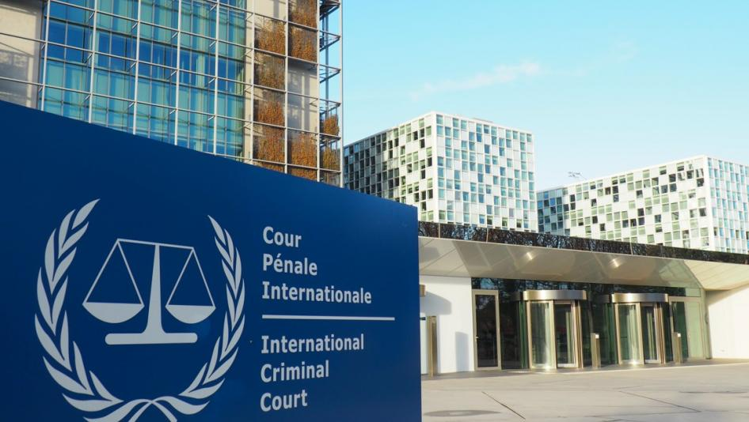

**Is the world's highest court fit for purpose?**

The International Criminal Court was set up to deal with the worst criminals in the world. But as African countries threaten to leave and the US withdraws funding, how can it wield justice more effectively?

by [Jessica Hatcher-Moore](https://www.theguardian.com/profile/jessica-hatcher)

Wed 5 Apr 2017 – Guardian newspaper

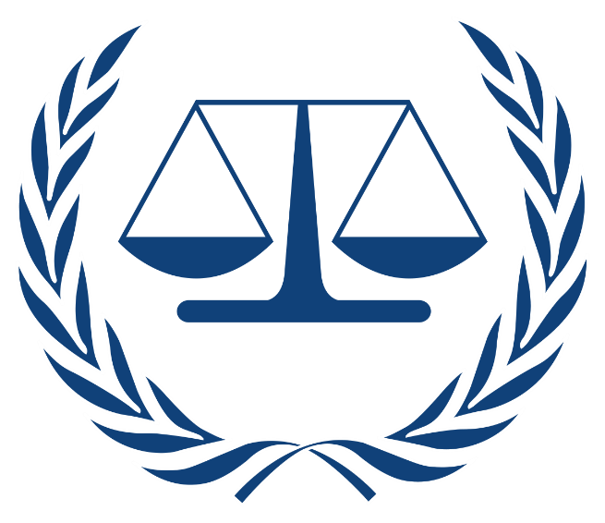**W**alking barefoot, Dominic Ongwen took a westerly course across the tropical savanna in the Central African Republic where it meets the border of Sudan. The Ugandan rebel leader had been on the run for days from Joseph Kony, the notoriously elusive chief of Lord’s Resistance Army (LRA). After 30 years as a rebel, from child soldier to commander, Ongwen had fallen out of favour with Kony and had three options: face likely execution, escape, or die trying.

Ongwen met a group of cattle herders, who led him to a group of former rebels. A succession of phone calls eventually brought news of his defection to US and Ugandan soldiers in Obo, 500km south, who had been hunting him for six years. US special forces flew Ongwen to their base by helicopter. It was January 2015.

Ongwen agreed to record a message to lure other LRA commanders out of the bush. “I am now a free man despite the ICC [International Criminal Court] case against me,” Ongwen said on the recording, addressing his old comrades. He sounded confident, boastful even, mentioning the quality of the women and the luxury of his quarters. “Even the president has agreed to forgive me,” he said.

It could have been a textbook example of the US and Ugandan strategy to encourage LRA defection, and a catalyst to dismantle the remains of the group (who reportedly now [number less than 100](http://www.africom.mil/media-room/pressrelease/28776/u-s-forces-transition-counter-lra-mission-to-broader-security-and-stability-activities), down from [up to 4,000 fighters in 1997](http://pdf.usaid.gov/pdf_docs/Pnacc245.pdf)). Except Ongwen wasn’t going to get amnesty. Under pressure from the Obama government to show results, the US transferred him swiftly to the ICC in The Hague.

Human rights defenders in Uganda felt Ongwen was deceived, which undermined a basic tenet of criminal law – truth –and prompted criticism of the ICC from many people in northern Uganda who support granting [amnesty to former rebels who were abducted as children](https://justicehub.org/article/courtside-justice-icc-and-africa-part-2).

As a result, Ongwen’s trial has swollen from a simple trial to a do-or-die chance to prove the validity – or not – of the ICC at a time when it is undergoing an existential crisis.

The ICC was founded with the idealistic goal of trying the perpetrators of the world’s worst atrocities – genocide, war crimes and crimes against humanity. The dream was to offer victims justice and to act as a deterrent. After the post- second world war criminal trials in Nuremberg and Tokyo, the UN security council established two temporary courts in response to atrocities committed in Rwanda and former Yugoslavia during the 1990s. Seeing the efficacy of international justice, the world sought to establish a permanent court from which no leader, rebel group, junta or army could hide. In 1998, leaders met in Rome and 120 of them voted for, and later ratified, the [Rome Statute](https://www.icc-cpi.int/nr/rdonlyres/ea9aeff7-5752-4f84-be94-0a655eb30e16/0/rome_statute_english.pdf), creating the ICC.

The court’s first referral was in 2003 when Uganda’s President Museveni asked it to investigate the LRA in northern Uganda. The rebel group had been waging war on the Ugandan army for over a decade, recruiting children through abduction, making sex slaves of girls, and [forcing boys to kill their loved ones](http://www.telegraph.co.uk/news/worldnews/africaandindianocean/uganda/10621792/Konys-child-soldiers-When-you-kill-for-the-first-time-you-change.html).

But by 2016, when the ICC finally brought a member of the LRA, Ongwen, to trial, Museveni had turned on the “useless” court, criticising it of “western arrogance”. He[told Der Spiegel](http://www.spiegel.de/international/world/interview-with-ugandan-president-yoweri-museveni-a-1096932.html): “This is our continent, not yours”.

This mistrust of the ICC is echoed across the African continent. Last year, South Africa, Burundi and the Gambia’s [stated intention to quit](http://www.independent.co.uk/news/world/africa/gambia-international-criminal-court-hague-yahya-jammeh-south-africa-burundi-a7380516.html) as members of the court, and talk of a mass African exodus promoted Kofi Annan to pen an [impassioned call](https://www.theguardian.com/commentisfree/2016/nov/18/state-impunity-international-criminal-court-african) for African nations to support the ICC.

Meanwhile, nationalism and disdain for globalised organisations is rising in the west. President Donald Trump has made clear[his intention to slash funding](http://www.foxbusiness.com/politics/2017/03/16/un-fires-back-after-trump-releases-budget-calling-for-funding-cuts.html) for international programmes. Although the US, as a non-member, does not support the ICC directly, it shares intelligence, supports logistics, funds a rewards programme, and is traditionally a major donor to international tribunals.

International law is premised on the idea that nations can’t be separate – they must work in harmony. Diminished funding, cooperation, political will and engagement from Europe and America could severely hamper progress towards the[UN sustainable development goal 16](http://www.un.org/sustainabledevelopment/peace-justice/), to promote peaceful and inclusive societies, justice for all, and effective, accountable institutions at all levels.

So how can we hope to improve international justice for all, and achieve the goal, if its main institution – the ICC – is under threat from multiple directions?

Critics highlight the fact that nine out of its 10 investigations to date have focused on Africa

Even with its unprecedented territorial reach and independence, the court has flaws. Without an international police force, it relies on the cooperation of [member states](https://asp.icc-cpi.int/en_menus/asp/states%20parties/pages/the%20states%20parties%20to%20the%20rome%20statute.aspx), and among its leaders are those the court may one day have to prosecute. Critics highlight the fact that nine out of its 10 investigations to date have focused on Africa. The court also stands accused of inefficiency, having cost [over $1bn](https://www.forbes.com/sites/daviddavenport/2014/03/12/international-criminal-court-12-years-1-billion-2-convictions-2/#4338b08b2405) (£800m) with a current annual operating budget of [€145m](https://asp.icc-cpi.int/iccdocs/asp_docs/Resolutions/ASP15/ICC-ASP-15-Res1-ENG.pdf) (£123.9m) but only convicted [four people](https://www.icc-cpi.int/Pages/cases.aspx#Default=%7B%22k%22:%22%22%7D%232ae8b286-eb20-4b32-8076-17d2a9d9a00e=%7B%22k%22:%22%22%7D).

The ICC, says Ugandan human rights lawyer Nicholas Opiyo, made mistakes with the LRA case from the outset. When then chief prosecutor Luis Moreno Ocampo announced the investigation in [Uganda](https://www.theguardian.com/world/uganda), he stood shoulder-to-shoulder in a London hotel with President Museveni. “The court turned up with one of the parties to the conflict,” Opiyo says, effectively vindicating the Ugandan army – which also committed serious crimes – of responsibility in the Ugandan civil war.

If Ongwen is prosecuted it would be “justice for the Ugandan government as opposed to justice for the victims,” says Opiyo. The trial appears foreign and confusing to victims as it is geographically removed. “To the victims of the LRA, including my own sister, justice means peace,” he says. “Victims do not see justice as incarceration; that is not their concern.”

The debate over the best way to pursue justice in Uganda has raged for years. In 2008, Kony’s representatives visited the ICC to negotiate. The LRA and the government had finalised a peace agreement, but Kony would only sign it if the ICC dropped their case. The court considered his demands, but ultimately rejected them. “What was the impact of that? The LRA is still going and Kony is still at large,” says Yvonne McDermott Rees, senior lecturer at Bangor Law School, who specialises in international criminal law.

The problem with international criminal law is that, unlike domestic criminal law, it’s idealistic, McDermott Rees says. “The international justice project sets a huge number of goals: to set a historical record, establish peace and security, end impunity, deter future offenders and lead to the reestablishment of the rule of law. But at the end of the day, these are criminal trials and as such their core purpose is to determine criminal liability.

**Questions**

1. On what basis was the ICC founded?
2. When and where was the ICC officially created?
3. What was its first referral?

1. Why is there mistrust of the ICC from African states?

1. Why is Trump’s attitude towards the ICC a potential problem?

1. What are some of the criticisms levelled at the ICC?

**Other Human Rights Organisations**

**Task:** Choose one of the organisations below and research it’s work. Find out:

* What type of organization is it? (e.g. NGO, government commission, charity etc)
* What are it’s aims/mission?
* Examples of key cases the organization has been involved in that you find interesting.

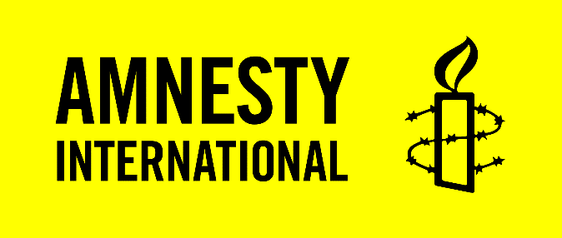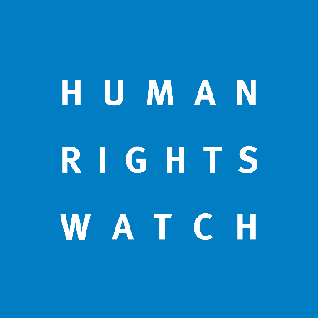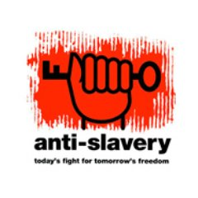

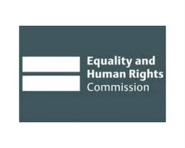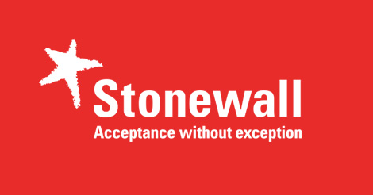

**Sovereignty and human rights**

One of the main issues facing many human rights organisations is the sovereignty that states continue to possess. The key principle of the concept of ‘Westphalian sovereignty’ is the lack of interference by other states in the affairs of their fellow nations.

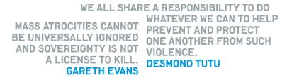This has been notably challenged by the concept of ‘R2P’, or **Responsibility to Protect**. Under this doctrine the idea that states have a duty to their own citizens was formalised. It established that if a state was committing violations of human rights against the residents of its nation, then the rest of the international community had a responsibility to intervene. This posed a remarkable break from the previous view on sovereignty. R2P was endorsed at the 2005 United Nations World Summit.



[Responsibility to protect: The lessons of Libya](https://www.economist.com/news/international/18709571-outsiders-had-good-reason-intervene-libya-their-cause-may-suffer-it)

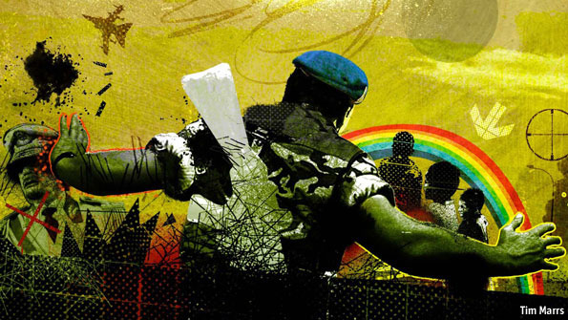

FOR those who back muscular humanitarian intervention, both the words and deeds of Colonel Muammar Qaddafi provided absolute moral clarity. “Come out of your homes, attack [the opposition] in their dens,” he told his supporters on February 22nd. He called the protesters “cockroaches” and “rats” who did not deserve to live: language chillingly reminiscent of the broadcasts of Radio Mille Collines, which spurred on the perpetrators of Rwanda's genocide in 1994.

As he spoke, his forces had set their sights on Benghazi, their adversaries' stronghold. According to Human Rights Watch, a New York-based group, government forces had already killed 233 people in the preceding week. A bloodbath beckoned, in a city of 700,000 people. The United Nations Security Council invoked a fateful formula, urging the regime to meet its “responsibility to protect” its people. On March 17th the council, “expressing its determination to ensure the protection of civilians”, ordered air strikes.

That set the stage for the first full-blown test of a principle that the UN adopted in 2005 and has been refining since. The doctrine of “responsibility to protect” (R2P) holds that when a sovereign state fails to prevent atrocities, foreign governments may intervene to stop them. Human-rights advocates say it saves lives. Sceptics see it as too easily misused to be useful: a cover for imperialism, or even an incentive to kill (because even if a massacre is not looming, an unscrupulous warlord might be tempted to engineer one against his own people to spur outside support).

Previous uses of R2P have been solo ventures. In 2008 Russia used it to justify attacking Georgia, and France cited it after the cyclone in Myanmar, implying that humanitarian aid might have to be brought in by force if the regime persisted in stonewalling (it backed down). But before this year, no mission had been authorised by the UN Security Council that so explicitly cited the new principle.

**Swamps and fogs**

At first it looked likely that the doctrine would either triumph or die in Libya. But two months and thousands of air strikes later, war's messy reality has merely hardened views on both sides. On one hand, the decision to go to war was made in good faith at a time when the risk of massacres seemed real. As Mats Berdal, a professor at King's College London, points out, the world's leading powers had good reason to think they were “avoiding a Srebrenica”—the massacre of Bosnians which UN forces failed to avert in July 1995.

But as the war drags on and NATO strikes more widely, sceptics also feel their case has been bolstered. “For those of us who feared that R2P was just a warrant for war, our fears have been vindicated,” says David Rieff, an advocate-turned-critic.

Responsibility to protect gained ground after ghastly mass killings in the late 20th century, including massacres by the Khmers Rouges in Cambodia in the 1970s; the use of chemical weapons in Iraq in 1988; and ethnic cleansing in Bosnia. In 1999 NATO unleashed an air war, without a UN blessing, to stop a Serbian campaign in the province of Kosovo. It argued that the need to protect civilians was an overwhelming moral imperative. The UN gave a sort of retrospective blessing by endorsing an international tutelage for the territory, led by Bernard Kouchner, a French pioneer of humanitarian intervention.

But the terrible civil war in Iraq that followed America's invasion in 2003—portrayed as intervention against tyranny—shrivelled support for the doctrine. A possible result of that may have been hesitancy in intervening to stop the Sudanese government's genocide in Darfur.

Seeking to restore liberal hawkishness's good name, a group led by Gareth Evans, a former Australian foreign minister, pushed the UN's 60th anniversary conference in 2005 to endorse the idea that the world has a “responsibility to protect” civilians. Eventually 150-plus countries agreed to allow armed intervention through the Security Council “should peaceful means be inadequate and national authorities are manifestly failing to protect their populations from genocide, war crimes, ethnic cleansing and crimes against humanity.”

So much for the theory. What about the practice? Colonel Qaddafi provided an all-but-unique test. Regional leaders loathed him and readily dumped him. The Arab League's support for the intervention stopped Russia and China wielding their vetoes. And the concentration of the rebels in the east, combined with flat desert terrain, at first made the regime's forces easy bombing targets. “The stars were well and truly aligned in the Libya case,” says Mr Evans. “All the criteria were satisfied.”

The immediate goal of protecting Benghazi from massacre was achieved within days. Having destroyed Libya's air defences, Western bombers and missiles pummelled the advancing troops into a speedy retreat.

Harder decisions followed. Libya's army continued to shell other rebel-held cities, and its snipers were plainly targeting civilians. Protecting all Libyans, not just those in the east, would require the end of Colonel Qaddafi's rule—an outcome that both Western and Arab governments had already called for. NATO stepped up its military campaign, bombing retreating columns as well as advancing ones, and attacking command-and-control centres frequented by Colonel Qaddafi and his family. On April 30th an air strike killed one of his sons. The line between curbing atrocities and an air war for regime change blurred—though a land operation is ruled out, for the moment.

**Your war is my argument**

Both sides of the debate will eagerly cite Libya the next time mass murder seems imminent. It shows that a modest dose of air power can save lives; but also that the rhetoric of civilian protection can be stretched to justify a creeping mission. Power politics decides which lives get saved, and which policy aims triumph.

Mr Rieff decries a “two-tiered system of interveners and intervened upon”, where the “old imperial powers” make the rules. But which powers exactly? The Libyan vote passed only because non-Western Russia and China withheld their Security Council vetoes: all but unimaginable until recently. Both countries are now getting cold feet, claiming misuse of the resolution's elastic language. For different reasons Mr Evans bemoans excess zeal too: he wants to preserve the purity of R2P, and fears an interpretation that allows for “all-out aggressive war”. A lot rides on this war—and not just for the Libyans.

|  |  |
| --- | --- |
| **Evidence that intervention in Libya provided support for R2P** | **Evidence that intervention in Libya undermined the idea of R2P** |
|  |  |

**Challenges to Human Rights in the 21st Century**

**Terrorism and Counter-terrorism**

**Task:** Watch ‘The Secret War on Terror’ (Pt 1)

1. What did 9/11 ‘usher in’? (5 mins)
2. What immediate problems did the CIA have?
3. What question did the interrogators of Abu Zubaydah raise?

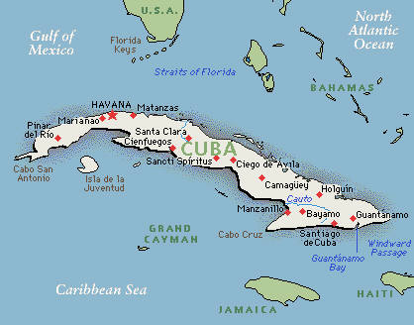

1. Why was Guantanamo Bay chosen as an interrogation centre and what did President Bush declare?
2. What did the CIA begin to do?
3. What methods were used as part of the interrogation and what was this termed?
4. Why was ‘waterboarding’ defined as lawful?

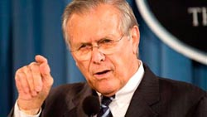

1. What did Donald Rumsfeld order of the military at the end of 2002?
2. 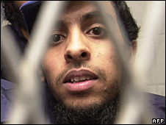What happened to Detainee 63, Al-Qahtani?
3. What was ‘Extraordinary Rendition’ and why was it used?
4. What was the CIA defence to Extraordinary Rendition?

**Debate: Should terrorists have human rights too?**

|  |  |
| --- | --- |
| **Yes – terrorists have human rights like everyone else** | **No – terrorists do not have human rights** |
|  |  |

**The Facebook-Cambridge Analytica data scandal: should ‘data rights’ be considered human rights?**

**Task:** Watch the extracts from ‘The Great Hack’ documentary (21.17-25.15, 34.55, 1.43.48). On what basis could the revelations about Facebook and Cambridge Analytica’s use of user data be considered a violation of human rights?

***Extension:*** *Watch Carole Cadwalladr’s TED talk ‘Facebook’s role in Brexit and the threat to democracy’.*

**The impact of new technology on human rights**

**Task:** Read the article that follows. What are the four new human rights that are being proposed here? Do you think it is the right thing to do?

# New human rights to protect against 'mind hacking' and brain data theft proposed

**A response to advances in neurotechnology that can read or alter brain activity, new human rights would protect people from theft, abuse and hacking**

[**Ian Sample**](https://www.theguardian.com/profile/iansample)*Science editor*

[**@iansample**](https://twitter.com/iansample)

Wed 26 Apr 2017 11.26 BSTLast modified on Wed 26 Apr 2017 13.54 BST

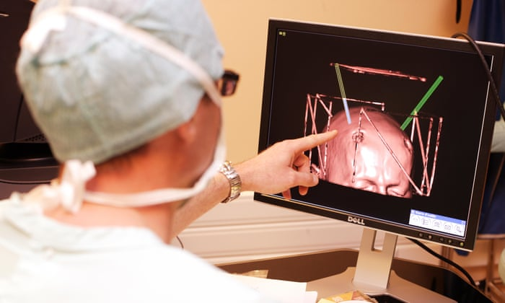

The use of deep brain stimulation, involving electrodes implanted in patient’s brains, has already raised concerns about its impact on patients’ personal identity. Photograph: Alamy

New human rights that would protect people from having their thoughts and other brain information stolen, abused or hacked have been proposed by researchers.

The move is a response to the rapid advances being made with technologies that read or alter brain activity and which many expect to bring enormous benefits to people’s lives in the coming years.

Much of the technology has been developed for hospitals to diagnose or treat medical conditions, but some of the tools – such as brainwave monitoring devices that allow people to play [video games with their minds](https://www.theguardian.com/media/2015/jun/18/bbc-mind-control-experiment-iplayer), or brain stimulators that claim to boost mental performance – are finding their way into shops.

But these and other advances in neurotechnology raise fresh threats to privacy and personal freedom, according to Marcello Ienca, a neuroethicist at the University of Basel, and Roberto Andorno, a human rights lawyer at the University of Zurich. Writing in the journal [Life Sciences, Society and Policy](https://lsspjournal.springeropen.com/articles/10.1186/s40504-017-0050-1), the pair put forward four new human rights that are intended to preserve the brain as the last refuge for human privacy.

“The question we asked was whether our current human rights framework was well equipped to face this new trend in neurotechnology,” Ienca told the Guardian. Having reviewed the rights in place today, the pair concluded that more must be done to protect people.

“The information in our brains should be entitled to special protections in this era of ever-evolving technology,” Ienca said. “When that goes, everything goes.”

The suggested new rights assert what the researchers call cognitive liberty, mental privacy, mental integrity and psychological continuity. The first of these concerns a person’s freedom to use, or refuse to use, brain stimulation and other techniques to alter their mental state. If adopted, it could defend people against employers who decide their staff might be more effective if they zapped their brains with weak electrical currents. In [November last year](https://www.theguardian.com/science/2016/nov/07/us-military-successfully-tests-electrical-brain-stimulation-to-enhance-staff-skills), US military scientists reported that a procedure called transcranial direct current stimulation (tDCS) boosted the mental skills of personnel. The devices are available on the open market, but [there are concerns over their safety](https://academic.oup.com/jlb/article/3/2/304/1751225/The-regulation-of-consumer-tDCS-engaging-a).

The right to mental privacy is intended to plug a gap in existing legal and technical safeguards that do nothing to prevent someone from having their mind read without consent. While modern brain scanners cannot pluck thoughts from a person’s head at will, improvements in the technology are expected to reveal ever more precise information about people’s brain activity. In 2011, scientists led by Jack Gallant at the University of California in Berkeley used brain scans to [reconstruct clips of films](http://www.cell.com/current-biology/abstract/S0960-9822(11)00937-7) people had watched beforehand.

Today, there are no firm rules on what brain information can be gathered from people and with whom it can be shared. What Ienca and Andorno fear is “the indiscriminate leakage of brain data across the infosphere”, as happens now with the personal information people share on social media such as Facebook and Twitter.

The third right, to “mental integrity”, aims to defend against hackers who seek to interfere with brain implants, either to take control of the devices people are connected to, or to feed spurious signals into victim’s brains. The fourth right, covering “psychological continuity”, would protect people from actions that could harm their sense of identity, or disrupts the sense of being the same person throughout their life.

The use of deep brain stimulation, in which people have electrodes implanted deep into their brains to control Parkinson’s symptoms and other conditions, has already raised concerns about its impact on patients’ personal identity, with some stating that they no longer feel like themselves after the surgery.

Ienca admits that it may seem a little early to worry about brain hackers stealing our thoughts, but he said it was usually more effective to introduce protections for people sooner rather than later. “We cannot afford to have a lag before security measures are implemented,” he said. “It’s always too early to assess a technology until it’s suddenly too late.”

**A History of Human Rights – Next Steps**

**Documentaries and podcasts**

1. Watch TED Ed on human rights: <https://ed.ted.com/lessons/what-are-the-universal-human-rights-benedetta-berti#watch>
2. [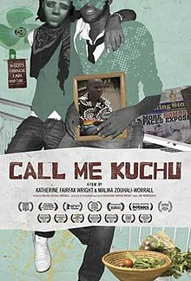](https://www.google.co.uk/url?sa=i&rct=j&q=&esrc=s&source=images&cd=&ved=2ahUKEwjhnMqOouniAhUQxIUKHYdQDbUQjRx6BAgBEAU&url=https%3A%2F%2Fen.wikipedia.org%2Fwiki%2FCall_Me_Kuchu&psig=AOvVaw0BtA4f58eLII8lic0_0geC&ust=1560611792387111)Steven Wise, *Chimps have feelings and thoughts: they should also have rights*, TED talk at <https://www.ted.com/talks/steven_wise_chimps_have_feelings_and_thoughts_they_should_also_have_rights>
3. *Call Me Kuchu* (Netflix documentary)
4. *The E-Team* (Netflix documentary)
5. Declarations: The Human Rights podcast

[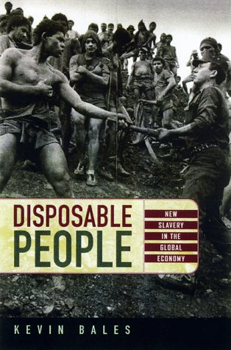](https://www.google.co.uk/url?sa=i&rct=j&q=&esrc=s&source=images&cd=&ved=2ahUKEwjvuti9ouniAhVP1hoKHRp2DWcQjRx6BAgBEAU&url=https%3A%2F%2Fwww.goodreads.com%2Fbook%2Fshow%2F178676.Disposable_People&psig=AOvVaw2-UWyHyMkaTRlzxtbBlohz&ust=1560611886170209)**Reading**

1. Andrew Clapham, *A Very Short Introduction: Human Rights*
2. Kevin Bales, *Disposable People*
3. Phillip Gourevitch, *We Wish to Inform You that Tomorrow we will be Killed with our Families*
4. Elie Wiesel, *Night*
5. Romeo Dallaire, *Shake Hands with the Devil: the Failure of Humanity in Rwanda*

**Careers/university options**

1. Many degree courses can be combined with a study of human rights: for example Law, International Relations/Development, Politics
2. Can be useful for NGO or Charity-based work e.g. Amnesty International
3. Natural links to careers in law.