This is an evolving list of suggested reading, viewing, activities and volunteering opportunities related to the Art for All +Explore course.

Please check back regularly, as more materials will be added.
Watch | The Habits of Effective Artists
 | Don’t let the title mislead you! This video offers advice on how to develop your attitude towards work/study and therefore improve your results. Various examples mentioned in this video, from JK Rowling to Kanye West, have all struggled and failed but eventually succeeded. See how you can improve in areas of study or life that you might be experiencing difficulty with. | 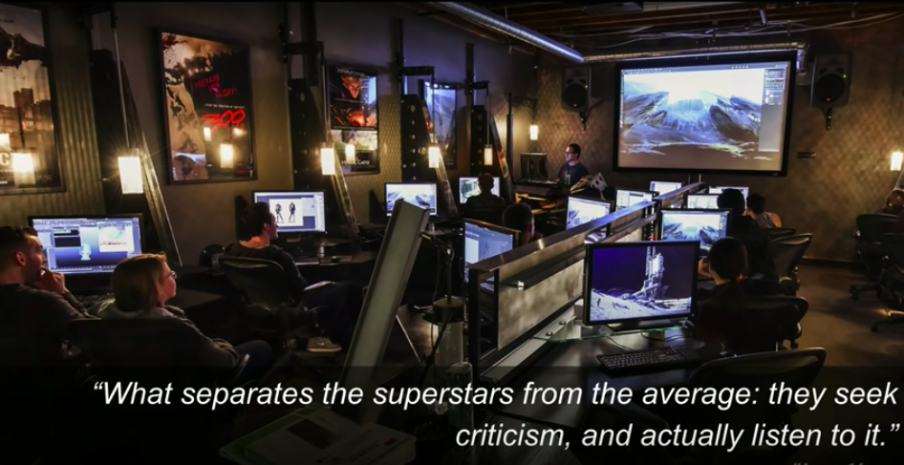
 | Web link | https://www.youtube.com/watch?v=vM39qhXle4g
Watch | Keith Haring Uncovered
 | This short documentary looks at a mural painted on the outside of a school in Australia by street artist Keith Haring with the help of schoolchildren and the local community. Haring intended the work to bring a sense of pride to the school and to allow participants to feel they had accomplished something of importance.  - How valuable was the contribution made by the local community to the creation of this mural?  - What legacy has this mural had on the community?  - Is there an area in your local community you think would benefit from a similar work? Why? | 
 | Web link | https://www.youtube.com/watch?v=jAEjO2i4OC4
Activity | Art as a cure for….
 | Clicking on the link below will take you a website. On that site, you will see a list of themes including Love. Work. Anxiety. Self. Politics. Free Time.  Choose a theme and you will be taken to a list of statements that might relate to you. Clicking on a statement will reveal a work of art or design centred on that statement. An explanation of that work is provided and how you might be able to use its meaning for your own life.  Web link | 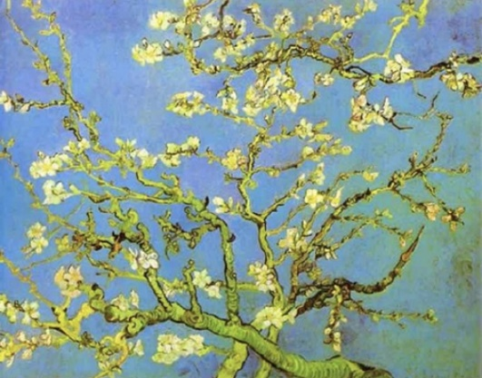  http://www.artastherapy.com/
Watch | My Place: Jean-Charles de Castelbajac | 
 | Look inside the home and studio of fashion designer Jean-Charles de Castelbajac. He describes this space as a ‘castle of authenticity’. His home is filled with various objects that have inspired both his work and life including art but also personal mementoes such as family photos. De Castelbajac states that he does ‘not like perfection but accidents’. What can you take from this to help you in your own attitude towards work or study? | - Consider the items and objects you like to have in your own space. Are they personal mementoes? Gifts from others?  - What is your relationship to these objects?  - Can you make any links between the material objects you cherish?  - How do these items contribute to your own wellbeing?
 | Web link | https://vimeo.com/183458414
Read/do: | Art in London: Paintings for mindfulness at London art galleries. | 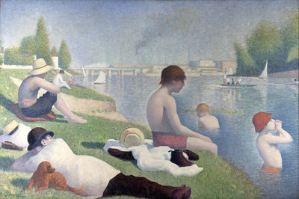
 | Mindfulness encourages you to be present in the moment and get back in touch with your body and mind, as opposed to rushing through life. The link below highlights a number of paintings on display in venues across London. The next time you visit the Capital why not seek out one of these works and just spend some quiet time looking at it.
 | Web link | https://www.standard.co.uk/go/london/arts/paintings-for-mindfulness-mental-health-art-a3957796.html
Do | Surrey Art School | 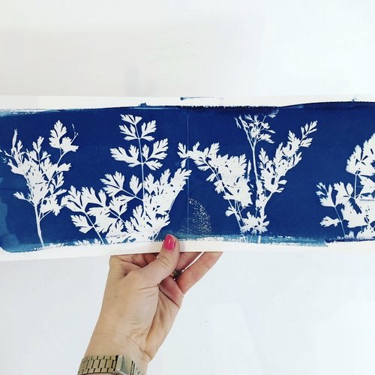
 | Surrey Art School provides contemporary art classes that connect you to the natural beauty of Surrey and encourage well-being through activity. They offer a range of workshops, courses and stage regular events for all ages.
 | Weblink | https://www.surreyartschool.com/
Do/Volunteer/Jobs | Lightbox Gallery | 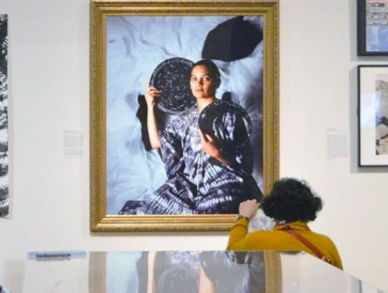
 | Lightbox Gallery in Woking runs a series of exhibitions, workshops and events, all of which are aimed at the community. They are seeking volunteers to assist in the running of these activities.
 | Weblinks | https://www.thelightbox.org.uk/art-and-wellbeing-programme
 |  | https://www.thelightbox.org.uk/volunteering
Do/Volunteer/Jobs | Watts Gallery – Artists' Village | 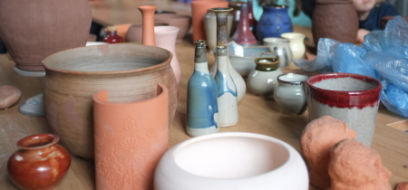
 | Located in the village of Compton, near Guildford. This venue stages regular changing exhibitions. It also provides workshops and short courses. Every Sunday the gallery runs artistic activities in their ‘Make Space'. These activities are inspired by the collection and are open to all ages and abilities.  Web links | https://www.wattsgallery.org.uk/whats-on/make-space/  https://www.wattsgallery.org.uk/get-involved/volunteering/
Do/Volunteer/Jobs | Farnham Maltings | 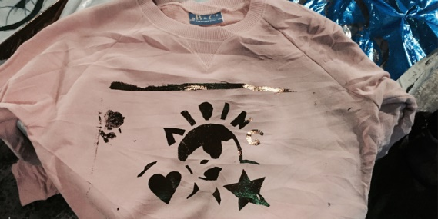
 | Based in South West Surrey. They believe that by being actively creative, connecting with others and articulating new ideas we will foster a happier, healthier and more inclusive set of communities. They run a wide range of workshops for all abilities and are also looking for volunteers.
 | Web links | https://farnhammaltings.com/about/
 |  | https://farnhammaltings.com/join-us-and-support-us/volunteer/
Read | 10 important skills to learn from art education
 | Most educators and parents can agree that art is important, in that it stirs the imagination and gives a sense of wonder. However, did you know that art in education could help children develop vital educational and leadership skills that can be applied to every aspect of their lives? This article highlights some important skills that students can learn from art education. | 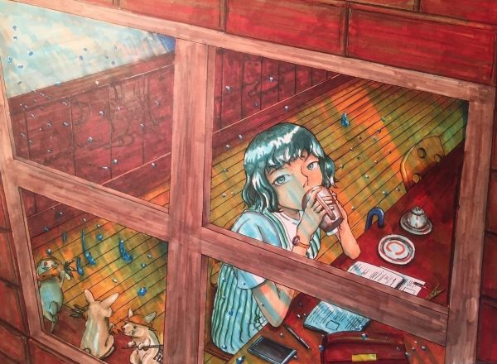
 | Web link | https://stateoftheart.creatubbles.com/2017/02/08/10-important-skills-learn-art-education/

