**Godalming Fieldtrip Preparation Work**

**Purpose of the trip:**

**To explore a range of data collection techniques that could be used to answer the following potential investigation titles:-**

* **To what extent is Godalming a ‘Placeless’ town?**
* **How does the microclimate of Godalming change?**
* **How globally connected is Godalming town centre?**

**Advanced instructions for the day**

**You will be required to attend a fieldwork session in Godalming where you will be collecting data to help you investigate the above questions.**

**Your allocated time is _______________(time) on ____________________(date).**

**During this time you will complete a microclimate session from ____________________.**

**It is your responsibility to make your way to the meeting point outside Fat Face. You will be registered for the trip but must attend all other lessons in college which fall outside of your trip time. Sufficient travel time has been built into the schedules so that you are not late to college classes.**

**You must register with a member of staff at the start and end of the fieldwork sessions.**

**You must make sure that you attend your microclimate session on time so that the equipment can be shared with other groups.**

**Please remember to dress appropriately for the weather conditions and wear comfortable footwear. Lanyards should be work at all times and be visible. You must bring with you the fieldwork handout you have been issued and the questionnaire and recording sheet you have created.**

**You may purchase food in town if it coincides with lunchtime. However, it is your responsibility to manage your time wisely and so the time taken to purchase and consume food should be kept to a minimum.**

1. **To what extent is Godalming a ‘Placeless Town’?**

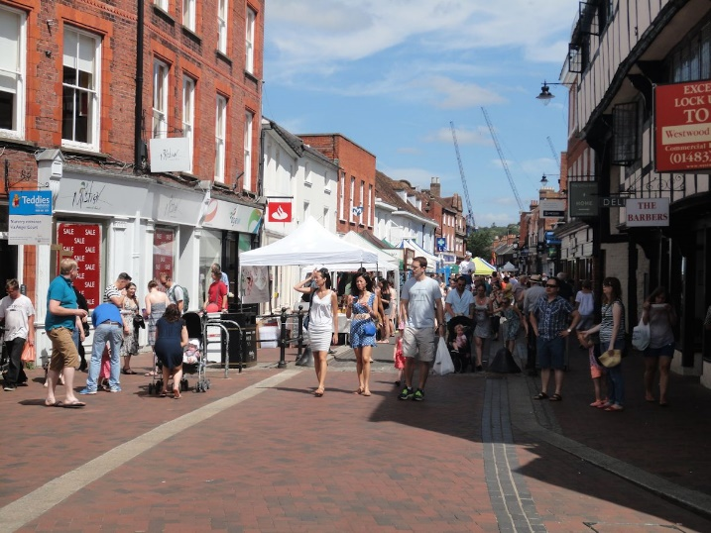

How could we test this?

Clone town survey

* + Where do you think you will start your survey? What will you need to consider?

What sort of questions can you ask?

* + Closed questions – those that you answer with a yes or no. e.g. Do you live in Godalming?
  + Questions with a choice on answers. e.g. Why have you come to Godalming today? Possible answers being shopping, work, appointment or other.
  + Questions that allow people to rate their opinion on a scale. e.g. on a scale of 1 to 5 with 5 being high and 1 being low, how would you rate the schools in Godalming?
  + Open questions – What 3 words would you use to describe Godalming?

**How useful are the above questions in answering our question:** **To what extent is Godalming a ‘Placeless Town’?**

Think about who you want to ask and what you need to know about them.

* You may need to make sure that you ask people who live in Godalming and not tourists. You could ask if they live in Godalming in the questionnaire.
* You may wish to check you get a range of ages to see how people’s opinions differ. How might you ask people’s ages without offending them?
* What sampling technique will you use? (stratified, systematic, random or pragmatic)
* Where will you conduct the questionnaire?
* How many questions and how many questionnaires to complete? People will not want to spend too long answering questions so make it quick and easy to complete
* You need a decent number of questionnaire so that your research is detailed enough. (At least 25-50 is a good number – the more the better)

**In pairs/threes come up with a range of questions which will help you investigate the question. These questions are the ones that you will use on the day but you may find that you have to amend/refine them.**

**Design a recording sheet for your questionnaire responses.**

Possible stats test to use with your questionnaire results

The Chi Squared Test is a statistical test that is often carried out at the start of an intended geographical investigation.

We may have noticed a pattern, distribution or anomaly in a feature of the human or physical world and have a hunch that ‘something is going on’ to produce it.

The Chi Squared Test tells us whether our ‘hunch’ is statistically significant – i.e. that – yes, we have noticed a valid geographical phenomenon that deserves further investigation as part of a geographical enquiry. Alternatively, it can indicate that what we think is a ‘phenomenon’ is actually just a random variation in the feature we’ve noticed, and doesn’t deserve further investigation or research.

So it’s a test to indicate: ‘There’s something valid going on here – investigate it further and work out what it is and what’s causing it’, or ‘Don’t waste your time – it’s just ‘chance’ or ‘random events’ that you’re seeing – move on and give your time to studying some other aspect of geography.

**I have a hunch that the students in this room prefer marmite to jam or peanut butter.**

**I am going to test this hunch to see if it is statistically significant. If it is, I will then investigate it further.**

**With chi squared tests we come up with a null hypothesis.**

**What do you think this could be for this example?**

**There is not/no __________________________________________________________________________**

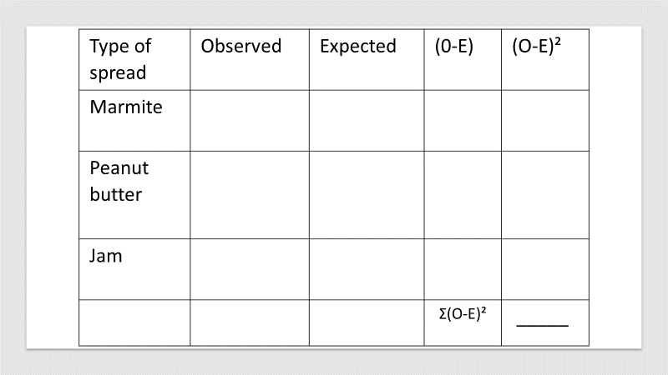

**Do you think that we have enough samples to complete a valid test?**

**You need a decent number of questionnaire so that your research is detailed enough. (At least 25-50 is a good number – the more the better)**

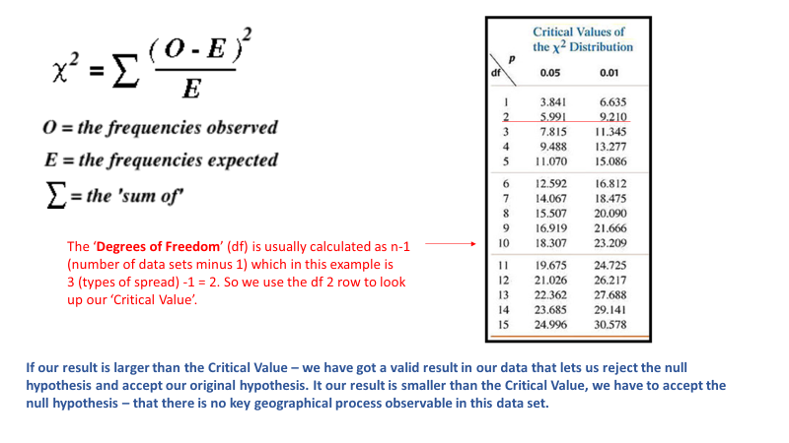

**Calculate the X² for own example.**

**Is our result larger than the critical value? ____________________________________**

**Do we accept or reject out null hypothesis? ____________________________________**

**How confident can we be with our result? ­­­­­­­­­­­­­­­­­­­­­­____________________________________**

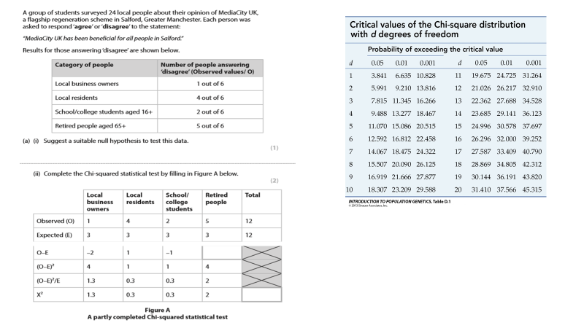

Look back at the questions on your questionnaire.

Have you a question that will give you data to do a chi squared test? If not add one.

**2) How does the microclimate of Godalming change?**

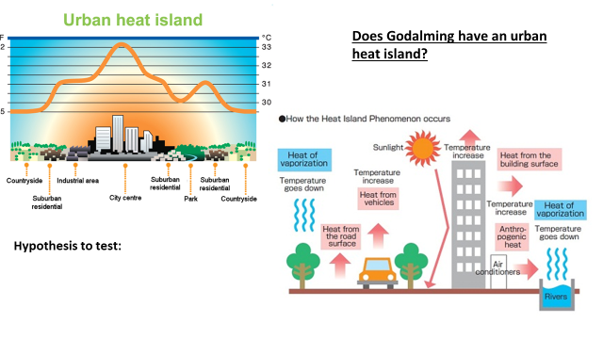

**A hypothesis is a proposed explanation that can be tested**

**Humidity in Urban areas**

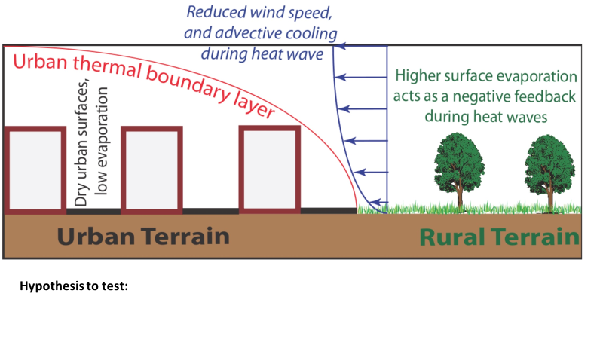

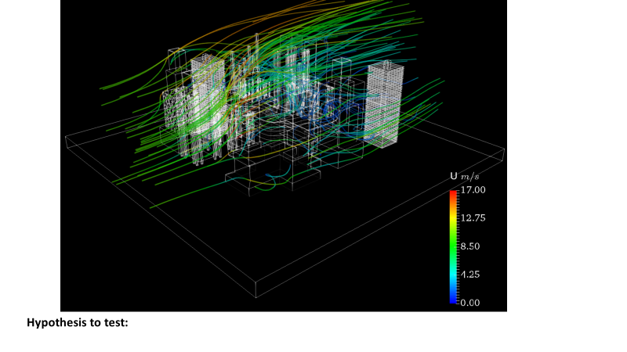

**Wind Speed in Urban areas**

**A map to show microclimate sampling points**

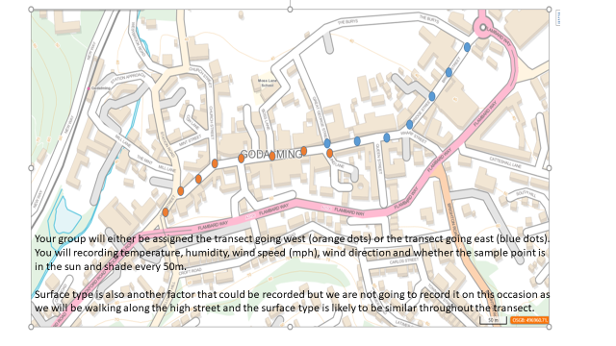

**3) How globally connected is Godalming Town Centre?**

What is globalisation?

* + A process by which national economies, societies and cultures have become increasingly integrated through the global network of trade, communication, transportation and immigration.

**What evidence do you think there is of globalisation in Godalming and how could we collect it?**

**Ethical Dimensions**

When planning your fieldwork you need to consider the ethical implications that your fieldwork might have. These considerations then need to be included in your write-up.

You will need to ensure that you minimise the harm that your investigation may have upon the environment and the people in it.

**P63-64 in the coursework workbook contains further information on ethical dimensions to fieldwork**

**Create a mind map of the ethical dimensions which need to be considered when on your fieldtrip to Godalming.**

**How might these ethical dimensions differ to when you went on the fieldtrip to the Witterings?**