**A History of Warfare**

What will we look at?

* The use of technology
* The evolution of siege warfare
* The role of leaders in warfare
* The impact of warfare on the civilian and society
* The end of war - peace and diplomacy
* How soldiers are treated in war
* The significance of different tactics in war
* 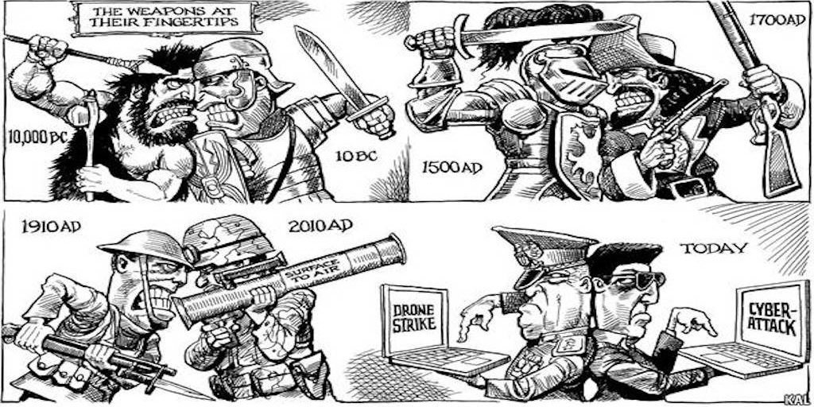Modern warfare and the future of warfare

Why study this course?

* 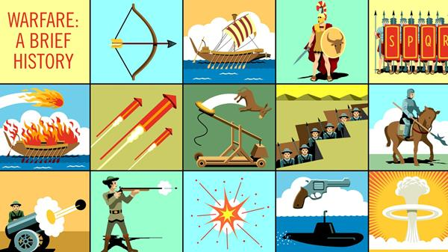Develop a good understanding of how warfare has evolved over time
* Helps to develop cross curricular links, which would support applications at university level to degrees such as War Studies, History, Politics, Sociology or Anthropology.
* Look at new areas of history that you won’t have encountered at GCSE or A Level.
* Find out about something interesting!

Research a key battle, military event or breakthrough. Produce a mainly ‘wordless’, which is engaging and interesting, PowerPoint presentation that includes the following:

* The background to the battle/event – it’s context
* Details of the battle/event – an overview
* Why the battle/event went the way it did
* Long term implications of it
* A quiz on their talk

|  |  |  |  |
| --- | --- | --- | --- |
| Battle/event/ breakthrough | Details | Why did it go the way it did? | Long term implications |
|  |  |  |  |
|  |  |  |  |
|  |  |  |  |
|  |  |  |  |
|  |  |  |  |

Which of these had the greatest importance?

**The use of technology in warfare**

Research and add detail to the below timeline, on the development of technology.

The use of iron weapons.   
When introduced:  
What was the impact:

The industrialisation of warfare.   
When introduced:  
What was the impact:

Gunpowder.   
When introduced:  
What was the impact:

The bow and arrow.   
When introduced:  
What was the impact:

Nuclear weapons.   
When introduced:  
What was the impact:

The tank.   
When introduced:  
What was the impact:

We’re going to have a debate on which of these caused the greatest change in the nature of warfare.

Listen to the arguments that are being presented and take notes below:

Notes on which of the technological changes resulted in the most significant shift in the nature of warfare:

Which overall do you think in your opinion was most important?

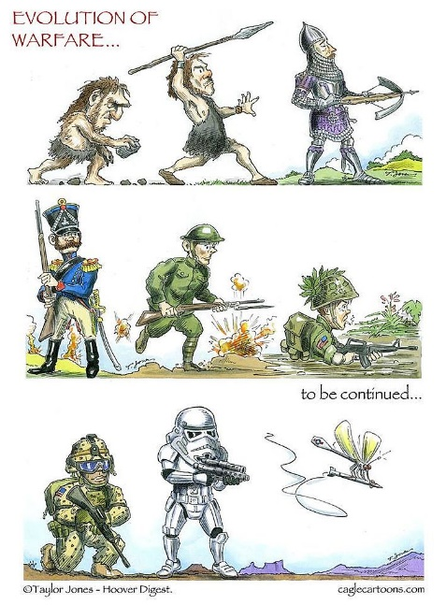

**Siege weaponry**

Read the article and then answer the questions

Siege tactics were a crucial part of medieval [warfare](https://www.ancient.eu/warfare/), especially from the 11th century CE when castles became more widespread in [Europe](https://www.ancient.eu/europe/) and sieges outnumbered pitched battles. Castles and fortified [cities](https://www.ancient.eu/cities/) offered protection to both the local population and armed forces and presented an array of defensive features which, in turn, led to innovations in weapons, siege engine technology, and strategies. From the 12th to 15th century CE medieval warfare became very much a case of win the siege, win the [war](https://www.ancient.eu/war/), especially when targets were administrative centres or occupied a position of particular strategic importance.

**Castle &** [**City**](https://www.ancient.eu/city/) **Defences**

Early castles in France and [Britain](https://www.ancient.eu/britain/) during the 11th century CE adopted the [motte and bailey castle](https://www.ancient.eu/Motte_and_Bailey_Castle/) design. This involved placing a wooden tower on a natural or artificial mound (motte) with an accompanying walled courtyard (bailey) at the base with the whole structure surrounded by a ditch or moat (which could be dry or contain water). As these castles were gradually converted into stone, which made them much more resistant to fire, or entirely new castles were built and the idea of their usefulness spread, so, too, their defensive designs improved.

[[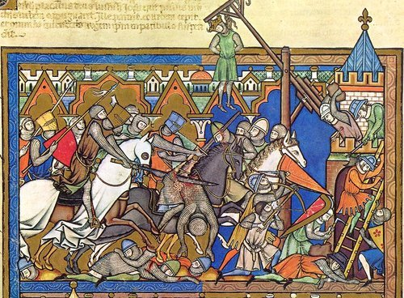](https://www.ancient.eu/image/8792/medieval-siege/)](https://www.ancient.eu/image/8792/medieval-siege/)

The particular weak point of any defensive fortification was its main access door, but this came to be protected by a tower on either side with additional safety measures such as a drawbridge, portcullis and ‘murder holes’ (holes above the doorway through which missiles and burning liquid could be thrown down). The celebrated King’s Gate of Caernarvon Castle in Wales had two drawbridges, six portcullises and five doors. The gate might also receive extra protection with a barbican - a short piece of fortified [wall](https://www.ancient.eu/wall/) built in front of it. City gates were such substantial structures that many still stand today across Europe from York to Florence.

The outer walls of a castle (and sometimes even smaller cities) were protected by a moat (dry or wet) and wherever possible built on a rise in the land. In the Low Countries, where this was often not possible, the moat was made extremely wide. Walls were given towers at regular intervals to provide more scathing fire from archers, and the construction of wooden hoardings which overhung the top of the wall was for the same purpose. Further tweaks in design included having the towers project from the wall so that the defenders could fire back towards it if it were being climbed by the enemy. Eventually, it was discovered that round towers were better than square ones because they eliminated the firing blind spot of the corners and made them more stable and more difficult to dismantle from the base by enemy sappers or miners (who preferred easy corners to swing their picks at). Walls and towers were given a protective covering of stone at their bases (a talus) to impede the enemy climbing them, make undermining more difficult and give objects thrown down an unpredictable bounce into the enemy ranks.

Finally, there were the defenders themselves to contend with. Castles and fortified cities controlled the local countryside and so were usually the permanent home of a force of knights who might be mercenaries, militia, or serving a local lord on a rotation basis. These heavily armoured cavaliers might ride out at any time and attack the attackers, sometimes by surprise using a well-hidden postern gate as happened during Frederick II’s siege of Parma in 1247-8 CE. Indeed, the very presence of such a force meant that an invader could not simply bypass and ignore a castle or city or he and his supply lines risked being attacked by them later in his campaign.

Safe behind the walls, there were archers and crossbowmen who could fire missiles through narrow window slits. The defenders also had catapults to hurl large boulders into the besiegers and damage their siege engines and own catapults. When all the conventional weapons ran out, the defenders then resorted to whatever they could hurl down on the attackers such as burning oil, flaming logs, spikes, and rocks.

**Opening Attack**

Faced with all of these ingenious defences, the attackers had to consider carefully how to best go about besieging a castle or city. The simplest method was to encircle the target, cutting off its supply of food and reinforcements, and then wait for thirst and starvation to drive the defenders to a surrender. Torching any surrounding farmland and villages was a wise move, too, just in case the defenders were able to smuggle in supplies. Naturally, with a large castle or a city, this could take several months to have its desired effect. The defenders probably had their own water supply, had stocked up on foodstuffs and in an emergency could always resort to drinking wine, [beer](https://www.ancient.eu/Beer/), or even horse blood. Castles such as those in Wales built by Edward I (1272-1307 CE) were specifically situated by the sea so that they could be resupplied under siege unless the attackers had a naval force as well as a land army.

The defenders might even have secret tunnels which allowed some movement of people and goods to circumvent the besiegers camped outside. If an entire city needed to be attacked, then encirclement could be an impossibility given the size of the force needed to surround it completely. This did not stop some ambitious commanders, though, such as the attack on Antioch during the [First Crusade](https://www.ancient.eu/First_Crusade/) (1095-1099 CE) when the attackers built their own castles to protect themselves from sorties from the city. Indeed, building a siege castle to attack another castle was not an uncommon strategy in the Middle Ages. A castle was sometimes erected right in front of a gate to block any movement while the rest of the invading army left to fight elsewhere. In most cases, it was certainly advisable to protect one’s camp with a palisade and ditch as a minimum precaution.

The best result possible, of course, was that the defenders would surrender immediately. Sieges were expensive and troops might be on a fixed term of service (40 days in English armies, for example) so time was also a factor to consider. In addition, the campaign season was typically limited to spring and summer, and the longer the attackers remained cooped up in their own camp, the more prone they were to attack from a relief force, disease, or even starvation themselves from lack of supplies in a hostile territory.

[[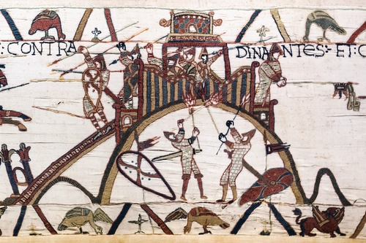](https://www.ancient.eu/image/8757/motte-and-bailey-castle-bayeux-tapestry/)Motte and Bailey Castle, Bayeux Tapestry](https://www.ancient.eu/image/8757/motte-and-bailey-castle-bayeux-tapestry/)

If the defenders remained resolute, then the first step was to communicate a warning via messengers. In the age of chivalry during the High Middle Ages (1000-1250 CE), non-combatant residents might be permitted to flee the scene, but this was not the case when fighting the [Crusades](https://www.ancient.eu/Crusades/), for example. If the terms of surrender were rejected, then that might be the opportunity to employ a few terror tactics. The lobbing of a few severed heads of messengers (even the messenger himself sometimes) or other captives over the defender’s walls via catapult was a common tactic and reminded of the consequences of continuing the [battle](https://www.ancient.eu/battle/). Another strategy was to threaten to hang someone near and dear to the owner of the castle outside its walls - as happened when King Stephen threatened to hang Roger le Poer, whose mother held the castle of Devizes in 1139 CE.

**Artillery**

Artillery machines had been in use since antiquity, and as warfare spread in the High Middle Ages so they returned to the fore in sieges, blending designs from ancient [Rome](https://www.ancient.eu/Rome/) and [Greece](https://www.ancient.eu/greece/) with new ideas from the [Byzantine Empire](https://www.ancient.eu/Byzantine_Empire/) and the Arab world. One attack strategy was to pound the wall with huge boulders fired by catapults (or mangonels, which used the torsion of twisted ropes and were based on ancient designs) and trebuchets (which used a counterweight and were first seen in [Italy](https://www.ancient.eu/italy/) in the 12th century CE). Both types had a single arm with a sling or bucket attached which could launch a large boulder towards the enemy weighing anything from 50 to 250 kilos.

[[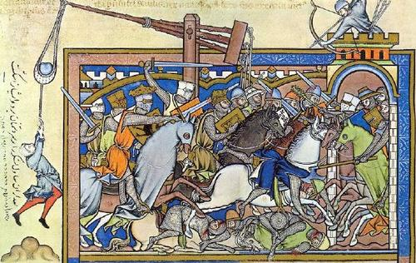](https://www.ancient.eu/image/8790/medieval-trebuchet/)Medieval Trebuchet](https://www.ancient.eu/image/8790/medieval-trebuchet/)

More imaginative weapons included kites being used to float incendiaries over the walls which were then shot down. In the 15th century CE, there was even the use of sulphur gas to drive the defenders out of their retreat - Pope [Alexander](https://www.ancient.eu/Alexander/) VI was accused of such tactics during the siege of Ostie in 1498 CE. Naturally, the defenders had their own versions of missiles and could hurl hot coals, torches, boiling water or heated sand onto the attackers below. In addition, they could protect their structures from fire by covering them in noncombustible material like clay, chalk, turf or vinegar.

The earliest depiction of gunpowder artillery is a 1326 CE English manuscript which shows a cannon on a wooden stand ready to fire a metal bolt. Such early firearms, sometimes known as bombards, were usually more lethal to the people firing them, such was the lack of knowledge and design know-how of the medieval period in this area. James II of [Scotland](https://www.ancient.eu/scotland/), for example, was killed by an exploding cannon in the 1460 CE siege of Roxburgh. Small firearms weighing up to 15 kilos were used from the 14th century CE and fired small balls, bolts or lead pellets. Walls were thickened and heightened as a response to the arrival of cannons, and defenders could, of course, have their own, which saw windows altered accordingly in many fortifications. When in the 15th century CE batteries of huge cannons were being used which fired balls weighing over 100 kilos, the days of static siege warfare effectively came to an end.

[[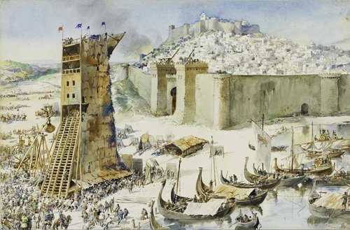](https://www.ancient.eu/image/8791/siege-of-lisbon-1147-ce/)Siege of Lisbon, 1147 CE](https://www.ancient.eu/image/8791/siege-of-lisbon-1147-ce/)

**Siege Towers**

An all-out assault on a section of wall at some point involved good old-fashioned scaling ladders and siege towers. The enemy could be softened up by artillery, but hand-to-hand combat - bloody and chaotic - was almost inevitable. Siege towers allowed the attackers to get near a wall or tower and possibly scale it or, at least damage it. Built of wood and assembled on site, they had their own wheels so that they could be positioned against a wall using manpower or oxen. These huge structures, often given names like the cat or bear, must have had a tremendous psychological impact. First, though, a portion of the castle or city’s moat had to be filled in or bridged over - sometimes using prefabricated folding bridges - and then the tower could be wheeled across to within touching distance of the walls.

As the towers were made higher than the defender’s walls, archers within the tower could fire down on the walls, clearing them of the enemy before they climbed across the tower’s own drawbridge. Towers at the siege of Lisbon in 1147 CE were over 24 metres (80 feet) high, for example. The defenders tried all they could to resist the towers, for example shooting fire arrows at them, but a tower might be covered in water-soaked animal skins or metal plates to resist such a strategy.

**Aftermath**

If a castle or city did fall, then it was common practice to sack, pillage, burn, rape, and murder. Acts of clemency towards defenders who had not surrendered when they had had the chance at the start of the proceedings were the exception, not the rule. Churches and members of religious orders were, though, expected to be left unharmed. Oddly enough, soldiers might be better treated than non-combatants as they were thought to have simply done their professional job. Some slaughters were deliberate to send a strong message to the enemy during a wider war such as the massacre ordered by Edward III after the fall of Caen in 1346 CE. Naturally, if a castle was in a strategically important position it was advantageous for the new owners to maintain it to defend their own regime so many were repaired and reused, sometimes even defended against a counter-siege, when the whole process started over again with the roles reversed.

1. How did the castle’s construction evolve over time?
2. Why were the defenders in the castle such a problem for the besiegers?
3. Why was starving the enemy to death hard to achieve?
4. How did the use of gunpowder in siege change?
5. How high was the siege tower at the Siege of Lisbon?
6. What happened when the castle fell?

|  |  |  |
| --- | --- | --- |
| Type of castle, location | Picture | What features can you notice? |
| Hillfort  Old Sarum, Wiltshire | Prehistoric hillfort |  |
| Roman fort  Segedunum near Newcastle (artist’s impression) | Image result for roman fort |  |
| Motte and Bailey Castle  Tonbridge Castle (artist’s impression – it later had stone walls added) | Image result for motte and bailey castle |  |
| Stone keep  Orford castle, Suffolk | Orford Castle |  |
| Middle Medieval period castle  Dover castle, Kent | Image result for dover castle |  |
| Late Medieval period castle  Bodiam castle, East Sussex | Image result for Bodiam Castle |  |
| Tudor period castle  Deal Castle, Kent | Image result for Deal Castle, |  |
| Trace Italienne/Star Fort – Europe  Fort Bourtange, Bourtange, Groningen, Netherlands. | http://www.castlesandmanorhouses.com/pics/graca.jpg |  |

Summarise the evolution of castles in 1-2 sentences:

**The role of leaders in warfare**

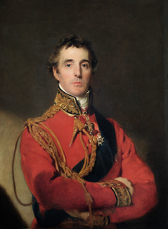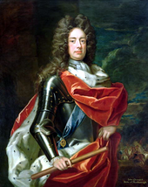Watch the two videos on two great British military generals, and add detail to the table below <https://www.youtube.com/watch?v=yX8FH7ESkFo> and <https://www.youtube.com/watch?v=jEEdS5HzCuc>

|  |  |
| --- | --- |
| Evidence that it is the role of the leader which has the greatest impact | Other factors having a more significant impact |
|  |  |

Research one of the following ‘great leaders’ and make a note of the key features/characteristics they had:

|  |  |  |
| --- | --- | --- |
| Leader | Who were they/what did they do? | Key characteristics/features |
| Napoleon |  |  |
| Genghis Khan |  |  |
| Hannibal |  |  |
| Alexander the Great |  |  |
| Saladin |  |  |
| Zhukov |  |  |

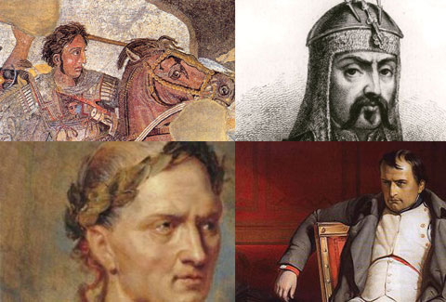What are the common features of great military leaders?

**Key debate – Are military leaders the main reason for an army’s success?**

|  |  |
| --- | --- |
| Yes, they are | No, other factors are more important |
|  |  |

**The impact of war on civilian and society**

Use the materials provided by the teacher to research one the following case studies about the impact of war:

Imagine a debate between two historians. They are debating whether or not war has more of an impact on the life of a civilian than it did in the past. Recreate their debate below:

**Peace**

You have been assigned either the position of Russia or Germany in November 1917, at the peace treaty of Brest-Litovsk. Read over your briefing and discuss with your team what your targets are going to be from the negotiations.

Write down how your negotiations finished:

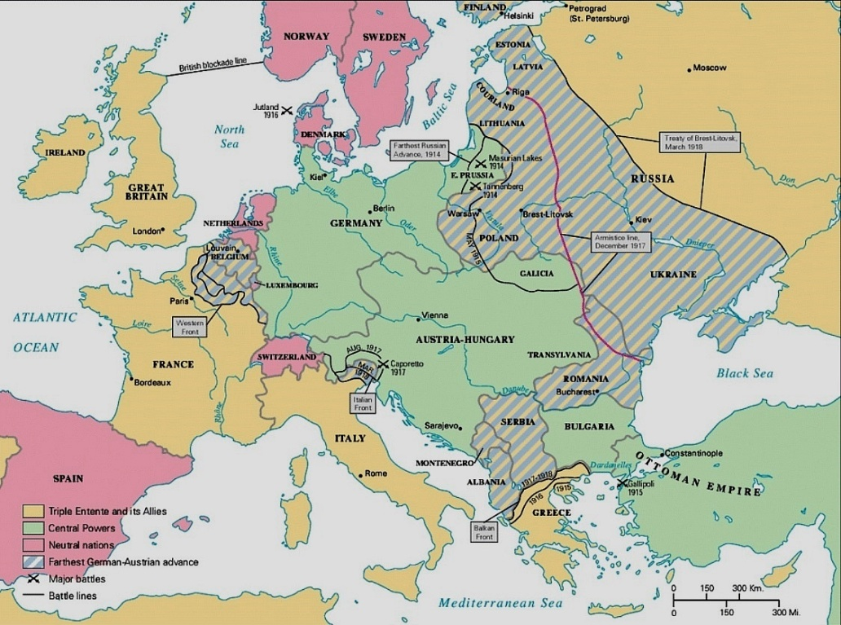

One of the most famous peace treaties in history is the Treaty of Versailles, after the end of World War I. Watch the following video (<https://www.youtube.com/watch?v=azPDVBz108s>) and answer the questions below:

1. How many German soldiers died in WWI?
2. Which four empires/powers collapsed as a result of WWI?
3. What was David Lloyd George most interested in getting out of the peace conference?
4. What did Ho Chi Minh request at the peace conference?
5. What were “mandates”?
6. Which delegation did Prince Faisal lead?
7. Vittorio Orlando and the Italian delegation walked out of the conference due to clashes with which statesperson?
8. The Japanese wanted the racial equality clause written into the League’s covenant. They were concerned as the only non-white power at the delegation. What became of this amendment?
9. Both Japan and China felt betrayed at the conference. Did the Chinese delegation sign the treaty?
10. John Maynard Keynes, a well-known economist, warned the Allies that austere economic reparations might have what kind of effect?
11. What were some of the special effects that Clemenceau aimed for at signing of the Treaty of Versailles?
12. Was this international body that took part on the treaty a “force for good” as the narrator mentioned Wilson had hoped it would be?

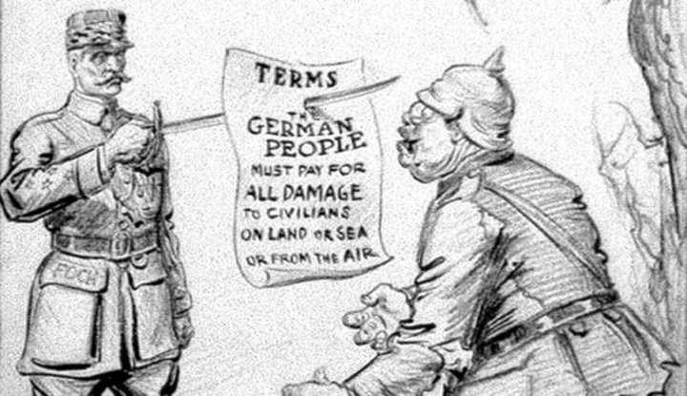

Peace treaties in review:

What are the key problems that a peace treaty faces?

What should the priorities be?

Describe the perfect treaty, what would it look like:

**Treatment of enemy soldiers**

Watch the “Rules of War” video from the Red Cross (<https://www.youtube.com/watch?v=HwpzzAefx9M>) and make a note below the key rules of war:

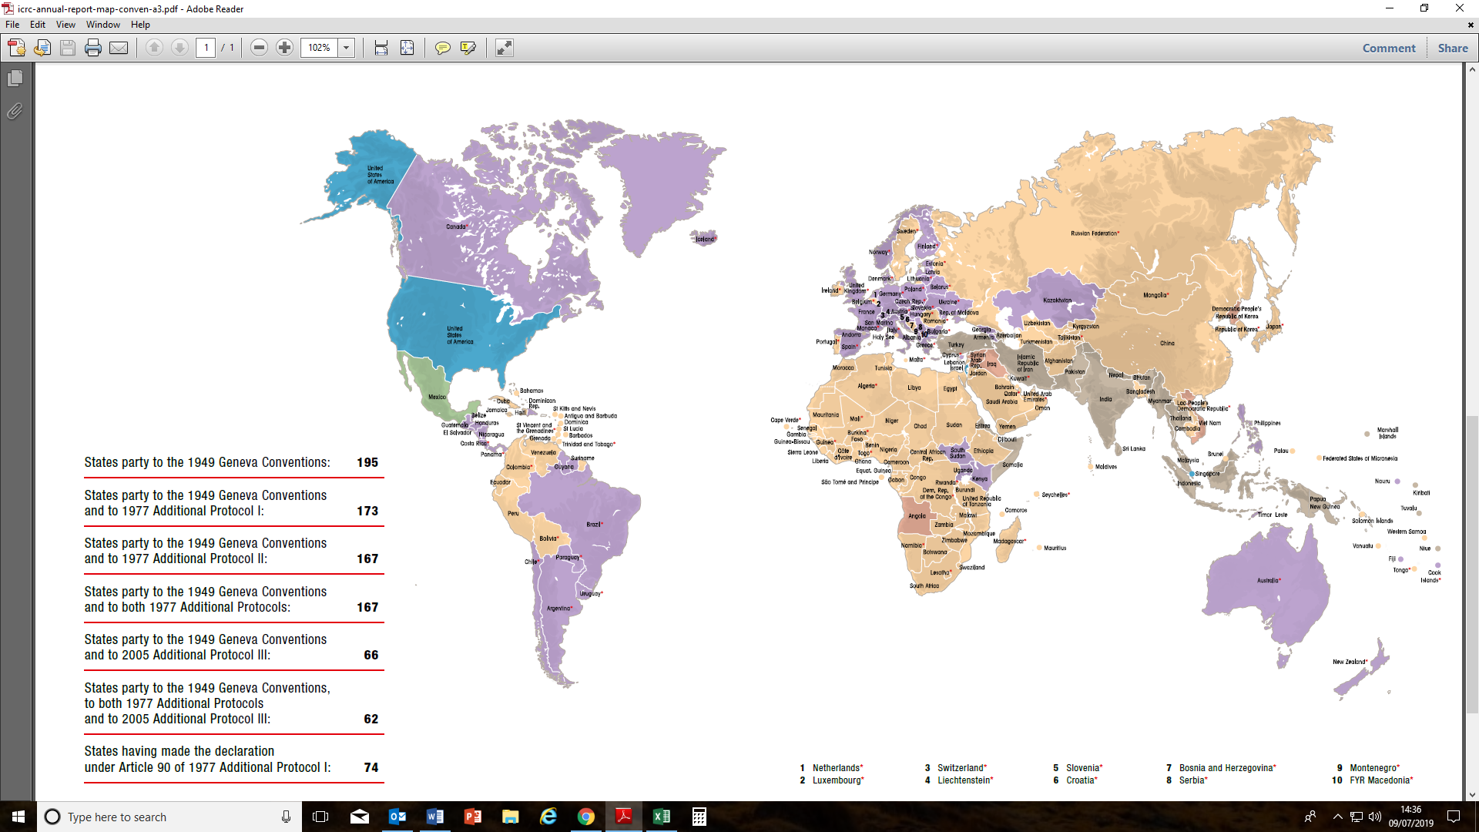

Create a timeline of the evolution of soldier’s rights in warfare below:

1864

1899

1906

1907

1925

1929

1949

1977

What actions in war are legal? Walk round the room and make a decision on each scenario and whether you think it is legal:

|  |  |  |
| --- | --- | --- |
| Scenario | Legal or illegal? | Why? |
| Shooting enemy soldiers during a conflict. |  |  |
| Shooting enemy soldiers who have surrended. |  |  |
| Shelling a hospital. |  |  |
| Shelling a hospital from which snipers are killing your soldiers. |  |  |
| Bombing military targets in a city – knowing that lots of civilians will be killed as well. |  |  |
| Destroying the drinking water supply to a city. |  |  |
| Shelling a Red Cross ambulance which is helping wounded enemy soldiers. |  |  |
| Destroying a dam to gain military advantage. |  |  |
| Making prisoners of war clear landmines that they laid. |  |  |
| Shooting at enemy soldiers who appear to be children |  |  |

]

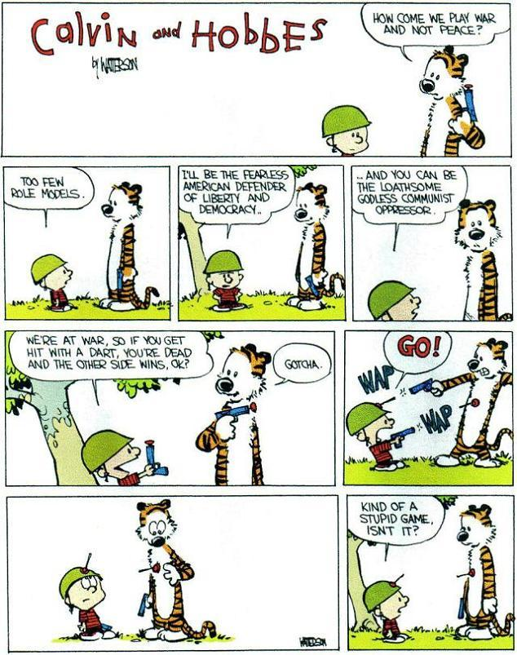What do you think the rules of war should be?

**Tactics**

How important are tactics in warfare, in your opinion?

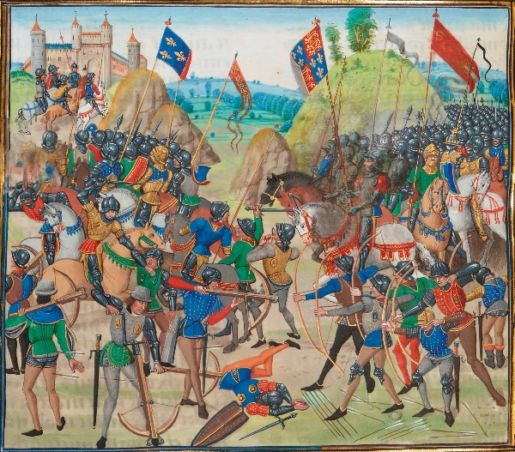

Watch the video (<https://www.youtube.com/watch?v=bhQe2cjr5XQ>) on Napoleon’s use of tactics at Austerlitz. Add detail to the spider diagram below on how tactics made a difference:

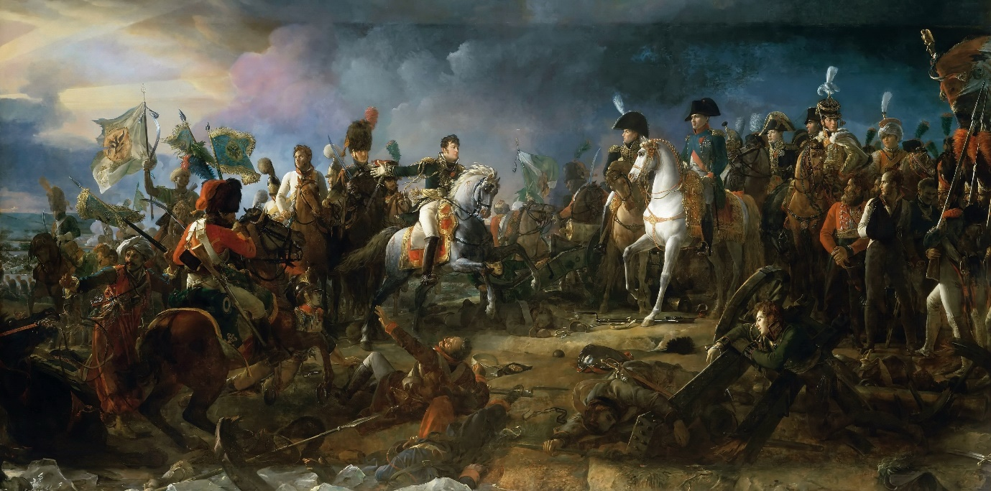

Research a battle from the list that your teacher has presented to you. Produce a poster on it, including:

* Who the battle was between?
* What the outcome was?
* What role tactics had and their importance.

Write your own judgement on which of the battles tactics played the most important role in below:

**Modern warfare and the future of warfare**

Contemporary discussion of modern warfare tends to centre around the concept of ‘New Wars’, as described by Mary Kaldor. Watch this video from 20-34 minutes and make a note of the features of these ‘New Wars’: <http://estream.godalming.ac.uk/View.aspx?ID=8810~4r~SGdEPyeT>



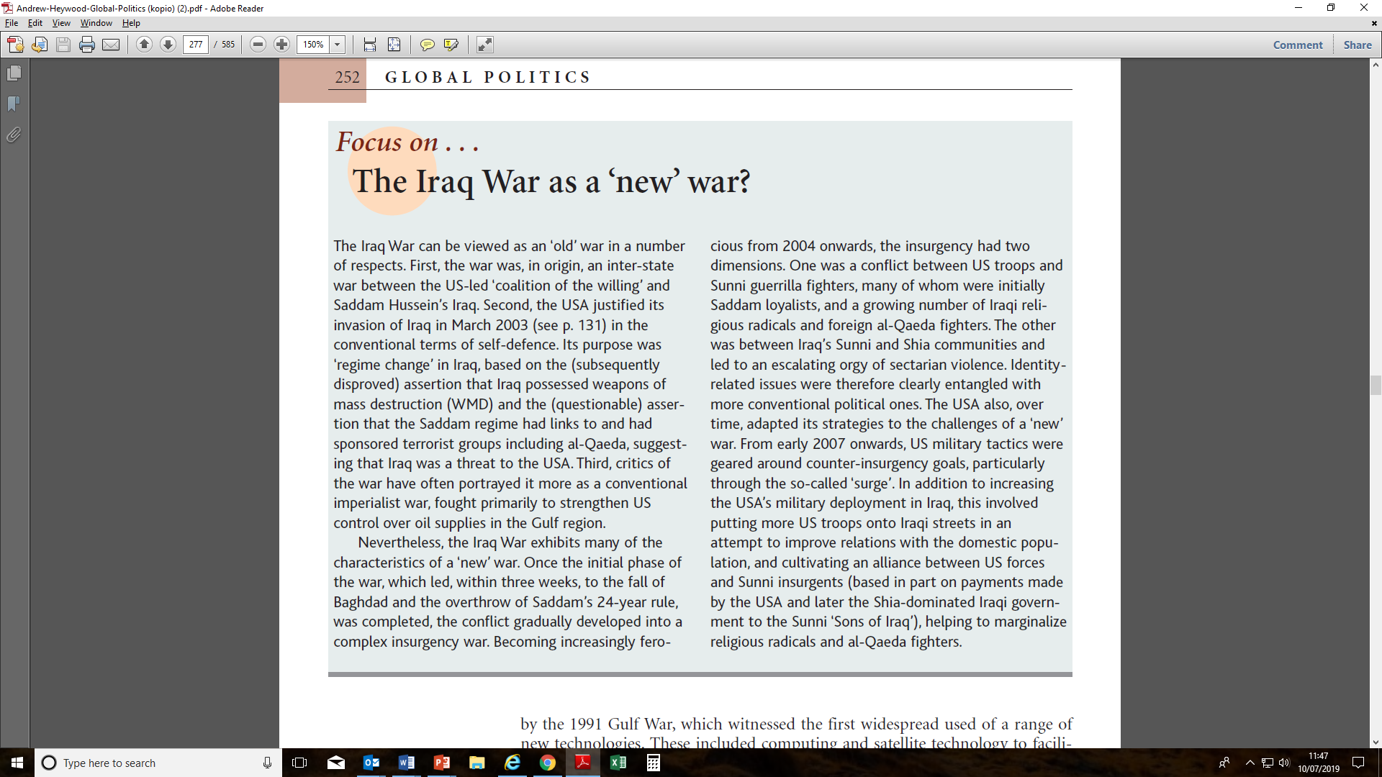

Iraq is often seen as one of the ‘New Wars’. Read the extract above and then make a note of below of the ways in which it can be seen as either a ‘new’ or ‘old’ war. Add to this with the following video (<https://www.youtube.com/watch?v=AQPlREDW-Ro>)

|  |  |
| --- | --- |
| Iraq as a ‘New War’ | Iraq as an ‘Old War’ |
|  |  |

The future of warfare – the Revolution of Military Affairs (RMA).

The way in which wars are fought is rapidly changing. Below are some of the ways this is happening.

|  |  |  |  |
| --- | --- | --- | --- |
|  | Explanation | An example of them in action | Judgement of how effective they are |
| Precision Guided Weaponry |  |  |  |
| AI and automated warfare |  |  |  |
| Predator Drones and their use by the CIA |  |  |  |
| Cyberwarfare |  |  |  |
| Overall how much of an impact due you think these developments have had? |  | | |