**History of Warfare   
Next steps**

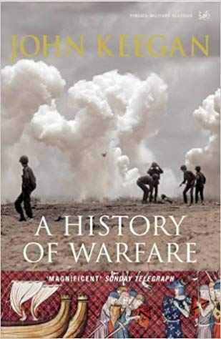

Additional reading, watching and listening:

* 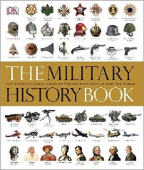A History of Warfare, John Keegan
* The Military History Book, by Dorling Kindersley
* An overview of the evolution of warfare by the Red Cross: <https://www.icrc.org/en/international-review/evolution-warfare>
* A telegraph article on Agincourt: <https://www.telegraph.co.uk/news/8648068/Battle-of-Agincourt-ten-reasons-why-the-French-lost.html>
* BBC documentary – Battlefield Britain (available on YouTube)
* BBC documentary – Sword, Musket & Machine Gun (available on YouTube)

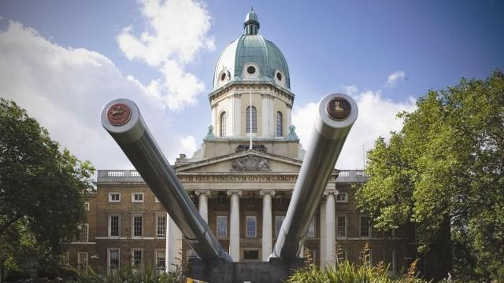

Museums and places to visit:

* Imperial War Museum, London
* Royal Armouries museum, Leeds
* Bosworth battlefield
* Hastings battlefield
* Royal Marines Museum and Royal Naval Museum, Portsmouth
* 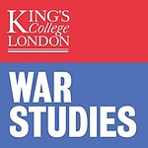National Army Museum, London

Careers/university options

* War studies degree
* Military history topics within a History degree
* Topics on the impact of war on society, within sociology, politics or related fields
* Helpful for jobs in the military, MI5 and MI6