**NEWSPAPER INDUSTRY – CONTEXT**

Forty years ago (1970s) Teletext was the fastest way of receiving on-demand news.

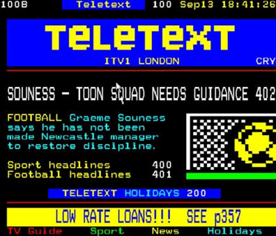

By the 1990s – satellite and cable tv brought audiences 24-hour news coverage. 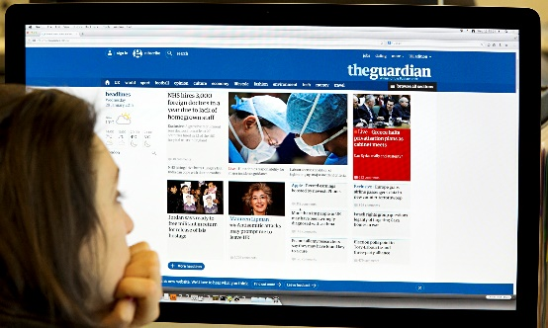

Recognising this, newspapers (spearheaded by *The Guardian*) established their own websites. In some cases you can read the whole paper on-line free of charge but some (e.g. *The Times*) charge a subscription for this.

Most newspapers also have their own website (which is not the whole paper but a selection of the day’s news) e.g. *MailOnline*.

Digitisation has meant a proliferation of news platforms and newspapers and print are now seen by younger audiences as ‘old media’.

The rise of social media, online news platforms, 24-hour rolling news offer immediacy – challenging the relevance of newspapers.

Apps offer ease of access and online news can exploit convergence (available on different media platforms e.g. iPad; phone; PC…)

**Task 1:**

Where do you access your news?

Do you actively seek it out? If so, for what type of stories?

Look at the following two slides and answer the questions in **Task 2**, below:

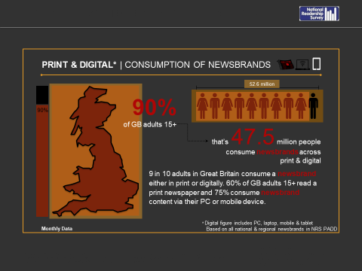

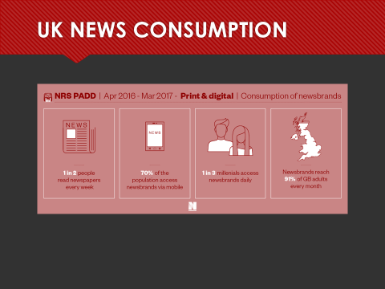

**Task 2:**

1. What percentage of GB adults read a print newspaper?
2. What percentage of adults consume newsbrand content via their PC or mobile device?
3. How many millennials access newsbrands daily?
4. Do these figures surprise you? Why do you think some people still like to read *printed* newspapers?

­_________________________________________________________________________________

**NEWSPAPER OWNERSHIP**

**Why own a newspaper?**

* Newspapers exist primarily to make **money**, however, they are desirable for their owners due to the impact and **political** **influence** they can exert.
* *The Times* had been a loss-maker for many years, but unlike *The Sun it* has a readership of politicians and business leaders who **wield power**. Newspapers still drive the news agenda (that is then followed by other media outlets).
* **Income** is made from both cover price and advertising. (For some free papers such as *The Evening Standard* or *The Metro* advertising is the sole source of income.)

**Who owns what?**

* By far the biggest player in the UK newspaper industry is **News UK** (part of Rupert Murdoch’s News Corp empire). His UK newspapers are*: the Sun, The Times, The Sunday Times,* and the *Sun on Sunday*.
* The***London Evening Standard* and The Independent (online-only newspaper)** are 63% owned by father and son Evgeny and Alexander Lebedev (Alexander is a Russian oligarch – i.e. one of the richest Russians in the world, worth around $1.1 billion)
* ***The Guardian*** and the ***Observer***: owned by the Scott Trust Limited
* ***The Daily Mirror***; the ***Sunday Mirror Daily Express; Sunday Express, Daily Star; Daily Star on Sunday*** and the ***People***: owned by Reach plc
* ***The Daily Telegraph*** and the ***Sunday Telegraph***: Press Holdings, owned by the secretive Barclay brothers – super wealthy British businessmen, worth £7.2 billion
* The ***Daily Mail*** and the ***Mail on Sunday***: owned by Lord Rothermere’s Daily Mail and General Trust plc (owned by them since 1922)

The newspaper industry is very powerful and, as you can see, **is largely in the hands of a few powerful media groups and individuals**. Although the sales of print newspapers are falling, the front page of a newspaper is still an important vehicle to target audiences and through which messages are communicated.

As journalist and political activist, Owen Jones, said:

‘*the press is largely run by a very small group of very right-wing media moguls who defend the status quo of which they are part. If you are on the left and want to change society, the media will always come and get you*’ ([www.yougov.co.uk](http://www.yougov.co.uk/))

The political associations of a newspaper will affect how they represent particular stories and in turn will influence what their readers think and believe. YouGov conducted a survey into readers’ perceptions of the political leaning of specific newspapers.

Out of eight newspaper, five were seen to be predominantly right wing and two, including the ***Daily******Mirror***, were perceived to be centre to left wing.

For the ***Daily Mirror***, 76% of those asked thought it was to the left of centre. 11% thought it was ‘very left wing’, second to the ***Guardian*** in being the most left wing.

***The Daily Mail***was perceived to be the most right-wing newspaper. As this is also the best-selling daily newspaper it is likely to be influential in how their readers view events and issues.

**Task 3**

Why own a newspaper when many people now access their news from other media sources?

What is the problem with a few people owning a large number of newspapers? Consider Curran & Seaton’s views about media ownership.