**COMPONENT 1**

**MEDIA PRODUCTS, INDUSTRIES AND AUDIENCES**

**NEWSPAPERS**

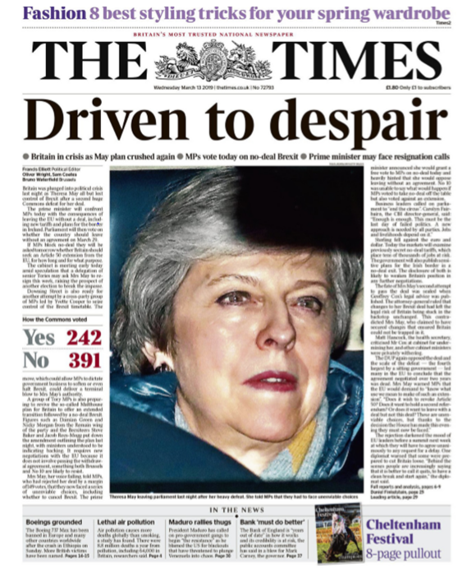

***THE TIMES***

**BREXIT VOTE (13 March 2019)**

1. **BREXIT: CONTEXT**

On 23rd June 2016, the UK voted to leave the European Union (EU). This was nicknamed ‘Brexit’. The vote was very close with 51.9% voting leave and 48.1% voting remain.

The controversies from the campaign continued even after the vote. **Remainers accused Leave voters of xenophobia and racism**; **Leavers accused Remainers of being unpatriotic and un-democratic**.

The period since the referendum has been one of political turmoil. Following the resignation of David Cameron shortly after the referendum, Theresa May (the new Prime Minister) faced regular leadership challenges from within her own party, and called a snap general election in 2017 in which her party suffered heavy losses. Meanwhile, she had been regularly visiting Brussels and other EU countries to create a Brexit deal that would satisfy both the EU and the UK parliament.

On the date this edition of *The Times* was published, MPs had voted against the deal she had negotiated with the EU. This was very serious as the UK was scheduled to be leaving the EU in just 10 days. Withdrawing from the EU with ‘no deal’ could have catastrophic consequences on trade, immigration, healthcare etc., affecting all UK citizens.

**Brexit negotiations timeline**

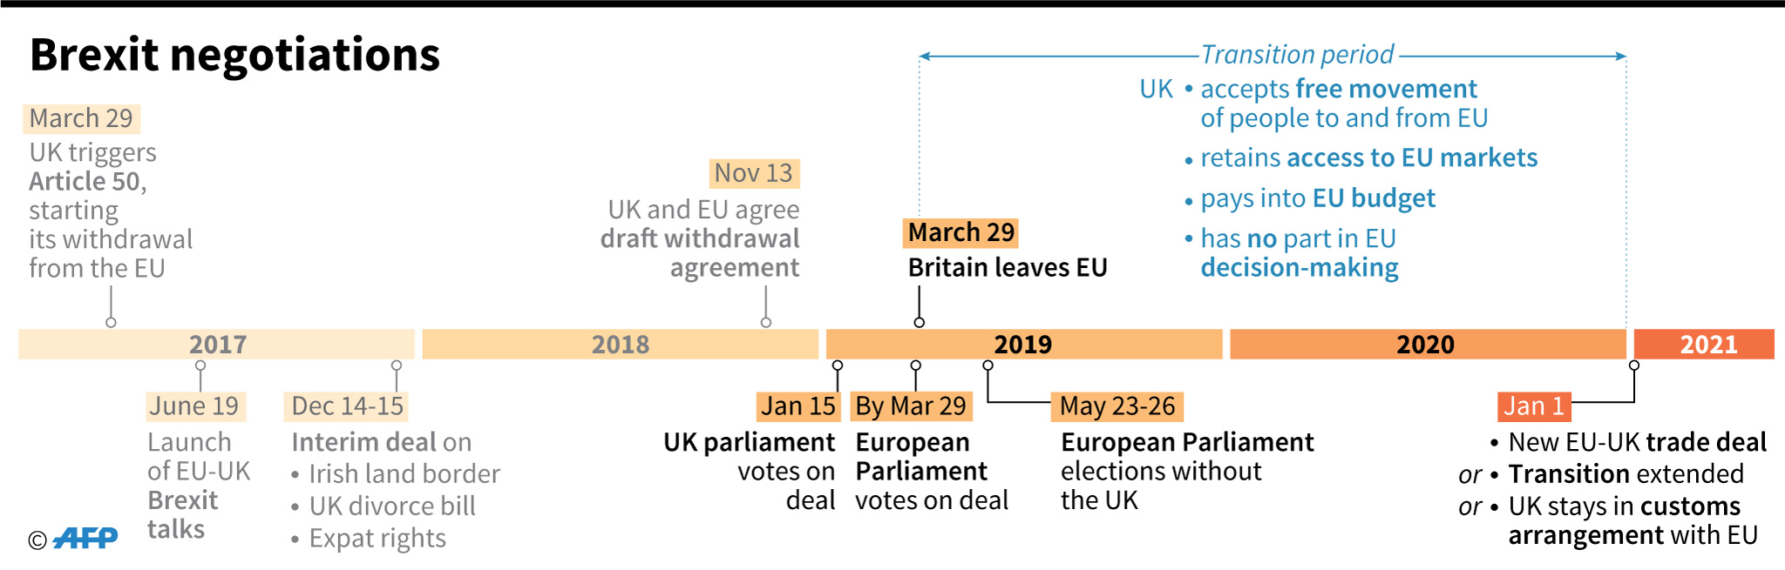

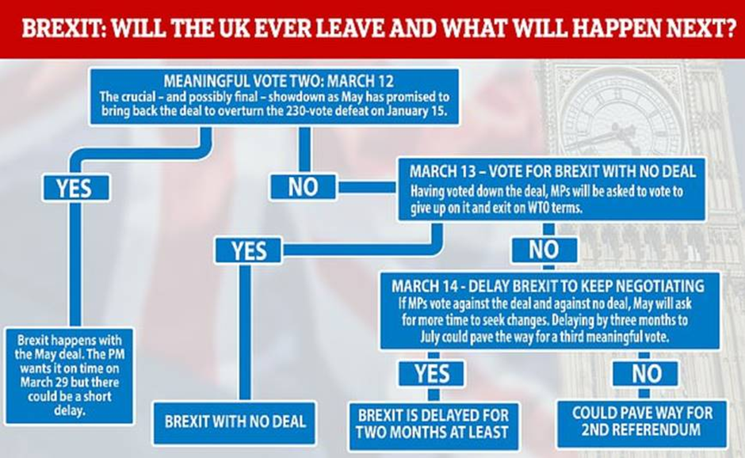

Click on this *BBC News* link and answer the following questions: <https://www.bbc.co.uk/news/uk-politics-47482047>

Why was the vote on 12 March 2019 so important?

What took place on 15 January 2019? Click on the ***Haven’t MPs already rejected May’s exit plan*?** link.

Watch ***Brexit Basics: The backstop*** short clip. Why is the backstop such an important part of the Withdrawal Agreement?

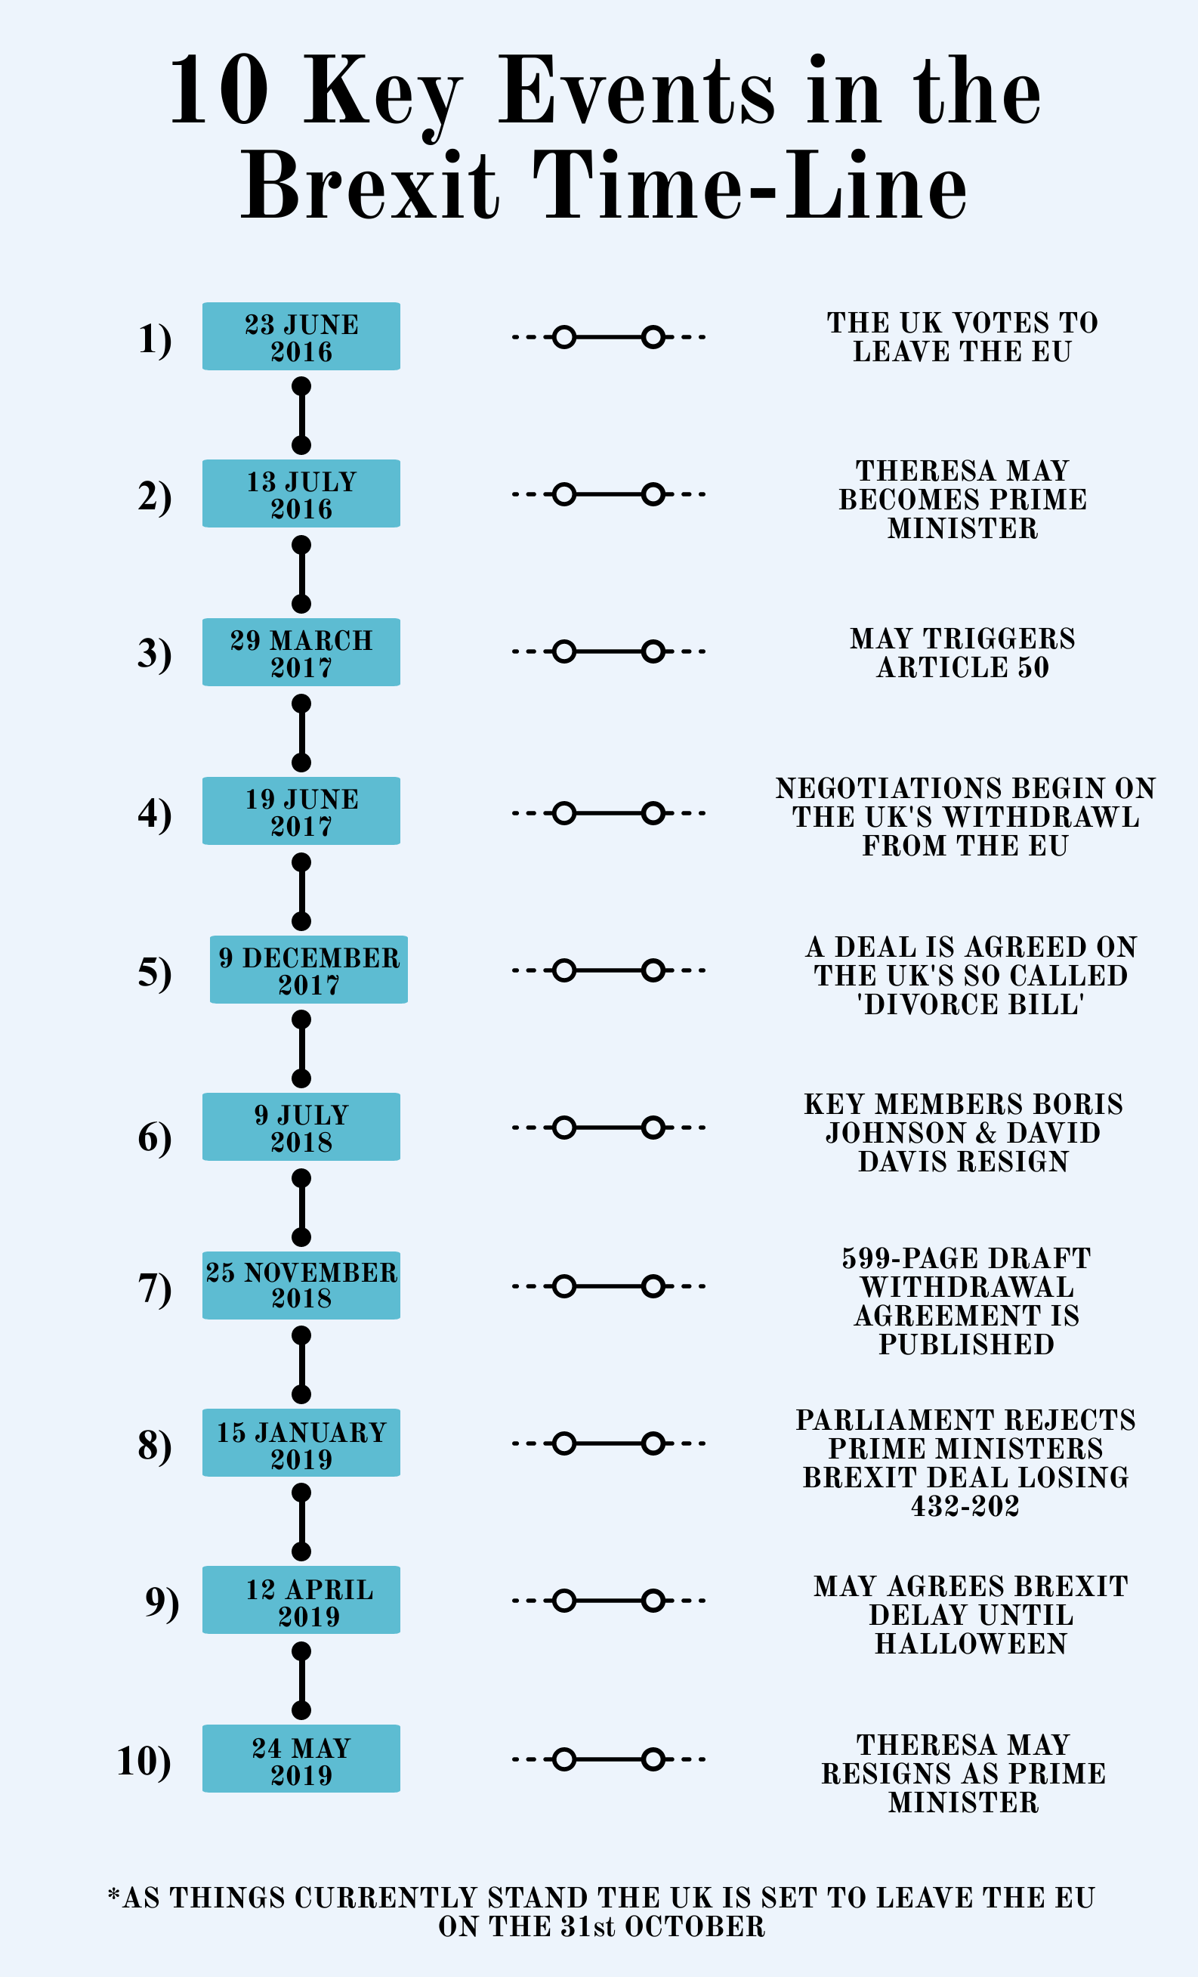

1. **MEDIA LANGUAGE**

**Cultural context:**

**Horse racing events such as Ascot and Cheltenham are an iconic part of British culture, often associated with the upper classes.**

**The contemporary audience can be assumed to be familiar with the codes and conventions of newspaper front pages and the mode of address that these newspapers present to their readers.**

**The layout of the broadsheet newspaper usually has one main story, with lots of details, then smaller headlines at the bottom.**

**TASK:**

Carry out analysis of the **Media Language** of the front cover (using the A3 sheet provided). **Consider how its ownership shapes the design and content/ideology of the stories.**

1. **REPRESENTATION**

Looking at *The Times’* front cover, consider how May’s representation is created through a process of *selection and construction* (reflecting the paper’s ideologies).

Consider the representation of:

Gender

Costume (including colour)

Facial expression and body language

Anchorage of the words (connotes?)

|  |
| --- |
| **Theoretical perspective: Van Zoonen**  Explain what messages/ideologies are being connoted in this representation by the use of specific ‘signs’, in particular around gender. |
| ­ |

1. *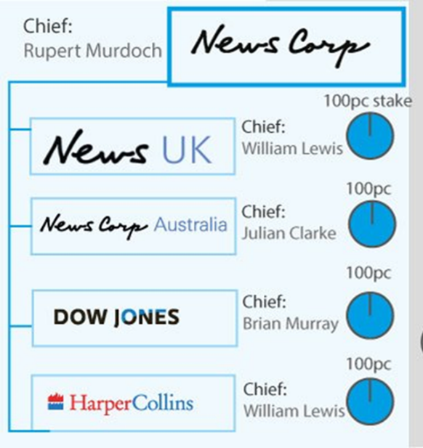***INDUSTRY CONTEXT - OWNERSHIP**

*The Times* newspaper is a British national ‘quality’ newspaper first published in 1785. *The Times* is a subsidiary of **News UK**, wholly-owned by American media conglomerate, **News Corp. This makes *The Times*** part of a **horizontally** *and* **vertically integrated company** and part of a **large media conglomerate (News Corp)**.

News UK has mainly demonstrated a **right-wing political allegiance** with *The Sun* newspaper backing the **Conservative government** in recent elections. However, *The Times* has maintained a more centre right/**neutral stance**.

Please answer the following questions:

1. **News Corp**. was created in 2013 following a restructuring of News Corporation in to two distinct companies. Its businesses cover newspapers and publishing. <https://newscorp.com/>

<https://www.bbc.co.uk/news/av/business-23095421/news-corp-splitting-broadcasting-and-publishing-operations>

Why was News Corporation re-structured? What significant event in the UK occurred that impacted on the company in 2011?

1. Which other newspapers are published by **News UK**?
2. Who is the Chairman and CEO of News Corp? What can you find out about him?

<https://www.bing.com/videos/search?q=how+is+rupert+murdoch&&view=detail&mid=018149E2EFEE5E039B44018149E2EFEE5E039B44&&FORM=VDRVRV>

|  |
| --- |
| **DISCUSSION POINTS**  **James Curran and Jean Seaton (*Power Without Responsibility*). The main points of their theory are that:**   * *the media are controlled by a small number of companies primarily driven by the logic of profit and power.* * *media concentration generally limits or inhibits variety, creativity and quality.* * *more socially diverse patterns of ownership help to create the conditions for more varied and adventurous media productions.* |
| Q1. How do you think being part of huge media organisation could limit or inhibit creativity and journalists’ freedom? Consider what Rupert Murdoch is known for in terms of editorial control.  Q2. How might a more **diverse pattern of ownership** (a more **pluralistic approach**) impact on a media product such as *The Times*? |

**KEY TERMS:**

**Vertical integration -** when two companies in the same industry but at different stages of production come together.This could be through the two businesses merging together or through one company taking over another.For example a television studio may buy up a production company which produces some of its television programmes.

**Horizontal integration** - when two companies in the same industry and at the same stage of production come together. This could be through the two businesses merging together or through one company taking over another. For example two book publishing companies or two film studios may decide to join together.

**INDUSTRY - DIGITAL TECHNOLOGY**

The group was one of the first companies in the UK to introduce an online newspaper (in June 2010) but also **paywalls** which requires readers to pay for access to *The Times Online*. This was introduced in response to the fall in print sales within the group.

A subscription of £6 a week provides access to:

* a tablet edition
* smartphone app
* the website, as well as
* a print edition.

**HOW HAS DIGITAL TECHNOLOGY IMPACTED ON NEWSPAPERS?**

* **Productio**n: newspapers have seen an improvement in high quality photography and printing techniques in terms of print copies
* **Distribution***:* there has, however, been a drop in print sales generally due to ***digital convergence***: readers can access news on a range of devices and through many different routes e.g. search engines/social media/online news sites/apps
* **Consumption***:* readers are now far more interactive with the news

**WHAT ARE THE BENEFITS OF ONLINE NEWS SITES?**

Rather than seeing digital media as a threat, the company has embraced its digital expansion and introduced paywalls to allow for online content to be viewed while still generating income.

As part of News Corp, The Times Newspaper Group finds itself part of a wide organisation responsible for different cultural industries. This can benefit *The Times* newspaper greatly in terms of production and promotion.

|  |
| --- |
| **David Hesmondhalgh is professor of Media, Music & Culture at Leeds University. In his book *The Cultural Industries* he has looked at changes that are taking place within the media in this digital age.**  **In summary he states:**   * the idea that cultural industry companies try to minimise risk and maximise audiences   through vertical and horizontal integration, and by formatting their cultural products  (e.g. through the use of stars, genres, and serials)   * the idea that the largest companies or conglomerates now operate across a number   of different cultural industries   * the idea that the radical potential of the internet has been contained to some extent   by its partial incorporation into a large, profit-orientated set of cultural industries |
| Q1. How does being part of both a **vertically and horizontally integrated company** with a wide range of titles on offer benefit *The Times* and the journalists that work for it?  Q2. How and why has The Times Newspaper Group **embraced its digital expansion**? |

1. **AUDIENCE**

*The Times*’ **target audience** is predominantly ABC1, over 35 (slightly more men than women) and has a liberal/centre right political stance.

*The Times* is famous for having a range of journalists with varied political viewpoints which allows the newspaper to offer a more **neutral political stance** on the Brexit vote.

1. What is the readership figure for *The Times*? Look on **the National Readership Survey** (NRS) website <http://www.nrs.co.uk/downloads/pdf/newspapers_201709.pdf>
2. What is the paper’s circulation figure? Visit the **Audit Bureau of Circulation** website to find the latest figure. <https://www.abc.org.uk/product/2896>

1. Explain what the differences are between *circulation figures* and *readership figures*.
2. How does the set front page appeal to different audiences?
3. Could different audiences interpret the story in different ways (based on social, cultural and historical considerations)? **Applying Stuart Hall’s Reception Analysis theory,** which different ‘readings’ could be taken? Explain your answer.
4. Exposure to **repeated patterns of representation** (of May struggling to reach a deal, general Brexit chaos) by newspapers can shape and influence audiences’ views and opinions. **Apply George Gerbner’s Cultivation Theory to this story**
5. The concept of audience members as **passive consumers** is no longer tenable in the age of the internet with the rise of the **prosumer** who can create their own content such as submitting stories and being part of forums. **Can Clay Shirky’s ‘End of Audience’ be applied to *The Times*?**
6. Has *new media* democratised the production of media texts by shifting the control of media content away from large media institutions?

**KEY TERMS:**

**Citizen journalism** - public citizens playing an active role in the process of collecting, reporting, and disseminating news and information.

**User Generated Content** - any form of content created by users of a system or service and made available publicly on that system. UGC most often appears as supplements to online platforms, such as social media websites, and may include such content types as blog posts, wikis, videos, e-commerce or comments

**VI: REGULATION**

*The Times* Newspaper Group and News UK are facing increasing pressure along with the rest of the UK press industry to adhere to strict rules and guidelines on industry practice. This has arisen after the phone hacking scandal (which involved one of its own newspapers – the now closed *News of the World*) and subsequent Leveson enquiry into the industry.

There is an underlying issue of protecting citizens from harmful material while ensuring choice and press freedom.

The increasing power of companies like News Corp and their expansion into digital media has also placed traditional approaches to media at risk.

<https://www.telegraph.co.uk/news/uknews/phone-hacking/8634176/Phone-hacking-timeline-of-a-scandal.html>

**DISCUSSION POINT:**

1. Which organisation did IPSO replace? What problems did the old regulator face?
2. What does the role of IPSO involve?
3. What was one of the main recommendations by Sir Brian Leveson that was not adopted by IPSO?
4. What are the main criticisms of IPSO?
5. Which papers have not signed up to IPSO, and why not?

|  |
| --- |
| Applying Livingstone and Lunt’s ideas around regulation, there is an **underlying issue** of **protecting citizens from harmful material while ensuring choice and press freedom**. The increasing power of companies like News Corp and their **expansion into digital media** has also placed traditional approaches to media at risk.  Explain what this means for readers of *The Times* and the paper’s journalists. |
|  |

APPENDIX

# A BACKGROUND TO PHONE HACKING AND HOW THIS HAS IMPACTED ON THE REGULATION OF THE UK PRINT MEDIA INDUSTRY

# NEWS OF THE WORLD PHONE-HACKING SCANDAL

4 August 2012, BBC News

The row over phone-hacking by journalists has led to the closure of the News of the World newspaper, the establishment of the Leveson Inquiry, an MPs' inquiry and the launch of three police investigations.

The BBC takes a look at the key questions it poses.

What is the phone-hacking scandal?

The story goes back to 2006-07 when Clive Goodman, the then News of the World royal editor, and Glenn Mulcaire, a private investigator were [convicted of intercepting voicemail messages](http://news.bbc.co.uk/1/hi/6301243.stm) left for royal aides and subsequently jailed.

Their newspaper said they had acted alone - but the then editor Andy Coulson quit, saying he took responsibility for what happened.

Two years later, the Guardian newspaper reported that News International had made confidential settlements totalling £1m to three people who said their phones had been hacked. By September 2010 a string of well-known people began legal moves to have their claims looked at again amid mounting suspicions that phone hacking had been more widely used.

The turning point came in January 2011 when the Metropolitan Police launched Operation Weeting, a fresh phone hacking investigation which included looking at the original 2006 case. The investigation slowly widened to include allegations of improper payments to public officials and separate claims of computer hacking.

The critical political moment in the affair came when the Guardian newspaper reported that the newspaper had hacked the mobile phone belonging to murdered schoolgirl Milly Dowler.

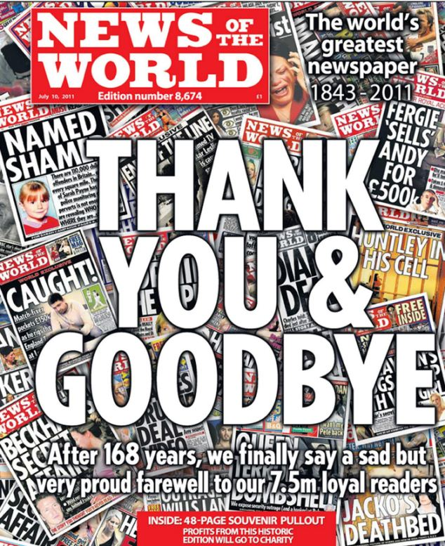

What happened to the News of the World?

The Sunday newspaper was one of the oldest in the UK and sold some 2.8m copies every week. Its fondness for sex scandals gained it the nickname "News of the Screws".

Rupert Murdoch closed it down in the wake of the Milly Dowler revelations. Its final front page declared "Thank you and goodbye".

How many people have been hacked?

More than 4,000 people have been identified by police as possible victims of phone hacking by the NoW. The forthcoming prosecutions (see below) specify 600 identifiable alleged victims.

The alleged targets have included politicians, celebrities, actors, sports people, relatives of dead UK soldiers and people who were caught up in the 7/7 London bombings.

How does phone hacking work?

The opportunity to access voicemail messages came down to a simple security oversight. Mobile phones used to be supplied with a default factory-set personal identification number that could be used to access voicemail from another phone or abroad. Customers were encouraged to change that Pin, but very few did.

That meant that anyone could call the phone and if the owner did not answer, the caller could use the Pin to access the voicemail and any stored messages.

Is phone hacking illegal?

Yes. Hacking voicemails is classed as an unlawful interception of communications under Section One of the **Regulation of Investigatory Powers Act 2000**.

Has anyone been charged?

On 24 July 2012, the Crown Prosecution Service **announced it would be charging eight people** with phone hacking. The group includes Andy Coulson, the former News of the World editor and, more recently, David Cameron's former spokesman. Rebekah Brooks, the former chief executive of News International, was also among those charged. Both Ms Brooks and Mr Coulson have said they will fight to clear their names. Rebekah Brooks, her husband and others also face a separate charge of conspiracy to pervert the course of justice in relation to the police investigations.

What role has the Met Police played in the affair?

The Met has faced enormous criticism over its initial approach to the allegations.

The original inquiry in 2006 resulted in just two arrests. Officers told MPs on the Home Affairs Select Committee that News International had tried to "thwart" the original inquiry.

In 2009 the force decided not to relaunch the investigation despite pressure to do so. Since then, the force has faced claims of an overly cosy relationship with News of the World journalists. Sir Paul Stephenson quit as the Met's commissioner, as did assistant commissioner John Yates, following criticism of police links to former News of the World deputy editor Neil Wallis.

In February 2012, the force also formally accepted it had failed to warn some people they could have been victims of hacking by the NoW.



What has happened to victims?

News Corporation set up a special process to consider compensation claims for those who believe they were hacked. Some cases have already been settled in the High Court. These include a payment of £600,000 to singer Charlotte Church and her parents.

How has the government handled the affair?

**The prime minister has announced two inquiries** and said the **Press Complaints Commission should be scrapped.**

Lord Justice Leveson is conducting a **two-part inquiry,** initially looking at "the culture, practices and ethics" of the UK press and its relationships with police and politicians. It will later examine the extent of unlawful conduct within newspaper groups and the police's original phone-hacking investigation.

Former Parliamentary Commissioner for Standards Elizabeth Filkin has already examined the relationship between the media and Metropolitan Police.

She concluded that the "close relationship" between parts of Scotland Yard and the media had caused "serious harm". She said there were "some very serious issues" relating to contact between journalists and police which had "eroded trust from the public". Among her recommendations, she told officers to "watch out" for "late-night carousing" with journalists, and flirting.

Prime Minister David Cameron has faced questions over his judgement, given that he employed Mr Coulson.

How has News International responded to the scandal?

News Corp boss Rupert Murdoch has issued an apology for the "serious wrongdoing" by the NoW.

In July 2011, Rupert Murdoch and James Murdoch gave evidence to the House of Commons Culture, Media and Sport Select Committee and denied knowing the full extent of the allegations until evidence in civil cases was requested in late 2010.

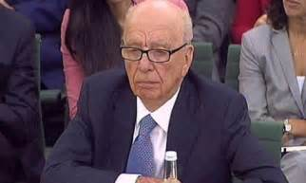

James Murdoch told MPs he had not been aware of an email suggesting hacking went beyond a single "rogue" reporter. Two former News of the World executives later issued a statement claiming they had informed him.

James Murdoch was questioned again by the media committee in November 2011 and reiterated his claim that he had been unaware of the scale of phone hacking.

# Phone-hacking trial explained

25 June 2014, BBC News

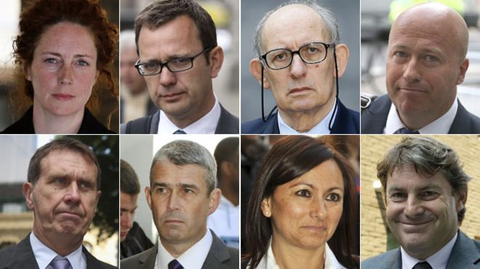

**News of the World editor Andy Coulson was found guilty of conspiracy to hack phones and one-time chief executive Rebekah Brooks was cleared in what became known as the phone-hacking trial. Four other defendants were cleared along with Ms Brooks.**

## What was the hacking trial?

Allegations that News International journalists were involved in hacking people's phones for information led to the closure of the 168-year-old News of the World tabloid in 2011 and a trial costing [**reportedly up to £100m**](http://www.telegraph.co.uk/news/uknews/phone-hacking/10924109/Rebekah-Brooks-walks-free-as-100m-phone-hacking-trial-ends.html).

The scandal went to the heart of Downing Street. Among those in the dock at London's Old Bailey for the eight-month trial were a close family friend of the prime minister and Coulson, David Cameron's official spokesman.

It was some nine years ago that the News of the World published a story about Prince William's treatment for an injury, based on information that it could only have come by because one of its journalists had listened to the prince's voicemails.

The ensuing police investigation, which uncovered "a vast number" of other victims, would begin the saga that led to the conviction of Coulson, the closure of a newspaper bought by millions every week and moves to change the way newspapers are regulated.

line break

line break

## Why did this trial come about?

The News of the World was [**closed down in 2011**](http://www.bbc.co.uk/news/uk-14096215) after its owners, Rupert Murdoch's News International, admitted the scale of hacking that had been going on, dating back many years.

The company had battled against growing allegations for two years - one of its private investigators and the News of the World's royal editor were jailed in 2007 over a story gleaned from hacking.

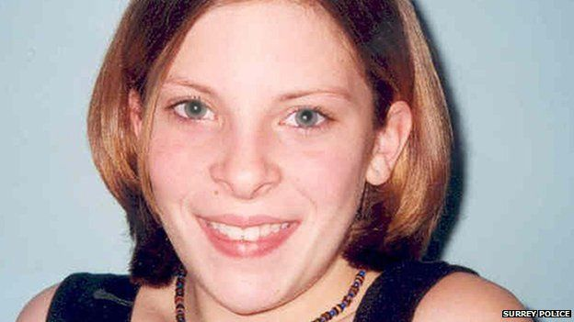

The paper's original position - that rogue staff had acted alone - could not stand. Eventually Rupert Murdoch decided he had no choice but to close the newspaper down after it emerged Milly Dowler, a teenager who was abducted and murdered, [**had her voicemails hacked.**](http://www.bbc.co.uk/news/uk-14017661)

The Crown Prosecution Service charged two former editors - [**Rebekah Brooks**](http://www.bbc.co.uk/news/uk-politics-13117456) and her successor [**Andy Coulson**](http://www.bbc.co.uk/news/uk-11204150)with conspiracy to intercept mobile voicemails alongside others connected to the newspaper.

line break

## Who was on trial?

Alongside Rebekah Brooks and Coulson was former managing editor Stuart Kuttner. Five others had pleaded guilty to conspiracy to hack phones before the trial began: private investigator Glenn Mulcaire, news editors James Weatherup and Greg Miskiw and reporters Neville Thurlbeck and Dan Evans. Mulcaire performed thousands of hacks for the newspaper under the instruction of news editors.

The newspaper's former royal editor Clive Goodman was also charged with illegal payments to public officials - as was Rebekah Brooks and Coulson.

Brooks' husband Charlie Brooks, her former personal assistant Cheryl Carter and News International's head of security Mark Hanna were accused of a conspiracy to hide material from the police.

Mrs Brooks, Charlie Brooks, Cheryl Carter, Mr Kuttner and Mr Hanna were cleared of all charges against them.

The jury was discharged after failing to reach verdicts on charges that Coulson and Goodman conspired to commit misconduct in a public office by paying police officers for two royal directories.

line break

## How did hacking come to light?

Glenn Mulcaire and Clive Goodman were jailed seven years ago after pleading guilty to intercepting voicemails - but that first trial only concerned a small number of cases. Police did not go through all the evidence seized from Mulcaire. Two years later it emerged that News International had agreed a series of confidential out-of-court settlements which had prevented more allegations being aired.

HOMEWORK: PHONE HACKING QUESTIONS:

What is the “phone hacking scandal’?

How widespread was it?

How did it come to light?

Who went to trial?

How did News International respond to the scandal?

**LEVESON REPORT: AT A GLANCE**

BBC News, 29 November 2012

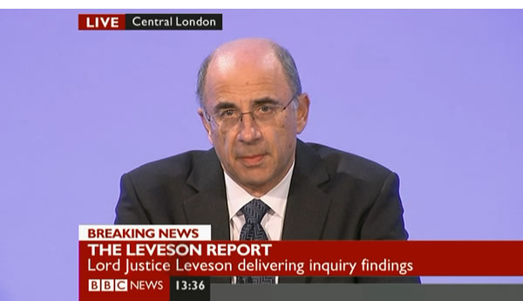

The Leveson Inquiry into the culture, practice and ethics of the press has published its report. Here are the key points.

Briefly:

* New self-regulation body recommended
* Independent of serving editors, government and business
* No widespread corruption of police by the press found
* Politicians and press have been too close
* Press behaviour, at times, has been 'outrageous'

## Regulation

An **independent regulatory body** for the press should be established.

It should take an active role in **promoting high standards**, including having the power to investigate serious breaches and sanction newspapers.

The new body should be **backed by legislation** designed to assess whether it is doing its job properly.

The legislation would enshrine, for the first time, a **legal duty on the government** to protect the freedom of the press.

An **arbitration system** should be created through which people who say they have been victims of the press can seek redress without having to go through the courts.

Newspapers that refuse to join the new body could face direct regulation by media watchdog Ofcom.

The body should be **independent** of current journalists, the government and commercial concerns, and not include any serving editors, government members or MPs.

The body should consider encouraging the press to be as transparent as possible in relation to **sources** for its stories, if the information is in the public domain.

A **whistle-blowing hotline** should be established for journalists who feel under pressure to do unethical things.

## Police

No evidence of widespread police corruption.

Former Met Police Assistant Commissioner John Yates's relationship with media publisher News International, where he had friends working at the News of the World, including the deputy editor, was criticised.

## Politicians

Politicians of all parties had developed "too close a relationship with the press in a way which has not been in the public interest".

The relationship between politicians and press over the last three decades has damaged the perception of public affairs.

But former Culture Secretary Jeremy Hunt and PM David Cameron were cleared of being too close to the Murdoch media empire.

## Public

When chasing stories, journalists have caused "real hardship and, on occasion, wreaked havoc with the lives of innocent people". This happened to both famous people and members of the public. Press behaviour, at times, "can only be described as outrageous".At the News of the World, quite apart from phone hacking, there was a failure of systems of management and compliance. There was a general lack of respect for individual privacy and dignity at the paper.

**HOMEWORK QUESTIONS on LEVESON REPORT:**

Why was the Inquiry set up?

Who chaired it? What’s his background?

What were the main recommendations in the Inquiry’s report?

**THE FORMATION OF THE INDEPENDENT PRESS STANDARDS ORGANISATION (IPSO)**

* IPSO was set up in September 2014 following the Leveson inquiry (replacing the Press Complaints Commission)
* The problem with newspapers is their regulatory body (IPSO), like the previous regulatory body (PCC) is a ‘toothless’ organisation – i.e. it does not have legal powers
* IPSO deals with complaints that have breached the **Editor’s Code of Practice**. It does have some ‘New Sanctions’ – for example, they can dictate ‘the nature, extent and placement of corrections’
* Decisions are made by a committee of 12 members, seven are independent and five represent the magazine/newspaper industry (so IPSO is still a form of self-regulation)
* Impress is a pro-Leveson alternative regulator but no national newspaper has signed up to it (some magazines have).

**REGULATION**

The newspaper industry used to be regulated by the Press Complaints Commission (PCC). However, the PCC was severely criticised in the Leveson inquiry, which in 2012 investigated the culture, practice and ethics of the British press in the light of the phone hacking scandal and other issues related to intrusion of privacy by the press. The PCC was seen to be largely ineffectual in regulating the newspaper industry. Lord Leveson made recommendations for a new regulatory body to replace the PCC.

In his report he says:

*The press needs to establish a new regulatory body, which is truly independent of industry leaders and of government and politicians. It must promote high standards of journalism and protect both the public interest and the rights of individuals. The chair and other members of the body must be independent and appointed by a fair and open process (*[www.bbc.co.uk](http://www.bbc.co.uk)*)*

He also stated that there would be firmer sanctions for those newspapers that were deemed to have broken the law, including substantial fines. Newspapers at the time were concerned that this would be set up by Royal Charter and therefore the self-regulatory system would be governed by legislation. The press industry was unhappy abut these recommendations becoming a legal requirement. Those against the reform wanted newspapers to still have some independence regarding self-regulation in order to protect the freedom of the press.

The new regulatory body is the Independent Press Standards organisation (IPSO), whose stated aim is to uphold professional standards in journalism. The role of IPSO involves:

The regulation of more than 1,500 print and 1,100 online titles

Dealing with complaints about possible breaches of the Editor’s Code of Practice

Giving help with unwanted press attention or harassment issues

Giving advice to editors and journalists

**New press self-regulation body 'not a fake', says Ipso chairman**

BBC, 8 September 2014

The chairman of a new press self-regulation body set up in the wake of the phone-hacking scandal says he wants to show critics it is not a "fake".

Sir Alan Moses heads the Independent Press Standards Organisation (Ipso) which begins its work on Monday.



Ipso has replaced the discredited Press Complaints Commission, although not all newspapers have signed up to it.

Sir Alan said he understood why campaigners felt the new body was a "sham" but wanted to prove them wrong.

Campaign group Hacked Off, which pushes for tougher regulation of the press, described Ipso as a "sub-standard regulator" which fell short of the principles set down in the Leveson report.

Sir Alan said newspapers would have 28 days to resolve a complaint before Ipso moved in to adjudicate.

He told BBC Radio 4's Today programme: "What is very important is those who feel they are victims of press abuse should not feel that they are at the mercy of the press during that initial period.

"People who can't afford to go to court must have some means of speedy and cheap redress."

Sir Alan said an independent figure would be appointed to oversee the work of Ipso and report publicly on its progress.

"No respectable board can operate without people looking and monitoring what we're going to do," he said.

"The critics, and people like Hacked Off and the Media Standards Trust, will be very important to our success, because we have to listen to them and hear from them how we're doing."

## 'No credibility'

Sir Brian Leveson led an inquiry into the ethics and practices of the press following public and political anger at phone hacking.

Among its recommendations, the report called for a tough new press regulator backed by statute.

A Royal Charter agreed by the main Westminster parties established a panel to independently verify a new regulator, although Ipso has not sought recognition from this.

A rival independent self-regulator, Impress, has been set up by a group of high-profile free speech campaigners, with the aim of becoming compliant with Leveson's requirements.

Earlier, former Court of Appeal judge Sir Alan said he had had a lot contact with hacking victims and opponents of Ipso.

He said that despite "losing my temper twice", he understood "distress and frustration" of Hacked Off's supporters such as Gerry and Kate McCann, parents of missing girl Madeleine.

"Of course they're angry, desperately angry. Of course they don't trust Ipso and they regard it as a fake and I'm not at all surprised but I want to show that they're wrong," he said.

## 'Wild, unruly press'

**According to the Guardian newspaper**, 30 victims of press intrusion have written to Sir Alan claiming: "In its current form, Ipso retains no credibility with us or with the wider British public."

While most newspapers have signed up to the new body, the Guardian, Financial Times, Independent and London Evening Standard have not.

Sir Alan said he would like to them join but their doing so was not "vital to its existence".

He added that the industry-funded regulator could "cost substantially more" than its predecessor the PCC.

Sir Alan also said Ipso would never intervene to "prevent publication in advance", adding: "Of course I want a wild, unruly press. The last thing I want is a boring press."

But victims of press intrusion have continued to criticise the body. In June, Gemma Dowler, sister of murdered schoolgirl Milly Dowler, said Ipso was "just the newspapers looking after themselves". Hacked Off executive director Joan Smith said: "Neither we, nor victims of press abuse, nor the wider public will accept a sham regulator that fails to meet the Leveson criteria of independence and effectiveness and which refuses to be subject to the audit that Lord Justice Leveson said was vital to prevent a repeat of the disastrous failures of the past."

Useful links: these can be accessed from GOL

<https://www.bing.com/videos/search?q=what+is+phone+hacking+and+leveson&&view=detail&mid=0C993C6F200EC86EE7500C993C6F200EC86EE750&&FORM=VDRVRV> (phone hacking trial/Leveson inquiry)

<https://www.bing.com/videos/search?q=ipso+media+regulator&&view=detail&mid=4583DA43CE58E7F22D414583DA43CE58E7F22D41&FORM=VRDGAR> (IPSO)

<https://www.bing.com/videos/search?q=steve+coogan+hacked+off&&view=detail&mid=6B66FD304E754776BE486B66FD304E754776BE48&&FORM=VRDGAR> Steve Coogan (Hacked Off)