**Smoking – Biological Model**

**Initiation**

There is evidence that the reason people take up smoking in the first place may well be something to do with their genetics.

For example, Lerman et al (1999) have shown that people with a particular gene are less likely to take up smoking than those without it. The gene, called SLC6A3-9, works in the dopamine system. Dopamine is a neurotransmitter which is associated with reward/pleasure.

Wang and Li (2009) conducted a literature review and found 16 genes reported to be associated with smoking initiation, 5 of these genes are involved with nicotine receptors (nAChR) on neurons and 2 of the genes are involved with dopamine receptors on neurons. Stefansson et al (2010), in a study of over 140,000 participants reported the existence of three genetic mutations that appear to increase the number of cigarettes smokers consume each day. Furthermore, Maes et al (2004) found ~75% heritability rates for tobacco initiation. This research suggests that genes may make some people more susceptible to addiction.

However, genes alone cannot explain addiction. Genes, therefore, can only provide a predisposition to an addiction.

**Maintenance**

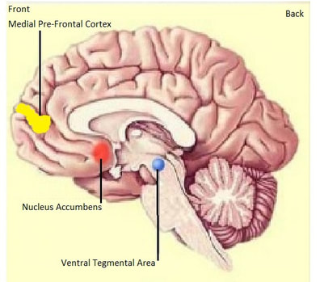

The picture above shows three areas of the mesolimbic system in the brain.

The Nucleus Accumbens (NAcc) is the reward and pleasure centre of the brain.

The Desensitization Hypothesis (Dani & Heinemann, 1996) focuses on our brain chemistry – specifically, on neurons that produce the neurotransmitter acetylcholine (ACh) and ACh receptors on neurons. As with all receptors, the receptors for acetyl choline come in different ‘flavours’. One subtype of ACh receptor in particular in particular, the nicotine acetylcholine receptor (nAChR) is crucial in understanding what follows. This receptor can be triggered not only by ACh but also by nicotine. However, when it does trigger a receptor that receptor immediately stops working and shuts down temporarily. The number of active receptors is said to be downregulated. This leads to desensitisation of the neuron (because fewer active receptors are available).

When downregulation of nAChR receptors occurs in the NAcc it triggers the release of the neurotransmitter dopamine, resulting in a feeling of increased alertness, reduced anxiety and mild euphoria, and is similar to the effects of heroin or amphetamine.

Repetition of this process over time creates a chronic (long-term) desensitisation of nAChRs which can only be overcome by increasing nicotine intake, a tolerance develops. This results in consistently high levels of dopamine. Eventually the brain will adapt by producing less dopamine resulting in a dampening down and less experience of pleasure. To achieve the same result, increased quantities of the nicotine will be needed. Not only does the pleasure disappear but the user now has to take nicotine, not to get the pleasure as initially, but to stave off withdrawal symptoms

After a period without a cigarette, for example while the smoker sleeps, the downregulated nAChRs become upregulated again (receptors are active). This creates withdrawal symptoms: anxiety, agitation and restlessness. This is why smokers often describe the first cigarette of the day as the most enjoyable – as the nAChRs are most sensitised after a period of abstinence. This daily cycle of morning upregulation and night downregulation is referred to as the Nicotine Regulation Model.

**Relapse**

If a person has quit smoking ‘cold turkey’ and has a long period of abstinence from nicotine, there is upregulation (resensitisation of the nAChRs) and an increase in the number of nAChRs. If someone smokes a cigarette then, research (Nisell et al, 1996) has suggested that they are more likely to relapse (and continue to smoke) as the pleasure reward (increased dopamine) is substantial.

A history of major depression may exacerbate withdrawal after smoking cessation (Pomerleau et al. 2004) and may increase the risk of relapse in women but perhaps not in men (Hall et al. 1998).

Some studies also suggest that a dysregulation in the hypothalamic-pituitary axis (HPA axis; involved in the long term stress response) occurs subsequent to withdrawal (al’Absi et al. 2004), and this dysregulation has been associated with relapse to smoking (al’Absi et al. 2005).