 GODALMING COLLEGE
20 Mark Questions

Geography - Assessment for Learning

We need to consider the emotional and practical learning needs of all our students, consider our own teaching and learning strategies and allow students the opportunity to identify their strengths and weaknesses and plan for improvement.

Conventional teaching practice involves the following summative assessment:
Teach
Test
Grade
Move on

"Too often the teacher teaches a topic, sets homework, grades it, criticises it in a more or less constructive way, but does not check that the student has made good any deficiencies. Then the teacher moves on to the next topic. A common assumption behind this approach is that learning quality and quantity depend on talent or ability, and that the role of assessment is to measure this ability. If learning is wanting, this is attributed to a lack of ability, flair or intelligence". [Petty, 2004].

Best practice involves assessment that is diagnostic:
Fix
Find faults
Follow up

Black and William's review suggests a different approach. A topic is taught, and some work is set. The student and the teacher use this work to diagnose deficiencies and set targets for improvement. This improvement is itself reviewed.

The assumption is that learning quality and quantity depends on time and effort spent on improvement, and that the role of assessment is to diagnose deficiencies so that time and effort can be focused on improvement. Indeed weaknesses are the very areas where the greatest improvement can be made with least effort. If learning is wanting, you need to try harder for longer.
Can't do
Can do
Self - assessment
Peer and spoof assessment
Medals and missions
Corrections
Targets for next piece of work
Mastery learning
Avoid grading
Assessment proformas
100%
Find this and get
the student to fix it

Praise this

0%

Student and Teacher Record of Identified Areas for Improvement

Student |  | Date
Unit |  | Staff
Date | What needs fixing and how are we going to fix it | Review

Peer Assessment

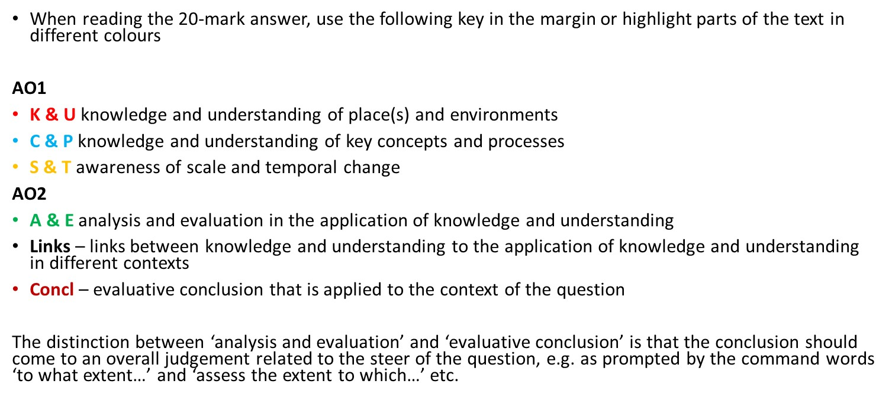
ASSESSMENT FOR LEARNING – 20 Mark Question: -

Assessment criteria
A01 – Knowledge and understanding  A02 – Evaluation and application of knowledge and understanding | C&P: Full and accurate knowledge and understanding of key concepts and processes throughout. (AO1)
 | S&T: Detailed awareness of scale and temporal change, which is well integrated where appropriate (AO1)
 | K&U: Detailed, highly relevant and appropriate knowledge and understanding of place(s) and environments used throughout (AO1)
 | Links: Full evidence of links between knowledge and understanding to the application of knowledge and understanding in different contexts (AO2).
 | A&E: Detailed, coherent and relevant analysis and evaluation in the application of knowledge and understanding throughout (AO2).
 | Concl: Detailed evaluative conclusion that is rational, and firmly based on knowledge and understanding which is applied to the context of the question (AO2).
Overall comment
Target 1
Target 2

