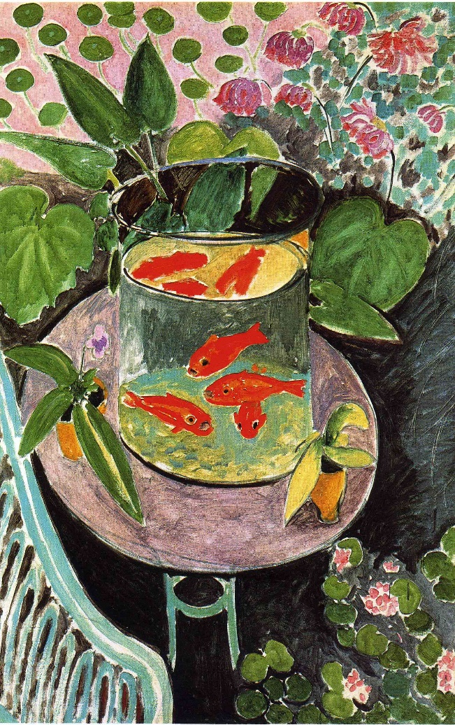Matisse ‘Goldfish’ 1912

**Scope of work**: Still life

Still Life as a subject became popular in the late 19th century as an ideal vehicle for Modernist experimentations and suitable for Bourgeois family homes. Edouard Manet said ‘a painter can say all he wants to with fruits or flowers, or even clouds.’

**Conventions of the genre:**

* Small scale
* Non figurative
* Elements drawn from everyday life
* Demonstration of artistic skill
* Symbolism
* Significance of forms

1. Describe the subject matter in two sentences:
2. Comment on how his use of colour is challenging:

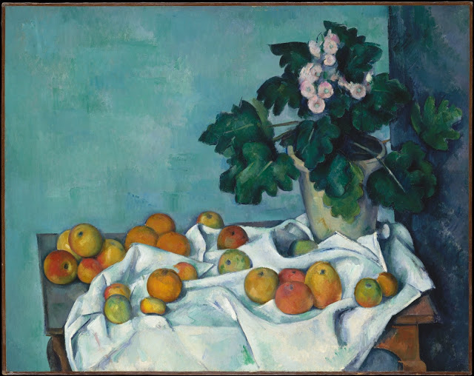

1. Comment on Matisse’s depiction of space and depth here:

Influences:

* Matisse’s own trip to Tangier, N Africa: Jan-April 1912
* Gauguin eg: Still Life 1891
* Cezanne: eg: Still Life Apples with Primroses 1890

*Now answer these two questions:*

1. 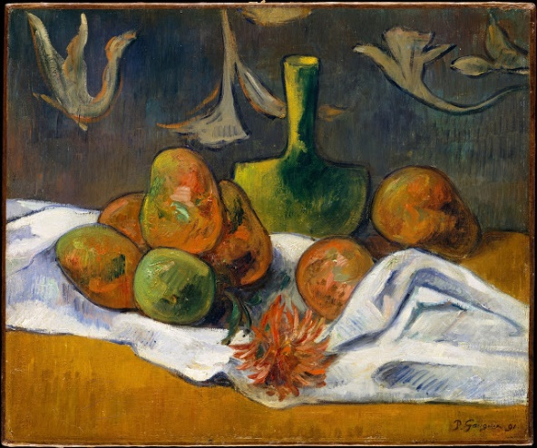In 7 mins, try a 5 mark response to this **Explain the ways in which one artist presents objects in one still life painting**.
2. And now do the same with the Picasso ‘Still Life with Chair Caning that you have already studied.
3. And try this 15 marker question, in 21 mins: **Explore and evaluate the influences and innovations in two still life paintings completed during this period.**