Picasso Still Life with Chair Caning, 1912

[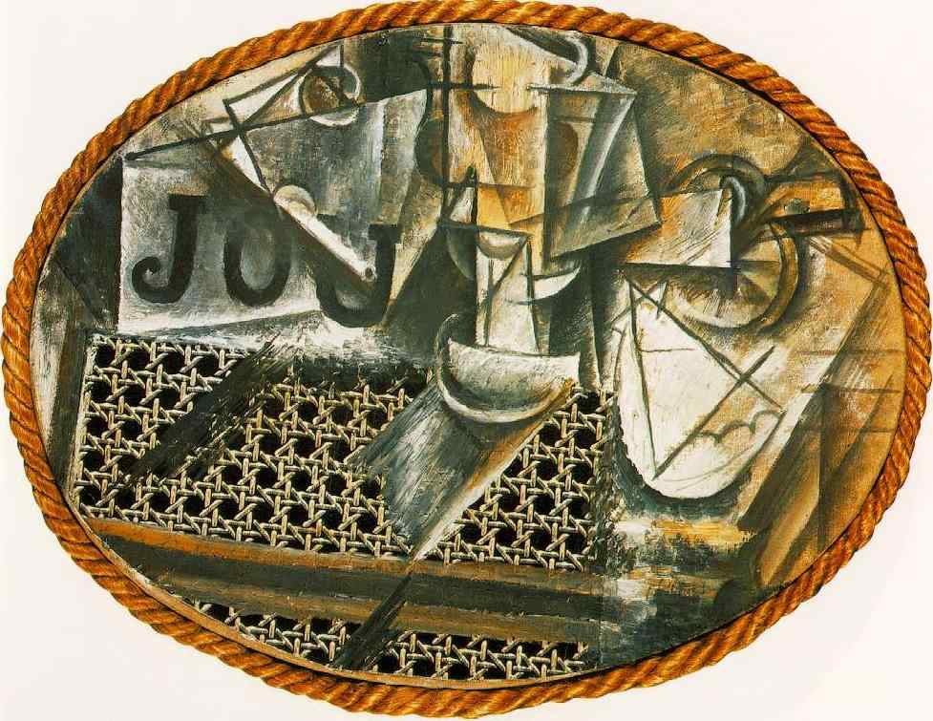](http://www.google.co.uk/url?sa=i&rct=j&q=&esrc=s&frm=1&source=images&cd=&cad=rja&docid=3vX0N7ilxpFV9M&tbnid=1X3ohkOVf9oAtM:&ved=0CAUQjRw&url=http://nonsite.org/article/picasso-and-warhol-and-things&ei=puBKUszBO63J0AWX2YHgBQ&bvm=bv.53371865,d.d2k&psig=AFQjCNFW-YdNTAnoVaJ5l6NK7XYMuHLQdg&ust=1380725277213194)

1. This work uses found materials: a piece of printed oil cloth that looks like chair caning (bottom left) and a length of rope which pokes fun at the traditional idea of a gilt frame.

*Explain how and why the use of these materials challenges the expectations of ‘high art’.*

1. Picasso follows Braque’s lead in using lettering here (top left). These letters challenge our ideas about the flatness of the surface as the facets penetrate the space between and around them.

*They also add suggestions to the meaning or content of the work. Using a French dictionary, find four words that begin with the letters JOU. List them here – which one/s do you think might be appropriate? Why is Picasso playing games with the viewer?*

1. Picasso includes a number of items typically found on a café table here.

*Make a list of the other items you can see in this work. Please watch this podcast on Smart History to help you. Link*: <https://smarthistory.org/picasso-still-life-with-chair-caning/>

1. This is a work of Synthetic Cubism, a phase of the movement that spans the period 1912-14. This involved the image being built up (‘synthesised’) from pre-existing elements or shapes rather than being created through a process of fragmentation.

*Make a list of 6 bullet points to explain how this work is associated with Cubism. (Make sure you have specific evidence/detail from the work AND an explanation of how that makes it Cubist.)*

1. This work is a Still-life (as he says in the title). Think about the conventions of this genre and how they are challenged by Picasso. What was the traditional appeal of the genre? What was Picasso’s aim – what was his motivation for innovation?

*Again, make 6 bullet points to list the ways in which this work challenges the expectations of the genre of Still Life?*

1. The size and use of facets changes throughout Cubism and is a useful clue to help you identify which stage of the style a work ‘belongs’ to.

*Look back at all the Cubist works we have studied (Picasso Les Demoiselles d’Avignon) 1907, Braque Houses at L’Estaque (1908); Picasso Portrait of Ambroise Vollard (1910) and Picasso Still Life with Chair Caning (1912) and then fill in the grid below, noting the typical subject matter, colour palette and use of facets in particular.*

|  |  |  |  |
| --- | --- | --- | --- |
| **Date** | **Stage of Cubism** | **Work** | **Characteristics** |
| **1907** |  |  |  |
| **1908-1910** |  |  |  |
| **1910-1912** |  |  |  |
| **1912-1914** |  |  |  |