**PRACTISING YOUR MEDIA LANGUAGE ANALYTICAL SKILLS**

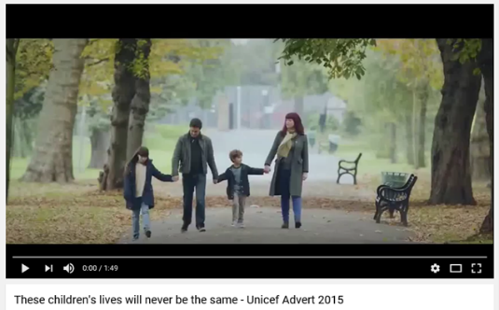**ANALYTICAL SKILLS - UNICEF 2015 advert**

1. Watch the following advert for UNICEF and complete the table, taking notes as you watch; <https://www.youtube.com/watch?v=S4eR48HYpwE>

NOTE TAKING TIPS: Take notes in chronological order, across all elements of media language. Make sure you have notes on all areas:

* **Cinematography**: Camera angle, movement and position etc.
* **Editing**: Continuity, discontinuity, pace, selection, transitions etc.
* **Sound**: Diegetic and non-diegetic, dialogue, contrapuntal or parallel sound, sound bridges etc.
* **Lighting & Colour:** high key, low key, desaturated, shadows etc.
* **Mise-en-scene**: Costume, make-up, props, setting, character etc.

|  |  |  |
| --- | --- | --- |
| **Scene** | **Denotation** | **Connotation** |
| Opening family scene at the park |  |  |
| Girl under the table |  |  |
| Boy playing at the park |  |  |
| Boy in an alleyway with a gun pointed at him |  |  |
| Girl at the park swinging on a bar |  |  |
| Girl on her knees in a house |  |  |
| Boy on a swing |  |  |
| Boy on train tracks |  |  |
| Parents getting upset in the park |  |  |
| End institutional details |  |  |

1. Now pick **one** scene and turn it into a focused and analytical sentence…

**APPLYING THEORY**

1. Apply Barthes 5 codes to the advert.

|  |  |
| --- | --- |
| **BARTHES CODES** | **ANALYSIS OF UNICEF** |
| **SEMANTIC** |  |
| **ENIGMA** |  |
| **ACTION** |  |
| **REFERENTIAL** |  |
| **SYMBOLIC** |  |

1. Now apply Levi-Strauss’s (Structuralist) theory. What binary oppositions can you see? How important are they to the narrative of the advert?
2. **HOMEWORK** - Complete the WaterAid revision knowledge organiser – this will provide you with a useful breakdown of all the areas needed for this text. There are sections on context, media language, representation and audience.