 Department of Digital & Creative Technology

**DESIGN YOUR OWN NEW ANIMATED STORY My Name: ________________________**

Name of my animation: _______________________________ Duration: _________________________

Planned Type of Animation Technique: _______________________________ Audio: ___________________________

Storyline: ______________________________________________________________________________________

______________________________________________________________________________________

Character Design Grid Setting/Layout Design Grid

|  |  |  |  |  |  |  |  |  |  |  |  |  |  |  |  |  |  |  |  |  |  |  |  |  |  |  |  |  |  |  |  |  |  |  |  |  |  |  |  |  |
| --- | --- | --- | --- | --- | --- | --- | --- | --- | --- | --- | --- | --- | --- | --- | --- | --- | --- | --- | --- | --- | --- | --- | --- | --- | --- | --- | --- | --- | --- | --- | --- | --- | --- | --- | --- | --- | --- | --- | --- | --- |
|  |  |  |  |  |  |  |  |  |  |  |  |  |  |  |  |  |  |  |  |  |  |  |  |  |  |  |  |  |  |  |  |  |  |  |  |  |  |  |  |  |
|  |  |  |  |  |  |  |  |  |  |  |  |  |  |  |  |  |  |  |  |  |  |  |  |  |  |  |  |  |  |  |  |  |  |  |  |  |  |  |  |
|  |  |  |  |  |  |  |  |  |  |  |  |  |  |  |  |  |  |  |  |  |  |  |  |  |  |  |  |  |  |  |  |  |  |  |  |  |  |  |  |
|  |  |  |  |  |  |  |  |  |  |  |  |  |  |  |  |  |  |  |  |  |  |  |  |  |  |  |  |  |  |  |  |  |  |  |  |  |  |  |  |
|  |  |  |  |  |  |  |  |  |  |  |  |  |  |  |  |  |  |  |  |  |  |  |  |  |  |  |  |  |  |  |  |  |  |  |  |  |  |  |  |
|  |  |  |  |  |  |  |  |  |  |  |  |  |  |  |  |  |  |  |  |  |  |  |  |  |  |  |  |  |  |  |  |  |  |  |  |  |  |  |  |
|  |  |  |  |  |  |  |  |  |  |  |  |  |  |  |  |  |  |  |  |  |  |  |  |  |  |  |  |  |  |  |  |  |  |  |  |  |  |  |  |
|  |  |  |  |  |  |  |  |  |  |  |  |  |  |  |  |  |  |  |  |  |  |  |  |  |  |  |  |  |  |  |  |  |  |  |  |  |  |  |  |
|  |  |  |  |  |  |  |  |  |  |  |  |  |  |  |  |  |  |  |  |  |  |  |  |  |  |  |  |  |  |  |  |  |  |  |  |  |  |  |  |
|  |  |  |  |  |  |  |  |  |  |  |  |  |  |  |  |  |  |  |  |  |  |  |  |  |  |  |  |  |  |  |  |  |  |  |  |  |  |  |  |
|  |  |  |  |  |  |  |  |  |  |  |  |  |  |  |  |  |  |  |  |  |  |  |  |  |  |  |  |  |  |  |  |  |  |  |  |  |  |  |  |
|  |  |  |  |  |  |  |  |  |  |  |  |  |  |  |  |  |  |  |  |  |  |  |  |  |  |  |  |  |  |  |  |  |  |  |  |  |  |  |  |
|  |  |  |  |  |  |  |  |  |  |  |  |  |  |  |  |  |  |  |  |  |  |  |  |  |  |  |  |  |  |  |  |  |  |  |  |  |  |  |  |
|  |  |  |  |  |  |  |  |  |  |  |  |  |  |  |  |  |  |  |  |  |  |  |  |  |  |  |  |  |  |  |  |  |  |  |  |  |  |  |  |
|  |  |  |  |  |  |  |  |  |  |  |  |  |  |  |  |  |  |  |  |  |  |  |  |  |  |  |  |  |  |  |  |  |  |  |  |  |  |  |  |
|  |  |  |  |  |  |  |  |  |  |  |  |  |  |  |  |  |  |  |  |  |  |  |  |  |  |  |  |  |  |  |  |  |  |  |  |  |  |  |  |

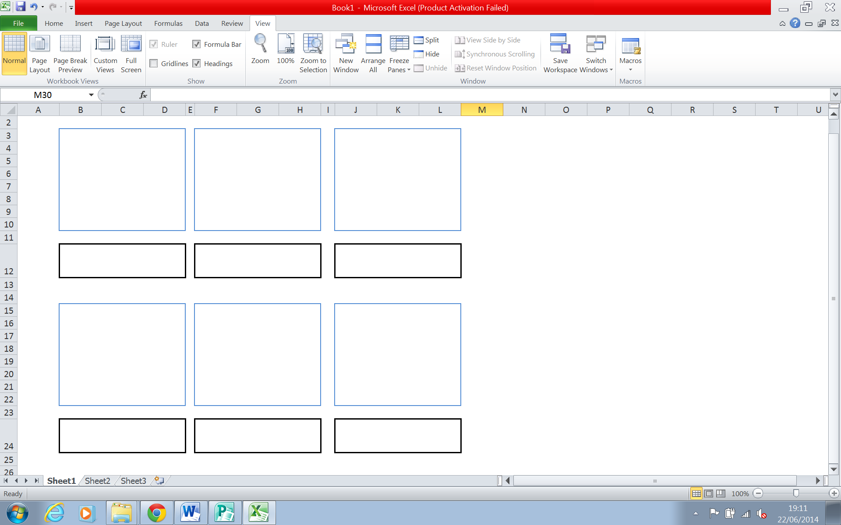Storyboard the Key Scene/Stage Designs (use the blue boxes to draw the scene and the black boxes to describe what is going on in the scene)