**Music Practitioner’s Qualification**

**Unit 338**

**Music Event Health and Safety**

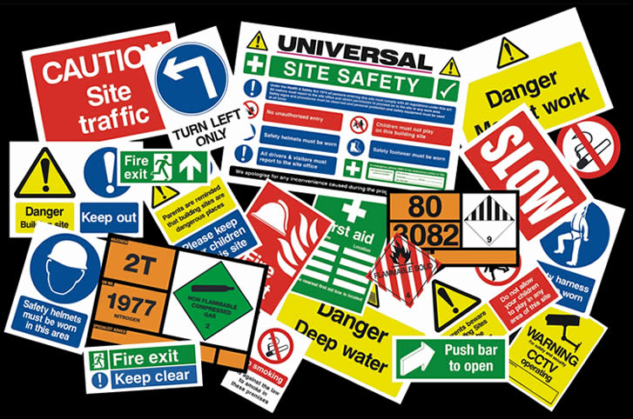

**Name ________________**

**Task 1 – Liability**

**Task 2 – Planning**

**Task 3 – Monitor Health and Safety**

**Task 4 – Evaluation**

**Task 1 – Liability**

**What is liability?**

**Describe the three events that you will be performing at.**

**What is the venue? Who will be attending?**

**1.**

**2.**

**3.**

**Who is liable at each of the three events you will be performing at?**

**1.**

**2.**

**3.**

**What are you personally liable for at each of these events?**

**1.**

**2.**

**3.**

**Choose one of these events.**

**As a performing musician, what are the implications of personal liability?**

**How will you manage these implications?**

**Task 2 – Planning**

**What are the legal responsibilities of event management in relation to current health and safety laws?**

**What are the HSE’s Five Steps to Risk Assessment?**

**Create a Risk Assessment based on your outdoor performance at the Piazza.**

1. **Describe the Venue. You should include;** **number of potential attendees, position and size of the stage, where equipment can be loaded in and out, power supplies and any general constraints to the venue.**

**What does each letter of ERICPD stand for and what does each category mean?**

**E**

**R**

**I**

**C**

**P**

**D**

**Place the Risks that you have identified into the categories based on ERICPD.**

**Describe how you could avoid risks using these approaches.**

|  |  |
| --- | --- |
| **Elimination** |  |
| **Reduce** |  |
| **Isolate** |  |
| **Control** |  |
| **PPE** |  |
| **Discipline** |  |

**2. Complete this table based on the risks you have identified at the venue.**

|  |  |
| --- | --- |
| Safe Sound Levels | Please write a description of this and how you would avoid any problems with this issue. |
| [https://encrypted-tbn0.gstatic.com/images?q=tbn:ANd9GcSyQfjuQuo2Apo8W-2Zum6XGNNBi61VsTSACJB6kDcDupWJ8mx0CQ](http://www.google.co.uk/url?sa=i&rct=j&q=&esrc=s&frm=1&source=images&cd=&cad=rja&docid=VvhYDb1sHOWufM&tbnid=0yTMOiS6ymzwyM:&ved=0CAUQjRw&url=http://www.sxc.hu/photo/914993&ei=UIihUpjUMafU0QXV04CAAg&bvm=bv.57752919,d.ZGU&psig=AFQjCNFtaEslKUCJ4rzM-fqfN1_KHm-2pQ&ust=1386404298521994) | Legal Decibel Level = |
| Hazardous Substances / Liquids | Please write a description of this and how you would avoid any problems with this issue. |
| [https://encrypted-tbn3.gstatic.com/images?q=tbn:ANd9GcTObWfFefUzUznSLiEL7-fWr3WsfhuUhph_2tqyetuNFWMhaeuU](http://www.google.co.uk/url?sa=i&rct=j&q=&esrc=s&frm=1&source=images&cd=&cad=rja&docid=hCjgs3gp7-XyVM&tbnid=PkDjsWj6QnT2fM:&ved=0CAUQjRw&url=http://www.clker.com/clipart-2649.html&ei=8YihUpKqEKmh0QXWioG4BA&bvm=bv.57752919,d.ZGU&psig=AFQjCNFfRmuoOaeOEL2jTKyj7-uCdv75cw&ust=1386404433028216) |  |
| Crowd Safety | Please write a description of this and how you would avoid any problems with this issue. |
| [http://www.limitedrisk.co.uk/images/services/event-security-crowd-safety-consultancy.jpg](http://www.google.co.uk/url?sa=i&rct=j&q=&esrc=s&frm=1&source=images&cd=&cad=rja&docid=dNkCnFtB4aXNoM&tbnid=VvvEzxvkAbuJaM:&ved=0CAUQjRw&url=http://www.limitedrisk.co.uk/event-security.html&ei=V4qhUobcFsSg0wXhpYDIDQ&bvm=bv.57752919,d.ZGU&psig=AFQjCNGJHLjtIYwhmn3JlmeLa5EAwIrfwg&ust=1386404776397002) |  |
| Stage safety e.g. cables, equipment placement, exits, hearing protection | Please write a description of this and how you would avoid any problems with this issue. |
| [http://www.wandcreativemedia.net/edge-safe/wp-content/uploads/stage-safety-dark.jpg](http://www.google.co.uk/url?sa=i&rct=j&q=&esrc=s&frm=1&source=images&cd=&docid=fXRS69HDv-ZAuM&tbnid=5ryLVEr4xy3hPM:&ved=0CAUQjRw&url=http://www.edge-safe.co.uk/testimonials/&ei=yIqhUoO7EojC0QW4sIAg&bvm=bv.57752919,d.ZGU&psig=AFQjCNHyjxXaAXXWG5XeibGVIMIQCGROAg&ust=1386404903371358) |  |

|  |  |
| --- | --- |
| Controlling feedback | Please write a description of this and how you would avoid any problems with this issue. |
| [https://encrypted-tbn0.gstatic.com/images?q=tbn:ANd9GcSkHTiIqYrQzFf7b83Bkx1LGyj1kGv9CR9BEDuPTVLE14ZgfMJR](http://www.google.co.uk/url?sa=i&rct=j&q=&esrc=s&frm=1&source=images&cd=&cad=rja&docid=DPbiQ7RvKdpyAM&tbnid=0NwgmX9JJO6q4M:&ved=0CAUQjRw&url=http://360degreefeedback.blogspot.com/2012/12/effective-leaders-use-feedback-to-their.html&ei=touhUoHUOYbJ0QXEj4GoCA&bvm=bv.57752919,d.ZGU&psig=AFQjCNGgUeSmns9yeaf09yhgBWWYobGnBQ&ust=1386405052191907) |  |
| Lifting and Carrying | Please write a description of this and how you would avoid any problems with this issue. List some of the equipment that might cause concern when lifting. |
| [http://cermsafety.files.wordpress.com/2010/08/lifting-pic.jpg](http://www.google.co.uk/url?sa=i&rct=j&q=&esrc=s&frm=1&source=images&cd=&cad=rja&docid=ASfRzoiXel8jIM&tbnid=v4rBc50n5qoEdM:&ved=0CAUQjRw&url=http://cermsafety.wordpress.com/2010/08/05/safe-lifting/&ei=FIyhUsKPCdL20gWjoIFA&bvm=bv.57752919,d.ZGU&psig=AFQjCNFUoRjsuTjOq_UnyZoZOGs2nifVjw&ust=1386405235422016) |  |
| Electrical Power Distribution | Please write a description of this and how you would avoid any problems with this issue. |
| [http://www.beananimal.com/media/9563/ul-approved-6-outlet-surge-protector-1036s-%5b1%5d.jpg](http://www.google.co.uk/url?sa=i&rct=j&q=&esrc=s&frm=1&source=images&cd=&cad=rja&docid=WN97g6qFtG48tM&tbnid=w_yq0vtDhggVZM:&ved=0CAUQjRw&url=http://www.beananimal.com/articles/outlet-strips.aspx&ei=f4yhUrCBAYaw0AWau4E4&bvm=bv.57752919,d.ZGU&psig=AFQjCNG9QJVAw8JdoJtLbN59I6QU-foc4g&ust=1386405353900097) |  |
| Identifying hazards in different scenarios | Please make a list listing as many hazards as possible. Name the situation / scenario |
|  |  |

**Task 3**

**Health and Safety Checklist**

**Name ________________________________________________**

|  |  |  |  |
| --- | --- | --- | --- |
| **Identify the Hazards** | **Who may be harmed and how?** | **Evaluate Risks and Precautions** | *Tick this box when you have checked this before your performance* |
| Sound levels |  |  |  |
| Hazardous substances/liquids |  |  |  |
| Crowd safety |  |  |  |
| Stage safety e.g. Cables, equipment |  |  |  |
| Feedback |  |  |  |
| Lifting and carrying |  |  |  |
| Electrical power distribution |  |  |  |

**Section 3:**

__________________________ completed their health and safety checklist prior to the event:

|  |  |  |  |
| --- | --- | --- | --- |
| **Fail** | **Pass** | **Merit** | **Distinction** |
|  |  |  |  |

**Signed __________________________ Dean Ormsby (course leader)__Date: __________________**

**Witnessed _____________________________ Paul Clifford (IV)__Date: __________________**

**Task 4**

**Section 4:**

__________________________ attended the event and effectively monitored the health and safety issues:

|  |  |  |  |
| --- | --- | --- | --- |
| **Fail** | **Pass** | **Merit** | **Distinction** |
|  |  |  |  |

**Signed __________________________ Dean Ormsby (course leader)__Date: __________________**

**Witnessed _____________________________ Paul Clifford (IV)__Date: __________________**

**Task 5 – Evaluation**

**How successful was Health and Safety maintained at the event? – Give three specific examples?**

**What issues arose during the event and how had preparation during the checklist stage ensure accidents did not occur? – Give three specific examples?**

**What improvements do you need to make to the health and safety risk assessment and checklist you completed? – Give three specific examples?**

**What advice would you give future students who are completing this task in terms of health and safety? – Give three specific examples?**