**EDUQAS A LEVEL MEDIA STUDIES**

**COMPONENT 2: TELEVISION IN THE GLOBAL AGE**

***THE RETURNED* (2013)**

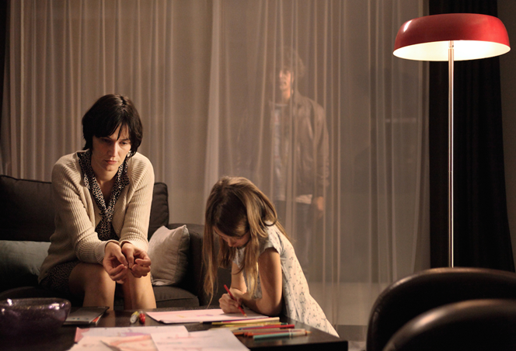

**MEDIA LANGUAGE AND**

**REPRESENTATION WORKBOOK**

**BACKGROUND *The Returned (Les Revenants)***

Based on the French film *They Came Back* (*Les Revenants*, dir. Robin Campillo 2004).

Created by Fabrice Gobert. Two series, eight episodes each.

In a small Alpine village, a group of men, women and children is in a state of confusion as they try to return to their homes after years of being away. What they don't know is that no one is expecting their arrival because they have been dead for several years. Upon returning, they realize that their friends and family have moved on to the next stages of their lives since the now-returning souls passed on. Coinciding with their reappearance is a series of murders that bears a chilling resemblance to those of a serial killer from the past.

**Series 1:**

• First broadcast in France (November 2012) on Canal+

• UK – (June 2013) on Channel 4

**Season 2:**

• Broadcast in France in September 2015 on Canal+

• UK October 2015 on More4

• US October 2015 on Sundance TV.

*The Returned* is difficult to categorise by genre. It won an **International Emmy for Best Drama Series** in 2013. It has elements of a supernatural horror text. Wikipedia classifies it as a ‘supernatural drama’, whilst IMDb classifies it as ‘drama, fantasy, horror.’ Rotten Tomatoes classifies it as ‘Mystery/Suspense’.

It is possibly closest to a zombie text because of its focus on the ‘undead’. Gabriel Tate in *The Guardia*n calls it ‘A zombie series like no other’.

**GENRE**

Having watched Episode 1 identify the **generic signifiers** in the text: Consider the signifiers of the ‘zombie’ show (use RESISTS). What *other* genres/generic features are evident? Use the **Genre Homework** sheet to help you complete.

Recurring situations

Elements of narrative

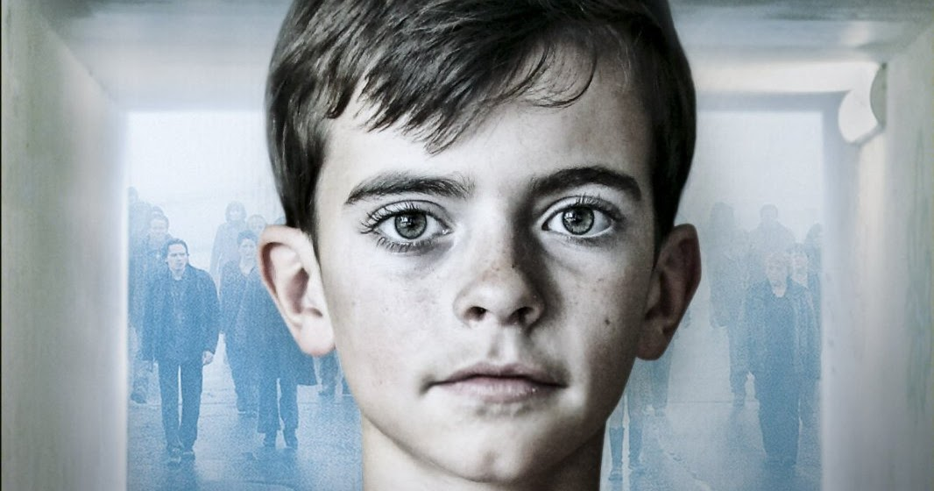

**GENRE CONVENTIONS**

Style

Iconography

Settings

Themes

Stock characters

**NARRATIVE**

**Steve Neale and Genre**

Applying Steve Neale’s theory of ‘repetition and variation’, what is ‘old’ in terms of the zombie genre and what is ‘new, innovative and imaginative’ in *The Returned*?

|  |  |  |
| --- | --- | --- |
| Repetition (convention) | Where? | Variation (where?) |
|  |  |  |
|  |  |  |
|  |  |  |
|  |  |  |
|  |  |  |
|  |  |  |

Why do you think the genre has changed/developed?

**NARRATIVE**

1. **TODOROV NARRATIVE STRUCTURE**

Can you identify the various stages of the narrative in Episode 1 of *The Returned*?

|  |  |
| --- | --- |
| **STAGE** | Episode 1 |
| EQUILIBRIUM |  |
| DISRUPTION |  |
| RECOGNITION |  |
| RESOLUTION |  |
| EQUILIBRIUM |  |

1. Does the episode fulfil the narrative (and genre) expectations of the audience? How?
2. Would we expect full closure in an episodic drama? Cliffhangers?

Can Todorov’s theory of narratology be applied to **Series 1 as a whole**? If so, how?

|  |  |
| --- | --- |
| **STAGE** | Series 1 |
| EQUILIBRIUM |  |
| DISRUPTION |  |
| RECOGNITION |  |
| RESOLUTION |  |
| EQUILIBRIUM |  |

1. **NARRATIVE BINARY OPPOSITES (LEVI-STRAUSS)**

Binary Opposition (defined by Levi-Strauss) is where many oppositions are set up to drive the narrative and we watch to discover which side ‘triumphs’ in the end.

Can you identify what is in ‘opposition’ to the first word within *The Returned*?

Past v M Costa v The ‘truth’ v

Living v Self-sacrifice v Camille v

Old relationships v The horde v Julie v

Serge v Illusion v Death v

Simon v Honesty v Immortality v

1. **STORY ARCS/CHARACTER ARCS**

**There are several story arcs and narrative strands (episode 1/series) – which can you identify?**

**BARTHES’ NARRATIVE CODES**

**Are there obvious codes around which the narrative is structured? Give examples.**

|  |  |
| --- | --- |
| Semantic codes |  |
| Enigma codes |  |
| Action codes |  |
| Referential codes |  |
| Symbolic |  |

**NARRATIVE DISCUSSION POINTS**

|  |
| --- |
| * **Is the narrative linear? If not, why not? Give examples** |
| * **Does the episode have a flexi-narrative?** |
| * **Are there story arcs that run across the series?** |
| * **Is it realist?** |
| * **How are time and space manipulated within the narrative?** |

**REPRESENTATION**

**When looking at representations you will need to consider:**

* The way events, issues, individuals (including self-representation) and social groups (including social identity) are represented through **processes of selection and combination**
* The **effect of social and cultural context** on representations
* How and why **stereotypes can be used positively and negatively**
* How and **why particular social groups**, in a national and global context, may be **underrepresented or misrepresented**
* How media representations **convey values, attitudes and beliefs** about the world and how these may be **systematically reinforced** across a wide range of media representations
* How **audiences respond to and interpret** media representations
* Theories of representation (including Hall). Representations are **constructed through codes,** stereotypes exist as a consequence of inequality of power, maps of reality & deviance – “otherness”
* Theories of identity (including Gauntlett)
* Feminist theories (including bell hooks and van Zoonen)

**How are representations constructed?**

Stuart Hall proposes that representations are constructed through a series of codes (visual/technical/audio):

* Narrative : e.g. audiences identify/empathise with characters through narrative positioning
* Humour - dialogue
* Technical codes (language) – camera, editing, sound. Look at use of deep/shallow focus.
* Lighting
* Framing
* Mise-en-scène (costuming, setting)
* Performance
* Barthes - cultural codes

Revisit Episode 1 on e-stream and highlight particular scenes. How have the following representations been constructed within the episode?

**Need to link to Stuart Hall throughout.**

|  |  |  |  |
| --- | --- | --- | --- |
| **Characters**  Consider costume/dialogue/  camera/actions | **Denotation**  (choose a specific scene**)** | **Connotations** | **How is the character represented?** |
| Camille |  |  |  |
| Simon |  |  |  |
| Claire |  |  |  |

|  |  |  |  |
| --- | --- | --- | --- |
| Julie |  |  |  |
| Mme Costa |  |  |  |

**REPRESENTATION THEORY**

**Applying bell hooks** 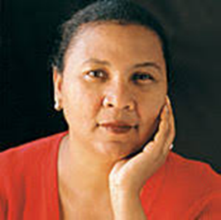

bell hooks argues that feminism is a struggle to end patriarchal oppression and the ideology of domination, and that the position of the underrepresented is by class and race as well as gender.

"Women in lower class and poor groups, particularly those who are non-white, would not have defined women's liberation as women gaining social equality with men since they are continually reminded in their everyday lives that all women do not share a common social status.”

**TASK: How is “patriarchal oppression and the ideology of domination” evident in *The Returned*?**

**Write three paragraphs that express your ideas.**

|  |
| --- |
|  |

**Applying Liesbet Van Zoonen **

*‘[There is] a depressing stability in the articulation of women’s politics and communication . . . The underlying frame of reference is that women belong to the family and domestic life and men to the social world of politics and work; that femininity is about care, nurturance and compassion, and that masculinity is about efficiency, rationality and individuality*.’

**Give examples from *The Returned* that illustrate this concept.**

|  |  |
| --- | --- |
| **Women** | **Men** |
| **Marginalised (or absent)** | **Efficient** |
| **Domestic** | **Rational** |
| **Sexualised** | **Individual** |
| **Nurturer** |  |

Referring back to van Zoonen’s essay *Feminist Perspectives on the Media, p*ages 33–37, in *Mass Media and Society* (Curran and Gurevitch) Arnold (1996), which we read and discussed with *Humans*, van Zoonen outlined the key differences between a:

• Liberal feminist perspective

• Radical feminist perspective

• Socialist feminist perspective

However, van Zoonen argues that gender is constructed and that its meaning varies dependent on cultural and historical contexts.

She suggests that masculinity as well as femininity is constructed – and that the codes used to construct men ‘as a spectacle’ are different.

Consider:

* Males constructed through movement (active)
* Silence and impassivity
* Strength, muscularity and aggression
* Competition – males as gladiators or combatants – ‘the spectacle’
* Constructed more through the intradiegetic gaze – the way they are looked at by other characters (e.g. with respect/fear)
* Allows narcissistic identification without erotic gaze

|  |
| --- |
| **TASK**  Is this the case in *The Returned* or are these constructed representations challenged in any way?  Give examples that either reinforce van Zoonen’s theory or challenge it. |

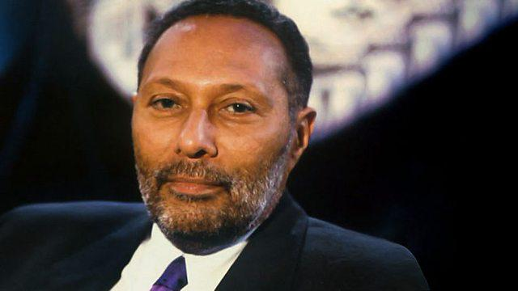

**Stuart Hall - the spectacle of ‘the Other’**

Stuart Hall also discusses the notion that the powerful elite groups (white, male, middle class, etc.), which control the media, create a ‘norm’ which reflects themselves. Representations of other groups are then constructed in terms of their difference to this – their ‘otherness’.

‘Stereotyping … is part of the maintenance of social and symbolic order. It sets up a symbolic frontier between the ‘normal’ and the ‘deviant’, ‘the normal’ and the ‘pathological’, ‘the acceptable’ and ‘the unacceptable’, what belongs and what does not or is ‘Other’, between insiders and outsiders, Us and Them.’

*Representation: Cultural Representations and Signifying Practice*, S. Hall, ed. 2013 Sage, p.258

Hall identifies three classic stereotypes of black people:

A) as slave, willingly serving a white master

B) as native, savage and uncivilised

C) as clown or entertainer, to be laughed at but not taken seriously.

***The Returned* as allegory**

‘Pierre symbolizes the current mediatic characterization of Others as ‘savages’ that serve the purpose of presenting the West as human, and migrants as non-human. While Gobert has not openly said that the series was a reflection of the Syrian migration, it can be inferred from the series’ narrative arcs that the many similarities in script and scenario with Campillo’s 2004 film do reflect the same sort of malaise concerning the treatment of migrant Others in contemporary French society.

Furthermore, in positing the character of Pierre as the voice of a traditional, Christian society that purposely rejects Others, drives them out of their ‘civilized’ town and into the woods, and characterizes them as the antithesis of humanity, Gobert is able to extend his criticism of the current situation in France.’

*Zombies and Refugees: Variations on the ‘Post-human’ and the ‘Non-human’* in Robin Campillo’s *Les Revenants* (2004) and Fabrice Gobert’s *Les Revenants* (2012–2015), Claire Mouflard, 2016

|  |
| --- |
| **TASK:**  How are ‘the returned’ constructed as ‘other’? Give examples from the text which represent this idea/concept of ‘other’ or ‘outsiders’. |

**Plot & characters**

Jérôme and Claire are shocked when their daughter, Camille, who was killed in a bus accident four years earlier, returns home unharmed and unaware that anything has happened to her.  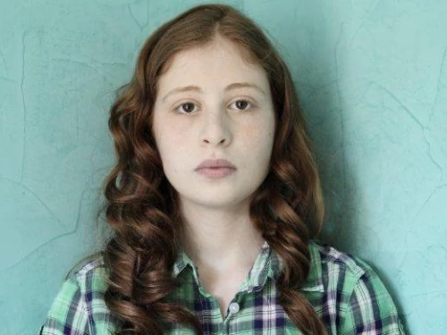 [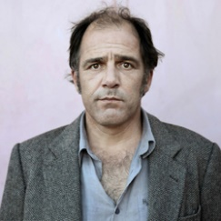](http://www.google.co.uk/url?sa=i&rct=j&q=&esrc=s&source=images&cd=&cad=rja&uact=8&ved=2ahUKEwijs9y6vvneAhUN1BoKHewvAT0QjRx6BAgBEAU&url=http://aarondouglasfans.com/2014/08/06/the-returned-aaron-douglas-has-joined-the-cast-of-new-ae-television-series/&psig=AOvVaw0HzdVoNWS_FihfSnMrXvzR&ust=1543576970193972)

Simon attempts to find his fiancée, Adèle, not knowing that he died ten years earlier.

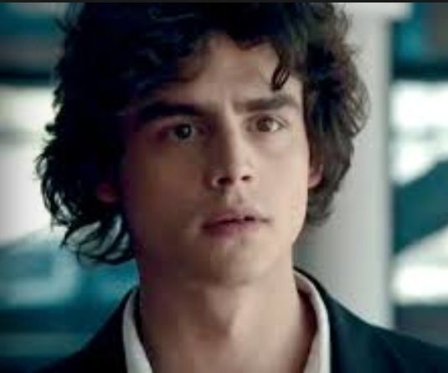 [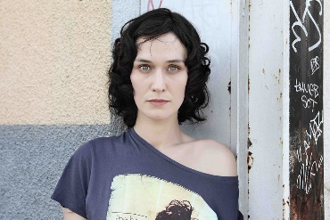](http://www.google.co.uk/url?sa=i&rct=j&q=&esrc=s&source=images&cd=&cad=rja&uact=8&ved=2ahUKEwjEpOvRvvneAhVM-YUKHRxsCy0QjRx6BAgBEAU&url=http://lesrevenants.wikia.com/wiki/Ad%C3%A8le_Werther&psig=AOvVaw0hpFJc8saTT5VeTJx32tkI&ust=1543577016823499)

Monsieur Costa is deeply disturbed when his wife (Viviane), who died 30 years earlier, shows up at their home. He hides her from his nurse, Julie, and later burns down his home with Madame Costa tied inside, before committing suicide by jumping from the dam.

[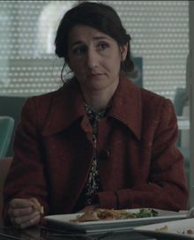](https://vignette.wikia.nocookie.net/lesrevenants/images/2/21/Mrs_Costa.jpeg/revision/latest?cb=20160223023732) [](https://vignette.wikia.nocookie.net/lesrevenants/images/d/d8/Julie.jpg/revision/latest?cb=20160223043801)

Julie is followed home by a young boy who refuses to speak. When her neighbour, Mademoiselle Payet, questions the boy's presence, Julie pretends he is her nephew, Victor. Lucy, a waitress who claims to be a medium, is stabbed on her way home from the bar.

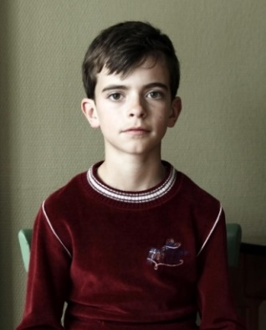 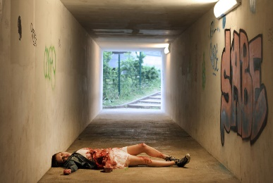

[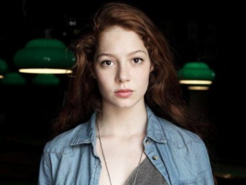](http://www.google.co.uk/url?sa=i&rct=j&q=&esrc=s&source=images&cd=&cad=rja&uact=8&ved=2ahUKEwiEq9SkwPneAhUDyIUKHSppARoQjRx6BAgBEAU&url=http://lesrevenants.wikia.com/wiki/L%C3%A9na_S%C3%A9guret&psig=AOvVaw2_bWUCdAiBGeDqNk17g9Fb&ust=1543577461565586)In a flashback to the day of the bus accident, it is revealed that Camille's twin, Léna, pretended to be sick in order to avoid the school trip. Her boyfriend, Frédéric, sneaked into her bedroom and Camille becomes distressed when she "senses" her twin's first sexual encounter. As Camille tried to get the bus to stop, the distracted driver noticed Victor standing in the middle of the road and swerved to avoid him, causing the bus to plummet over the cliff's edge.