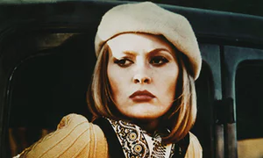Film Studies – Section A - Hollywood 1930 – 1990: *Bonnie and Clyde* (Penn 1967)

**Character profiles with focus on the representation of gender**

**In pairs discuss the films representation of BONNIE choosing two keys scenes to analyse.**

|  |  |  |  |  |
| --- | --- | --- | --- | --- |
| **How do the following elements of film form construct gender representation?** | **Representation**  AN OVERVIEW  How is female gender represented in your chosen scene considering the action/narrative development? | **Performance**   * Including facial expressions * Body language * Reactions to other characters   Quotes from key dialogue (diegetic sound) | **Mise en scene**   * Particular ref to costume * Location and setting * Props | **Cinematography**   * Framing * Movement * Composition * Lighting |
| *SCENE ONE*  *Include a screen grab from the scene here* | [A short paragraph discussing Bonnie and her gender role in this particular scene – is it stereotypical or does it challenge stereotypes?] | [How does PERFORMANCE build on the gender representation?] | [How do visual aspects support your ideas about Bonnie and her gender representation?] | [Arthur Penn is using the camera to ask the audience to look at certain aspects at certain times. Consider how the cinematography helps the audience develop an understanding of Bonnie’s complex characteristics] |
| *SCENE TWO*  *Include a screen grab from the scene here* |  |  |  |  |

Bonnie goes on a journey of development as a character in *Bonnie and Clyde*. Consider how she is represented at **three key** stages during the film. Make ref to a particular scene and jot down key words to explain her character during that moment.

|  |  |  |
| --- | --- | --- |
| Beginning | Middle | End |
|  |  |  |