‘Above the fold’

Scroll down for ‘below the fold’



Scroll down (above the fold)



‘Below the fold’

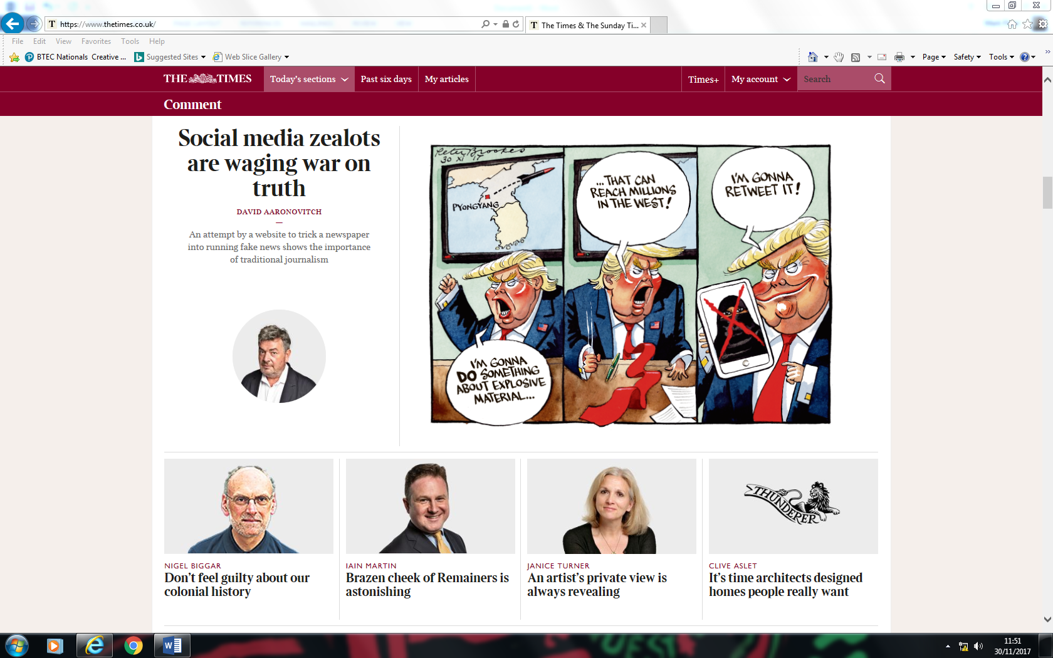

**TASK**

Analyse the home page of *The Times* online.

1. What different experiences does the online content offer readers compared to a print version of the newspaper? Click on different stories.
2. Does the home-page offer any **interactive** elements (where the reader can interact with the paper)? What are these?
3. Look at the *Times+* tab, what does this offer readers?
4. How has the home-page been constructed? *Consider ‘above the fold’ and ‘below the fold’ stories; fonts (including masthead), colours, picture to word ratio, conventions of websites.*
5. A **gatekeeper** is a person or organisation that is involved in filtering content in some way. In newspapers, the **editor** performs this function as they determine which stories make it into the newspaper (through the gate) and which do not. Which stories has the editor selected for inclusion on the home-page? Do they reflect the interests of the target audience? Do they reflect the ideology of the newspaper?
6. Read the following article from the *Press Gazette* website – [*Times Digital-Editor Alan Hunter on Paywall Success*](http://www.pressgazette.co.uk/times-digital-editor-alan-hunter-on-paywall-success-our-real-focus-is-in-pleasing-our-subscribers/). Consider and explain the reasons why *The Times* introduced a pay-wall to their website.