Unit 2 – Finance for Business

Revision Booklet



**Learner name:**

**Learning aims:**

A understand the costs involved in business and how businesses make a profit

B understand how businesses plan for success

C understand how businesses measure success and identify areas for improvement.

**This activity will test your understanding of the different types of costs there are in business and how they are related to each other.**

What is a fixed cost?

What is a variable cost?

Below are some costs for a furniture manufacturing business. Complete the table to show whether the costs are fixed or variable.

| **Cost** | **Fixed or variable cost?** |
| --- | --- |
| Power |  |
| Wood used to make chairs |  |
| Supervisor’s wages |  |
| Salesman’s commission |  |
| Business rates |  |
| Insurance |  |
| Hourly-paid operatives |  |

A bicycle manufacturer makes 100 bikes a week. It has the following costs:

* Rent – £1,000 per week
* Admin – £1,000 per week
* Interest – £500 per week
* Materials – £100 per bike
* Wages – £50 per bike
* Power – £10 per bike

For each week, calculate the following:

1. Fixed costs £ _______________
2. Variable costs £ _______________

Write here the formula for Total costs:

+ =

Most businesses have more than one source of revenue (money coming in). In pairs, identify three sources of revenue for each of the well-known organisations below.

| Company | Sources of revenue |
| --- | --- |
| Nike | **1** Running shoes  **2** Replica kits  **3** Sports clothes |
| Starbucks | **1**  **2**  **3** |
| McDonalds | **1**  **2**  **3** |
| Facebook | **1**  **2**  **3** |
| Thorpe Park | **1**  **2**  **3** |

1. To work out a business’s total revenue, you need to add together everything they sell. Dave sells the following items in his pizzeria in a year. What is his total revenue?

| Items sold in a year | Cost (£) |
| --- | --- |
| 7,000 pizzas at £10.00 each |  |
| 10,000 chip portions at £1.50 each |  |
| 7,000 garlic bread portions at £4.00 each |  |
| 5,000 soft drinks at £1.50 each |  |
| Total revenue |  |

In this activity, you will test your understanding of revenue, expenditure and profit, by advising the owner of a new business.

Task:

Robert is setting up a sandwich shop on a local industrial estate. He hopes to sell the following quantities of sandwiches each month:

* 2,000 at £3.00 each
* 3,000 at £2.50 each
* 2,000 at £2.00 each.

Robert expects to have the following expenses:

* rent – £1,000 per month
* lighting and heating – £200 per month
* advertising – £200 per month
* part-time help – £500 per month
* ingredients – £2.00 for the £3.00 sandwich, £1.50 for the £2.00 sandwich and £1.00 for the £2.00 sandwich.

To help Robert with his calculations, complete the table below.

| **Robert’s sandwich shop** | **Amount per month (£)** | **Amount per year (£)** |
| --- | --- | --- |
| Revenue |  |  |
| Variable costs |  |  |
| Fixed costs |  |  |
| Total costs |  |  |
| Profit/loss |  |  |

Robert is worried that his predictions may be wrong and his costs could go up. However, he thinks his sandwiches will do well because they are of a high quality. The feedback from a survey he carries out on the industrial estate is excellent and people say the prices are reasonable. That makes Robert think he can charge more, giving him a greater margin of safety.

He considers increasing the price of all his sandwiches by £0.50 and spending an extra £0.10 on making them look more attractive. He expects to sell the same quantities.

What would his new revenue be per month? ________________________

What would his new profit/loss be per month? ________________________

Do you think Robert is right to expect sales to stay the same given the price rise? Give a reason for your answer.

_____________________________________________________________________

____________________________________________________________________

___________________________________________________________________________

After the first month Robert decides to sell crisps and soft drinks because people keep asking for them, and keep the original price for the sandwiches. A packet of crisps costs him £0.30 and he will sell them for £0.50; a soft drink costs £0.80 and he will sell them for £1.00. He expects to sell 4,000 of each per month.

What will his new profit per month be?

___________________________________________________________________________

***Task:*** *work through the table and score yourself 1-3. Highlight any areas you need to revise.*

|  |  |
| --- | --- |
| **Learning aim A:** Understand the costs involved in business and how businesses make a profit | Checklist of knowledge   1. Very good 2. Needs improvement 3. Need to learn |
| **Topic A.1 Understand the costs involved in business**  ● understand and identify costs of a business, including:  o start-up costs – the costs incurred when setting up a business  o operating (running) costs – the costs incurred in the day-to-day running of a business  ● understand, define and identify the differences between fixed and variable costs, direct and indirect costs, total costs  ● calculate total costs (formula will not be given in the assessment) Fixed costs + Variable costs = Total costs |  |
| **Topic A.2 Understand how businesses make a profit**  ● understand and identify how businesses make money (generate revenue) – from selling their products or services  ● identify sources of revenue for a business  ● calculate revenue (formula will not be given in the assessment)  ● describe how businesses have to spend money (expenditure) in order to succeed  ● identify types of expenditure (including overheads) businesses may have  ● understand that expenditure is anything a business pays out and overheads are the everyday running costs of a business  ● understand that businesses must know how much money is coming in (revenue) and going out (expenditure), before they can work out whether the business has:  o made a profit  o made a loss  ● define:  o profit – revenue is more than expenditure  o loss – expenditure is more than revenue  ● calculate profit (formula will not be given in the assessment) profit = revenue – expenditure |  |

The following activities will help you with Learning aim B: understand how businesses plan for success

Complete the following:

Define breakeven:

What is a Break even chart?

Define margin of safety:

What is the break even formula?

Capon Ltd, a fashion retail company, produces a break-even chart, shown below, for the sales of a new skirt they are considering buying from a supplier. The employee who is preparing the presentation for this product asks for your help to understand the chart.

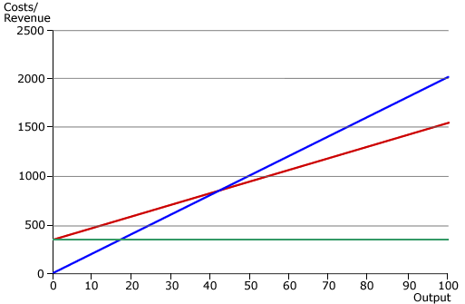

Task:

1. On the chart:
2. label the sales, total costs and fixed costs lines
3. mark clearly the break-even point
4. shade in and label the profit area
5. shade in and label the loss area
6. mark clearly the margin of safety in units.
7. Explain the term ‘margin of safety’ and why it is important to know what it is.

______________________________________________**_________________________________________________________________________________________________________________________________________________________________________________________**

On the grid below, produce a break-even chart for Capon Ltd for sales of slippers up to 10,000 units. The selling price is £10 per unit, variable costs are £5 per unit, and fixed costs are £20,000. Answer the questions below.



1. What is the break-even point in units? __________________________________________
2. What is the maximum profit they can make in £s? _________________________________
3. What is the margin of safety in units? ___________________________________________
4. What would the break-even point be in £s if the selling price was increased to £12?

_________________________________________________________________________

**Break even calculations**

Ben runs a sports equipment maufacturing business. His job is demanding and he needs a holiday. He asks you to help him work out whether he has enough money for a holiday.

Task:

Ben wants to know whether he can make a profit by manufacturing a football which he would sell for £25. The costs involved are:

* Materials (per ball) – £9
* Labour (per ball) – £8
* Rent (annual) – £15,000
* Power – £5,000
* Insurance – £4,000.

**Complete the table:**

| Output | Fixed cost | Variable cost | Total cost | Revenue | Profit/loss |
| --- | --- | --- | --- | --- | --- |
| 0 |  |  |  |  |  |
| 500 |  |  |  |  |  |
| 1,000 |  |  |  |  |  |
| 1,500 |  |  |  |  |  |
| 2,000 |  |  |  |  |  |
| 2,500 |  |  |  |  |  |
| 3,000 |  |  |  |  |  |
| 3,500 |  |  |  |  |  |
| 4,000 |  |  |  |  |  |
| 4,500 |  |  |  |  |  |
| 5,000 |  |  |  |  |  |

Ben thinks it would be a good idea to start a new line – football boots. At first, he thinks he can sell them for £40, but then realises that he may have to sell them for £35 to break into the market. The costs involved are:

* Materials – £15 per pair
* Labour – £5 per pair
* Rent – £5,000 per year
* Power – £6,000 per year
* Insurance – £4,000 per year

1. How many pairs does Ben need to sell at £40 to break even? ___________________
2. How many pairs does Ben need to sell at £35 to break even? ___________________

**Topic B.2 Understand the tools businesses use to plan for success**

* Define Budget:

* What is the purpose of a budget?
* What is the difference between budgeting and budgetary control
* Define cash flow forecast:
* Give an example for Cash ‘Inflow’
* Give an example of Cash ‘outlfow’

**Cash Flow Activity:**

Martin is opening a small shop selling puzzles. He asks you to help him work out his cash flow as he needs to know whether he will have any cash at the end of his first four months.

Martin currently has £15,000 in the bank. He expects the following cash totals to come into the business:

* July – £17,000
* August – £18,000
* September – £20,500
* October – £21,500.

Martin has the following expenses:

* Business rates – £15,000 per year (payable in equal monthly instalments)
* Purchases of stock – July £9,000; August £10,500; September £11,000; October £12,000
* Rent (paid monthly) – £700 in July, then £800 from August
* Wages – £10,000 per month
* Estimated gas usage for four months – £500 (payable in October).

**Tasks:**

Complete the cash flow forecast for Martin.

|  | July | August | September | October |
| --- | --- | --- | --- | --- |
|  | £ | £ | £ | £ |
| Opening balance |  |  |  |  |
| **Receipts** | | | | |
| Sales |  |  |  |  |
| Total receipts |  |  |  |  |
| **Payments** | | | | |
| Purchases |  |  |  |  |
| Rent |  |  |  |  |
| Wages |  |  |  |  |
| Rates |  |  |  |  |
| Gas |  |  |  |  |
| Total payments |  |  |  |  |
| Closing balance |  |  |  |  |

1. Is Martin’s cash flow positive or negative? Explain why.

______________________________________________________________________________________________________________________________________________________________________________________________________________________________

1. Suggest **two** steps Martin can take to improve his cash flow.

______________________________________________________________________________________________________________________________________________________________________________________________________________________________

|  |  |
| --- | --- |
| **Learning aim B.** understand how businesses plan for success | Checklist of knowledge   1. Very good 2. Needs improvement 3. Need to learn |
| **Topic B.1 Understand the planning tools businesses use to predict when they will start making a profit**  ● Define: breakeven – when a business has made enough money through product sales to cover the cost of making the product (no profit and no loss)  ● be able to interpret from a break-even chart:  o break-even point  o profit  o loss  o variable costs  o fixed costs  o total revenue  o total costs  o margin of safety  ● calculate the breakeven (formula will be given in the assessment)  ● analyse and explain the value and importance of breakeven analysis to businesses when planning for success  ● analyse and explain the associated risks to businesses of not completing a breakeven analysis  ● present given information graphically on a break-even chart  ● analyse the effect on the break-even point if sales or (fixed and variable) costs change, and explain the impact of these changes on the business |  |
| **Topic B.2 Understand the tools businesses use to plan for success**  **Budgeting** – learners should:  ● the purpose of budgeting in setting expenditure and revenue budgets  ● the difference between budgeting and budgetary control (checking performance against plan)  **Cash flow forecasting** – learners should:  ● know the purpose of a cash flow forecast – to identify the money that should be coming into a business (inflows) and the money going out of the business (outflows) over a period of time  ● be able to identify inflows and outflows  ● explain the purpose of a cash flow forecast, including that it identifies the flow of cash through a business over a period of time  ● understand the sources of cash coming into the business (inflows)  ● understand the sources and destination of cash leaving the business (outflows)  ● identify the impact of timings of inflows and outflows  ● understand the benefits of using a cash flow forecast to plan for success in a business (e.g. to produce new goods/services, invest in new resources, expand/reduce activities) and explain the associated risks to businesses of not completing a cash flow forecast  ● complete a cash flow forecast from given information, showing individual and total inflows, individual and total outflows, net inflows and outflows, and opening and closing balances  ● analyse a business’ finances based on cash flow information and identify possible issues for the business from any cash surplus or deficit |  |

**The following activities will help you with Learning aim C: understand how businesses measure success and identify areas for improvement**

Much of the terminology used in business finance is associated with the statement of the financial position of a business.

**Define the following terms in the table below:**

|  |  |
| --- | --- |
| Term | Definition |
| Creditors |  |
| Current assets |  |
| Share capital |  |
| Retained profit |  |
| Overdraft |  |
| Stock |  |
| Net assets |  |
| Balance sheet |  |
| Current Liabilities |  |
| Loan |  |
| Working Capital |  |
| Fixed assets |  |
| Debtors |  |
| Capital |  |
| Long –term liability |  |
| Profit |  |

Identify the formula to calculate gross profit:

Explain the impact of positive and negative gross profit on businesses:

Define net profit:

Identify the formula to calculate net profit:

Task:

Match the terms in the box at the bottom of this page to the clues in the table.

|  | Clue | Answer |
| --- | --- | --- |
| 1 | Resources owned and used by a business over the long term, such as buildings and machinery. |  |
| 2 | People, businesses or other organisations to which a business owes money in the short term. |  |
| 3 | Debts owed to the business by other organisations they trade with. |  |
| 4 | A loan facility from the bank that may have to be repaid at any time. |  |
| 5 | Creditors and overdraft are examples of these. |  |
| 6 | Current assets – current liabilities = |  |
| 7 | A mortgage is an example of this. |  |
| 8 | The money required to set up, run and expand a business. |  |
| 9 | Where money is borrowed and repaid under agreed terms and conditions. |  |
| 10 | Shows the financial position (assets and liabilities) of a business at a specific moment in time. |  |
| 11 | Cash, debtors and stock are all examples of them. |  |
| 12 | Raw materials, work-in-progress and finished goods held for resale. |  |
| 13 | The difference between the total value of assets owned by a business and the total value of its liabilities. |  |
| 14 | Money invested in a company by the shareholders. |  |
| 15 | Profits earned by a business that are reinvested in the business rather than paid out as dividends. |  |

|  |  |  |  |  |
| --- | --- | --- | --- | --- |
| Creditors | Retained profit | Net assets | Loan | Debtors |
| Current assets | Overdraft | Balance sheet | Working capital | Capital |
| Share capital | Stock | Current liabilities | Fixed assets | Long-term liability |

What is the purpose of a balance sheet?

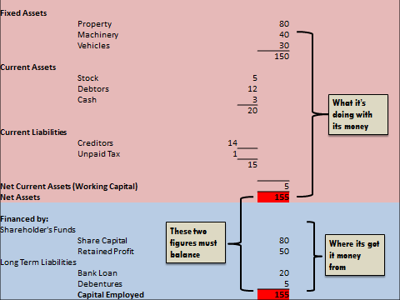

Below is a balance sheet;

Below is a balance sheet broken down

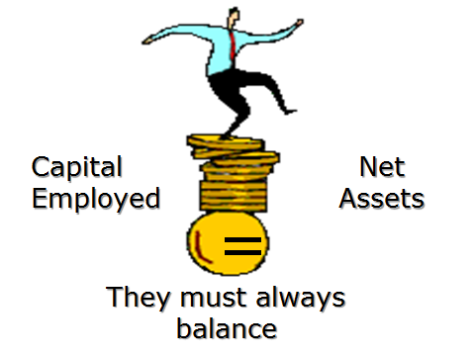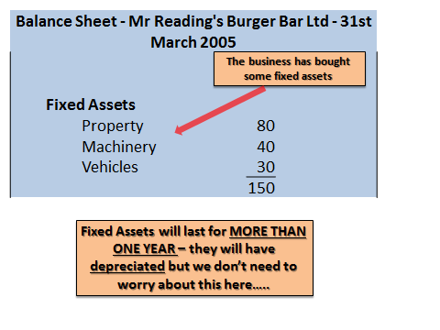

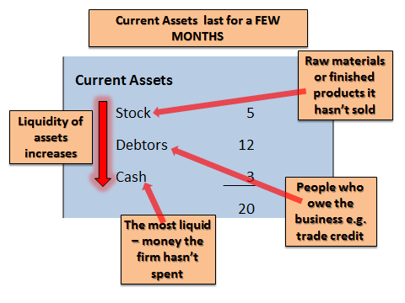

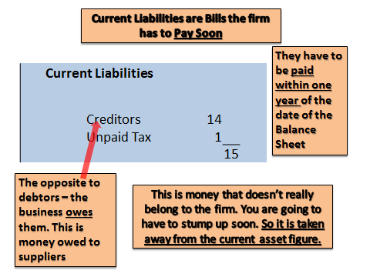

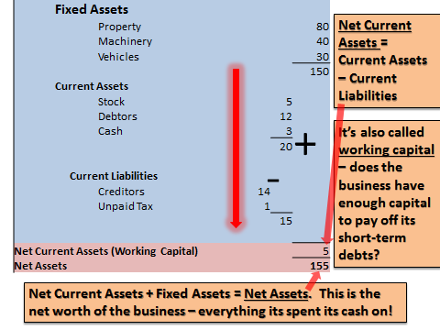

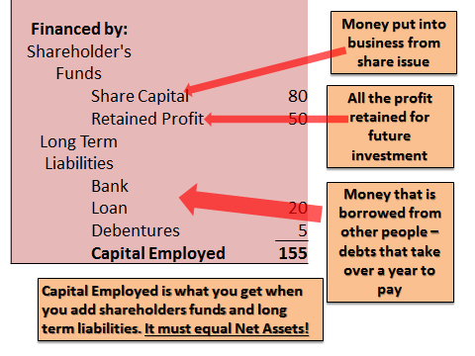

Top Tips:

Make sure you know what all the headings mean and what goes under it

Remember there are 2 parts: what it has done with it’s money and where the money came from

**Net Assets = Capital employed**

It shows the current position of a business on one particular date it is a snap shot of what it owns and what it owes

Balance Sheet Task:

Here is the balance sheet for Rex Motors as at 31 September 2005. Fill in the shaded boxes. You may want to use the balance sheet guide above.

|  |
| --- |
| Rex Motors at 31 September 2005 |
| **Fixed Assets** | £ |
| Buildings  Motor Vehicles  Machinery | 4,000  2,000  800 |
|  |  |
| **Current Assets** |  |
| Stocks  Debtors  Cash in bank  Cash in firm | 1,000  2,320  1,750  200 |
|  |  |
| **Current Liabilities** |  |
| Creditors | 1,500 |
| Working Capital |  |
| **Net Assets:** |  |
| **Financed by:**  (Where the money has come from) |
| Owners funds | 7,000 |
| Retained Profit | 2070 |
| **Long Term Liabilities** |  |
| Bank loan |  | |
| **Capital employed:** | 10,570 |

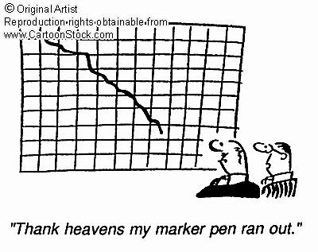

The amount of profit or loss a business has made over the previous financial year is shown in the **Trading and Profit and Loss Account**

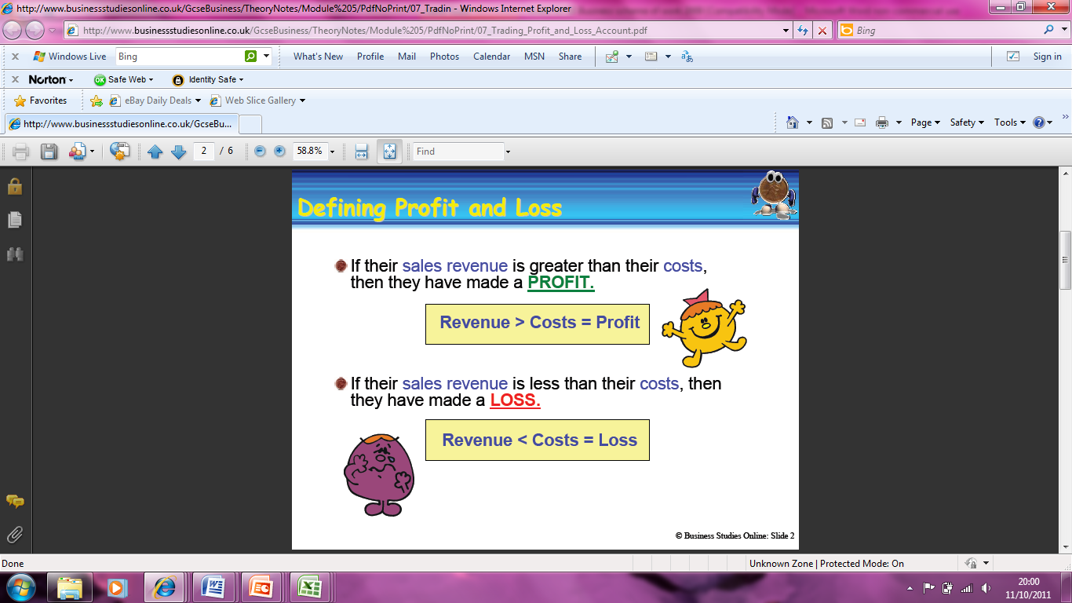

**Task:** Complete the definitions below

|  |  |
| --- | --- |
| **Key word** | **Definition** |
| Sales |  |
| Cost of Sales |  |
| Expenses |  |
| Gross Profit |  |
| Net Profit |  |

**Trading and Profit and Loss Accounts Dreamy Chocolate Bars**

Sales Revenue (Turnover)

Cost of Sales

GROSS PROFIT

Expenses

Rent and Rates

Wages/Salaries

Transport

Electricity

Insurance

Advertising

Depreciation

Total Expenses

NET PROFIT

**Task:**

**Fill in the Trading Profit and Loss Account above using the following figures:**

Sales revenue: £30,000

Cost of sales: £15,000

Rent: £5,000

Wages: £4,500

Transport: £1000

Electricity: £850

Insurance: £550

Advertising: £620

Depreciation: £200

**A**: Fill in the company’s total expenses

**B**: Work out the company’s gross profit – show your workings out

**C:** Work out the company’s net profit – show your workings out

**D**: Circle or highlight the trading part of the account

**E:** Circle or highlight the profit and loss part of the account

**Answer the following True or False on Profit or Loss:**

1. There is only one section in a Profit and Loss Account **T/F**
2. Net Profit is shown in the Trading account **T/F**
3. The amount of profit or loss a business has made is shown in the profit and loss account **T/F**
4. Cost of sales is shown in the trading account **T/F**
5. Gross profit is calculated by: Sales (Turnover) – cost of sales **T/F**
6. Depreciation is the term used for the amount of money items such as equipment and machinery fall by in the year **T/F**



|  |  |
| --- | --- |
| **Learning aim C.** Understand how businesses measure success and identify areas for improvement | Checklist of knowledge   1. Very good 2. Needs improvement 3. Need to learn |
| **Topic C.1 Understand how businesses measure success**  **Making a profit** – learners should:  ● Define: cost of sales – the cost of producing a product  ● Define: gross profit – the money made from selling a product (revenue) after the cost of producing the product (cost of sales) has been deducted  ● calculate gross profit (formula will not be given in the assessment)  ● explain the impact of positive and negative gross profit on businesses  ● Define: net profit – the money made from selling a product after all costs  (expenditure) have been deducted (formula will not be given in the assessment)  ● calculate net profit  ● explain the impact of positive and negative net profit on businesses  **Measuring success by looking at financial statements**  ● understand what financial statements are – documents that record the financial activities of a business, sometimes required by law, including income statement (profit and loss account) and statement of financial position (balance sheet)  **Income statement (profit and loss account)** –  ● identify the purpose of an income statement (profit and loss account) – to show how the business performed financially over a period of time (usually one year)  ● complete an income statement (profit and loss account) from given figures, including:  o trading account (top section of the income statement) – includes figures for revenue (turnover) and cost of sales and calculates the amount of gross profit  o expenses/overheads (bottom section of the income statement)  o calculating net profit  **Statement of financial position (balance sheet)**  ● identify the purpose of a statement of financial position (balance sheet) – to show the financial position of a business at a point in time  ● understand the format of a statement of financial position (balance sheet)  ● categorise total assets and liabilities using a statement of financial position (balance sheet)  ● understand that a statement of financial position (balance sheet) shows at a point in time:  o how a business is funded (capital)  o how a business is using these funds (net assets)  **Understand:**  o net assets – what the business owns, or is owed (debtors/trade receivables), including fixed assets and short-term assets  o liabilities – what the business owes to others (creditors/trade payables), including current liabilities and long-term liabilities  o capital – how the business is funded (money invested in the business to generate revenue) from:  – internal sources – money from shareholders (share capital) or retained profits  – external sources – bank loans or other forms of finance that have to be repaid  o working capital – the amount of capital used to run day-to-day activities (current assets minus current liabilities): if this figure is negative, the business may have problems financing its day-to-day activities |  |
| **Topic C.2 Understand how businesses can be more successful**  Learners should:  ● identify ways in which a business can increase profits  ● analyse financial statements for a small business (such as a sole trader or  partnership) and suggest appropriate actions the business can take to succeed |  |

**REMEMBER!!!** This unit is externally assessed using an onscreen test. Answer the following questions to see how much you know. Complete the table by adding the formulas for the following:

|  | Formula |
| --- | --- |
| **Total costs** |  |
| **Revenue** |  |
| **Break-even point** |  |
| **Gross profit** |  |
| **Net profit** |  |

**Multiple choice**

**1**. If current assets are £50,000 and current liabilities are £90,000, which of the following describes the business?

1. Insolvent
2. Solvent
3. Making a loss
4. What is used to show the flow of money in and out of the business over a year?
5. A trading account
6. A cash flow statement
7. A balance sheet
8. Using the following figures, select the correct break-even point: selling price £25; variable cost £5 per unit; fixed costs £38,900.
9. 1628
10. 1945
11. 1876
12. Which of the following would *not* be a way of improving cash flow?
13. Upgrading equipment
14. Chasing debtors
15. Reducing stock
16. How is the net cash flow figure calculated on a cash flow forecast?
17. cash outflows – cash inflows
18. cash inflows – cash outflows
19. opening balance + cash inflows
20. Which of the following is not a direct cost?
21. Raw materials
22. Production workers’ wages
23. Production supervisor