Creating and analysing break-even charts

Learning aim B (Topic B.1)
Activity sheet 4
Calculating breakeven is an important part of business planning. One way to do this is to draw a break-even chart.
Your tasks
- Marcel’s company makes children’s scooters. This is a break-even chart for his business.

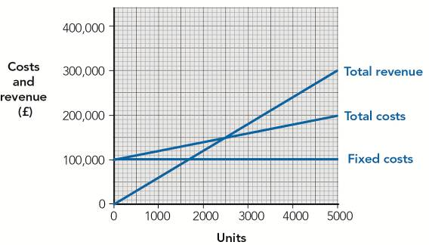

- Write a definition for the term ‘breakeven’.
_________________________________________________________________________
_________________________________________________________________________

- How much are Marcel’s fixed costs?
_________________________________________________________________________

- Draw an ‘X’ on the chart to show where the break-even point is. How many scooters must Marcel sell to break even?
_________________________________________________________________________

- Shade in and label the profit area on the chart.

- Shade in and label the loss area on the chart.
- The maximum number of scooters Marcel plans to sell is 5,000.

- What is Marcel’s total revenue if he sells 5,000 scooters?
______________________________________________________________________

- What are Marcel’s total costs if he sells 5,000 scooters?
______________________________________________________________________

- Calculate Marcel’s profit if he sells 5,000 scooters.
______________________________________________________________________
______________________________________________________________________

- What is the selling price of each scooter?
_________________________________________________________________________
_________________________________________________________________________

- Marcel aims to sell at least 3,000 scooters. He says that this gives him a margin of safety.
Define the term ‘margin of safety’.
_________________________________________________________________________
_________________________________________________________________________
_________________________________________________________________________

- Explain one advantage that Marcel has gained by carrying out break-even analysis.
_________________________________________________________________________
_________________________________________________________________________
_________________________________________________________________________

