Lodge Health Profit and Loss Worksheet

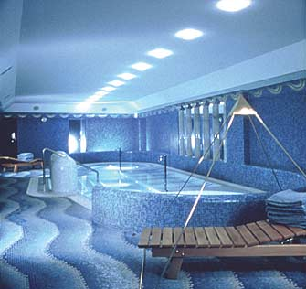
The Lodge Health Studio started operating in January 2018. The two owners had both worked for the local leisure centre previously. They decided that there was a growing demand for keep fit and beauty therapy in Dorking and surrounding towns.

During their first year of trading the Lodge Health Studio earned a sales revenue of £155,000. As managers they paid themselves salaries of £10,000 each and they also paid £9,000 to part-time staff. The purchase of supplies cost £25,000. Electricity bills came to £10,000 and their rent on the premises came to £7,500 which they had to pay in advance at the start of the year. They had spent £1,500 on local advertising and a further £2,500 on office expenses. Finally, interest on an overdraft with the bank was costing them £2500 a year.

- Produce a profit and loss account for Lodge Health Studios for the year of 2018.

- What is the net profit or loss for the business in 2018?

EXTENSION QUESTION

Do you have any recommendations for the business?

