Interpreting a Profit and Loss account

The figures below are taken from Domino’s Pizza PLC’s annual report. Using the information below answer the questions and work out how well the company is doing.

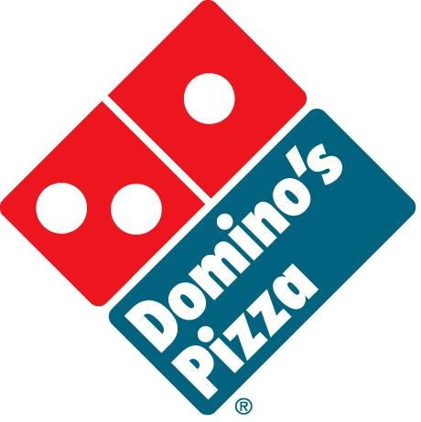
Domino’s Pizza PLC  Figures in 000s | 2017  £ | 2018  £
Sales | 94,965 | 81,660
Cost of Sales | 57,811 | 48,778
Gross Profit | 37,154 | 32,882
Expenses | 22,294 | 22,042
Net Profit | 14,860 | 10,840

1 What do the terms Gross Profit and Net Profit mean?

2 Compare the Gross and Net Profit figure in 2017 and 2018. Explain whether they have increased or decreased and by what %.

Note: to calculate a % change in two figures you firstly subtract one figure from the other to calculate the difference. You then divide the difference by the original figure and multiply by 100 to give a %.

3 Which figure has increased more out of the Gross and Net profit? What does this tell us about the company?

4 How well do you think Domino’s Pizza is performing? Would you invest money in the company?

