Bonnie and Clyde Aesthetic Challenge
Aesthetics: Concerned with beauty or the appreciation of beauty
Exam board |  | Your challenge | Screen Shot Examples | Analysis
1 | How are the elements of film form used to create aesthetic effect? | Find 3 beautiful screen shots  Use film form terminology to analyse why you think they contain beauty?
2 | Is the aesthetic effect in this sequence typical of this filmmaker? | Find a scene from Mickey One (1965) dir. Arthur Penn (e-stream) that has similarities in its aesthetics to Bonnie and Clyde.  Take a screen shot from each film.  What are the similarities (Film Form)? Why are there similarities?
3 | How is the look of the film being created? | What shots depic][t the look of the film? | 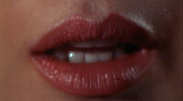  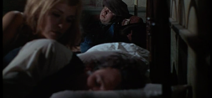  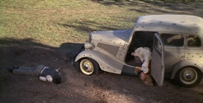 | Very diverse shot types, varying pace and discontinuity edits - the lack of clear patterns convey the unpredictability of New Hollywood and the film’s protagonists.
4 | How is sound design contributing to effect and audience response? | Find 2 contrasting uses of sound.  What effect does the use of sound have on the audience? | 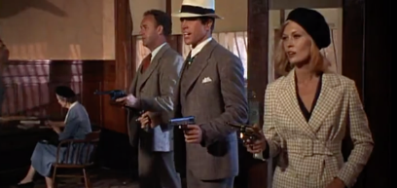  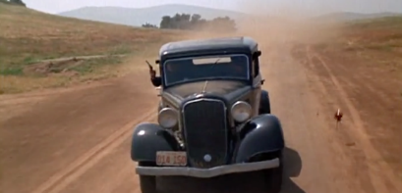 | This minimal use of non-diegetic music is effective in creating a contrast between the dialogue and the chases.  This ensures there is focus on the dialogue and the reality of their relationships This ensures there is focus on the dialogue and the reality of their relationships and robberies.
6 | Does the narrative pause to allow the spectator to appreciate the aesthetic qualities of the film? | Find 1 screen shot from each film where the narrative has been paused and there is focus on the aesthetics rather than the story  Use film form terminology to analyse the aesthetics. | CASABLANCA | BONNIE AND CLYDE
5 | ‘Compare how far your chosen films present different visual styles’ | Find 3 different screen shots from 3 different scenes which you can compare. | CASABLANCA | BONNIE AND CLYDE
‘Compare how far your chosen films present different visual styles’ | Write three short phrases to begin to compare the three screen shots above.

