La herencia árabe en [España](https://www.youtube.com/watch?v=Xx3VRElAokY)

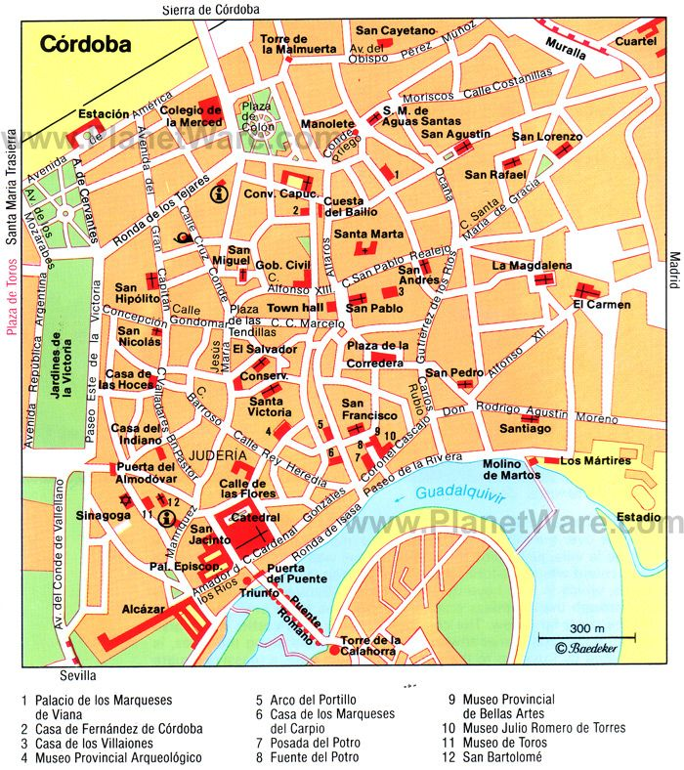

|  |  |  |  |
| --- | --- | --- | --- |
| **SAYING WHERE YOU ARE GOING** | | | |
| To say where someone is going, use the verb *ir* ( ‘to go’ ) followed by the preposition *a* ( ‘to’). | | | |
| Note that the verb *ir* is irregular (i.e. it does not follow a regular pattern). | | | |
| **IR** | | | |
| (yo) | voy | (nosotros, -as) | vamos |
| (tú) | vas | (vosotros, -as) | vais |
| (él/ella/usted) | va | (ellos/ellas/ustedes) | van |
| **Voy** a la oficina. (yo) | | | |
| ¿Adónde **vas ?** (tú) | | | |
| Juan **va** al bar. (él) | | | |
| ¿Adónde **vamos ?** (nosotros) | | | |
| If you are going somewhere relatively far away, like another city or country, you can also use the verb *viajar* ( ‘to travel’): | | | |
| ¿Adónde viajas? Viajo a Madrid. | | | |

[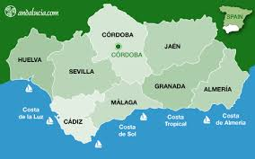](http://www.google.es/url?sa=i&rct=j&q=&esrc=s&source=images&cd=&cad=rja&uact=8&ved=&url=http://www.andalucia.com/cities/cordoba.htm&psig=AOvVaw2qBpC38Pr4Nbn7Qyos2oC9&ust=1512567306671667)

1. Create a sentence with each ‘sustantivo’ using at least one ‘abjetivo’.

|  |  |
| --- | --- |
| **Sustantivo** | **Adjetivo** |
| iglesia | grande • preciosa •• antigua |
| aeropuerto | moderno • grande • feo • gótico |
| restaurante | animado • agradable • moderno • metálico |
| bar | enorme • antiguo • comercial • céntrico |
| parque | blanco • grande • bonito • precioso |

|  |
| --- |
|  |
|  |
|  |
|  |
|  |

Córdoba Video <https://www.youtube.com/watch?v=28bh6IL2INM> (13.38 mins)

**Léxico básico**

|  |  |
| --- | --- |
| banco (el) | *bank (also: bench)* |
| bar (el) | *bar (establishment)* |
| cibercafé (el) | *cyber café, internet café* |
| cine (el) | *cinema* |
| Correos | *post office* |
| hipermercado (el) | *hypermarket* |
| oficina (la) | *office* |
| parque (el) | *park* |
| restaurante (el) | *restaurant* |

1. With a partner create a two days itinerary that shows all the places that you would like to visit in Córdoba. Don’t forget to include the name of the monuments and the architecture of Córdoba, Use the map to orientate yourself around the city.

1er Día:

|  |
| --- |
|  |
|  |
|  |
|  |
|  |
|  |
|  |

2do Día

|  |
| --- |
|  |
|  |
|  |
|  |
|  |
|  |
|  |

1. Name the places in the photos.

[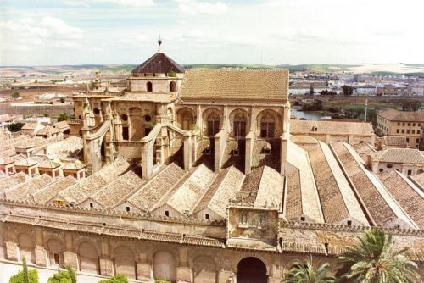](https://www.google.es/url?sa=i&rct=j&q=&esrc=s&source=images&cd=&cad=rja&uact=8&ved=0ahUKEwimlrSwkfPXAhVBNxQKHSMRCwYQjRwIBw&url=https://en.wikiarquitectura.com/building/mosque-of-cordoba/&psig=AOvVaw2qBpC38Pr4Nbn7Qyos2oC9&ust=1512567306671667)

[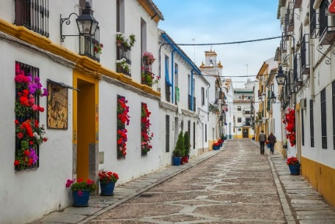](https://www.google.es/url?sa=i&rct=j&q=&esrc=s&source=images&cd=&cad=rja&uact=8&ved=0ahUKEwjpppilkPPXAhVFnRQKHe6UCZUQjRwIBw&url=https://www.tripsavvy.com/seville-to-cordoba-1642680&psig=AOvVaw2qBpC38Pr4Nbn7Qyos2oC9&ust=1512567306671667)

1. b.

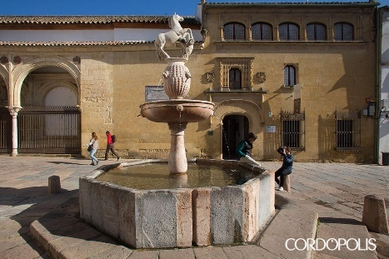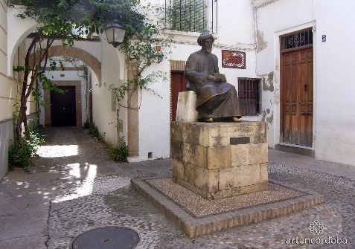

1. d.

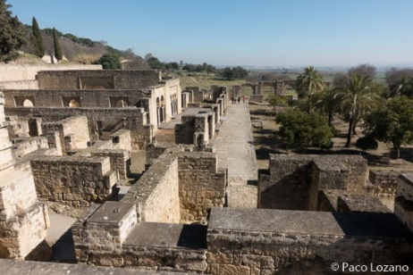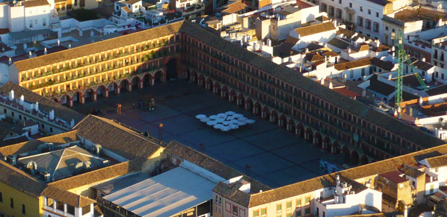

e. f.

1. **Mira el video y responde las preguntas.**

<https://www.youtube.com/watch?v=Xx3VRElAokY>

1. ¿Por qué hay tantos castillos en España?
2. ¿Qué conocimientos difundieron los árabes?
3. ¿Qué alimentos introdujeron los árabes?
4. Además del lenguaje, ¿qué más heredaron los árabes a la cultura española?
5. What do these words mean?

|  |  |  |  |
| --- | --- | --- | --- |
| 1 la pólvora | 2 pasa | 3 filosofía | 4 alimentos |
| 5 medicina | 6 visible | 7 lengua | 8 cuatro |
| 9 río grande | 10 Reconquista | 11 el árabe | 12 711 |
| 13 literatura | 14 la herencia | 15 la seda | 16 la numeración decimal |
| 17 el castillo | 18 árabes | 19 huella | 20 arquitectura |
| 21 la Edad Media | 22 influyentes | 23 tradujeron | 24 regadío |

Now log into the link to work with the OU website OpenLearn

<https://www.open.edu/openlearn/languages/spanish/beginners-spanish-getting-around/content-section-8.1>