AQA GCE PHY5 ASTROPHYSICS - REVISION CROSSWORD
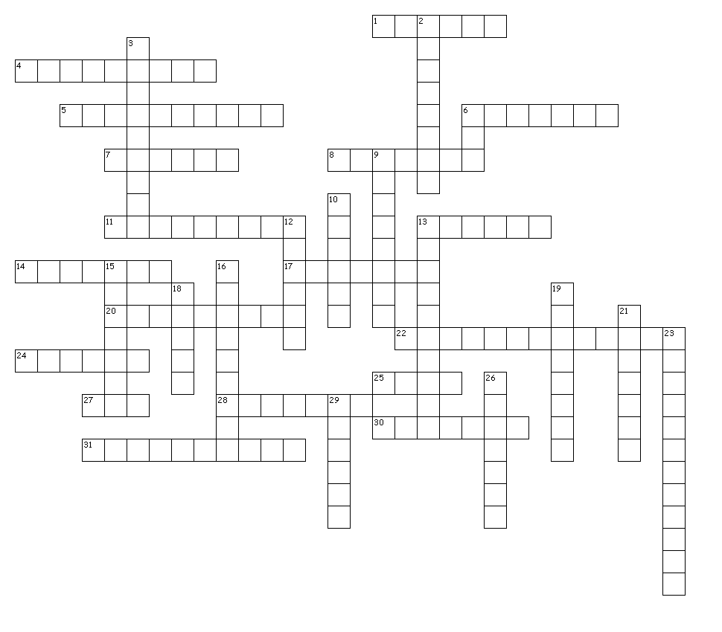

Across
1. unit of distance
4. aberration caused by curved mirrors
5. can be chromatic
6. an effect that can change colour
7. M of a telescope with objective
100cm eyepiece 5cm
8. spectral classes
11. motion causing Red shift
13. lighting device associated with
some type of supernova
14. star made of protons combined
with electrons
17. occurs with Hertzsprung
20. exploding star
22. a radius
24. has a law and a space telescope
25. the Sun is a **** sequence star
27. colour of a large star
28. force causing a Black hole
30. a type of magnification
31. power of a star
Down
2. a criterion
3. em radiation that supports Big
Bang theory
6. white dwarfs are very ?
9. brightness magnitude of a star
from the Earth
10. very bright and distant object
12. telescope adjustment with image
at infinity
13. the greater this power the
brighter is an image
15. obtaining a detailed image
16. what a convex lens does to
a beam of light
18. light takes just over four of these
to travel from the next nearest star
19. magnitude at 10pc
21. a large noisy theory (two words)
23. Wien’s **** law
26. efficiency to do with CCDs
29. image distance in cm with f=15cm
and u=30cm

