**LAW NEXT (EXPLORE) - WEEK 5; 15th November 2019 –**

**FOCUS = LEGAL EXECUTIVES, PARALEGALS AND LAW APPRENTICESHIPS**

|  |  |  |  |
| --- | --- | --- | --- |
| **Questions** | **LEGAL EXECUTIVES** | **PARALEGALS/ PARALEGALS APPRENTICESHIPS** | **LAW APPRENTICESHIPS** |
| 1. WHAT IS THEIR ROLE? AND WORKLOAD? I.E WHAT DO THEY DO? |  |  |  |
| 1. HOW DO YOU BECOME ONE? |  |  |  |
| 1. WHAT ARE THE CAREER PROGRESSION ROUTES? |  |  |  |

**YOUR CLASS TASK/ACTIVITY – To find out more about the different routes and career options into the legal profession; via the Lawyer Portal – complete the following;**

1. Take the quiz; have you got the right skills and attitude to be a good lawyer?

<https://www.thelawyerportal.com/quizzes/would-i-make-a-good-lawyer-quiz/>

1. There are a range of different quizzes to help you find out which law career is right for you and some random quizzes so choose 2-3 more quizzes to do on the lawyer portal site.

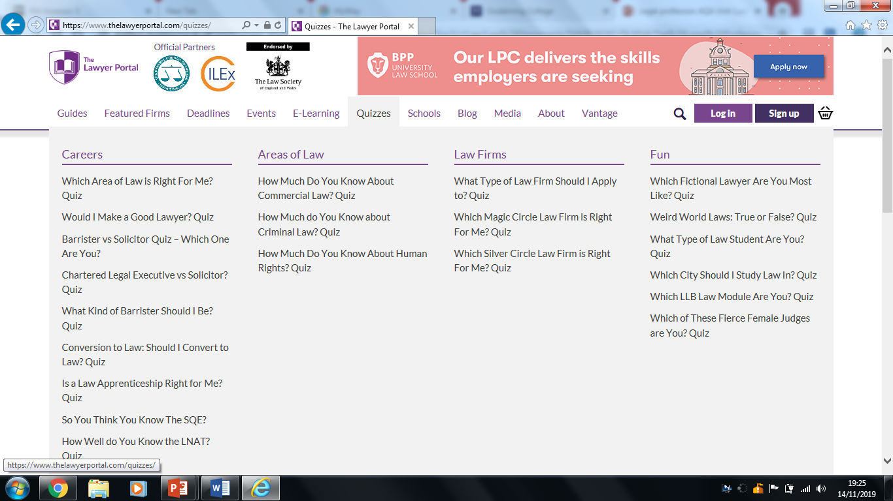

1. Find out more about a paralegal – read the guide, summarise their role and how you can become one; <https://www.thelawyerportal.com/free-guides/what-is-a-paralegal/>
2. Look at the range of law guides on the Lawyer Portal and find one that explains about Legal Apprenticeships and access it, to find out what’s involved, what does it mean you do and how can you apply to become one? <https://www.thelawyerportal.com/free-guides/> .
3. Finally find out about the Law Apprenticeship Conference on the 18th January 2020 and if it interests you, why not book yourself a free place and have a look at what else you could do to help you find out more about becoming a lawyer on the Lawyer Portal site – is it worth you signing up for updates?