***Component 1: Understanding Media Industries and Audiences***

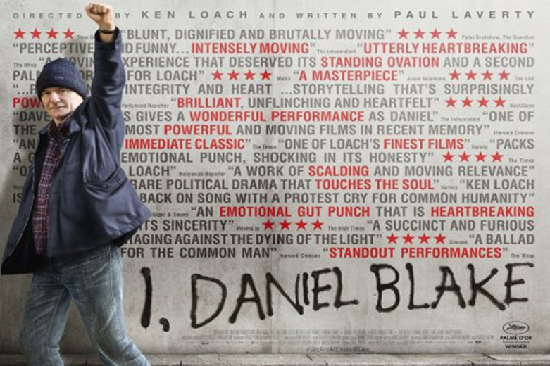

*I, Daniel Blake* (2016)

**CONTEXT**

*I, Daniel Blake* is an independent social realist film directed by renowned filmmaker Ken Loach (*Kes, Raining Stones, Sweet Sixteen etc.*).

A UK/French co-production, it received funding from the British Film Institute and BBC Films.

It became Ken Loach’s largest grossing film at the box office, was highly critically acclaimed and generated much debate due to the contemporary social and political issues addressed in the film.

*I, Daniel Blake* was exhibited at many film festivals (Vancouver, Stockholm, San Sebastian), won several awards including the Palme d’Or at Cannes, and a BAFTA for Best British Film and was nominated for many awards including several BAFTAs.

It received a theatrical release in Britain (October 2016) and various other countries (including France, Spain, Brazil and Japan).

It was released on DVD in February 2017.

**Social and Political Contexts:**

*I, Daniel Blake* addresses contemporary British social issues such as poverty, the welfare system and the Work Capability Assessment. The film portrays a group of traditionally underrepresented characters in Newcastle struggling in poverty to gain benefits and support. *I, Daniel Blake* conveys a clear left-wing political message and criticises specific government policies, such as the concept of ‘austerity’.

Much of Ken Loach’s work has addressed similar issues (*Cathy Come Home, Raining Stones*) and he is a social campaigner, known for his socialist political views. This is important to consider in terms of film production and maintaining audiences (arguably the intended audience for this film is educated, media literate and socially aware).

What are the codes and conventions of a British social realist film?

1. Having looked at Ken Loach’s back catalogue of work, what do they have in common? Make some notes here based on the clips from the Ken Loach documentary: *Versus – The Life and Films of Ken Loach.*
2. *I, Daniel Blake* is a British social realist independent film? What does this mean?
3. Although the film’s budget is not known, Ken Loach spends roughly £5m on his films (tiny in Hollywood terms). Discuss why vast financial **profits** might be less important for film-makers working in this genre (low budget, social realism). What didn’t they need to spend money on?
4. To what extent can *I, Daniel Blake* be described as a **mainstream** product? Loach is a well- known and successful figure in the UK and Europe but is his work mainstream? Does the fact he is challenging government policy mean he is also challenging mainstream opinions?

**DISTRIBUTION**

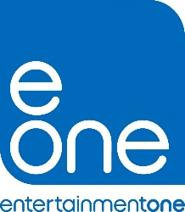The film was distributed in the UK by eOne films, and in France by Le Pacte. It was only released in European countries due to its relevance, and low budget. The company predominantly distributes small to medium budget British films.

It was released in October 2016, and was premiered at the Cannes Film Festival in May 2016. The gap between premiere and release date could be to do with the fact that big blockbuster films such as *Captain America: Civil War* were being released at this time, which would be more likely to overshadow a small low budget film like *I, Daniel Blake*. A lot of thriller and horror films were also released in October 2016 due to Halloween.

*I, Daniel Blake* had a significant **print media campaign** to reduce production costs but also to target the older demographic. The film’s **website** had convergent links to Twitter with the trailer also offering a hashtag which again promoted viral talkability through **social media**. It is often assumed that social media access is significantly less important for an older demographic yet *I, Daniel Blake* generated a lot of interest on this platform.

Again, this aspect to the film’s distribution reduced the economic impact of a potentially more expensive, traditional advertising campaign*. I,DB* did run trailers in independent cinemas but also utilised YouTube as a more cost effective platform. Unusually for an independent film trailer is has had more than 1m views.

***I, DANIEL BLAKE* MARKETING CAMPAIGN**

eOne campaign described their marketing strategy as a **“unique, grass roots” campaign. They did this through multiple techniques including:**

**Industry ‘buzz’** and hype was created by Ken Loach claiming that he would be retiring from filmmaking after *I, Daniel Blake’s* release (he has said this many times in the past!) – featured on *BBC News* etc.

**Print marketing** concentrated on the film’s critical success – film festivals, pull quotes from[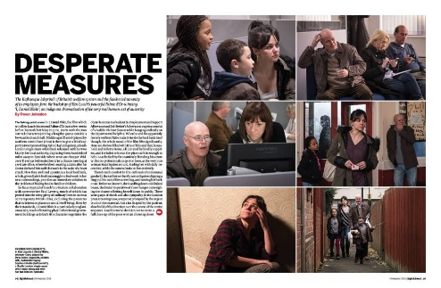](https://www.google.co.uk/url?sa=i&rct=j&q=&esrc=s&source=images&cd=&ved=&url=https%3A%2F%2Fwww.bfi.org.uk%2Fnews-opinion%2Fsight-sound-magazine%2Fnovember-2016-issue&psig=AOvVaw1Ni_3_Ih4vak_dHqxWf9lw&ust=1575386374512584) print reviews from *The Times, Sight & Sound*

**Viral marketing** – particularly drew on the controversy of narrative content which was [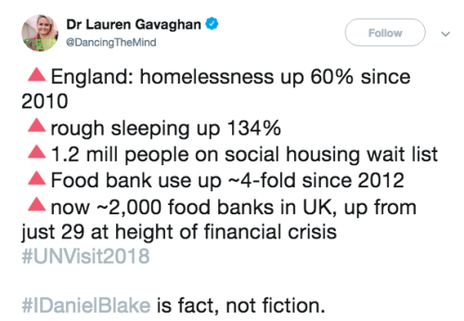](https://www.tumblr.com/tagged/i-daniel-blake)discussed on social media

**Tie-in campaigns** with left-leaning newspapers, trade-unions (*Daily Mirror* and Unite)

**Seeded *YouTube* trailers** plus reviews foregrounded on film posters (important approach for target audience)

**Limited cinema trailers before independent British films** – targeting same ABC1, politically aware, 35-55 primarily male demographic

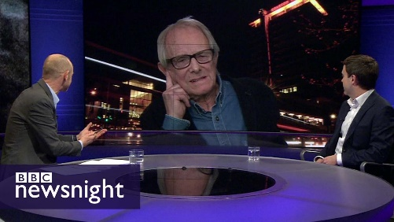

**Star marketing of Ken Loach** (regular TV and radio appearances including *Question Time, Newsnight*)

**The actors stood outside the West End premiere** holding placards to raise awareness of the 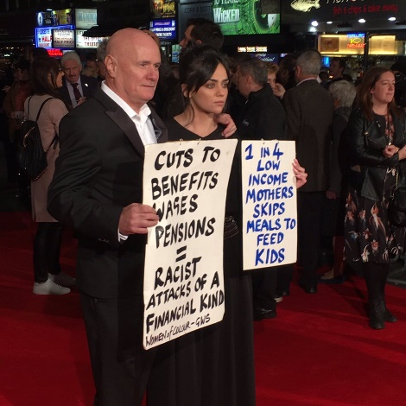issues covered in the film.

**Jeremy Corbyn** spoke about it in Parliament and went on to social media to support the film

You will be looking at a selection of these techniques in detail, but it’s important to be aware of all of the above strategies used.

**TRAILER**

<https://www.youtube.com/watch?v=ahWgxw9E_h4>

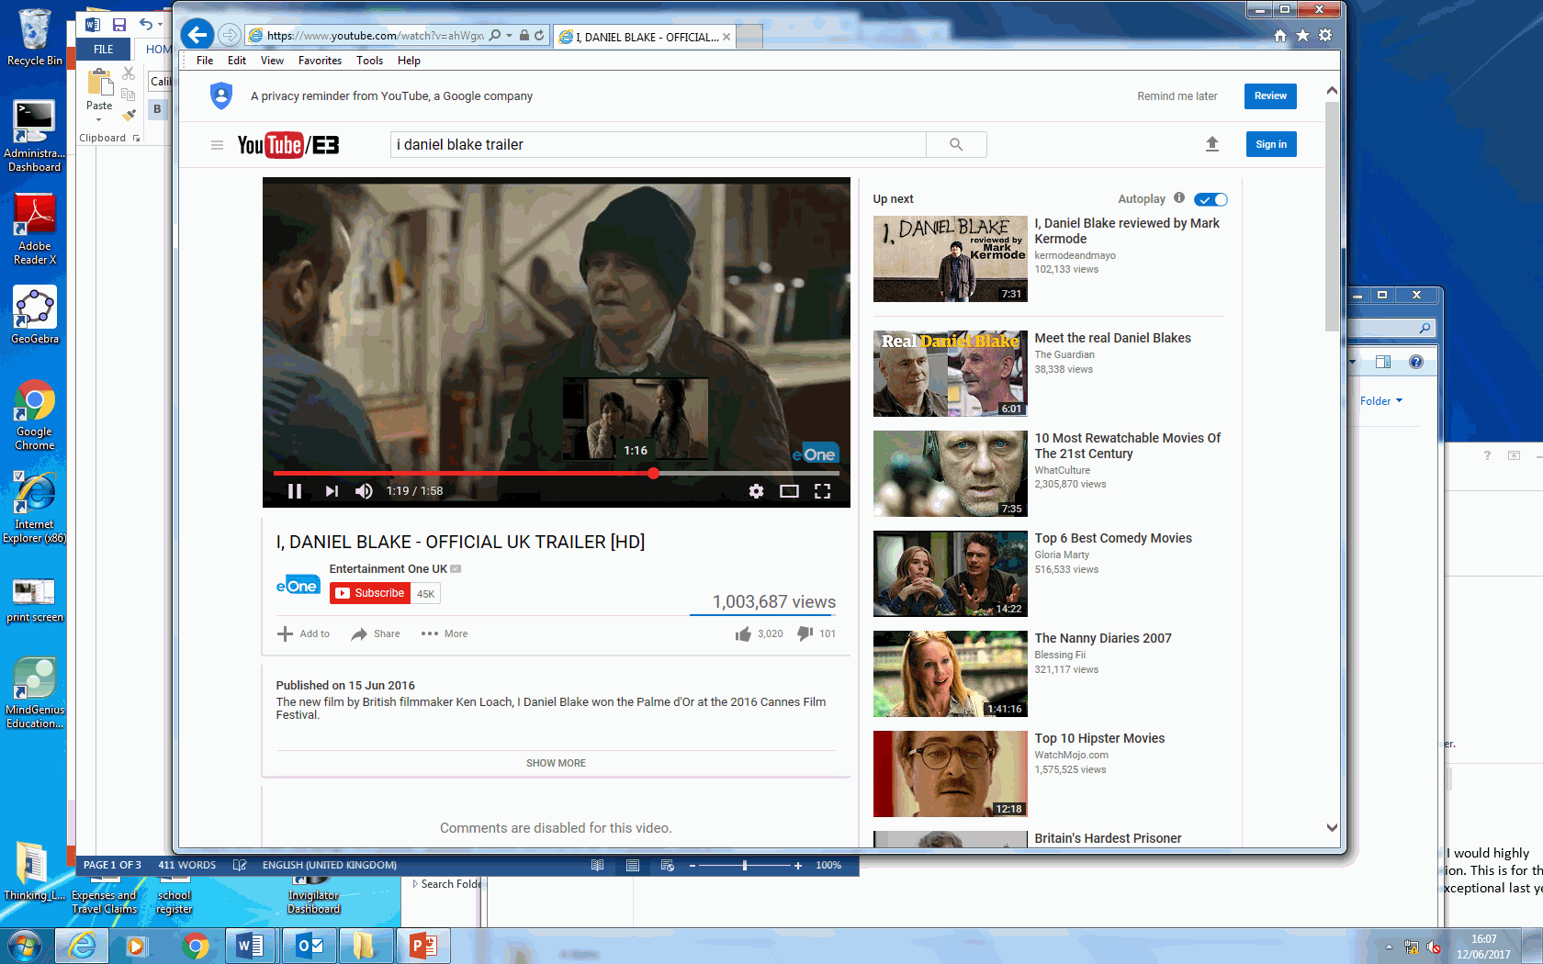

1. Key characters are introduced in the trailer. Consider what you think will be the main roles in the film? What would you expect to see of the relationships between various characters?
2. Where do you anticipate conflicts to arise? Try to identify at least one main plotline and a sub-plot.
3. How would you describe the principal character? Explore the effects of his costume, make-up, dialogue and physical presence in helping the audience identify with him in the trailer.
4. From watching the trailer, what genre conventions (social realism) can you identify? Comment on how the trailer's use of colour, titles, fonts, costumes and music contribute to creating the genre.
5. Is there anything in the trailer to suggest serious themes? Does it seem distinctly British? If so, how?
6. Newcastle is the principle setting for the film. In what ways is this location represented in the trailer?
7. Discuss the narrative structure. How has the trailer been constructed and why?
8. What is the film’s USP? How is it being used to sell the film?
9. The trailer references the BBC, BFI and the Palme d’Or. Does this suggest an assumed education and level of media literacy in the **target audience**?
10. How does the **trailer** explore specific government policy which reflects the audience’s awareness of political and social issues in the UK?
11. The only specific “star” identified in the trailer using intertitles is the **director** Ken Loach. Loach’s work whilst having broad appeal sits firmly within the niche of social realism. To what extent are audiences pre-sold on the director’s name alone?
12. If there is a pre-sold **audience** of Loach fans who are eager to watch his films to what extent does this give him license to make films that might not otherwise secure finance?

**Consider theoretical perspectives:**

**Power and media industries – Curran and Seaton**

James Curran and Jean Seaton are authors of the book *Power without Responsibility*, which identifies that the media is comprised of monopolies and that its main driving force is to make **profits for the small number of oligarchs** who share ownership of the media.

Consider the extent to which the trailer is a **challenge** to ideas set out by Curran and Seaton.

Is the trailer able to offer a more adventurous production due to socially diverse patterns of **ownership** or (as above) Loach’s own ‘pre-sold’ **audience**?

**POSTER**

Analyse the main campaign film poster – use *Analysing a Film Poster* guidelines on GOL : consider key marking strategies; genre; director

The poster is an important promotional tool for selling a film. The poster needs to engage potential audiences by telling us what to expect as well as providing information on stars, genre, plot and production. Posters will often organise this information based upon which of these will attract the largest audience.

Please answer the following questions:

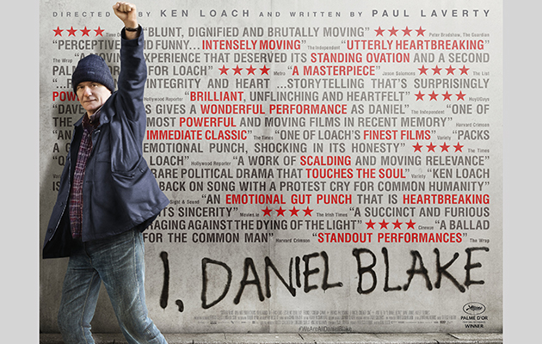

1. What does the choice of image connote about the film's narrative?
2. What appears to be the biggest **selling point** for this film? How can you tell based on what you see here?
3. Look at the list below of the different selling points conventionally used in film posters. Have any of these been used for *I, Daniel Blake*? How have they been used? Are they a major selling point for this film or not?

* Britishness
* Star quality
* Cast List
* Title
* Tagline
* Director
* Genre/generic iconography
* Main image
* Production credits
* Press reviews

**Carry out some research in to the following marketing techniques. What can you find out?**

*UNITE* Campaign

Trinity Mirrorcampaign

Free screenings

Labour Party/Jeremy Corbyn support (synergy)

Press events (Cannes Film Festival press conference*)*

*Versus: The Life and Films of Ken Loach*

**DIGITAL/ONLINE MARKETING**

Explore the websites below and answer the following questions:

<https://www.wildbunch.biz/movie/i-daniel-blake/> *Wild Bunch Films*

<http://www.ifcfilms.com/films/i-daniel-blake> *IFC Films*

<https://www.festival-cannes.com/en/films/i-daniel-blake> *Cannes Festival*

<https://www.bbc.co.uk/bbcfilms/film/i_daniel_blake> *BBC Films*

<https://www.facebook.com/IDanielBlake/> *Facebook*

<https://twitter.com/idanielblake> *Twitter*

<http://www.imdb.com/title/tt5168192/?ref_=nv_sr_1> *imdb*

<https://www.theguardian.com/film/i-daniel-blake> *Guardian* film site page

<https://www.theguardian.com/commentisfree/2017/feb/16/daniel-blake-realistic-life-benefits>

1. How has the viewing of films changed/been impacted by widespread use of **online and social media**?
2. Are audiences now more likely to seek out marketing (e.g. new trailers) online as **active consumers**?
3. How does this impact the **relationship** between audience and product?
4. Do you think the **target audience** for this film will have searched for this online, or more likely seen a trailer at the cinema or read reviews? Explain your answers.
5. As part of the marketing of the film, the BFI made an interactive film called *How to Make a Ken Loach Film*, which could be downloaded as an app and available on YouTube. Look at the link and consider who this would appeal to: <https://www.bing.com/videos/search?q=youtube+how+to+make+a+ken+loach+film&&view=detail&mid=290E0C58009C8793C8BD290E0C58009C8793C8BD&&FORM=VRDGAR>

**EXHIBITION**

1. The film was **exhibited** at various film festivals and received a **theatrical release** in Britain (UK opening weekend 94 cinemas). Read this article to see how well it did against other releases in the same week and make notes in the box below. <https://www.theguardian.com/film/2016/oct/25/i-daniel-blake-ken-loach-uk-box-office-trolls-top-spot>
2. The film was also released in various other countries (including France, Spain, Brazil and Japan) together with a very limited release – 12 cinemas – in the USA. It was later released on **digital download** and **DVD/Blu-ray in** February 2017. ***Why do you think it was not widely distributed in the US?***

**REGULATION**

The following is from the BBFC’s **Insight** feature, which outlines why *I, Daniel Blake* received a 15 certificate.

*I, DANIEL BLAKE is a British drama in which a 59-year-old joiner, unable to work due to a recent heart attack, befriends a young single mother as they both struggle with the red tape of the British benefits system.*

**Language** - There is infrequent use of very strong language ('c**t'), as well as more frequent use of strong language ('f**k'). Milder terms include 'bastard', 'bullshit, 'wanker', and 'twats'.

Other issues include **visual and verbal references to prostitution**.

**Task:** Look at the BBFC Guidelines <http://www.bbfc.co.uk/what-classification/15> for a 15 certificate film. Does *I, Daniel Blake* sit comfortably within these Guidelines? How does the decision compare to that for *Black Panther*?

**THEORETICAL CONTEXT**

**REGULATION – Livingstone & Lunt**

It could be argued that UK regulation policy (the BBFC) is driven by a conflict to ‘protect’ the public from harmful content but also allow diversity/choice.

There is a need for the film industry to appeal to contemporary audiences through stronger material. **Desensitisation** and **deregulation** are core concepts here.

Why would distributors E-One want a 15 certificate for *I, Daniel Blake?*

Despite the use of strong language, why do you think *I,DB* gained a 15 release?