EXPLORE-MAGAZINE PRODUCTION

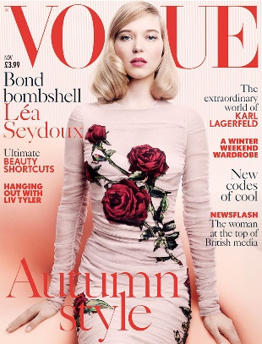

MAGAZINE FRONT COVER ANALYSIS

As the front cover is generally the first part of the publication the reader will see, it has to:
- indicate who the magazine is intended for, drawing the attention of the target audience;
- indicate the type of magazine it is (the relevant genre or sub-genre should be clearly signalled to the reader);
- help the magazine stand out from its competitors by conveying a clear sense of brand identity;
- persuade potential readers to buy the magazine by creating audience interest and appeal.

Each cover has to be sufficiently different from the one before so that readers feel as if they are getting something new every time they buy the magazine. This is important in order to encourage repeat purchase. At the same time, there has to be continuity from issue to issue in order to establish a sense of brand identity. This is typically achieved through a recognisable house style.

Looking at the front cover you have been given:

- What is the magazine called (masthead) and what does it suggest about the magazine?

2 What does the style of language and mode of address (how it speaks to the audience) tell you about the readership of the magazine? Eg. is the language informal, slang, assuming knowledge? Have any of the following been included: alliteration, assonance or rhyme; imperatives; a direct mode of address? If so, how and why?
It is also important to consider the lexis that the magazine uses. As well as conveying a sense of genre, this can reveal a great deal about the underlying values of the magazine.

- Look at the strapline or tagline (if it has one). What does it tell you about the target audience?

- The typography: what are the connotations of the font styles that are used? Are they serif or sans serif? Are they modern or traditional? Formal or informal? Masculine or feminine? What do they suggest about the title’s brand identity and target audience?

- The colour scheme: what does it signify?

- Cover lines – what kind of stories does this magazine cover? How is the target audience being appealed to, e.g. are they boy-mad, insecure schoolgirls; fit and well-paid gay men, or politically aware ethical consumers?

- What are the people like on the cover? Age, gender, race? Are the people on the cover of interest to the readers – reflect their aspirations?

8 How else does this magazine cover seek to persuade the consumer to buy? Tactics used to appeal to audiences may include use of stars, celebrities, sensationalist (count the exclamation marks) and cover-mounted ‘freebies’.

