DVD ANALYSIS
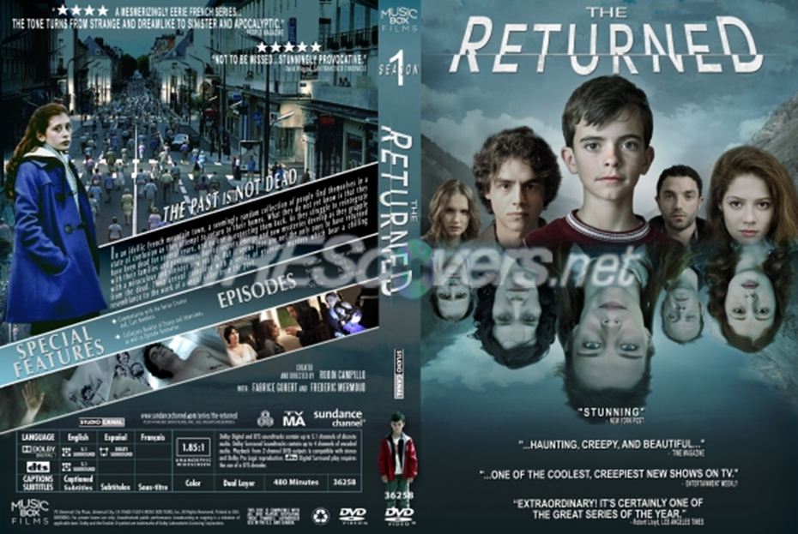

THE RETURNED
Analyse the front and back cover of the DVD (on GOL) taking into consideration media language, genre, narrative, audience and institution.
Copy and paste a copy of the DVD into a Word document and annotate, commenting on the points below.
1. Consider how the DVD attracts its target audiences. You should try to find at least seven different ways and consider the following, applying any relevant theories:
- Representations
- Genre conventions
- Use of characters
- Typography (size and style of letters)
- Signs & symbols
- Images/design/layout
- Extras
- Written codes (synopsis)
- Use of testimonials
- Classification

2. Does the audience need foreknowledge to understand what the series is about? Does the DVD packaging create enigmas?

