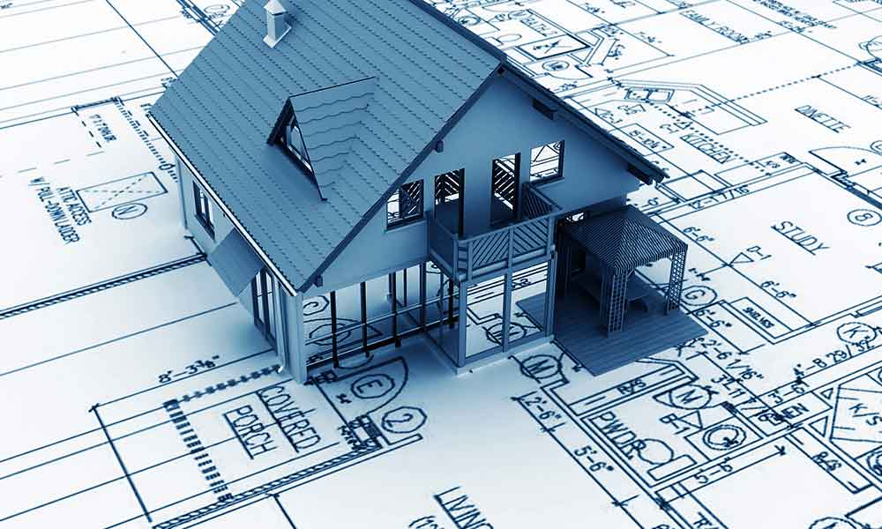ARCHITECTURE BEYOND COLLEGE: UNI/APPRENTICESHIP/EMPLOYMENT

**Entry requirements for architecture, building, and planning**

**A levels**: To get on to a related degree, you will usually need a minimum of two A levels, with three A levels and A/B grades required for the most popular courses. Entry requirements range from CCD to AAB, with the universities and colleges most commonly asking for BBB. In addition, you normally require five GCSEs at grade C or above, including maths and English. Planning and landscape architecture degrees do not normally require specific A level subjects. Some degrees in building and surveying may also require or prefer maths/science A levels.

**Selection:** Architecture courses may require applicants to submit a portfolio of their work, and this is combined with an interview at some universities. Universities will want you to show that you are an enthusiastic, practical person who is passionate about the environment and society, and how they interact with one another. You may also be asked to provide a portfolio of your work and/or be invited to come in for an interview. These are both good opportunities to clearly communicate your ideas, your creative skills, and your interest in the natural and built environment.

**Personal statement:** Competition for places can be high so personal statements form an essential part of the selection process. Admissions tutors want to see you have aptitude, interest, and motivation in you chosen subject. Many of these degrees are practical and vocational, which means some previous experience can be important: your +Explore course in Architecture is a great starting point and we will provide a reference for this if your attendance rate is over 66%. More personally, your tasks and submitted designs and a wide range of additional reading/ideas can be accessed via Godalming Online when you want to write your Personal Statement. If in doubt, please come and talk to me!

**+Explore Architecture** Universities will be looking for evidence you've done additional reading and research, for example, finding out about award winning architectural designs. NO problem – that’s exactly what we have been doing in this +Explore course. BUT, you need to explain WHY you have enjoyed a specific building/idea/concept/architect interview – you will be using this as a shared platform for discussion.

**Find out more**

UCAS is probably your easiest place to start. Then visit the websites of the following professional bodies to find out more about courses and careers in architecture, building and planning.

* [Royal Institute of British Architects (RIBA)](http://www.architecture.com/)
* [Royal Town Planning Institute](http://www.rtpi.org.uk/)
* [Be a Landscape Architect](http://www.bealandscapearchitect.com/)
* [Royal Institution of Chartered Surveyors (RICS)](http://www.rics.org/uk/)

**20 (or more) jobs you might want to explore:**

**1. Landscape Architect**

Designing outdoor landscapes, including [infrastructure](http://www.archdaily.com/tag/infrastructure), [public areas](http://www.archdaily.com/tag/public-space), agriculture and forestry is vital for constructing the webs that bind our urban and rural spaces, but also, and perhaps more importantly, it’s essential for responding to globalization and climate change. [Landscape architects](http://www.archdaily.com/tag/landscape-architecture) are involved in storm water management, environmental restoration, and recreational areas among other things. If you enjoy working with and in the natural environment, this could be the path for you. You might also want to get some practical experience on the

**2. Urban Planner**

As a result of a rapidly growing percentage of our population moving into urban areas, the conditions of [urbanism](http://www.archdaily.com/tag/urbanism) are constantly in a state of flux. The dynamic state of the urban environment makes it an exciting path to take as an architect, covering everything from economic and demographic changes, to [sustainable development](http://www.archdaily.com/tag/sustainable). It’s an essential responsibility within our profession, but a challenging one; it requires adaptability and problem solving on a large scale.

**3. Restoration Architect**

Our societies’ heritage and history as presented through architecture are not only beautiful glimpses into the past, but also crucial to understanding our culture as a discipline. [Conservation](http://www.archdaily.com/tag/conservation/) and [restoration](http://www.archdaily.com/tag/restoration) of buildings is undeniably a challenge; it is never possible to please everyone. The media often targets the act of restoration as a "[heritage massacre](http://www.archdaily.com/783861/cadiz-castle-restoration-interesting-interpretation-or-harmful-to-heritage)," in spite of the often very beautiful solutions.

**4. Research Architect**

With the current wave of [digital design](http://www.archdaily.com/tag/digital-architecture) and constant advancement of digital tools, our methods of representation and expression are changing dramatically. Information technology has had a profound impact upon architecture that is far from over. These constant improvements are in part made possible by the exciting research being done by architects, not necessarily consisting of designing buildings, but focusing more on how these new tools can enhance our work.

**5. Lighting Architect**

Light has a profound impact on our mental and physical health, as anyone living at high latitudes can empathize with. Delving into the architecture of [lighting](http://www.archdaily.com/tag/light-matters) entails improving the quality of our experiences, our health and well-being, and the sustainability of not only the natural environment, but also smaller spaces such as our [work environments](http://www.archdaily.com/796231/13-changes-to-your-work-space-that-could-improve-your-productivity-and-your-life).

**6. Political Architect**

Some argue that architecture is by nature political, however being active in the political decision of a city or country is a different story. Architecture is more than just creating beautiful objects; the discipline has a value in organizing society. Architecture firm [Terroir](http://www.terroir.com.au/page/1?utm_medium=website&utm_source=archdaily.com), for example, has worked with the [Burnie City Council](http://www.archdaily.com/96121/burnie-makers-workshop-terroir) as well as with the Parramatta City Council in Australia, to argue for a certain structure for the city, to predict what may happen, and to design a set of criteria for the evolution of the city. It is a case of architecture influencing politics, instead of the other way around.

**7. Extreme Architect**

With the current development of [climate change](http://www.archdaily.com/tag/climate-change), extreme weather conditions such as floods, heat waves and hurricanes are predicted to increase. Existing extreme environments, such as deserts, are likely to expand due to phenomena such as desertification. Being an architect who specializes in extreme weather conditions is therefore not only an incredibly fascinating way to tackle the subject, but also invaluable for us to [adapt](http://www.archdaily.com/773207/extreme-heat-hot-cities-adapting-to-a-hotter-world) to the future of our planet.

**Careers in Art and Design**

If, upon graduating, you realize that architecture is in fact not for you, design and art might be. Architecture already is a form of design (or maybe it’s the other way around), making it easier to create direct links between your education as an architect, and your profession as an artist or designer. Another alternative is to combine two disciplines, such as graphic design and architecture. Perhaps your passion is to make it easier for architects to communicate through graphics?

**8. Artist**

Although [Olafur Eliasson](http://www.archdaily.com/tag/olafur-eliasson/) did not study architecture, he works with many architects at [Studio Olafur Eliasson](http://olafureliasson.net/?utm_medium=website&utm_source=archdaily.com), exemplifying how harmonious and imperative the relationship between space and art is. The spatial reasoning and visualization skills one gains from an education in architecture lends themselves perfectly to installation art, sculpture and spatial experiences, without the necessity for functionality. If you haven’t already been, please go to Tate Modern and see his show. The RA Eco-Visionaries show is also relevant….

**9. Industrial Designer**

Several architecture firms have branched into [industrial design](http://www.archdaily.com/tag/industrial-design), due to their close creative ties. However, industrial design focuses on smaller scale objects of mass production, as opposed to large-scale buildings designed for a specific context. If the prospect of designing something enormous, permanent, and landscape changing sounds all too intimidating, industrial design is a great, smaller scaled alternative.

**10. Furniture Designer**

Even more so than [industrial design](http://www.archdaily.com/531228/when-architects-try-their-hand-at-industrial-design), furniture design can be seen as architecture’s sister. Countless famous architects have made significant contributions to [furniture design](http://www.archdaily.com/tag/furniture-design): [Charles and Ray Eames](http://www.archdaily.com/tag/charles-and-ray-eames/), [Alvar Aalto](http://www.archdaily.com/tag/alvar-aalto) and [Arne Jacobsen](http://www.archdaily.com/tag/arne-jacobsen), among others. Contemporary architects such as Zaha Hadid Architects are following suit, proving that the two can even be done simultaneously. We have looked at Gerrit Rietveld’s chair and Schroder House in this short course.

**11. Textile Designer**

Designing textiles requires sensitivity for colour, tactility, construction, patterns and forms, all of which are developed during any student’s years at architecture school. The relationship between ["skin" and structure](http://www.archdaily.com/415816/p-a-t-t-e-r-n-s-latest-expressive-experimental-pavilion-textile-room) is in some ways even more literal than in a building, as the two merge together. [High fashion](http://www.archdaily.com/tag/fashion) is also reminiscent of architecture in many ways, adopting the geometric and sculptural constructions of contemporary buildings.

**12. Graphic Designer**

Graphic design is the way in which we take in our world and identify it. It is invaluable when it comes to communication. It can also be so aesthetically pleasing that one can hardly resist becoming a graphic designer. Taking a short course in [graphic design](http://www.archdaily.com/tag/graphic-design) to supplement a degree in architecture can open up a range of possibilities to still work within the field, but take charge of tasks that are more suited to your interests in communication.

**13. Video Game Designer**

The near-limitless boundaries that come with designing a virtual world may be one of the most fun things a newly graduated architect could think of doing with their education. Constructing the architecture of a [video game](http://www.archdaily.com/tag/video-games) is a way of letting your imagination roam free, but could also [add more depth](http://www.archdaily.com/795554/11-non-architectural-ways-become-better-architect-without-doing-architecture) to your spatial reasoning. You might want to enrol on the +Explore course for Animation and Games Design if this appeals to you.

**14. Photographer**

[Architecture photography](http://www.archdaily.com/tag/architectural-photographers) is becoming increasingly popular, possibly due to the beautiful geometry that can emerge by constraining something within a lens. Photography concerns itself more with the aesthetic, with the object and the composition in that unique moment, within that specific frame. It concerns itself with the fleeting atmosphere, more than with the permanent organization of people and spaces. Yet it still consists of composition, colour, environment and experiences. Within the +Explore portfolio, we have two photography courses. Both are designed for students who are not taking A Level Photography but want to understand more. Look at Introduction to Photoshop and Photography for Beginners if this appeals.

**15. Production Designer**

Although a set or a stage are far smaller platforms than a virtual planet, [designing theater and film sets](http://www.archdaily.com/381007/a-conversation-with-academy-award-winning-set-designer-catherine-martin) allows for just as much creative flow. It lifts the pressure of traditional spatial design and expression, allowing for experiences that may be more evocative, sensuous, and story-driven, while still utilizing all the knowledge and skills one gains from an education in architecture: time pressures, conceptual environments and collaborative creativity. There are some really interesting technical courses at Drama Schools which cover these aspects: look at Central, RADA and don’t forget the libraries of the NT if you want more information for your EPQ or Personal Statement.

**Careers Outside of Design**

If you find yourself scrolling through this list and shaking your head at any mention of architecture, art or design, perhaps this final list is for you. It covers 6 careers outside of the stereotypical fields of design, mostly within the human sciences as architecture is inherently directed towards the human experience. Drawing the essence of this from your architectural education and injecting it into another discipline may even make you a stronger candidate in the professional sphere.

**16. Teacher/Professor**

Young teachers at [architecture schools](http://www.archdaily.com/tag/architecture-school) are becoming more common, and if you’re looking for more time to learn about the field before making a decision on whether or not you want to remain in it, taking up a year or two of teaching could be an ideal way to do so. Teaching is a two-way street (as you well know!), especially at such a young age, which provides you with an excellent method to learn from your students and reflect on your view of architecture.

**17. Philanthropist**

Contemporary architecture has a necessary focus on sustainability: environmental, social, psychological, and economic. The knowledge and awareness of these ideals can be converted into other types of philanthropy, if that’s what interests you. Founding – or joining - a sustainable foundation towards a humanitarian aim is never a waste of time. You might find either the Greening Godalming or Sustainable Living +Explore courses give you some useful insights if you are interested in this. Also check out Debating, Human Rights and International Development.

**18. Politician**

Architecture and politics are in many ways inherently tied together. The knowledge one gains of people, and the way they interact with their environment, the way they are organised, what makes the human body and psyche feel comfortable; all of these skills contribute hugely to making a good politician. In fact, in Finland, Anders Adlercreutz, a current first-term Member of Parliament, is educated as an architect and practiced as one for many years before turning to politics, while in Britain [Richard Rogers](http://www.archdaily.com/tag/richard-rogers) serves in the House of Lords alongside running [his practice](http://www.archdaily.com/office/rogers-stirk-harbour-partners).

**19. Conservationist**

Conservation of the environment is, at last, becoming a focal point within architecture. If Britain is to become carbon neutral by 2050, this will be THE issue of your career. Despite many efforts, our planet is still [heading down a path leading to disaster](http://www.archdaily.com/798621/watch-leonardo-dicaprios-before-the-flood-climate-change-documentary-free-online) when it comes to our natural surroundings. Using your knowledge of spatial organization to develop a method of environmental conservation is not only intellectually stimulating, but also vitally important for our society. Join the Sustainable Living or Climate Change +Explore courses if you want easy access to more information on this.

**20. Writer**

Becoming a writer or journalist can be a great way to utilize an architectural education; we learn to articulate ourselves using ([mostly](http://www.archdaily.com/775615/150-weird-words-that-only-architects-use)) descriptive language and rhetoric, in order to communicate our complex projects to teachers and critics. Turning that into writing, whether fictional or not, is another way of constructing another world and an experience for others. Despite the print being two-dimensional, the stories definitely aren’t. The Journalism +Explore course might be useful here.

**21. Entrepreneur**

Problem solving, creative thinking and the art of persuasion are three skills [architects and entrepreneurs](http://www.archdaily.com/773232/9-entreprenurial-architects-who-developed-innovative-products-and-services) have in common that you can use to your advantage. Your experience with abstract concepts and human interaction can make you a stronger competitor with an alternative way of thinking.

**The list above is of course incomplete, as the careers mentioned here can be combined in many ways, and other, unmentioned vocations can be brought to the table to provide virtually infinite possibilities. As German educator**[**Kurt Hahn**](https://www.roundsquare.org/about-us/who-we-are/kurt-hahn/?utm_medium=website&utm_source=archdaily.com)**said, "there is more in us than we know. If we can be made to see it, perhaps, for the rest of our lives, we will be unwilling to settle for less." Don’t forget that there is a sea of possibilities out there.**

**In the 21st century, it is unlikely that any of you will have a single career for life. You need to think about your personal and professional satisfaction and how you will (quite literally!) put a roof over your head. Don’t be afraid of making mistakes: that’s inevitable. Do make sure you pick yourself up, look after yourself (and your colleagues), take time to reflect, improve/refine your CV/approach and go back for another round……**

***Good luck! And please keep me posted! Sarah***