**Trash to treasure: Organic bio-bricks made from mushrooms make for cooling (and cool-looking) construction**

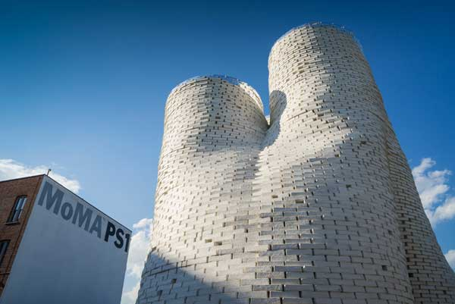Installation view of The Living’s Hy-Fi, the winning project of The Museum of Modern Art and MoMA PS1’s 2014 Young Architects Program. Credit: Kris Graves

Sustainable building materials [aren’t just for science](https://ceramics.org/ceramic-tech-today/research-aims-at-greener-sustainable-concrete) anymore.

A new bio-brick installation that marries form with function shows that [carbon-friendly construction components](https://ceramics.org/ceramic-tech-today/biomaterials/biocementation-of-bricks-set-to-produce-greener-building-materials) can also be award-winning works of art.

[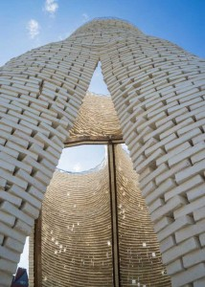](https://ceramics.org/wp-content/uploads/2014/08/0729-ps1_10-lo.jpg)Designed by New York architecture-design firm [The Living](http://thelivingnewyork.com/hy-fi.htm), Hy-Fi is an impressive-looking tower of bricks made from mushrooms and corn stalks.

Yes, you heard right. The scraps from your dinner table and cornfield aren’t trash, they’re treasure. Dorothy—[we’re not in Kansas anymore](https://www.youtube.com/watch?v=vQLNS3HWfCM).

(Corn seems to be a hot topic this month. Catch corn’s cover-girl turn in the August [ACerS Bulletin](https://ceramics.org/publications-and-resources/the-bulletin-of-the-american-ceramic-society). Inside, authors I.A. Cornejo, S. Ramalingam, J.S. Fish, and I.E. Reimanis [explore new research](http://americanceramicsociety.org/bulletin/2014/aug14/#/26/) that shows glass and glass-ceramics can be made using only mineral content of food waste ash.)

These 100-percent organic—and thus, 100-percent compostable—bricks are made of corn that is dyed clay-red and held together by a mushroom “glue.” The biodegradable brainchild of [Ecovative Design](http://www.ecovativedesign.com/) (Green Island, N.Y.), the company’s high-performance Mushroom Materials are part-agricultural byproducts and part-mushroom mycelium (i.e., “[a natural, self-assembling glue, digesting crop waste to produce cost-competitive and environmentally responsible materials that perform](http://www.ecovativedesign.com/mushroom-materials/)”).

[According to an Ecovative press release](http://www.ecovativedesign.com/news/index.cfm?guid=8F0216CF2A036835311529B730C6AFE01A9E7E895C891E4AE5CCF579F128BF4B69270C5A0266ACB72F895D7AFE3EBEEF), David Benjamin, principal of The Living, knew early on that he wanted to incorporate the company’s renewable materials into the organic blocks that would help shape the design of Hy-Fi.

Credit: Kris Graves

[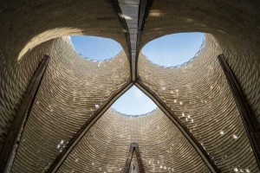](https://ceramics.org/wp-content/uploads/2014/08/0729-ps1_13-lo.jpg)Hi-Fy isn’t the only project to incorporate Ecovative’s material from mushrooms.  According to the company, designers around the globe are working to incorporate the sustainable substance into high-end lampshades, plant holders, and an eco-friendly surfboard dubbed “El Portobello.”

Working with the company to prototype and test Benjamin’s bio-bricks resulted in the manufacture (to scale) of the more than 10,000 bricks that would bring the 40-foot tower to (renewable) life.

Credit: Kris Graves

The bio-bricks that form the Hi-Fy’s three “arteries” also boast a special reflective film developed by 3M. [A press release from the Museum of Modern Art](http://momaps1.org/yap/view/17) (MoMA), where the installation is currently on display, says that the mirror film will be used as growing trays, and, ultimately, shipped back to 3M for “use in further research.”

[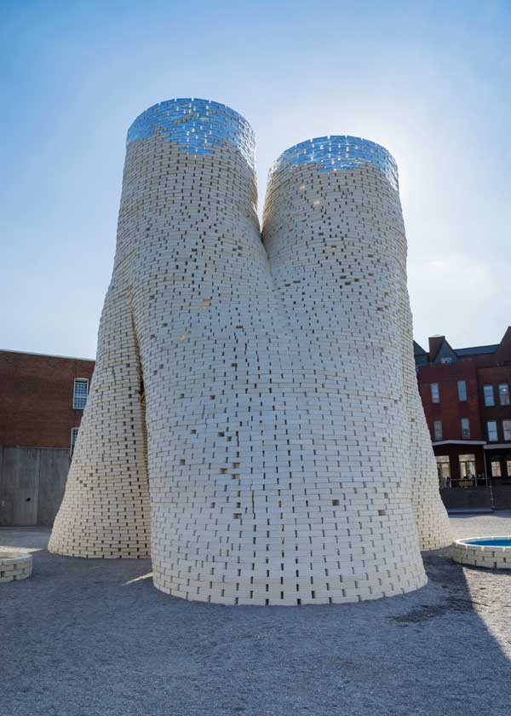](https://ceramics.org/wp-content/uploads/2014/08/0729-ps1_18-lo.jpg)What makes this mountain of mushrooms and corn stalks stand out from less-sustainable structures?

According to the release, “The structure inverts the logic of load-bearing brick construction and creates a gravity-defying effect—instead of being thick and dense at the bottom, it is thin and porous at the bottom. The structure is calibrated to create a cool micro-climate in the summer by drawing in cool air at the bottom and pushing out hot air at the top.”

It’s both brains and beauty, and its sleek, space-like design—which has nearly no carbon footprint—was recognized by MoMA PS1, which declared Hi-Fy the winner of the museum’s 15th Young Architects Program.

“It is the first sizable structure to claim near-zero carbon emissions in its construction process, and, beyond recycling, it presents itself as being 100% compostable,” [says](http://momaps1.org/yap/view/17) Pedro Gadanho, MoMA curator. “Recurring to the latest developments in biotech, it reinvents the most basic component of architecture—the brick—as both a material of the future and a classic trigger for open-ended design possibilities.”

Credit: Kris Graves

If you’re in the New York area, you can check out Hi-Fy for yourself. The winning project is a “temporary urban landscape,” providing shade and shelter to visitors at MoMA PS1’s courtyard until September 6.

Time is of the essence though—at the conclusion of its run at MoMA, Hi-Fy, in the ultimate act of sacrificial sustainability, will be composted and converted to fertilizer.