1. Comment on the aspects of this building that interest you. (30 mins)

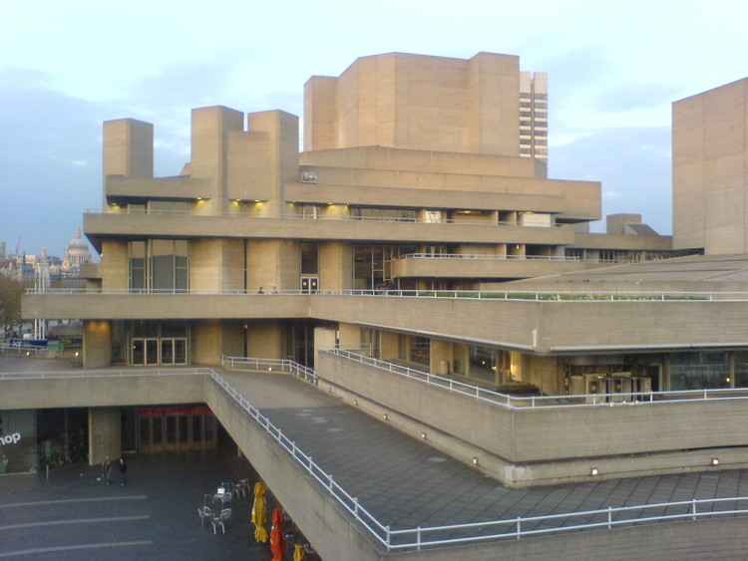

*More questions to play with – all in 30 minutes!*

1. Architecture always responds to the social/political mood of the time.
2. Explore the relationship between technology and architecture.
3. Explore the idea of nationality in architecture.
4. Share your ideas for the building of a new cultural centre in your nearest town.