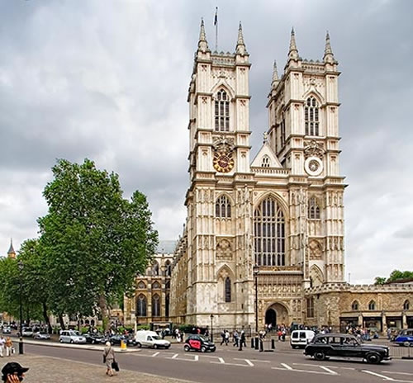**London’s most iconic buildings?**

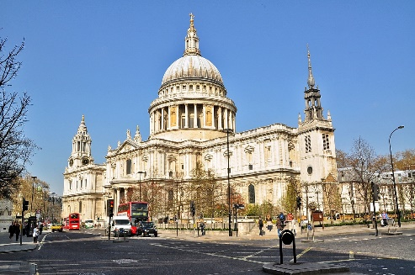St Paul’s Cathedral, designed by Christopher Wren (1699-1730): English Baroque style

Westminster Abbey designed between 960-1269, Gothic style

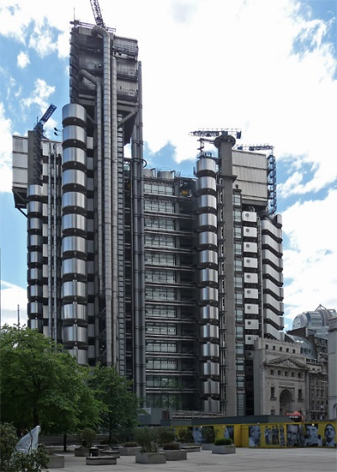

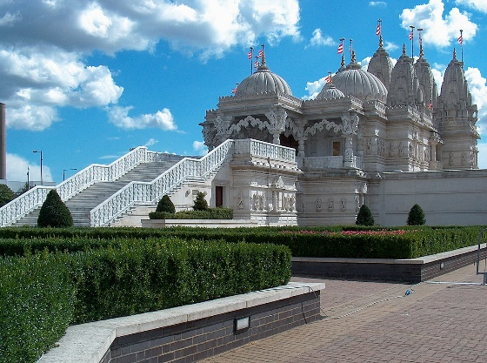

Lloyds Building designed by Richard Rogers, 1986, Hi-tech style

Neasden Temple: Europe’s first Hindu temple, built 1992-5

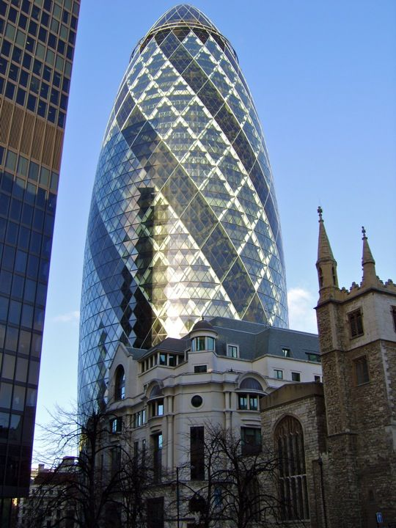

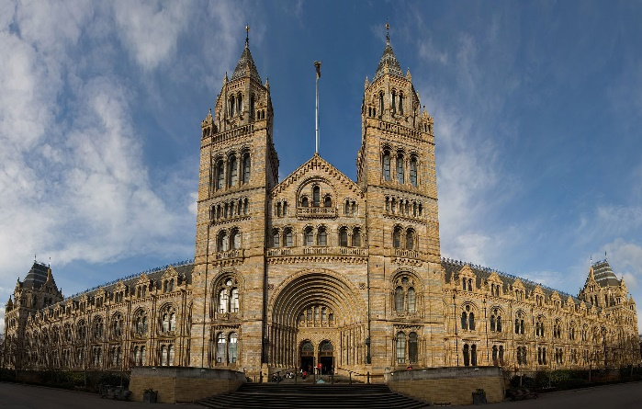Natural History Museum, Neo-Romanesque style, built 1881, designed by Alfred Waterhouse

30 St Mary’s Axe (‘The Gherkin’) Norman Foster, built 2003, Hi-tech style

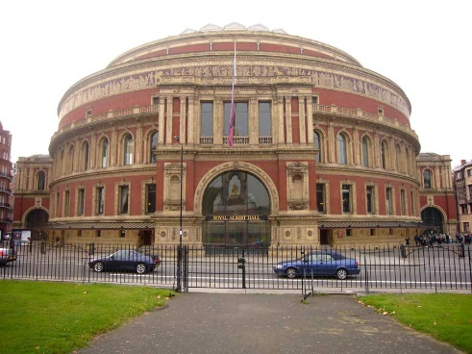

Royal Albert Hall 1867-71, designed by Francis Fowke, Victorian Italianate style

[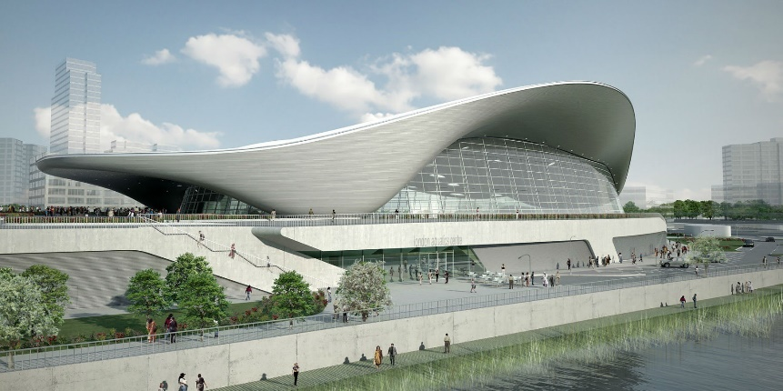](https://www.google.co.uk/url?sa=i&rct=j&q=&esrc=s&source=images&cd=&ved=2ahUKEwilucyy8bblAhWDAmMBHQJNDrQQjRx6BAgBEAQ&url=https%3A%2F%2Fwww.arch2o.com%2Flondon-aquatics-centre-zaha-hadid-architects%2F&psig=AOvVaw2thVykApCY5ae1blSWZU6K&ust=1572074864260714)

London Aquatics Centre, Parametric style, 2011 by Zaha Hadid