Approaching Architecture unseens

**What to write:**

1. Do not write an introduction. There is no need to write out the name of the building or full name of the architect: this cannot gain you credit because you have been given the information.
2. Use your first sentence to summarise the entire building: eg; This building is a three storey, large scale, symmetrical construction in a rural location.
3. Then begin at ground level and go through all the specific detail/parts you can see. Link each to the question you have been asked so that you can explore what (the parts) and why (the effect).
4. Continue in this detailed fashion right up to and including the roofline.
5. You should always consider the environment/location of the building too and make a comment on its situation within the landscape.

**How to prepare:**

Learn your architectural vocabulary

There are basically three options for this question and you should have a set of vocabulary to go with each:

* 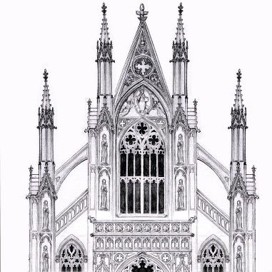A Classical building (includes Greek, Roman and Revival)
* A Gothic building (includes Revival/Neo-Gothic)
* A Modern/Post-Modern building

**What kind of questions to expect:**

There is a limited range of questions:

* How does the building serve the function?
* How does the building show Power/Status/Meaning?
* How does the use of materials affect the construction/decoration?

So read the question carefully and ensure you make each sentence relevant. (If you happen to know this building, do NOT get distracted into telling the story of the architect, patron or style as this cannot earn you credit in an unseen.)

**Sample questions:**

1. Describe this building and comment on the relationship between decoration and structure.
2. Describe the appearance of this building and consider how it expresses its function
3. Analyse the composition of this building and comment on the features that indicate its status.