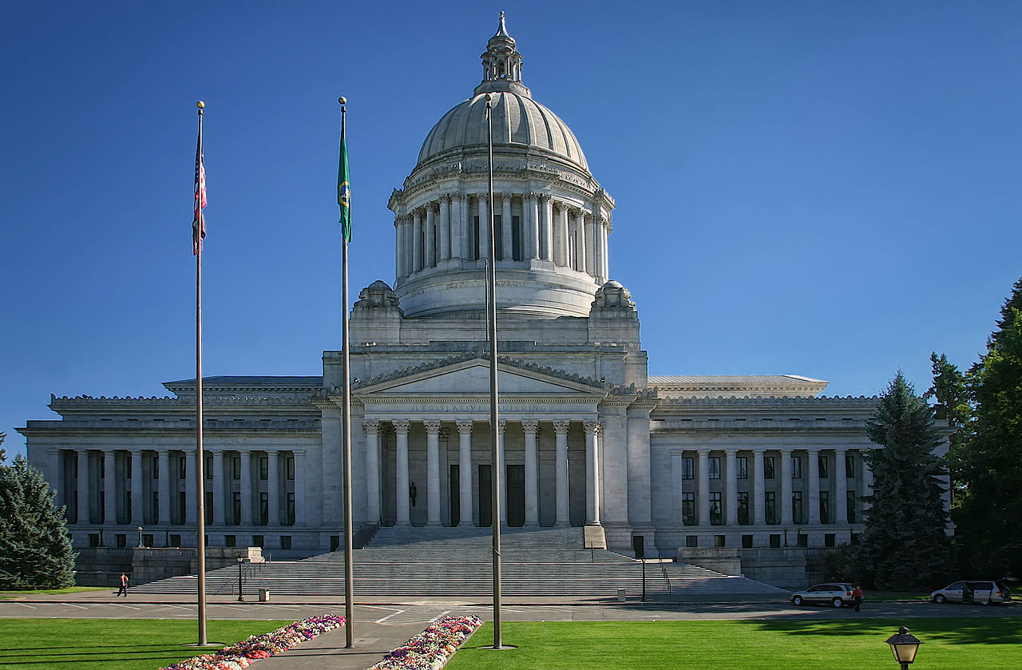

Wilder & White (1922-28) The Washington State Capitol Legislative Building in Olympia, Washington

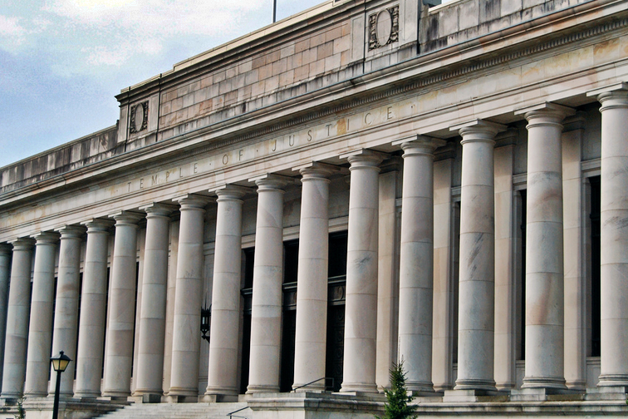

Wilder & White Temple of Justice, Washington 1912

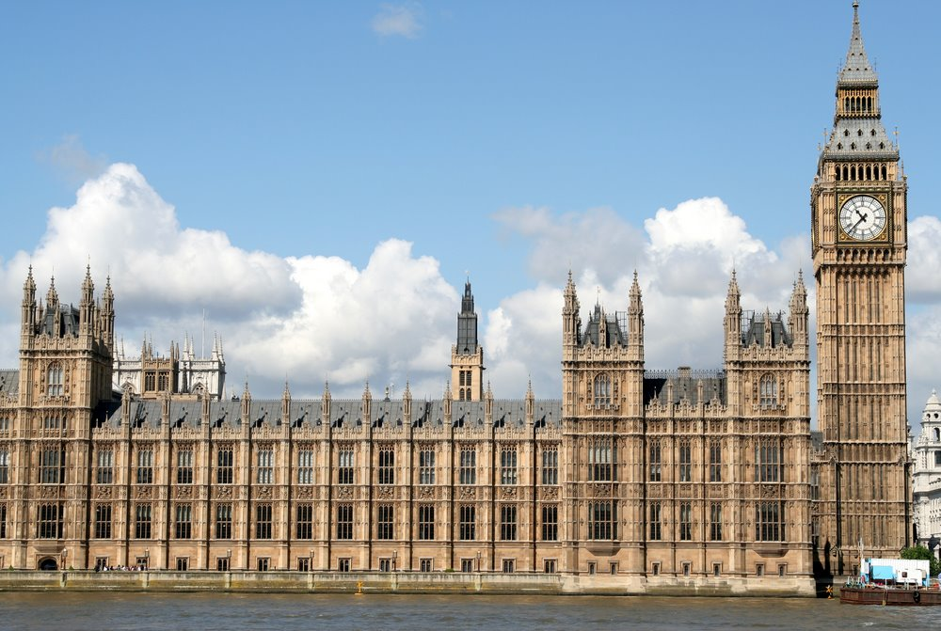

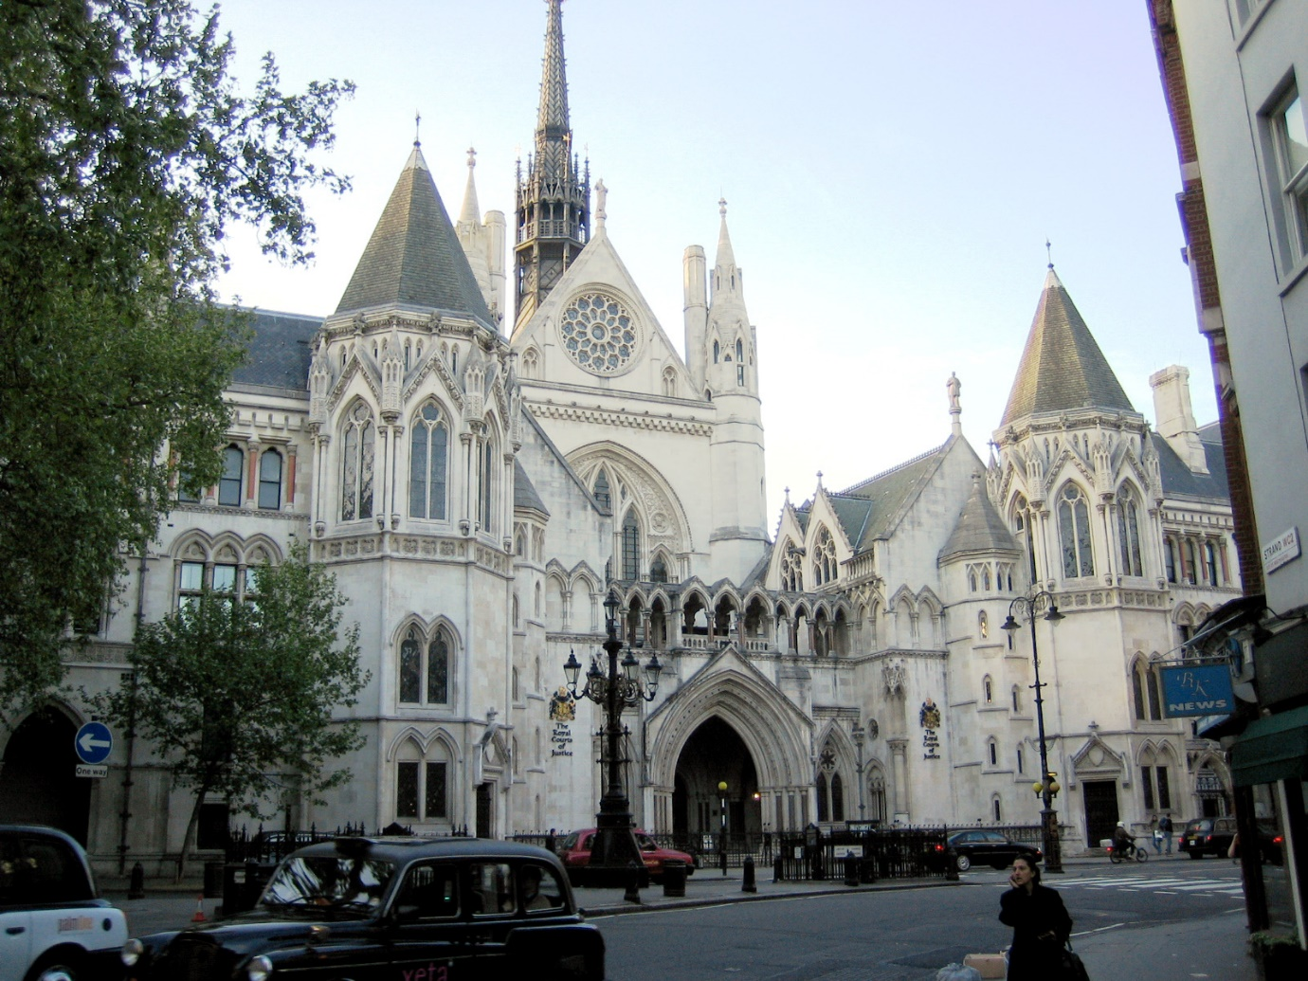Barry & Pugin Houses of Parliament, London (1840-70)

GE Street (1870-82) Royal Courts of Justice, London