Renaissance Architecture

[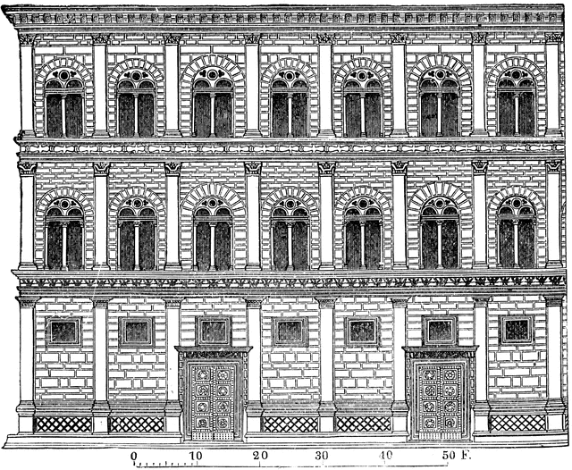](https://www.google.co.uk/url?sa=i&rct=j&q=&esrc=s&source=images&cd=&cad=rja&uact=8&ved=2ahUKEwiRmrGpg9ndAhXKY1AKHZFBDjoQjRx6BAgBEAU&url=https%3A%2F%2Fetc.usf.edu%2Fclipart%2F73600%2F73652%2F73652_rucellai_pal.htm&psig=AOvVaw3FciNDSIRcGVNdjr-qjbFD&ust=1538063540148593)Alberti: Ruccellai Palace (1446-1451)

**[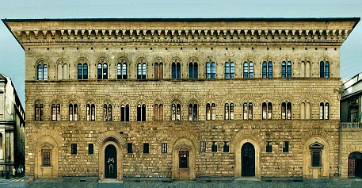](http://www.florencewebguide.com/images/palazzo-medici-riccardi-exterior.jpg)**[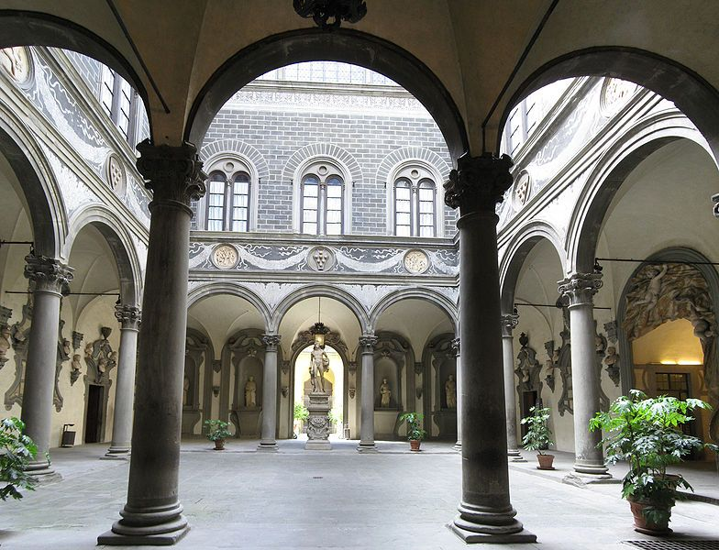](https://www.google.co.uk/url?sa=i&rct=j&q=&esrc=s&source=images&cd=&cad=rja&uact=8&ved=2ahUKEwjKnPDmg9ndAhUBfFAKHfEADHIQjRx6BAgBEAU&url=https%3A%2F%2Fwww.pinterest.co.uk%2Fpin%2F161003755398933580%2F&psig=AOvVaw2DhC1GDG-iC1nA7ov1CJkR&ust=1538063669222960)

Michelozzo Medici Palace (1444-84)

Aims of the Renaissance:

Characteristic features of Renaissance architecture:

Baroque Architecture

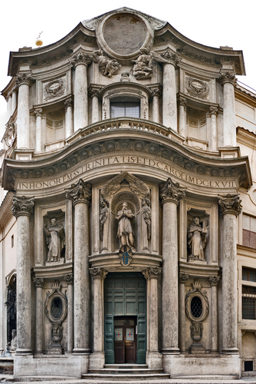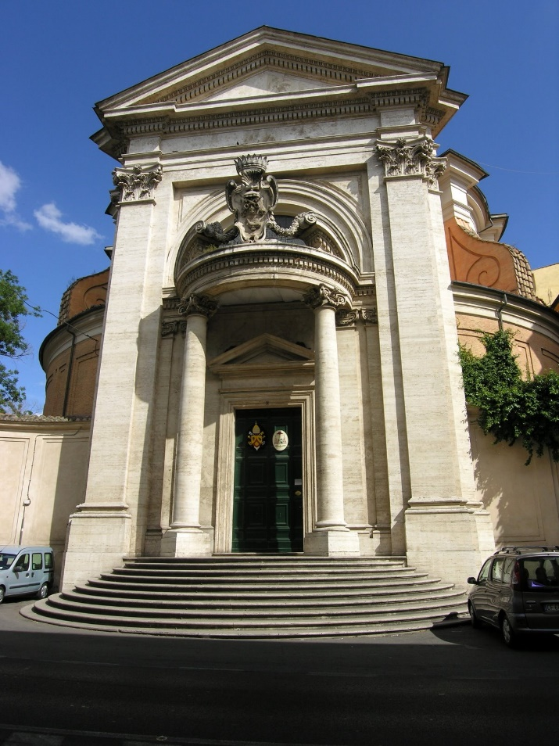

*Above left: Borromini ‘San Carlo alle Quattre Fontane Above right: Bernini Sant’ Andrea al Quirinale (1634-1661) (1658-1661)*

Aims of the Baroque:

Characteristic features of Baroque architecture: