

Unit 2

Composition

4-Part Writing

String Quartet



Compose a piece for a string quartet designed to introduce this ensemble to an audience of adults unfamiliar with any chamber music. Your piece should exploit a variety of textures.

Composition Final Checklist

1. Clarity is both compositional and notational

* Title Page with your brief clearly stating your intention and audience
* Form and structure-double bar lines( and/or rehearsal marks) after every section
* Check you composition review form for balance in all sections
* Clear tempo markings for each section-*Allegro con spirit, Allegro ma no troppo, Vivace assai*
* Expression markings-*cantabile ed expressive, tranquillo*
* Clearly marked dynamics and technique

1. Coherence- High marks are not just concerned with the fact that you have come up with material but how it is used

* Repetition of ideas-if *it’s nice say it twice.* Forms are defined by repetition.
* Refresh the repeated sections each time
* Balance between repeated sections and contrasting sections

1. Character-Getting to know the character of the instruments in your composition is important to achieve high marks. Can you answer the following questions:

* How would you describe the sound of your instrument?
* Does the instruments have different qualities in different parts of register?
* How is the sound made? What implications does this have for a composer
* Can the sound of the instrument be modified in any way?
* How does the instrument balance with other instrument?
* Is the instrument associated with a particular type of music?
* Find a piece which really shows of the instrument well. Which elements of the instrument has the composer highlighted?

Melody Techniques

* Repetition-All memorable melodies contain repetition
* The journey( melodic shape)-A good melody should have a journey-don’t be afraid to move your melodic ideas up or down the stave to explore new territories.
* Use of melodic sequence-beloved baroque technique by taking a fragment of your melody and moving up or down by step or spin it through the cycle of 5ths
* Augmentation-making notes twice as long
* Diminution-making your notes half as long
* Retrograde-see how you melody works backwards
* Inversion-if your melody goes up a 5th in the original, it will go down a 5th in the original.

Harmony Techniques

* Research the key you in-you must know all( 7) chords in your chosen key
* Create your own chord ‘family’
* Use inversions to add variety
* Play through your chord progressions first to get an idea of which chords work together well.
* Change the harmonic rhythm( 1 chord per bar to 2 chord per bar)
* Extend your harmonic vocab( sus4, 7ths, 9ths. 13ths)
* Vary the way the chord is played( arpeggiated, broken chords, rhythmic variation), avoid constant block chord progressions

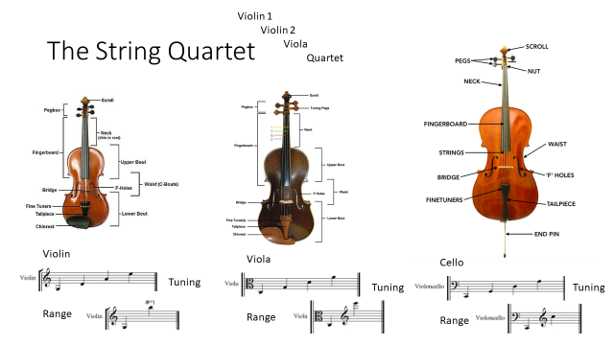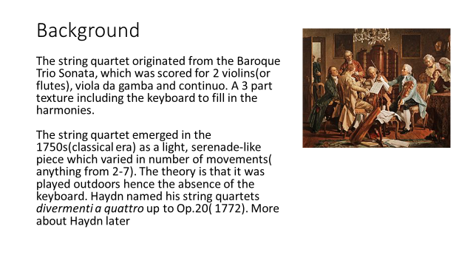

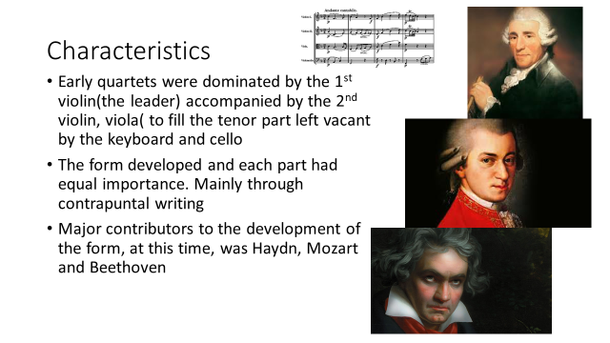

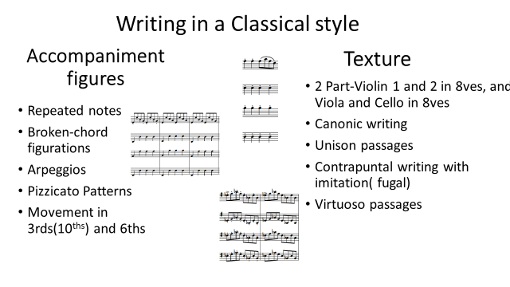

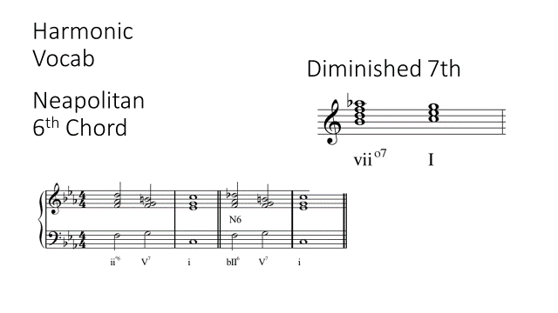

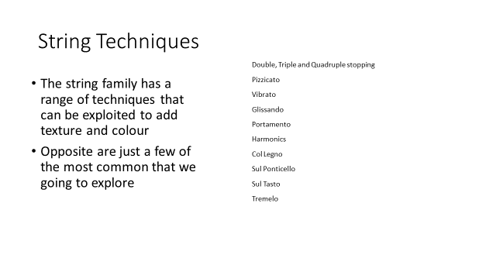

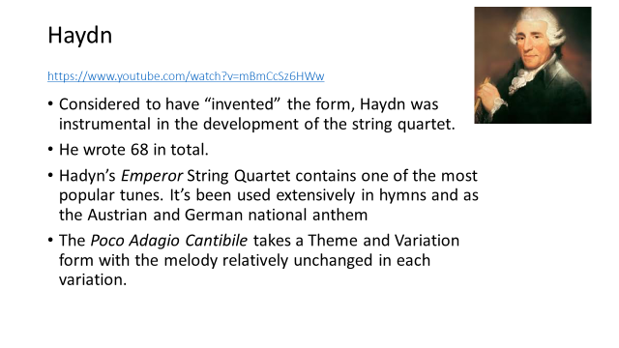

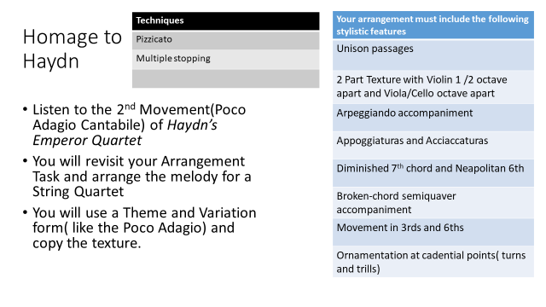

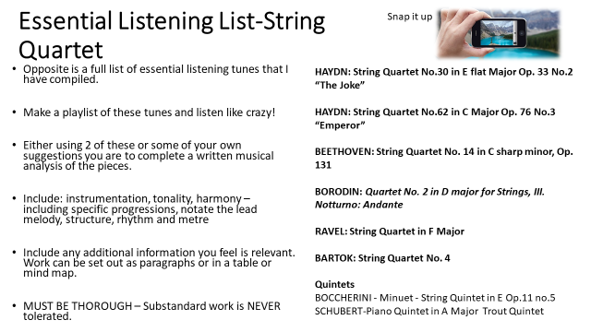

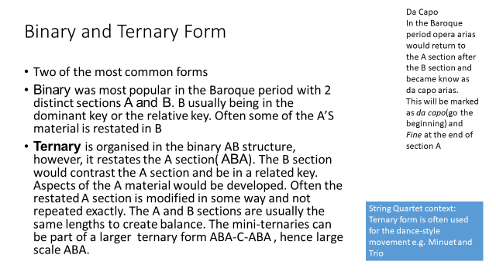

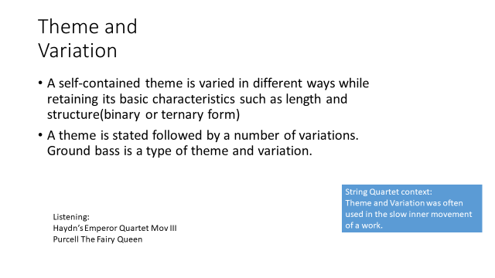

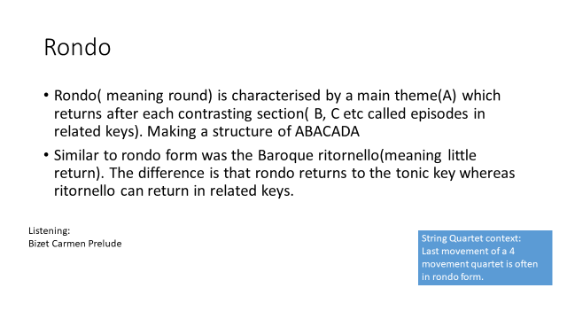 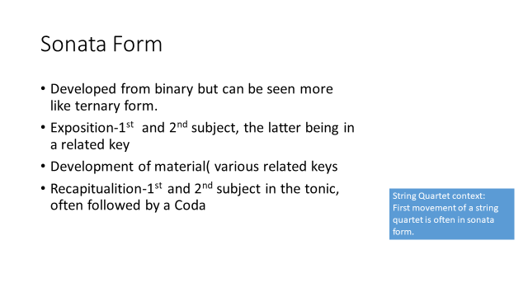 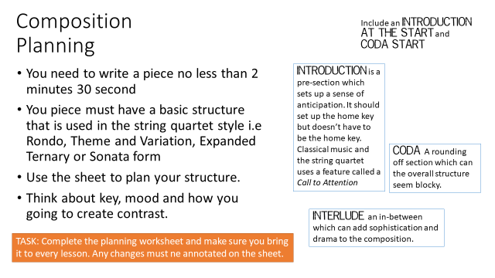 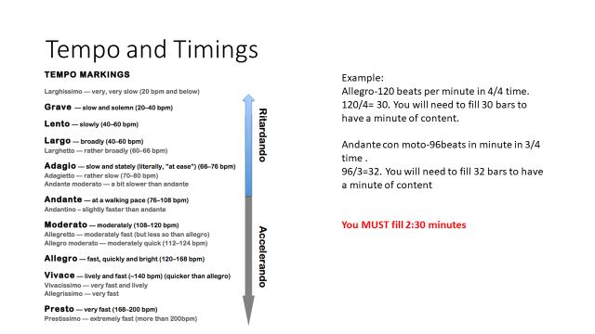

1. Unison “call to attention”

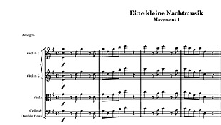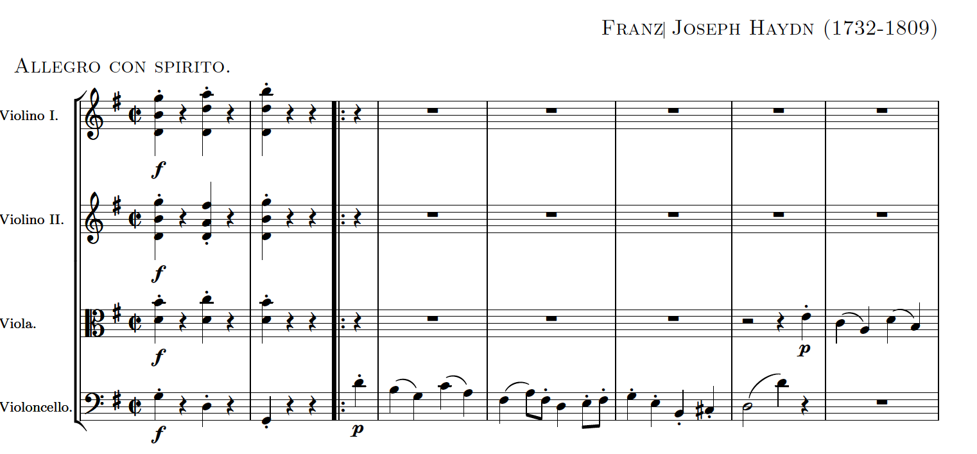

1. A melody with *Alberti Bass* accompaniment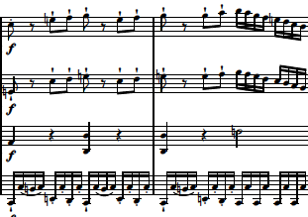
2. *Trommelbasse* accompaniment passage

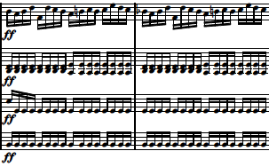

1. Unison 8ve melody passages( Violin 1 /2 or Viola and Cello)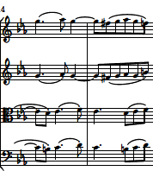

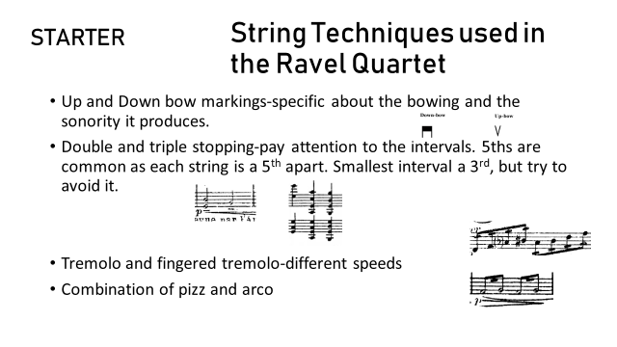

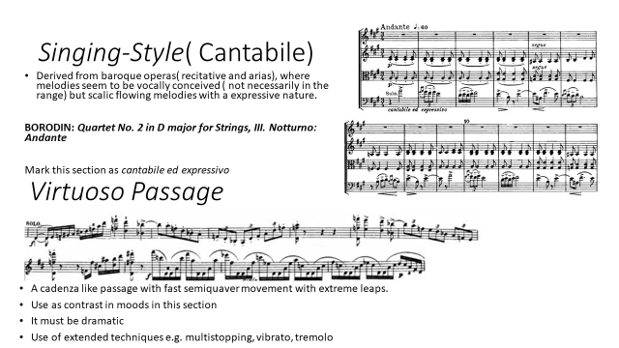

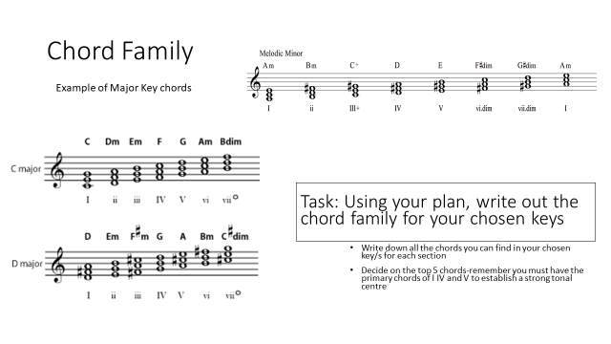 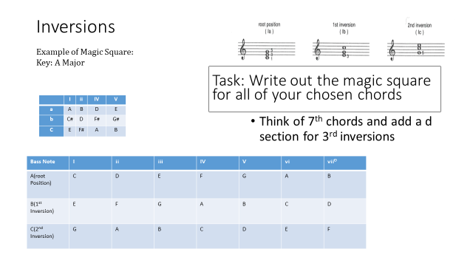 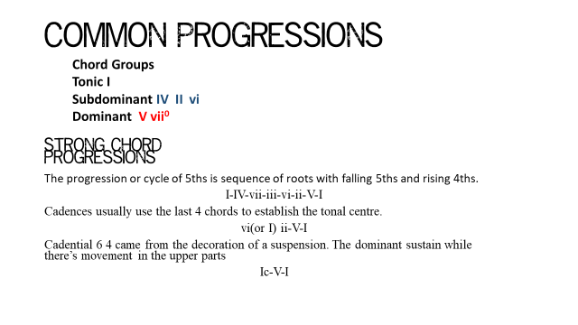 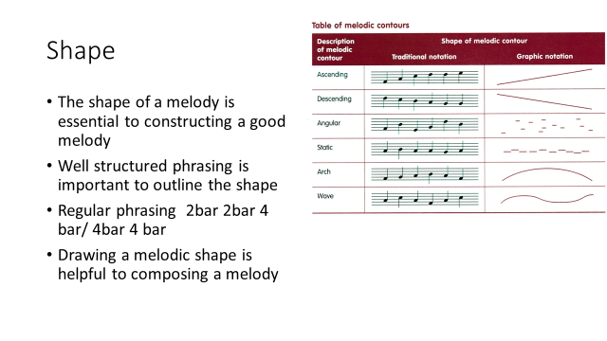 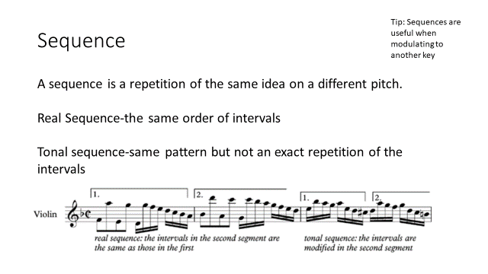 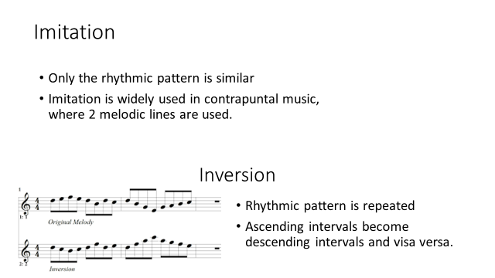 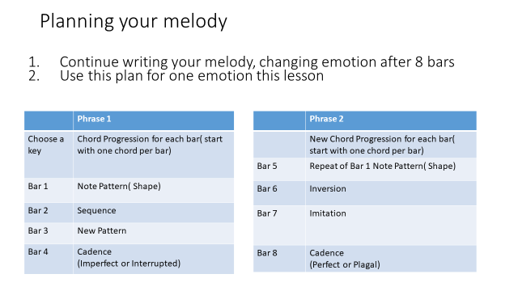 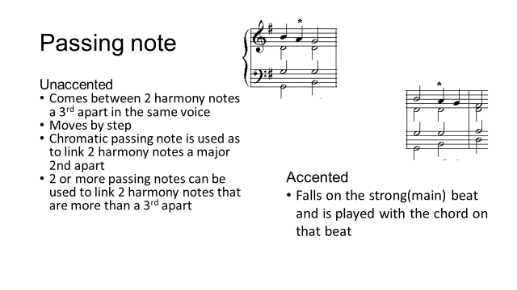 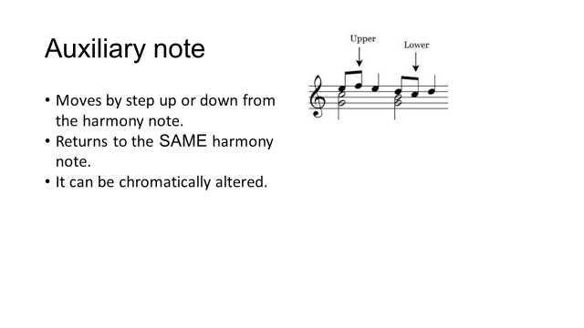 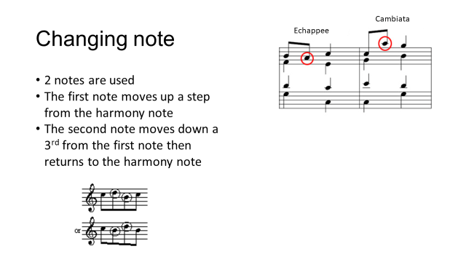 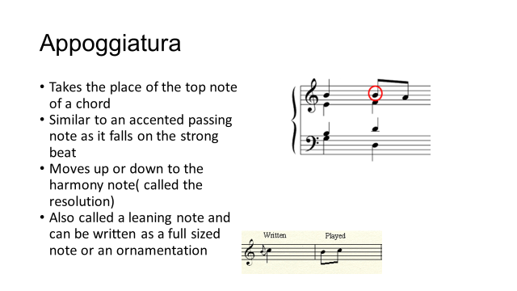 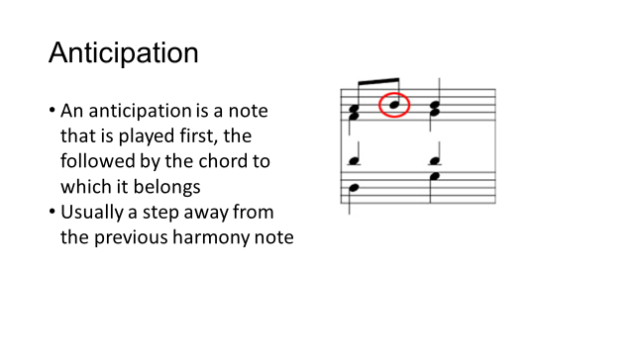

String techniques

