**A Level Film Studies**

Aims and Context

WJEC / Eduqas, the Film Studies exam board expects you to write a document discussing the aims and context of your coursework before you start. It is a good idea to brainstorm a few different scenarios before settling on the one you wish to develop. Once you have decided on an idea, narrative structure and style for your piece please complete the following document.

**Idea Aims**

*Consider the following questions:*

1. What is the genre of your idea?

*Write a brief sentence stating your chosen genre….*

1. What is the narrative structure of your sequence and what takes place during each scene? Consider; flashbacks, voice over, three act structure, linear or nonlinear storylines . . .

*Write a brief sentence explaining your narrative structure…*

1. Who are the characters in your sequence? Create a back story for each character. What is their motivation in your sequence?

*Write a brief sentence for each of your main characters- describe character traits, motivation, key costumes and props…*

**The Context**

*Consider the following questions:*

1. What are you making and why? (Screenplay / storyboard) or Short film)

*Write a brief sentence stating which medium you are planning to work on…*

1. What other work (films, directors, cinematographers, actors) have inspired or influenced you?

*Write a brief sentence stating what professional films have inspired your idea…*

1. What kind of style (visual and audio) do you hope to achieve?

*Finally, write a brief sentence discussing a particular element of film form you are planning to focus on…*

This document should be word-processed and approx. 250 words

**Deadline:**

Friday 7th January 2022 - E1 & GC1

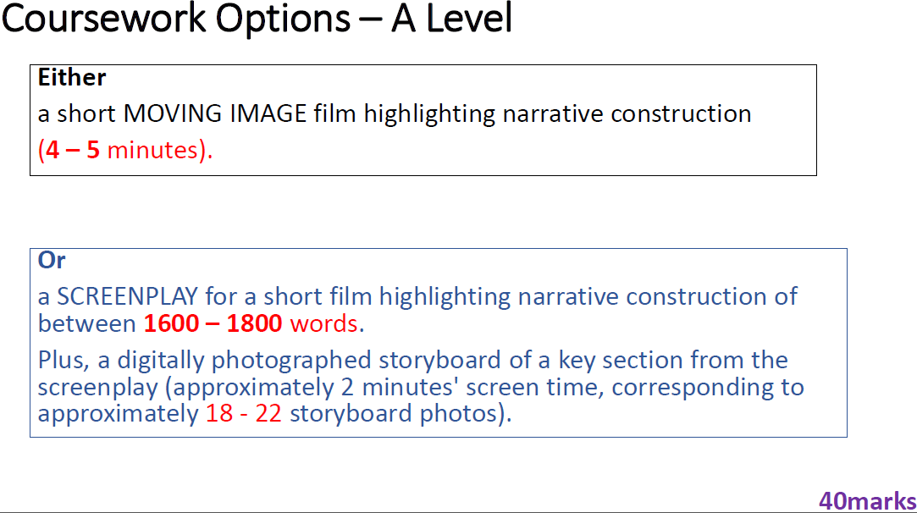

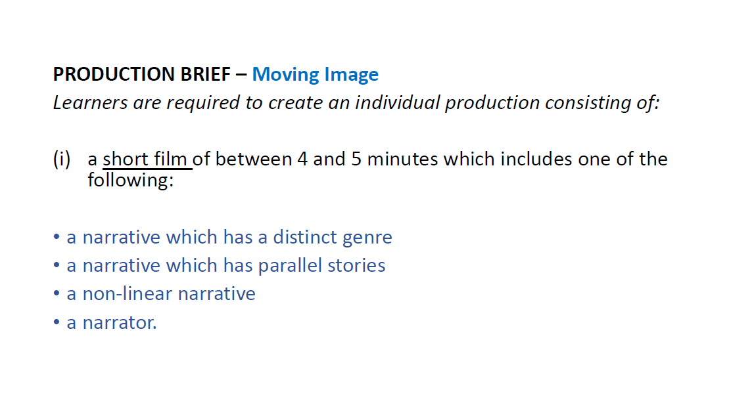

**Or**

