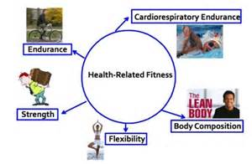

**Unit 14: Exercise, Health & Lifestyle**

Submission Date: Monday 20th January 2020

**Task 3 ‘6 week health-related physical activity programme’**

You must include the following in a written document:

* Collect information from your client on:
  + Clients background on lifestyle, medical history, physical activity history and motivation and attitude to types of exercise activities.
  + Goals – 2 short, 2 medium & 2 long – one based on aerobic endurance and one on strength as in the national government guidelines. These should be SMART targets.
* Use principles of training, FITT principle, appropriate activities & intensity for your client to construct a 6-week health-related physical activity programme. Use the attached structure to complete the 6-week timetable for your client.
* Within the short written document describe the following:
  + Specificity – How did you make the programme specific to your client? (Think about what they already do and what you have kept the same)
  + Progression – How did you progress your client over the 6 weeks?
  + Overload – How did you ensure they worked hard enough to see adaptations occur?
  + Reversibility – How did you ensure reversibility did not take place?
  + Tedium – How did you ensure the programme was varied to ensure your client was not bored?

