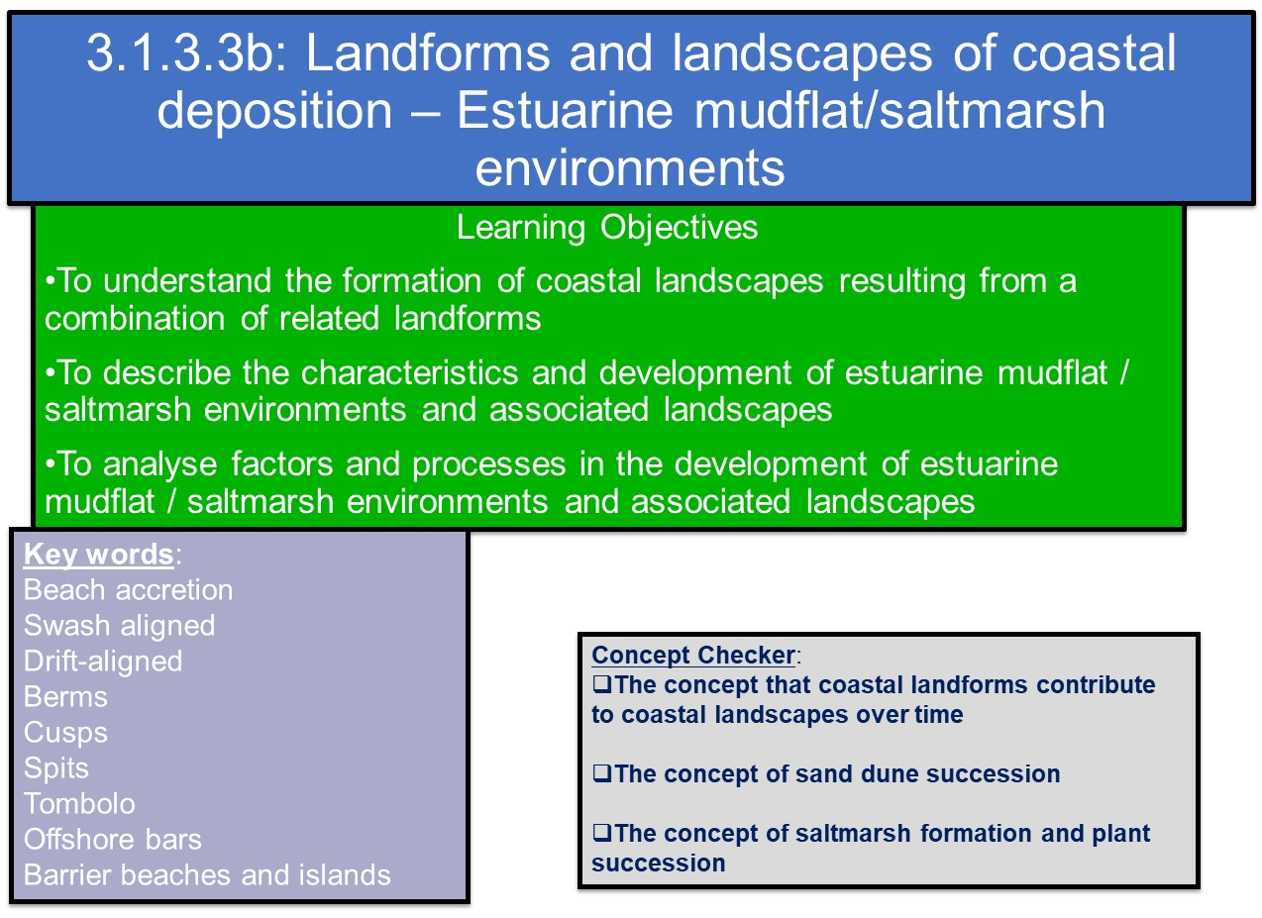

Depositional features at the coast may be temporary (beach cusps) or longer-lasting (spits), but others are transformational; they undergo change from one form to another over relative short periods of time measured in decades. Environmental habitats at the coast alter as a result of plant succession.

Mudflats and Salt Marshes

Research mudflats and saltmarshes using the links here.

- Salt Marshes

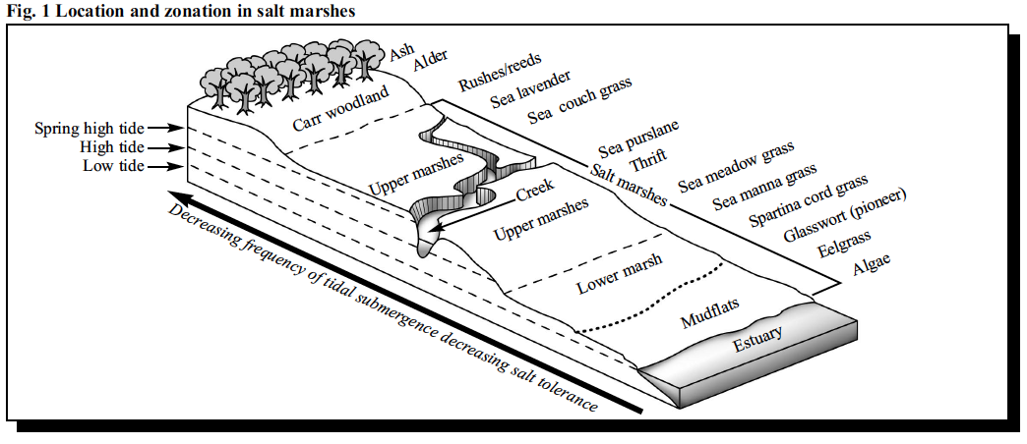

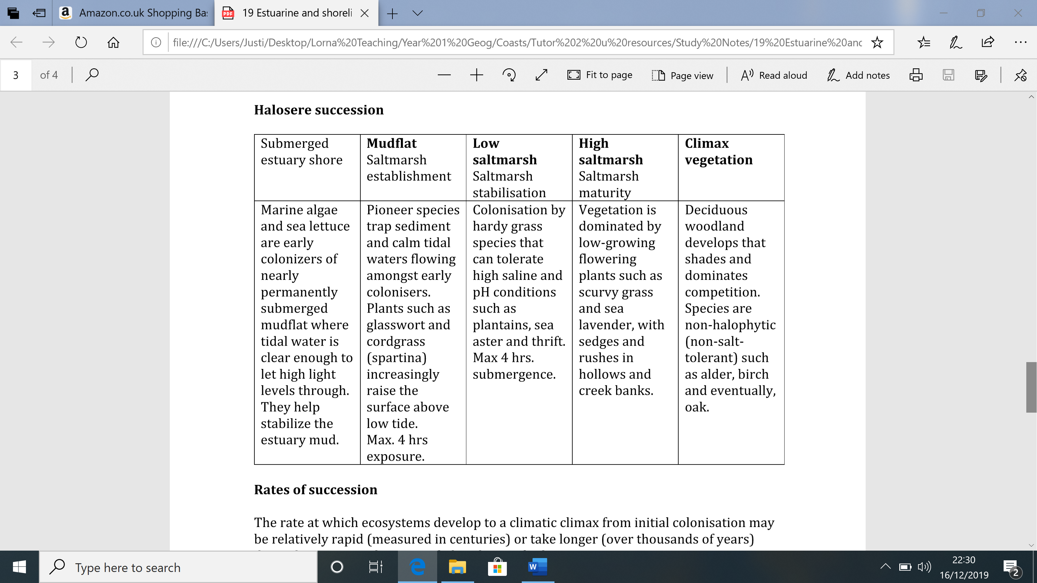

TASK:

Read the Geofactsheet No 124: “Salt Marshes Cinderellas or Ugly Ducklings in the Coastal Environment?”

Write up full answers to the following questions:

- Draw an annotated diagram to explain how a halosere develops.
- Examine the threats facing saltmarshes in the UK, both directly and indirectly. Do you consider these threats to be more related to natural or human causes?
- Using the Severn Estuary Case Study of a salt marsh area (see Godalming Online Folder 7 Estuarine and Saltmarsh Environments) and the case study of Key Haven marshes:
  - compare its value as an ecosystem and
  - the threats facing it.

- Annotated diagram:

- Threats facing saltmarsh (human and physical):

- Case study comparison:

 | Key Haven marshes | Severn Estuary
Ecosystem importance
Threats facing marsh

- Create a Revision Tool
Produce a revision style resource (sheet) detailing the formation of estuarine mudflats and salt marshes.
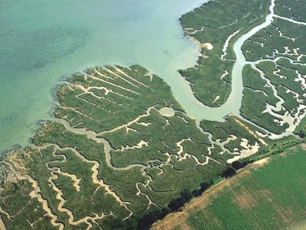

The resource should include the following:
- An annotated sketch/ diagram showing its characteristics
- a flow diagram giving a sequenced explanation of formation – explaining processes of in their development.
- factors affecting their formation - reference to inputs, processes and outputs of coastal landscapes
- a named illustrative example (not developed case study) from a local UK area, e.g. East Head Spit, and one from beyond the UK
- include maps of each case study and images
- a summary of the timescales involved in the formation of the landform – find maps of changing landforms

Your target audience is fellow A level students

Please do not just cut and paste chunks of writing. Make the work your own.

- Further reading / research to understand saltmarsh environments

Estuarine mudflats in Pembrokeshire (useful for researching a case study) (http://www.pembrokeshirecoast.wales/Default.asp?PID=149)

Background information on mudflats
(http://www.geography-site.co.uk/pages/physical/coastal/mudflats.html)

Summary of saltmarshes
(http://www.geography-site.co.uk/pages/physical/coastal/saltmarsh.html)

Simple animation illustrating the locational relationship between mudflats and saltmarshes (https://oceanservice.noaa.gov/education/kits/estuaries/media/supp_estuar06a_saltmarsh.html)

Video of estuarine environments in Cardigan Bay in west Wales (https://www.youtube.com/watch?v=LGOECERzlws)

Estuarine environment beyond the UK: saltmarshes in the USA (https://www.youtube.com/watch?v=3HXyTMnj7ac)

Videos giving aerial views of estuarine mudflat (http://www.gettyimages.co.uk/detail/video/crossing-morecambe-bay-stock-video-footage/558298865) and salt marsh landscapes at Morecambe Bay.(http://www.gettyimages.co.uk/detail/video/morecambe-bay-stock-video-footage/559381239)

http://www.theseashore.org.uk/theseashore/Saltmarsh%20Section/Saltmarsh%20introduction.html

- Complete the review questions below: Estuarine and shoreline successions

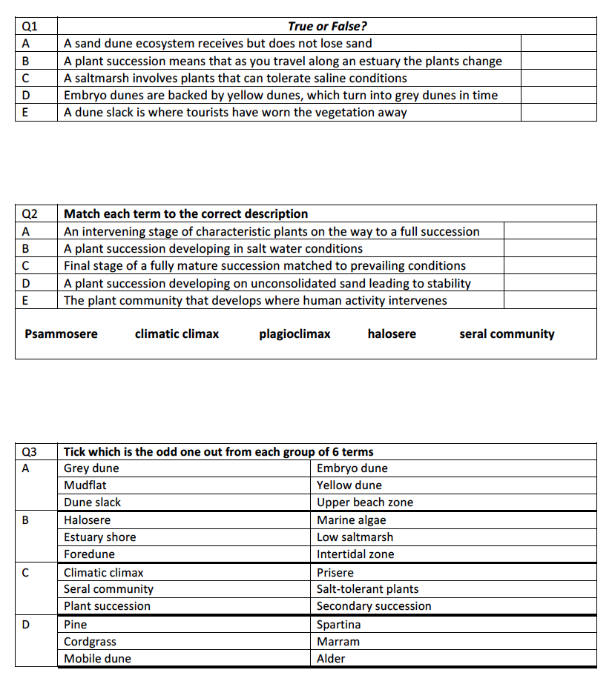
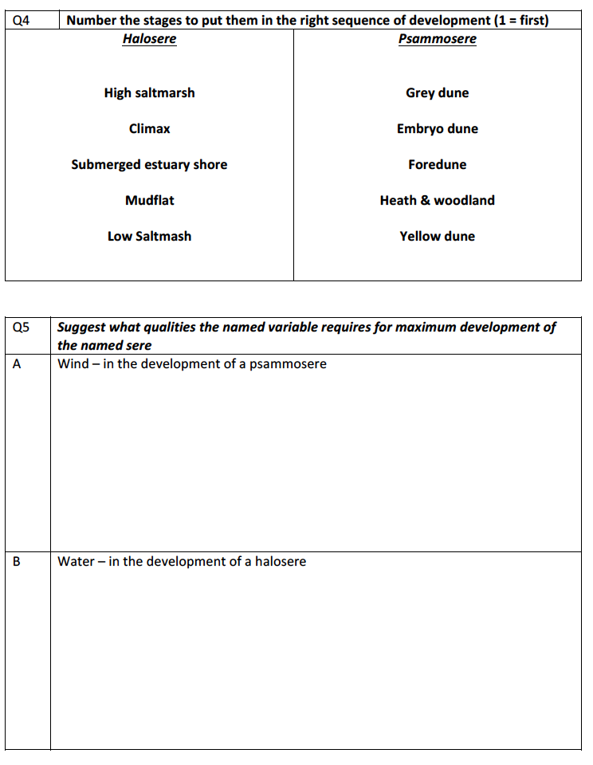

Exam Style Questions

Explain the development of a saltmarsh (6 marks)

