BTEC Health and Social Care Name………………………………

Unit 1: Human Lifespan Development

**C: Effects of ageing**

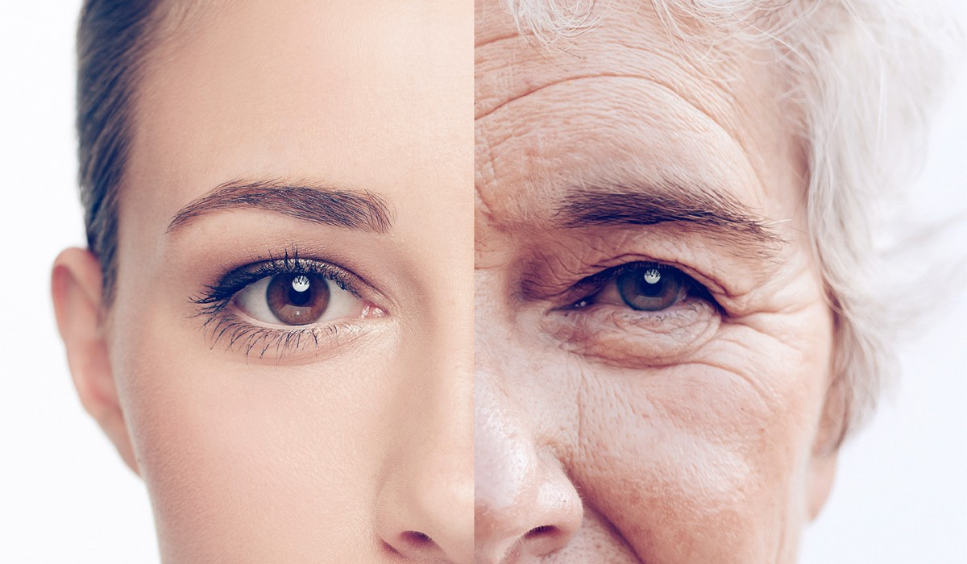

Contents

C1 the physical changes of ageing 3

Cardiovascular disease 3

Degeneration of nervous tissue 4

Parkinson’s disease 5

Osteoarthritis 5

Degeneration of the sense organs 6

1. Taste 6

2. Touch 6

3. Sight 6

4. Hearing 6

Reduced absorption of nutrients 8

Dementia and Alzheimer’s disease 9

Effects of illnesses that are common in ageing 10

How can lifestyle choice affect the impact of ill health on older people? 11

C2: The psychological changes of ageing 12

Self esteem 12

Effects of social change 13

Financial concerns 13

Social Disengagement theory 14

Activity theory 15

C3 The societal effects of an ageing society 16

Health and social care provision for the aged 16

Types of provision 17

Economic effects of an ageing population 19

# C1 the physical changes of ageing

## Cardiovascular disease

Changes in the heart with aging:

This is where the arteries narrow as cholesterol builds up (called **atherosclerosis**). It leads to high blood pressure and fatty deposits falling away may cause blockages

High blood pressure can cause:

What might happen if arteries become blocked?

Why may people get cardiovascular disease?

How might cardiovascular disease affect someone’s development (PIES) ?

## Degeneration of nervous tissue

As we age our nervous tissue also ages and impulses become slower. This can cause:

………………………………………………………………..

………………………………………………………………..

………………………………………………………………..

………………………………………………………………..

………………………………………………………………..

………………………………………………………………..

What can make the degeneration of nervous tissue worse?

### Parkinson’s disease

What is Parkinson’s disease?

Physical effects

……………………………………………………..

……………………………………………………..

Cognitive effects

……………………………………………………..

……………………………………………………..

……………………………………………………..

## 

## Osteoarthritis

This is due to swelling in the joints, as the soft tissue is damaged. It makes walking and climbing stairs difficult.

Risk of osteoarthritis is increased by:

……………………………………………………..

……………………………………………………..

……………………………………………………..

……………………………………………………..

……………………………………………………..

……………………………………………………..

## Degeneration of the sense organs

### Taste

Why does taste reduce as we get older?

………………………………………………………………………………………………………………………………………………………

………………………………………………………………………………………………………………………………………………………

………………………………………………………………………………………………………………………………………………………

………………………………………………………………………………………………………………………………………………………

### Touch

How does touch change as we age?

………………………………………………………………………………………………………………………………………………………

………………………………………………………………………………………………………………………………………………………

………………………………………………………………………………………………………………………………………………………

………………………………………………………………………………………………………………………………………………………

### Sight

What can happen to our eyes and eyesight as we age?

………………………………………………………………………………………………………………………………………………………

………………………………………………………………………………………………………………………………………………………

………………………………………………………………………………………………………………………………………………………

………………………………………………………………………………………………………………………………………………………

………………………………………………………………………………………………………………………………………………………

………………………………………………………………………………………………………………………………………………………

………………………………………………………………………………………………………………………………………………………

………………………………………………………………………………………………………………………………………………………

### Hearing

What problems with hearing can someone experience as they age?

………………………………………………………………………………………………………………………………………………………

………………………………………………………………………………………………………………………………………………………

………………………………………………………………………………………………………………………………………………………

………………………………………………………………………………………………………………………………………………………

………………………………………………………………………………………………………………………………………………………

**Social and emotional effects of sense organs degenerating**

## Reduced absorption of nutrients

|  |  |
| --- | --- |
| Essential nutrient | Effects of deficiency |
| Vitamin D |  |
| Calcium |  |
| Vitamin B12 |  |
| Magnesium |  |
| Omega-3 |  |
| Potassium |  |
| Vitamin C |  |
| Iron |  |

## Dementia and Alzheimer’s disease

What is the difference between Dementia and Alzheimer’s disease?

………………………………………………………………………………………………………………………………………………………

………………………………………………………………………………………………………………………………………………………

………………………………………………………………………………………………………………………………………………………

………………………………………………………………………………………………………………………………………………………

………………………………………………………………………………………………………………………………………………………

|  |  |  |
| --- | --- | --- |
| **Effects of Alzheimer’s** | **Support needs** | **Who can provide the support** |
| Short term memory loss |  |  |
| Difficulty with routine tasks |  |  |
| Impairment in thinking |  |  |
| Language impairment |  |  |
| Changes in behaviour |  |  |
| Lack of judgement |  |  |
| Unable to recognise family members |  |  |
| Unable to feed or care for self |  |  |



## Effects of illnesses that are common in ageing

Think about how illness would affect the different PIES development and note them down:

|  |  |
| --- | --- |
| Development | Affects |
| **P** |  |
| **I** |  |
| **E** |  |
| **S** |  |

### How can lifestyle choice affect the impact of ill health on older people?

# C2: The psychological changes of ageing

## Self esteem

How do you think a person’s self-esteem changes as they grow into later adulthood? (consider employment, health, finances, family)

………………………………………………………………………………………………………………………………………………………

………………………………………………………………………………………………………………………………………………………

………………………………………………………………………………………………………………………………………………………

………………………………………………………………………………………………………………………………………………………

………………………………………………………………………………………………………………………………………………………

How do you think culture, religion and beliefs can change an older person’s self esteem?

………………………………………………………………………………………………………………………………………………………

………………………………………………………………………………………………………………………………………………………

………………………………………………………………………………………………………………………………………………………

………………………………………………………………………………………………………………………………………………………

………………………………………………………………………………………………………………………………………………………

## Effects of social change

## 

## Financial concerns

Almost half the older population do have financial concerns, how would this affect them in their life?

………………………………………………………………………………………………………………………………………………………

………………………………………………………………………………………………………………………………………………………

………………………………………………………………………………………………………………………………………………………

………………………………………………………………………………………………………………………………………………………

………………………………………………………………………………………………………………………………………………………

## Social Disengagement theory

What does disengagement mean?

………………………………………………………………………………………………………………………………………………………

………………………………………………………………………………………………………………………………………………………

Some common issues back up social disengagement theory try to explain how they do this:

|  |  |
| --- | --- |
| Problem | Explanation |
| Ill Health |  |
| Geographical Mobility |  |
| Retirement |  |
| Ill Health of Friends and Relatives |  |

Arguments against this theory:

………………………………………………………………………………………………………………………………………………………

………………………………………………………………………………………………………………………………………………………

………………………………………………………………………………………………………………………………………………………

………………………………………………………………………………………………………………………………………………………

………………………………………………………………………………………………………………………………………………………

………………………………………………………………………………………………………………………………………………………

## Activity theory

Havinghurst (1960s) found through his ill health that older people don’t lose interest and become isolated, they just adjust to the aging process.

Why and how do older people do this?

………………………………………………………………………………………………………………………………………………………

………………………………………………………………………………………………………………………………………………………

………………………………………………………………………………………………………………………………………………………

………………………………………………………………………………………………………………………………………………………

………………………………………………………………………………………………………………………………………………………

………………………………………………………………………………………………………………………………………………………

How can older people be supported to continue to get satisfaction out of life?

………………………………………………………………………………………………………………………………………………………

………………………………………………………………………………………………………………………………………………………

………………………………………………………………………………………………………………………………………………………

………………………………………………………………………………………………………………………………………………………

………………………………………………………………………………………………………………………………………………………

# 

# C3 The societal effects of an ageing society

## Health and social care provision for the aged

The number of older people in society has increased. Provision has to be made for these older people.

Why might older people need this provision?

### Types of provision

|  |  |
| --- | --- |
| Type of provision | What it is used for |
| Acute care |  |
| Primary care |  |
| Secondary care |  |
| Social care |  |
| Community equipment |  |
| Psychological care |  |
| Benefits and entitlements |  |
| End-of-life care |  |

**Formal healthcare** – hospitals, GPs, community nurses

**Informal healthcare** – provided by family , community or religious groups.

## Economic effects of an ageing population