**Component 1:**

***SECTION B - Media Products, Industries and Audiences***

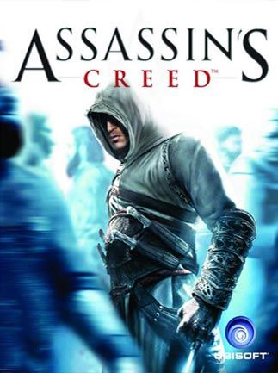

**BACKGROUND**

***Assassin's Creed*** is an open-world action-adventure stealth video game franchise published by Ubisoft and developed mainly by its studio Ubisoft Montreal using the game engine Anvil and its more advanced derivatives. The series's eponymous first title was released in 2007, and it has featured eleven main games in total, the most recent being 2020's *Valhalla*. Main games of *Assassin's Creed* are set in an open world and presented from the third-person perspective where the protagonists take down targets using their combat and stealth skills with the exploitation of the environment.

In our study of the franchise we shall be concentrating on *Assassin’s Creed III: Liberation -* developed by Ubisoft and released on October 30 2012, along with *Assassin’s Creed III*.

*Assassin’s Creed III: Liberation* offers familiar pleasures to existing fans (narrative situation of the Assassins v the Templars, open world gameplay etc.) along with new elements to target a wider audience (e.g. the use of a strong female protagonist).

**INDUSTRY**

*The computer games industry is relatively new compared with other media industries. However, it has experienced;*

***Rapid growth* –**In 2017, 32.4 million people played games in the UK. Spending **$4.2 billion**, they make the UK the 5th largest games market in the world.

***Changing attitudes to gaming*** - The playing of games is now taken more seriously, and computer games are accepted as **media texts** that are valid for study in the same way as films.

***Multi player activity which broadens the gaming experience and appeal*** *-* The profile of gaming has changed in that a gamer is **no longer** the lone teenage boy playing in his bedroom, gamers are now **all ages** and **demographics** of both genders.

**TASK ONE - How do video games appeal to audiences?**

*Brainstorm the various appeals of video games for audiences*

Appeal of Video Games?

**TASK TWO – A Brief History of Video Games**

Explore the following website:  
<https://www.computerhistory.org/timeline/graphics-games/>

Note down **three** events in this history of home gaming hardware (i.e. consoles) that you feel are significant to the development of the form. *Provide reasons for your choices.*

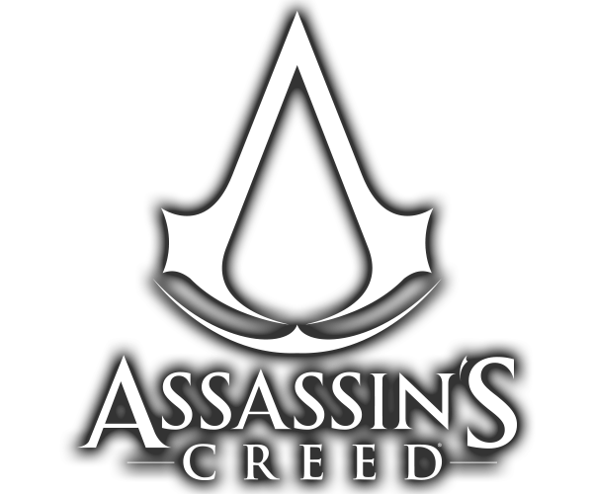

**TASK THREE - *Assassin’s Creed* Franchise Research**

Which company is responsible for the ***Assassin’s Creed*** franchise? How successful is the franchise? How far does the franchise extend (i.e. what other products form part of it)?

Which platforms are the ***Assassin’s Creed*** games released on?

What are the main historical frameworks for each of the games?

Do all the games all have the same main character?

How were the games received critically?

**ECONOMIC & POLITICAL CONTEXT**

Video games are culturally and financially significant across three major territories (**Japan, Europe** and the **USA**).

The release of new gaming **technology** (PS Vita is considered part of the 8th generation of game technology) or games from popular franchises can be major **economic events**.

Like any other media industry, there are **a number** of major players that dominate the games market. These include –

* TENCENT (China)
* SONY INTERACTIVE ENTERTAINMENT
* XBOX GAME STUDIOS
* NINTENDO
* ELECTRONIC ARTS
* ACTIVISION BLIZZARD
* [UBISOFT](https://www.ubisoft.com/en-gb/)

The *Assassin’s Creed* titles are developed across Canada, France, UK and Italy. **Multinational** development is typical of game production in larger studios such as Ubisoft. Wikipedia lists over **40 subsidiary companies** of Ubisoft around the world.

**CONVERGENCE & PLATFORMS & ASSASSIN’S CREED III**

Technological convergence is increasingly prevalent in the information technology world; in this context, the term refers to the combination of two or more different technologies in a single device.

The **PSVita** is a combination of computer game console and handheld Wi-Fi / Bluetooth / 3G accessible device.

The game itself is digitally convergent –bring high game **production values** to  
the emerging new mobile gaming arena. Its release on the PSVita was an excellent opportunity to introduce the new platform’s capabilities.

It is significant that the game was originally exclusive to the PS Vita but was later (2014) released in a modified HD version across a large range of consoles and **platforms** (including PS3, Xbox 360 and Microsoft Windows). It is also significant that the *Assassin’s Creed III: Liberation* **hand held game** could be linked to the full PS3 **console version** of the game (owning both versions would unlock additional game content). This use of **convergence** is relevant in terms of promotion/marketing and circulation.

The **internet/Wi-Fi functionality** of the PS Vita allows users opportunities to download additional content (DLC) such as weapons, characters and “skins” or outfits. It also affords users the chance to engage in **multiplayer versions** of the game. *These features promote gamer engagement and identification with the game.*

**TASK FOUR - write a paragraph on the following:**

*How does industry ownership affect video game production? Use* ***Assassins Creed III - Liberation*** *to help make your points.*



**David Hesmondhalgh**

David Hesmondhalgh’s ideas surrounding the ***cultural industries*** suggest that entertainment companies attempt to **minimise risk** and **maximise audiences**

.

Explore the articles on the marketing of *Assassin’s Creed Origins / Assassin’s Creed III* and *Assassin’s Creed Valhalla*. Make notes on the strategies used by Ubisoft to ensure the products are successful.

[**https://www.marketingsupply.co/blog/video-game-digital-marketing-we-love-assassins-creed-origins/**](https://www.marketingsupply.co/blog/video-game-digital-marketing-we-love-assassins-creed-origins/)

[**https://www.gamesindustry.biz/articles/2012-11-12-marketing-murder-the-secrets-of-selling-assassins-creed-iii**](https://www.gamesindustry.biz/articles/2012-11-12-marketing-murder-the-secrets-of-selling-assassins-creed-iii)

[**https://www.theoneswhocamebefore.com/valhalla-marketing-campaign**](https://www.theoneswhocamebefore.com/valhalla-marketing-campaign)

**TASK FIVE - How does the marketing campaign for the Assassin's Creed titles minimise risk and maximise profit?**

**Assassin’s Creed** is an established franchise with a large fan-base. Ubisoft clearly attempt to harness the popularity of this franchise to encourage sales of any new games the series.

**Ubisoft’s** marketing of the games uses familiar tropes that are recognisable to fans of the franchise:

*Historical settings*

*Fantasy cover art*

*Familiar fonts*

*Similar regulatory certificates – 15 and 18 – suggest similar graphic content*

Most video games are marketed towards a male audience, so it could also be argued that **Ubisoft** were taking a risk by launching *Assassin’s Creed III - Liberation* on the PS Vita by introducing a female protagonist. Previous games have allowed players the option to play as a female avatar, although *Liberation* leaves the player with no choice.

**Casual gaming** has seen an increase in female video game players and Sony have suggested that the PS Vita was partly designed to appeal to a female audience; described by PlayStation Europe boss Jim Ryan as the “*untapped holy grail of gaming”.* This may go some way to account for the decision to **maximise audiences**

*Assassin's Creed III – Liberation’s* **subject-matter** – American slavery in the 1700s – could also be seen as a risky move. It was the first time that the franchise had dealt with the topic from the perspective of a strong black (female) character. Some critics and fans felt that Ubisoft were only partially successful in this.

# TASK SIX – Read the following article from *gamesindustrybiz.com* and highlight relevant marketing techniques employed by Ubisoft

# Marketing murder: The secrets of selling Assassin's Creed 3

## *Geoffroy Sardin on starting early, cinema, Vita sales and going beyond the release day numbers*

Assassin's Creed III sold 3.5 million in its first week, double what its predecessor Assassin's Creed: Revelations managed this time last year. Here, Ubisoft's chief sales and marketing officer Geoffroy Sardin explains to GamesIndustry International how Ubisoft made that happen.

“It's not about doubling the investment, it's a question of communicating in advance with a lot of assets,” explains Sardin, who has been with the company since 1998. “We wanted to address and involve the consumer in advance, especially digitally. And through the marketing website to have direct contact in advance with the dev team, through our forums and community tools. To ask the community what they want and what they don't want. What they understood and what they didn't.”

Of course the people spending time on the Ubisoft forums are probably already a pretty sure bet when it comes to Assassin's sales, but the aim for this year really was introducing new people. “Our goal was to involve new consumers and I think the proof is here now with the first figures we communicate, we doubled the numbers on the week one compared to last year."

He says the new setting and hero helped towards that goal, giving people who perhaps weren't familiar with Ezio an entry point into the franchise. Also key was finding ways to reach people using new media, both social and mainstream. “Especially in the UK," says Sardin. "We decided with the team to use new media with the cinema. We supported in the summertime a huge campaign of advertising in the cinema, using a new type of communication based on the [Rise campaign](http://www.youtube.com/watch?v=Boy11rMf50Q), a short movie using new emotions in our communication for the brand. It was brand new and well executed."

“After that we used all our social websites and Facebook front page, and we recruited more than 2 million more on our Facebook fan page this year and those 2 million people more are new fans. So in a nutshell new media, quality, and social websites.”

He adds that if you turn on the TV in the UK this week you can expect to see a lot of Assassin's Creed III advertising there too. “It's not a question of changing and shifting our way to communicate, it's to combine all the media to reach our target.” And in this time of massive triple-A titles all competing for the Christmas sales, getting your game in people's minds early can make a huge difference.

“The marketing strategy was focused on consumer point of view in advance. It's not about spending money after launch, it's before launch,” says Sardin, pointing out that they first revealed the game in March, a full nine months before release.

Of course Ubisoft isn't just selling one Assassin's Creed game on release day, it is selling two, with Assassin's Creed: Liberation on PlayStation Vita released simultaneously. “It's the first time we've proposed another experience on another format, but there are some links between both of the games. The consumers are aware that Aveline, the main character on the Vita format, could have a future in our history for the Assassin's Creed brand, and the second thing is we wanted to bring a new experience using the features of the Vita. For now we are super happy with the first results we have got on the Vita, it is the biggest launch for week one for 2012, and it's the first Vita product for this end of the year.” He adds that the tactic “could give some ideas for another franchise, for sure.“

As for the future beyond release, Sardin hopes that the size and prestige of the franchise, complete with books, merchandise, an upcoming film starring Michael Fassbender and DLC will keep Assassin's Creed 3 selling long past day-one. “We announced a season pass [for DLC] and it was the first time we've done that for the Assassin's Creed brand. It could grant a better life cycle for sure."

“Another thing that is very important for the lifecycle is the transmedia offer. All the figurines, the books, the publishing, and we have a movie in the next coming year. So it's not only about games, we are talking about a global brand, and this is the life cycle management we want to set up now.”

**Now match Ubisoft’s marketing tactic in the left hand column with the explanation in the right hand column.**

|  |
| --- |
| Anticipation for a game can be built up and ensures that there is a significant interest on release of the game. |
| Fans of the franchise feel their input is being taken on board and feel part of the development of the game. |
| The franchise having products across a range of media leads to more focus on the product. |
| Interactive sites can increase involvement of the audience and encourage sharing amongst fans. |
| High quality marketing leads to an association that the game will also be high quality. |
| The availability of the game ensures audiences are not excluded. |

|  |
| --- |
| Cinematic trailer |
| Facebook and other social media marketing |
| Co-release across platforms |
| Continued presence through other creative industries |
| Interacting with fans on Ubisoft forums |
| Early reveal |

The video game industry offers many comparable examples of attempts to use software (games) to sell hardware (games systems and platforms).

**For Example** – in 2012 Nintendo failed to find an audience with the launch of ***Wii U*** – their console designed to compete with Sony's **PlayStation 4** and Microsoft's **Xbox One**. When launching the Nintendo ***Switch*** in 2017, they learnt that a huge part of a console’s success comes from the choice of games on offer to the audience.

**TASK SEVEN - Read the following article from the website Gamecrate - Breaking Down Nintendo’s Switch Strategy. Identify (highlight) how the company intelligently used its software to launch the new hardware console.**

**BREAKING DOWN NINTENDO’S SWITCH STRATEGY**

**Mar 27, 2018** by:[**Angelo M. D'Argenio**](https://www.gamecrate.com/author/angelo-m-dargenio)

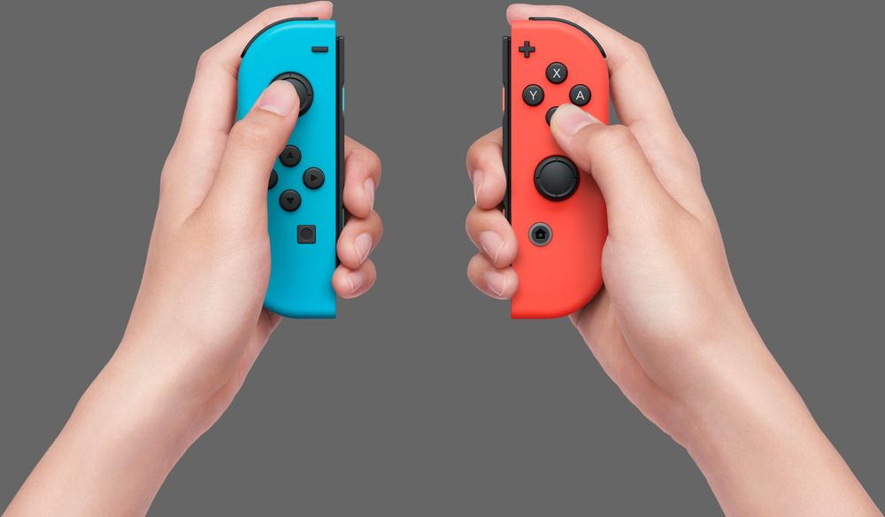

It’s no secret that the Nintendo Switch is doing fantastic right now, but there’s more to the Switch’s success than its portable gimmick and Nintendo exclusives. Nintendo learned a lot from their failure with the Wii U. Specifically, they learned that a huge part of a console’s success comes from marketing. So what is this new strategy Nintendo has employed and why is it working so well? Let’s take a look.

**Experimenting With New Genres**

The first phase of Nintendo’s plan was to release a bunch of games in genres they aren’t known for. *Arms* was their first foray into the fighting game genre since *Smash Brothers*, while *Splatoon* continued a tentative reach into the FPS genre. *Breath of the Wild*, Nintendo’s most successful launch title, revamped the Zelda franchise to focus on open world gameplay, another genre that Nintendo has rarely experimented with.

Every time a new console comes out, Nintendo swears that they aren’t going to be the same old family friendly company, and that hardcore gamers are going to find a home on their console. The issue with this marketing plan is that Nintendo only ever releases the same old family friendly games in the same old family friendly genres. They rely on third party developers to give them “hardcore” content, and since Nintendo consoles are always more difficult to develop for than other consoles this well runs dry quickly.

While *Splatoon*, *Arms*, and *Breath of the Wild* are clearly family friendly, the FPS, Fighting Game, and Open World Game are some of the most popular “hardcore” genres out there. This has given the more hardcore fanbase hope that Nintendo will take initiative to deliver new IPs in new genres outside of their comfort zone. This, in turn, increases the consumer base for the Switch, actually opening it up to the extended hardcore crowd which Nintendo has wanted to hook for years. When further hardcore titles, like the upcoming *BlazBlue Cross-Tag Battle* release, they will draw the hardcore fanbase in even deeper.

**Releasing Ports Of Older Games**

The Wii U was not a bad console, it was just unpopular. The Wii U’s game lineup was filled with quality games. In fact, the average review score of Wii U games was higher than the average review score for the PS4 and Xbox One at the time of its death.

So of course Nintendo is going to take this opportunity to expose a new fanbase to older games. We already saw them rerelease *Mario Kart 8* and a *Hyrule Warriors* rerelease is incoming. *Smash 5* may be a combination of rerelease and totally new game. Heck, even *The World Ends With You* is hopping off the DS and onto the Switch.

The Switch offers these gamers a chance to play very high quality games that they just didn’t have access to in previous generations. Note that Nintendo will eventually run out of titles to remake if they keep pushing this strategy, and in a year or two Nintendo is going to have to reach out to third party developers for some major killer apps. For now, this alone should keep the Switch afloat, even if Nintendo wasn’t developing a ton of first party exclusives.

**Lots Of Information Over A Short Period Of Time**

Surprise! Nintendo is releasing a new game and releasing it in a few months! This has been the pattern of Nintendo announcements over the past few years.

Why would Nintendo do this? Hype is a double edged sword. Hype can make you excited for an upcoming game, boosting Day One sales, but if you let hype linger for long enough it builds beyond the scope of what a development team can deliver. The longer the development cycle the harder it is to meet expectations, eventually leaving you with another *The Last Guardian* or *Duke Nukem Forever.*

Nintendo has seemed to learn this lesson well and has done their best to keep their hype cycles condensed. Fans will hear murmurings of a project years in advance, but Nintendo won’t announce anything definite until mere months before a game’s release. For example, we just got our first official announcement for *Smash 5*, and it’s coming out this year. The next*Fire Emblem* is also scheduled to come out this year, and we have nothing more than a title.

Come E3, however, Nintendo is going to dump a TON of info onto us about their upcoming titles. We aren’t just going to see trailers. We are going to see gameplay videos, interviews and much more. We are going to have a very, very clear picture of what Nintendo has in store. In a way, this is Nintendo’s method of managing expectations. If they bombard us with information, then we can get hyped over that info, rather than getting hype over our own speculation.

Nintendo has followed this pattern for the past few years, even before the Switch was released. It’s a marketing strategy that could work well for them in perpetuity. There’s only one problem: if a new Nintendo Direct comes out and they don’t absolutely blow us away with new info, then hype will die down very quick.

**Reducing Peripheral Dependence**

One of the biggest worries about the Switch in its early days was hidden costs. The Switch was $300, but when you factored in the costs of extra controllers, extra charges, software and more, you were looking at spending $800 or more on a console. It was a hefty investment.

Luckily, Nintendo has done a lot to put those worries at ease. Nearly every major Nintendo Switch release has been able to be played with just the two JoyCons. Multiplayer games can be played with a JoyCon each. Nothing has required an extra purchase, even though sometimes extra purchases can make controlling these games easier.

This was an incredible strategy on Nintendo’s part. It helped to alleviate the primary consumer worry for their new product. The question is, how long will this last? JoyCons are pretty rudimentary control devices, and many Nintendo titles would be served better with a pro controller, especially multiplayer titles.

**Making Games Playable in Short Chunks**

The Switch’s most appealing feature is its portability. However, all the portability in the world doesn’t matter if the game itself isn’t actually built for portable play.

What makes a good portable game? In general, any game that can be picked up at any time and put down at any time makes for a good portable game. The goal is to break down a game into small digestible chunks. The smaller the chunks the more portable the game.

Nintendo’s best titles have followed this philosophy. *Mario Odyssey* made it easy to find a moon or two before putting the game down. *Breath of the Wild* made it feel natural to turn the game off after finding or completing new shrines. Even the recently released *Kirby Star Allies* has short enough stages to allow you to play one or two on a commute.

The fact that Nintendo has managed to make their biggest games accessible in a portable setting has been a huge boon to the Switch. The question is, will their future games follow the same model?

Metroid Prime usually lends itself to hour long binge sessions, so *Metroid Prime 4 might*break this model. The same holds true for the *Shin Megami Tensei* series, which we are seeing a new installment of on the Switch. You would think that *Fire Emblem* lends itself to binge sessions, being a turn based strategy title, but the franchise found its way to the handheld space on the 3DS. Maybe Nintendo really can succeed in keeping their entire Switch library portably accessible.

**TASK EIGHT – Write a paragraph on the following:**

*How does the video games industry attempt to minimise risk and maximise audiences? Use* ***Assassins Creed III- Liberation*** *to help make your points. Don’t be afraid to make counter arguments.*

**REGULATION**

In the UK, since 2012, the VSC (Video Standards Council) have provided age ratings on games. They use the PEGI system (Pan-European Game Information).



**TASK NINE –Explore the PEGI website (**[**https://pegi.info/**](https://pegi.info/)**) and answer the following:**

What is PEGI and why was it created?

How are the games rated?

On which criteria are the ratings based?

Is the level of difficulty or quality rated as well?

Where can you find information on the content of a game?

Who checks the ratings?

Do all games have a PEGI rating?

Do retailers need to take the ratings into account?

ESRB VS. PEGI: WHAT IS THE DIFFERENCE?

* + 1. / Heather Johnson (http://media.equityarcade.com)

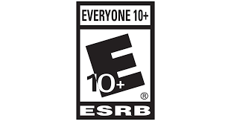If Game Tycoon 2 has taught me anything, it’s that making a game sure is tough. There’s more to game development than just creative design — there’s the production, legal, and marketing aspects that must be taken into consideration as well. Perhaps one of the most boring, uninspiring parts of video game-making is acquiring a rating — a standard procedure, especially for AAA games. Typically, they go through the ESRB, or Entertainment System Ratings Board, to receive a rating. However, there’s been a rise in popularity favouring the PEGI, or Pan European Game Information, as more and more regions begin to adopt the system.

*So, what are these rating boards anyway, and what’s the difference between them?*

Like most things in video game history, the ESRB was born out of controversy. Up until the early 90s, games were released with little regulation in regard to content and accessibility — you only knew what was in the game if you played it or a friend forgot to say “spoiler alert” before telling you the juicy details. This is how games like Custer’s Revenge and Night Trap were able to be published, despite them being terrible and rape-y.

The straw that broke the camel’s back was the beloved Mortal Kombat, a game deemed too violent and too mature for children that politicians decided it was time for them to officially meddle in video games. After years of interference, it was agreed that a rating system was needed to let parents know what kind of content their kids were absorbing through those scary, technologically advanced, new-fangled gizmos and gadgets. Much like movie ratings, the ESRB would evaluate game content and slap a letter on the game box that would indicate what age group it was appropriate for.

Simple, right? Not so much. As a former GameStop employee, I can’t even begin to tell you how many parents didn’t understand the ESRB ratings. I would have adults coming in with their 8-year-olds expecting their child to pick a harmless game to play. The kids would plead with their mother for the next GTA or CoD, and the parents would come up to the counter like it was a Mario or Kirby title — a game’s a game, right? Only I’d have to explain to them that the games their child wanted were essentially “rated R” and that “you have to acknowledge that we had this conversation in front of my supervisor; otherwise, you’ll accuse me of not explaining the concept of an ‘M’ rating to you when you come back after an hour of gameplay trying to return the game because it’s ‘too violent’, causing me to lose my job”.

It would seem that “E”, “T” and “M”, the three most common ESRB ratings, are just too complicated for parents to understand. The verbose content descriptors also fail to draw the eye, leaving the parent uninformed. Isn’t there anything easier? Something that readily tells parents and children alike what age group the game is meant for?

Enter the PEGI, the rating system based around numbers that translate to what age the game would be appropriate for. No more guessing what “M” or “T” means — with the PEGI, ratings such as “3”, “7”, “12”, “16”, and “18” easily convey what age group the game is meant for (note: this does not mean that the game’s difficulty is age-accordant…I checked, and Katamari Forever is a “3” on the PEGI so that’s proof enough). The PEGI also has small icons indicating the presence of violence, sex, drugs, and other age-appropriate themes, making it comprehensible across language barriers. Perhaps this is one of the many reasons why 30+ countries have already adopted it, including parts of Canada and Mexico. It is simply easier for the consumer to understand.

On the developer’s side, the battle rages over which is better. From a cost comparison standpoint, PEGI appears to be the winner, as the PEGI charges $300 – $2400 USD for a one-platform rating while the ESRB charges anywhere from $800 – $4,000 USD depending on the game’s development cost. However, the ESRB costs are a one-time thing; once the rating is received, it’s the same across all platforms, be it XBox, PlayStation, Nintendo or PC. The PEGI, on the other hand, charges a fee for each platform, meaning that there’s a fee for the XBox rating, a separate fee for the PlayStation rating, etc. etc. despite the fact that it’s the exact same content throughout. This may be no problem for the big league players like Square Enix and Bandai Namco, but it poses a problem for the indie developers trying to squeeze every possible penny.

Choosing a rating system is like choosing a security guard — they do their job with no real reinforcement power yet are considered a necessary evil. Getting a rating for a game may not be the most enthralling experience, but it is still a necessary part of video games. With these ratings, parents can guide their children through increasingly more adult-centred content and find a game that is suitable for their age just like movies. Whatever the system used, the PEGI and ESRB continue to quietly battle it out, unbeknownst to consumers everywhere, for the top spot as “the one and only video game rating board”.

**TASK TEN – answer the following questions**

* How do the two regulators differ? Which one do you feel is the most effective?
* Most of the *Assassin’s Creed* games (including *III: Liberation*) are given 18 certificates by the VSC / PEGI. What do you think the main classification issues are?

**Livingstone and Lunt**

Livingstone and Lunt’s consideration of the impact of convergence and diversification in media on regulatory practices, throws up a new set of problems when considering the role of new technologies.

* More convergent technologies with access to internet etc. opens up new opportunities and arguably new risks that complicate regulation and industry control:
* Protecting children and the vulnerable from online content.
* Issues of increased user addiction (this is debatable).
* Lack of control of content for the provider
* Increased breaches on institutional and user security

**TASK ELEVEN - In groups of four, discuss and come to some conclusions on the following areas. You may use the internet to help you mount your argument;**

*Should regulation be more flexible?*

*Should industries self-regulate?*

*Should individuals be empowered to make their own decisions?*

*Should individuals be expected to develop ‘media literacy’ and make informed decisions for themselves?*

**Now present your ideas to the class – be prepared to argue your case.**

**TASK TWELVE - AUDIENCE RESEARCH**

The A-level specification asks that “*learners should have knowledge and understanding of Assassin's Creed as a contemporary action adventure game in terms of the relevant video games industry and* ***audience issues*** *it illustrates”.* This means that it is important to; evaluate who the audience for the game and franchise is; consider the appeal of the game to its audience(s); apply audience theory to the text. Please complete the following tasks -

**Demographics/Psychographics**

*Research into who the target audience for Assassin’s Creed franchise is (demographic and psychographic). How does the audience for Assassin’s Creed; Liberation III differ from other titles within the franchise?*

*What pleasures might will audience gain from;*

1. *Assassin’s Creed games*
2. *Assassin’s Creed III - Liberation?*

*Have there been any controversies surrounding Assassin’s Creed III – Liberation or the Assassins Creed franchise?*

Providing evidence from the game to support, consider which audiences may take a -

**Preferred reading**

**Negotiated reading**

**Oppositional reading**

How was *Assassin’s Creed III - Liberation* received by critics*? Use extracts from reviews as evidence.*

How was the game received by the public? *Investigate user games forums, fan sites, Amazon user reviews etc. for evidence.*

**Audience: How do gamers interact with the game?**

*How do gamers interact with Assassin’s Creed III - Liberation?*

*What functions does the handheld device PSVita offer audeinces?*

*What player options are offered by Assassins Creed: Liberation on both the PS3 version and the PSVita?*

Look at the following resource and answer the questions; <http://resource.download.wjec.co.uk.s3.amazonaws.com/vtc/2016-17/16-17_1-34/eng/audiences/assassins-creed.html>

**ASSASSIN’S CREED, THEORY, AUDIENCE & FANDOM**

**Albert Bandura**



Albert Bandura (1963) – suggested that reinforcement is not just external but internal too. We learn aggressive behaviour from the people we observe. We also **monitor** our own actions – if rewarded (i.e. we feel good about acting aggressively) we are more likely to repeat the action or behaviour

Bandura hypothesized -

* the idea that the media can implant ideas in the mind of the audience directly
* the idea that audiences acquire attitudes, emotional responses and new styles of conduct through modelling
* the idea that media representations of transgressive behaviour, such as violence or physical aggression, can lead audience members to imitate those forms of behaviour.

**TASK THIRTEEN**

*How can Badura's experiment be applied to video games?*

Watch the following clip from the game - [*A Fool’s Errand*](https://www.youtube.com/watch?v=D6KnFVdZjwU). *Using the extract, how can we apply these ideas to Assassins Creed III - Liberation?*

*What concerns might the game present in terms of Bandura’s theory?*

*Are gamers likely to imitate the actions they see in the game?*

*Why do audiences play games in the first place?*

**Henry Jenkins**

Henry Jenkins (born June 4, 1958) is an American media scholar and Provost Professor of Communication, Journalism, and Cinematic Arts.  He has authored over a dozen books and in 2013 he was appointed to the board that selects the prestigious Peabody Award winners.

**Theory:** *Fandom, is a term which describes communities built around a shared enjoyment of an aspect of popular culture, such as books, movies, TV shows, bands or sports teams, etc. Fan cultures are examples of participatory cultures.*

**Participatory cultures** involve fans acting not only as consumers but also as producers and creators of some form of creative media. Jenkins defines a participatory culture more specifically as one that consists of:

1. *Relatively low barriers to artistic expression and civic engagement – easy access to technology / means and production.*
2. *Strong support for creating and sharing one’s creations with others – an existing fan-base who are already active.*
3. *Some type of informal mentorship in which the most experienced members pass along their knowledge to novices*
4. *Members who believe their contributions matter*
5. *Members who feel some degree of social connection with one another and care about other members’ opinions about their contributions.*



In fan cultures, these creations and artistic expressions take the form of fan fiction, fan art, fan videos, cosplay, filk songs, and other interactions with a person, group, or fictional universe. Jenkins contrasts participatory culture with consumer culture, suggesting that fans ‘poach’ from popular media, appropriating ideas from the text and rereading them in creative ways for their own uses.

Fan interaction with media becomes a social activity, and this process allows fans to build their own communities in which they can express themselves. In doing so, they create spaces where they can critique prescriptive ideas of gender, sexuality, and other norms promoted in part by the media industry.

Fan produced image of President Obama as Star Trek’s Mr Spock

**TASK FOURTEEN**

*Watch the following Brain Stuff YouTube video - How Does Fandom Work? Provide three reasons on the reasons why fans ‘poach’ ideas from popular media.*

**-**

**-**

**-**

Jenkins also suggests that participatory culture can be a **form of resistance**. For example, fan fiction, fan videos, and flik songs often explore themes and aspects of the source material which are of interest to the female-dominated parts of the fan community, going beyond the stories the male-dominated media industry is interested in or willing to tell. He suggests that “fandom’s very existence represents a critique of conventional forms of consumer culture” while also providing “a space within which fans may articulate their specific concerns about sexuality, gender, racism, colonialism, militarism, and forced conformity.” Not only do fans actively generate their own creative material, but they often do so in ways which critique the media they are consuming.

*Now watch the YouTube video of Henry Jenkin’s talking about the power of participatory fandom. Write down three examples of how participatory culture has been used a form of resistance.*

**-**

**-**

**-**

**TASK FIFTEEN**

*In pairs, explore how fans of the* ***Assassin’s Creed*** *franchise have used the internet to participate in their fandom. Look at some of the following areas;*

* *Fan art*
* *Fan forums*
* *Fan fiction*
* *Fan sites*
* *Fan videos*

*Write a paragraph on how ideas of fandom are expressed. How do they relate to Jenkin’s ideas on participatory culture?*

Jenkin’s suggests that fans may be passionate exponents of a game or the harshest critics and can often impact the development of games directly. The internet has afford the fans a voice to air both their praise and grievances.

*Find specific examples from fan forums of where fans have used the internet to disagree with the direction the franchise has taken.*

**Henry Jenkins Vs. Clay Shirky**

Both theorists discuss the huge possibilities offered to the consumer by the internet and both theorists believe that the Web 2.0 has altered the power dynamic between producers and consumers, ultimately leading to the rise of the prosumer.



Shirky sees the internet as a breakdown between the two camps - “every consumer is also a producer, and everyone can talk back” - *so in essence the traditional idea of an audience is over.* Organizations now have to understand, and respect, the motivations of the billion new participants in the contemporary media world.



However, Jenkins views this relationship as being much more participatory – audiences use the existing work of traditional media producers (films, games, TV etc.) to re-appropriate and create their own creative and artistic expressions. *Fans don’t want to take-over the media…they want to be an active part of it.*

**Audiences – Social/Cultural contexts**

**TASK SIXTEEN - Watch the following clip from Assassin’s Creed II – Liberation –** [**Aveline meets Connor**](https://www.youtube.com/watch?v=-Wj2a7Uzgq4)

*Does the Assassin’s Creed III – Liberation’s* ***female protagonist -*** *Aveline de Grandpré - subvert or reinforces expectations of female characters in games? How audiences may* ***respond*** *to this representation?*

*Aveline is also the first black female character to have a lead role in the series. Is this possibly a case of Ubisoft trying to reach a different demographic?*

*Which aspects of Aveline’s character may female audiences identify with?*

**Essay Plans**