COASTAL MANAGEMENT – PART 2 (Sustainable Approaches)
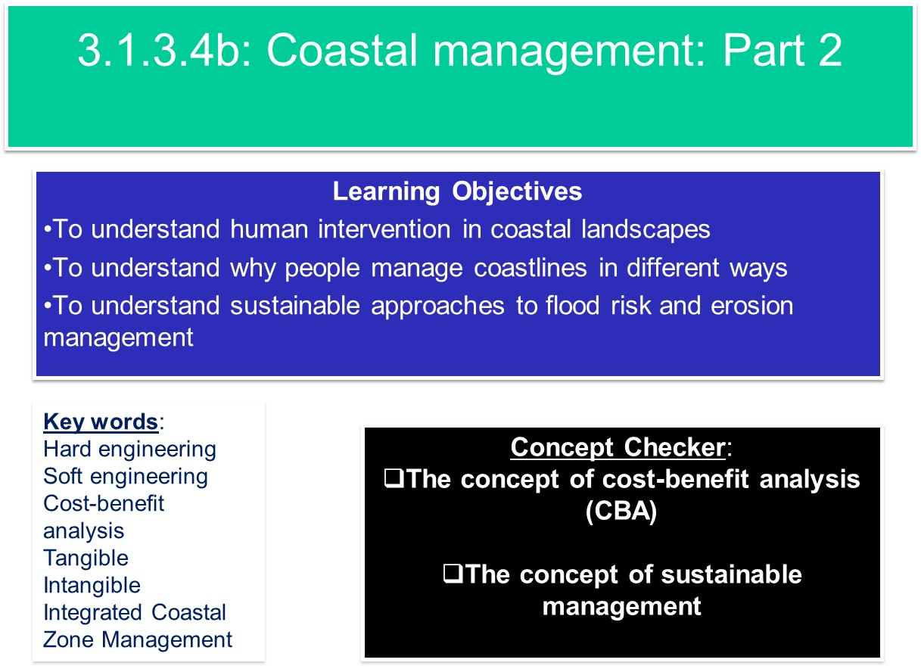
Using the information from Figure (a) explain why we need to protect the coastline.
............................................................................................
Figure (a). Landuse at the coast
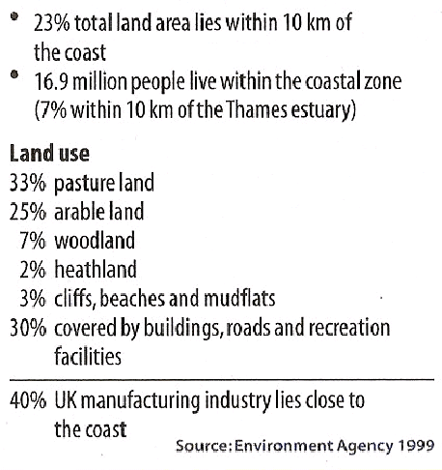
............................................................................................
............................................................................................
............................................................................................
............................................................................................
...........................................................................................
Sustainable approaches to coastal flood and erosion management
Some soft engineering schemes adopt sustainable principles, but they tend to be focused a particular stretch of coastline. Increasingly management authorities are looking at holistic management plans for significant stretches of coastline.
Policies have been adapted by the UK Government to make coastal management more sustainable and policies have developed at a global level to create a common and integrated approach around the world.
- Shoreline Management Plans
  - Introduced in 1995, 22 SMPs around England and Wales.
- Integrated Coastal Zone Management
  - Originated from the UN Earth Summit of Rio De Janeiro in 1992 (Agenda 21). The European Commission have developed a framework to promote ICZM to manage the fine balance between people, economy and environment. In 2013, the EC launched the maritime spatial planning (MSP) framework to support ICZM.

- Shoreline Management Plans
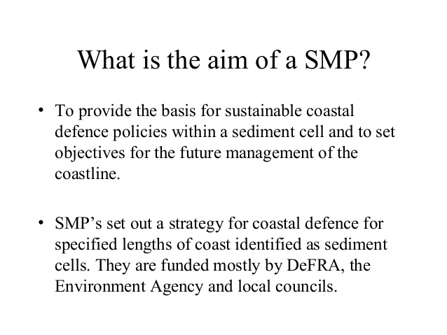
Using the images below and the textbook, describe each of the four strategy options:

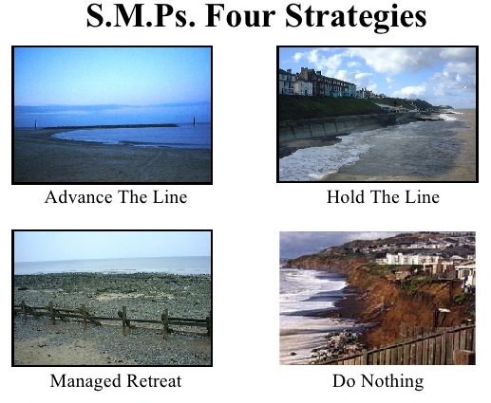

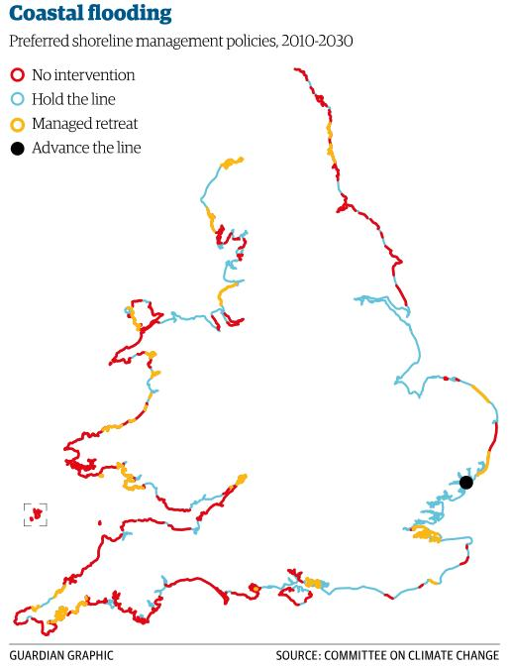

What factors will determine which of the above strategies is designated along the coast?

What issues might arise if different sections of coastline are designated different strategies?

- Tables 1 and 2 show different ways of looking at costs and benefits at the coast.
Table 1. A simple view of costs and benefits:
 | CONSIDERATIONS | BENEFITS | COSTS
£ | Economic considerations |  | e.g. Building and maintaining the coastal defences
 | Social considerations | e.g. Security and peace of mind | e.g. Increased problems of access to beaches
e | Environmental considerations | e.g. Rarely beneficial unless ‘soft’ engineering

Table 2. A simple cost-benefit calculation for three coastal defence options:
Options | Benefits | Damage | Costs | Benefit/  Cost Ratio
1. Do nothing | X | £650, 000 | X | X
2. ‘Holding the line’ along the whole section of the coast. | £650, 000 | £0 | £1, 000, 000 | 0.65
3. Protect some places but not others along the coast | £600, 000 | £50, 000 | £350, 000 | 1.5

i. Complete Table 1 by filling in the missing examples (2 marks)
ii. Explain why decision makers might choose option 3 in Table 2.
.......................................................................................................................................................
.......................................................................................................................................................
.......................................................................................................................................................
.......................................................................................................................................................
(2marks)
iii. Identify the circumstances in which ‘do nothing’ (Option 1) would be the preferred option.
.......................................................................................................................................................
.......................................................................................................................................................
.......................................................................................................................................................
.......................................................................................................................................................
(2 marks)
iv. Explain why it may be difficult to put value on some costs or benefits.
.......................................................................................................................................................
.......................................................................................................................................................
.......................................................................................................................................................
.......................................................................................................................................................
(2 marks)

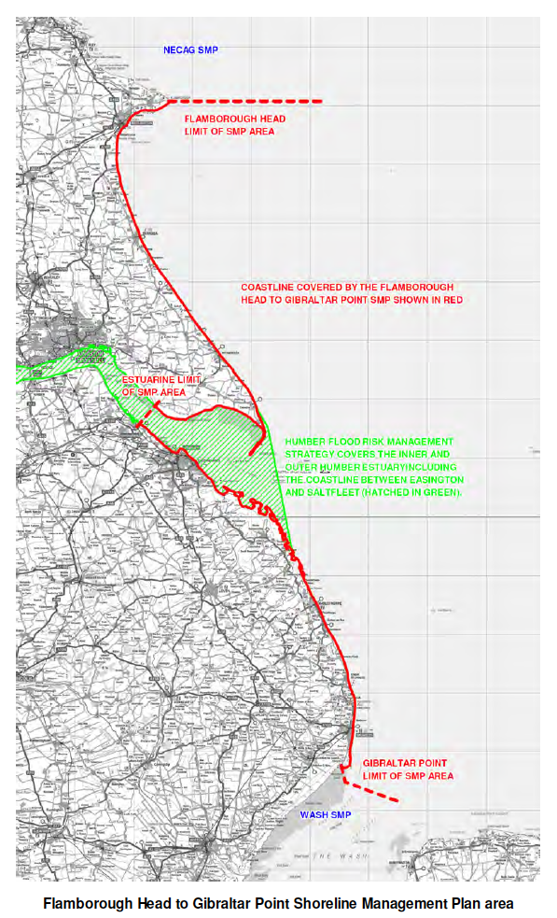
Why is the Holderness coastline so vulnerable to coastal erosion and flooding?

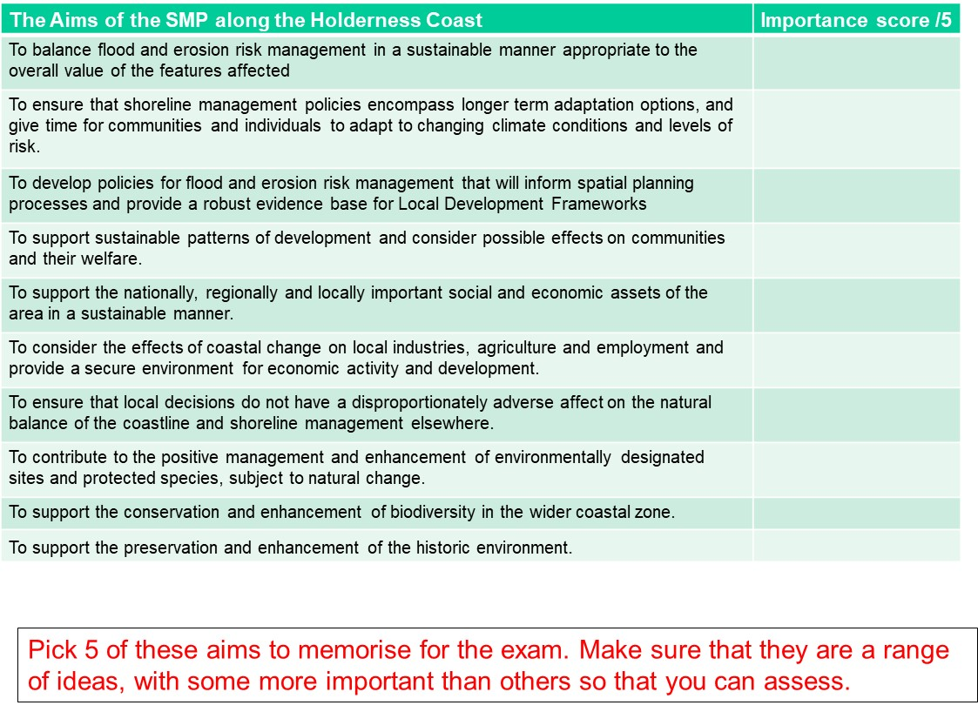
Key Stakeholders for Holderness:
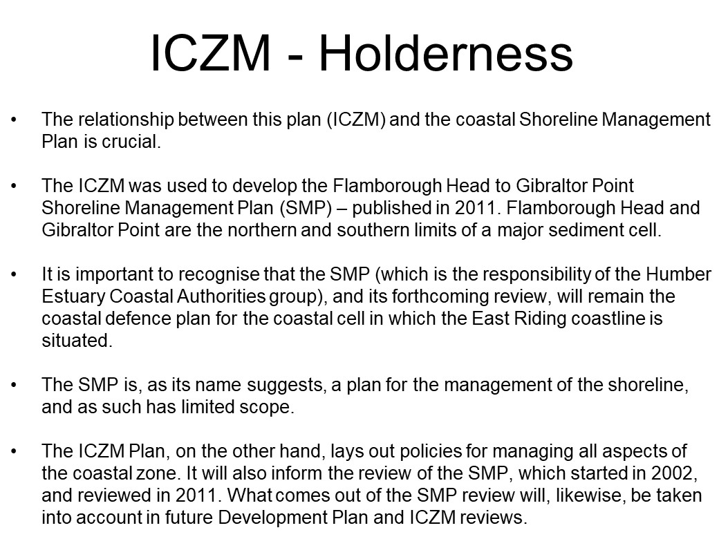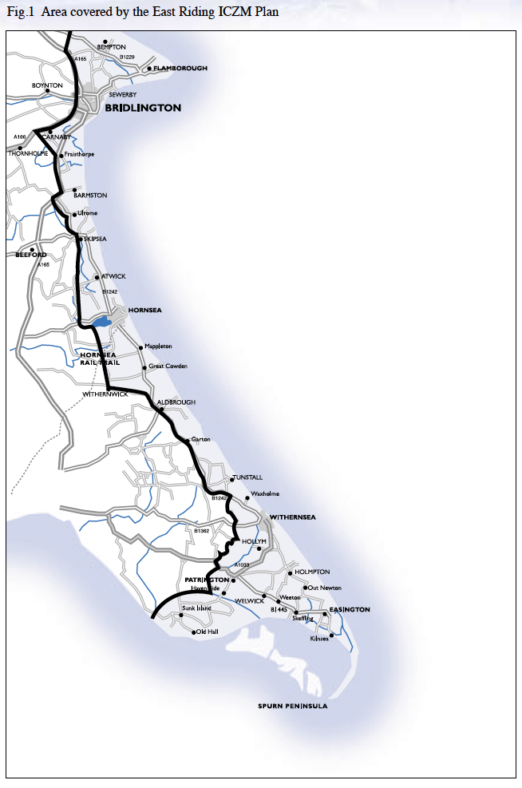
Review: Integrated Coastal Zone Management – a sustainable approach to flood risk and erosion management

Research Links:
20min interview with Dr. Burbridge from Newcastle University on
https://www.youtube.com/watch?v=g3uD-m6DPcc
European Commission information on ICZM: http://ec.europa.eu/environment/iczm/index_en.htm
Summary of the importance of ICZM for planning in the UK
https://www.gov.uk/guidance/flood-risk-and-coastal-change#Integrated-Coastal-Zone-Management
European Commission presentation on ICZM and Maritime Spatial Planning with useful summary diagrams
Summary of the origin of the concept and policies of ICZM:
http://www.coastalwiki.org/wiki/The_Integrated_approach_to_Coastal_Zone_Management_(ICZM)
In pairs, use the web links to research and answer the following questions:

- What are the origins of ICZM?

- What is the background to why an integrated coastal management is needed?

- Why is concentrating on people and economic activity putting pressure on coastal environments?

- What are the specific issues facing coastal environments in the future?

- Who are the stakeholders, who should be considered when thinking about coastal management?

- How can ICZM be viewed as a cyclical process?

Exam Style Question
Read Oxford textbook pages 142-143, Hodder textbook pages 122-124, and use the information to answer the question below.
- Assess the advantages of integrated management plans such as Shoreline Management Plans (SMPs) and Integrated Coastal Zone Management (ICZM) [9 marks]

