**Editing** – *Continuity or non-continuity? Interesting effects (slow-motion etc.) and transitions? Shot Length? Pace? Jump cuts?*

*Type your notes here…*

**Narrative** – *What is the structure of the story? What are the cause and effect elements? Narrative resolution / closure?*

*Type your notes here…*

**Cinematography** – Describe the cinematography- *Dynamic camerawork? Elements of documentary style? Handheld? Lighting? Shot on location?*

*Type your notes here…*

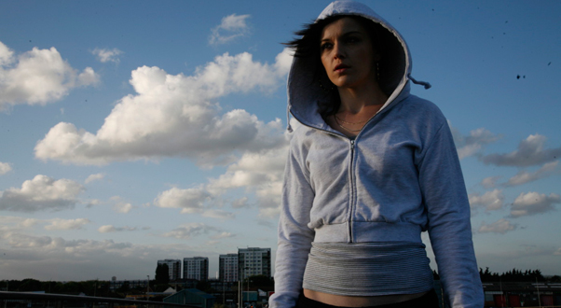

**Mise en scene** – *Notable* *costumes, props, locations / décor and performance?*

*Type your notes here…*

**Character profile** *– What is Mia like? Is she likeable? Who are the other main characters and what are their relationship to Mia?*

*Type your notes here…*

**Sound** *– Describe the musical score and non-diegetic music chosen? Are certain songs used more than once?*

*Type your notes here…*

*Fish Tank* (Andrea Arnold, 2009)