# Coastal Systems and Landscapes

[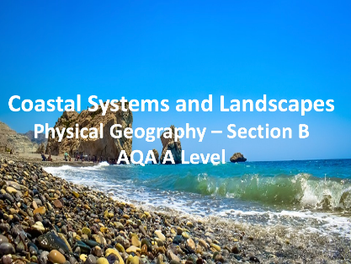](https://www.google.com/url?sa=i&url=https%3A%2F%2Fwww.tes.com%2Fteaching-resource%2Fcoastal-systems-and-landscapes-aqa-a-level-geography-11982291&psig=AOvVaw0I_rkIClH0qmo1_3NYpBMt&ust=1581006386090000&source=images&cd=vfe&ved=0CAIQjRxqFwoTCICC7fLpuucCFQAAAAAdAAAAABAE)

**Coasts as natural systems**

* Systems in physical geography: systems concepts and their application to the development of coastal landscapes – inputs, outputs, energy, stores/components, flows/transfers, positive/negative feedback, dynamic equilibrium. (***Apply to all coastal examples***)
* The concepts of landform and landscape and how related landforms combine to form characteristic landscapes.(***Dorset Coastline is a good illustration of this***)

**Systems and processes**

* Sources of energy in coastal environments: winds, waves (constructive and destructive), currents and tides. Low energy and high energy coasts. (***Named coastlines***)
* Sediment sources, cells and budgets.
* Geomorphological processes: weathering, mass movement, erosion, transportation and deposition:
  + Distinctively coastal processes: marine: erosion – hydraulic action, wave quarrying, corrasion/abrasion, cavitation, solution, attrition; transportation: traction, suspension (longshore/littoral drift) and deposition;
  + sub-aerial weathering, mass movement and runoff.

**Coastal landscape development**

This content must include study of a variety of landscapes from beyond the United Kingdom (UK) but may also include UK examples.

* Origin and development of landforms and landscapes of coastal erosion: cliffs and wave cut platforms, cliff profile features including caves, arches and stacks; factors and processes in their development. (***Holderness, Dorset, West Wittering, named examples from own research***).
* Origin and development of landforms and landscapes of coastal deposition. Beaches, simple and compound spits, tombolos, offshore bars, barrier beaches and islands and sand dunes; factors and processes in their development. ***Holderness, Dorset, West Wittering, named examples from own research***
* Estuarine mudflat/saltmarsh environments and associated landscapes; factors and processes in their development. (***East Head Spit, Keyhaven, and the Severn Estuary*** )
* Eustatic, isostatic and tectonic sea level change: major changes in sea level in the last 10,000 years.
* Coastlines of emergence and submergence. Origin and development of associated landforms: raised beaches, marine platforms; rias, fjords, Dalmatian coasts. (***NW Scotland, Devon, Cornwall, New Zealand)***
* Recent and predicted climatic change and potential impact on coasts. (***Canvey Island, UK and Kiribati in the Pacific Ocean, plus other named coastlines affected by SLC***)
* The relationship between process, time, landforms and landscapes in coastal settings.

**Coastal management Human intervention in coastal landscapes.**

* Traditional approaches to coastal flood and erosion risk: hard (***Holderness and West Wittering)*** and soft engineering (***Essex saltmarshes***).
* Sustainable approaches to coastal flood risk and coastal erosion management: shoreline management/integrated coastal zone management. (***Holderness example***)

**Quantitative and qualitative skills**

* Students must engage with a range of quantitative and relevant qualitative skills, within the theme landscape systems:
  + These should include observation skills, measurement and geospatial mapping skills and data manipulation and statistical skills applied to field measurements. (***East Head Spit at West Wittering, Holderness Case Study***)

**Case studies Case study(ies) of coastal environment(s)**

* At a local scale to illustrate and analyse fundamental coastal processes, their landscape outcomes as set out above and engage with field data and challenges represented in their sustainable management. (***Holderness)***
* Case study of a contrasting coastal landscape beyond the UK to illustrate and analyse how it presents risks and opportunities for human occupation and development and evaluate human responses of resilience, mitigation and adaptation. (***Odisha, India***)