# Changing Places

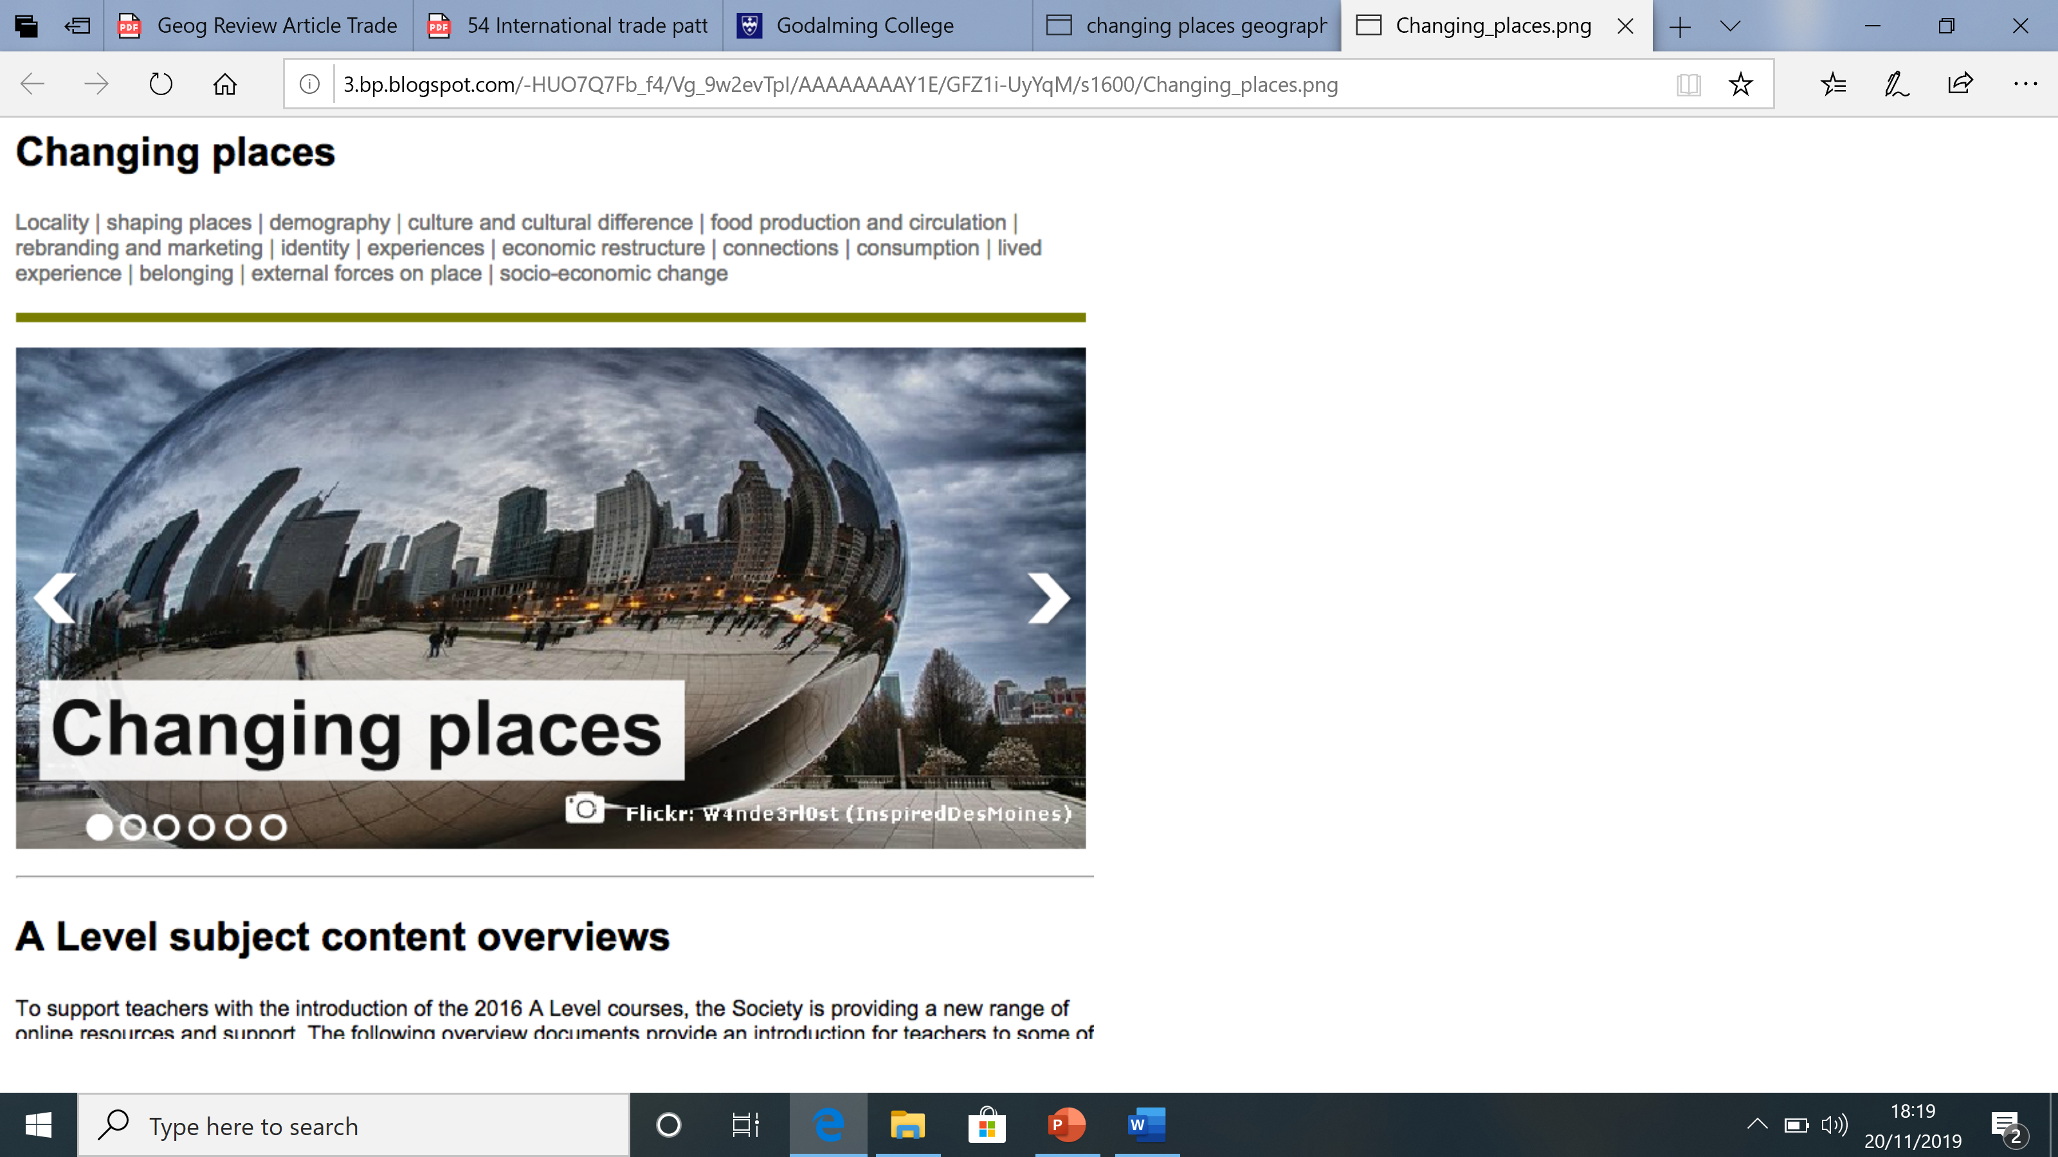

**Nature and importance of place**

* Insider and outsider perspectives on place.
* Categories of place: • near places and far places • experienced places and media places.
* Factors contributing to the character of places (e.**g. Boston, Lincolnshire**):
  + Endogenous: location, topography, physical geography, land use, built environment and infrastructure, demographic and economic characteristics.
  + Exogenous: relationships with other places.

**Relationships and connections**

* How the demographic, socio-economic and cultural characteristics of places (**Detroit, Stratford, Godalming**) are shaped by:
  + shifting flows of people, resources, money and investment, and ideas at all scales from local to global.
  + the characteristics and impacts of external forces operating at different scales from local to global, including either government policies or the decisions of multinational corporations or the impacts of international or global institutions.
  + how past and present connections, within and beyond localities, shape places and embed them in the regional, national, international and global scales.

**Meaning and representation** (**Llandudno, Coin Street, Stratford)**

* The importance of the meanings and representations attached to places by people with a particular focus on people's lived experience of place in the past and at present.
* How humans perceive, engage with and form attachments to places and how they present and represent the world to others, including the way in which everyday place meanings are bound up with different identities, perspectives and experiences.
* How external agencies, including government, corporate bodies and community or local groups make attempts to influence or create specific place-meanings and thereby shape the actions and behaviours of individuals, groups, businesses and institutions. E.g. **Llandudno, Stratford and Coin Street.**
* How places may be represented in a variety of different forms such as advertising copy, tourist agency material, local art exhibitions in diverse media (e.g. film, photography, art, story, song etc) that often give contrasting images to that presented formally or statistically such as cartography and census data. **Booklet examples**.
* How both past and present processes of development can be seen to influence the social and economic characteristics of places and so be implicit in present meanings. **(Godalming, Stratford, Detroit)**

Quantitative and qualitative data

* Quantitative data, including the use of geospatial data, must be used to investigate and present place characteristics
* Particular weight must be given to qualitative approaches involved in representing place, and to analysing critically the impacts of different media on place meanings and perceptions.
* The use of different types of data should allow the development of critical perspectives on the data categories and approaches.

**Place Studies**

* Local place study (**Godalming**) exploring the developing character of a place local to the home or study centre.
* Contrasting place study (**Stratford or Detroit**) exploring the developing character of a contrasting and distant place.
* Place studies must apply the knowledge acquired through engagement with prescribed specification content and thereby further enhance understanding of the way students' own lives and those of others are affected by continuity and change in the nature of places. Sources must include qualitative and quantitative data to represent places in the past and present.
* Both place studies must focus equally on: • people's lived experience of the place in the past and at present and either • changing demographic and cultural characteristics or • economic change and social inequalities.
* Suitable data sources could include: • statistics, such as:
  + census data
  + maps
  + geo-located data
  + geospatial data, including geographic information systems (GIS) applications
  + photographs
  + text, from varied media
  + audio-visual media
  + artistic representations
  + oral sources, such as interviews, reminiscences, songs etc.

**Student reflection – relate to own lives throughout the unit**

* Students acknowledge this importance and engage with how places are known and experienced, how their character is appreciated, the factors and processes which impact upon places and how they change and develop over time.
* The ways in which students’ own lives and those of others are affected by continuity and change in the nature of places and our understanding of place.