THE DIVING BELL AND THE BUTTERFLY (Schnabel. 2007 France)

REPRESENTATION

TASK 1 - THE RELATIONSHIP BETWEEN FATHERS AND SONS
Representation | Scenes  (Chaptered on estream) | Representation Thoughts and Analysis | How has Film Form constructed the representations  (cinematography, mise-en-scene, lighting, sound, editing and performance)
Relationship between Jean-Do and his father | The Shave
 | Father and Son phone call
Jean-Do as a father | Father’s Day
 | Jean-Do and Theo

TASK 2 - THE REPRESENTATION OF WOMEN

Representation | Scenes  (Chaptered on estream) | Representation Thoughts and Analysis | How has Film Form constructed the representations  (cinematography, mise-en-scene, lighting, sound, editing and performance)
Jean-Do objectifying women | Meeting female therapists
 | Lourdes Flashback
Relationships: mother of children and mistress | Celine and Ines
 | Celine

TASK 3 - CHARACTER PROFILES

Fill in the table below by revisiting the film on esteam and researching characters dialogue.
Character  Actor | Personality traits and how we feel towards them. | Do they develop throughout the film? | A quote that typifies their character (English translation and French)

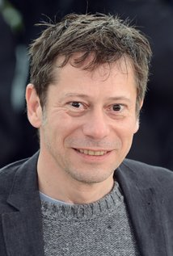
Jean-Dominique Bauby

Mathieu Amalric

Claude Mendibil
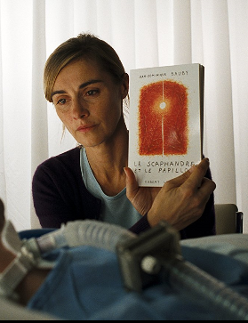
Anne Consigny

Henriette Roi
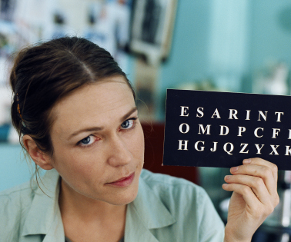
Marie-Josée Croze

Céline Desmoulins


Emmanuelle Seigne

Joséphine (Inès)

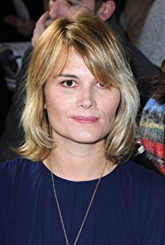
Marina Hands

Papinou
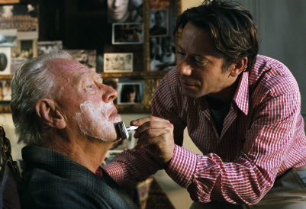
Max von Sydow

